**Neutronic Analysis of Annular & MOX Fuel Designs for SMART Core Using DeCART2D/MASTER codes**

Authors: Abdulelah Atiahallah, Saud Al Shikh.

Co-authors: Abdulrahman Al Tayeb, Esam Bafaraj. Hashim Al Attas

# Affiliation

*Atomic Energy Sector, King Abdullah City for Renewable and Atomic*

*Energy (K.A.CARE), Riyadh 11451, Saudi Arabia*

[*A.Atiahallah@energy.gov.sa*](mailto:A.Atiahallah@energy.gov.sa)*,* [*S.Shikh@energy.gov.sa*](mailto:S.Shikh@energy.gov.sa)*,*

[*A.Tayeb@energy.gov.sa*](mailto:A.Tayeb@energy.gov.sa)*,* [*E.Bafarj@energy.gov.sa*](mailto:E.Bafarj@energy.gov.sa)*,* [*H.Ttas@energy.gov.sa*](mailto:H.Ttas@energy.gov.sa)*,*

Abstract – *The SMART (System-integrated Modular Advanced ReacTor) reactor is a small, pressurized water reactor that utilizes integral pressurized water coolant, which offers many advantages over traditional designs. In this paper, a neutronic analysis of the SMART modular reactor fuel using the DeCART2D/MASTER computer codes, considering annular and mixed oxide (MOX) fuel designs. The study modeled and analyzed the behavior of the SMART reactor fuel at hot full power for the 1st cycle, including the use of annular fuel design and MOX fuel. DeCART2D code is a two-dimensional neutron transport code that uses the method of characteristics to solve the neutron transport equation, to simulate the neutronic behavior of these fuel types. MASTER is a neutron diffusion nodal code for PWR core design with equipping various calculation capabilities. The study explores the use of annular fuel design for the SMART reactor with respect to several key parameters, which are multiplication factor, maximum fuel temperature, fuel burnup, and power peaking factors. Overall, the neutronic analysis of the SMART modular reactor fuel using DeCART2D/MASTER computer codes provides valuable insights into the behavior of the reactor fuel and can inform the design and operation of the SMART reactor. The findings can also contribute to the development of advanced fuel designs for small modular reactors, with potential applications in both existing and future nuclear power plants.*

**Keywords:** SMART, Annular, MOX, DeCART2D, MASTER

I. Introduction

To improve the safety and efficiency of the SMART reactor, there has been growing interest in introducing alternative fuel designs that adopts the ATF concept. One such design is the annular fuel design, which involves using fuel pellets with a hollow center instead of solid ones. The annular fuel design has several potential advantages over traditional solid fuel designs, including improved fuel utilization, higher thermal margins, and reduced fuel failure rates **[1]**. Another alternative fuel design is the use of MOX fuel, which is a type of nuclear fuel that contains a mixture of plutonium oxide and uranium oxide. The use of MOX fuel has several potential advantages, including increased fuel utilization and reduced production of long-lived nuclear waste. However, the use of MOX fuel also presents several technical and safety challenges, including issues related to fuel fabrication, reactor physics, and radiation shielding. The objective of the study is to investigate the feasibility and performance of using annular fuel design in the SMART reactor. It will also explore the neutronic analysis of annular fuel assemblies and MOX fuel and compare them to those of traditional solid fuel assemblies such as the one used in SMART design. The study will also assess the impact of annular and MOX fuel designs on reactor safety during normal operations. The findings will provide insights to the benefits of using fuel with central hole over conventional fuel.

***I.A. SMART core design and assembly models***

Figure. (1) shows the core loading pattern of 57 fuel assemblies, utilizing two types, since the central region of the core contains higher flux value than the peripheral region, more burnable absorber materials with higher concentration of Boron (B-10) are used in fuel type A than type B. Furthermore, higher concentration of fissile material 235U is used in fuel type B to maintain a flat flux profile throughout the core.

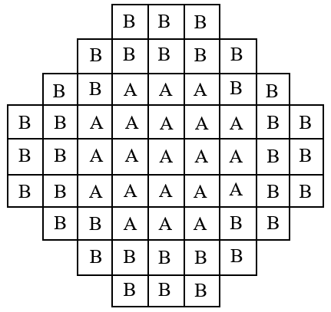

*Fig. 1. SMART core loading pattern*

The fuel assembly is based on the design of KOFA (Korean Standard Fuel Assembly) that was designed by KAERI/Siemens-KWU and used in the 900 MWe Westinghouse type Korean PWR's **[2]**. The fuel rods are arranged in rectangular lattices, as in KOFA but the length of the active region is reduced to 200 cm. SMART major parameters are listed in Table I **[3]**.

*Table I SMART major parameters*

|  |  |
| --- | --- |
| Parameter | Value |
| Thermal Output | 365 MWth |
| Electric Output | 107 MWe |
| Active Length | 200 cm |
| Cycle Length | 870 EFPD |
| Cladding Material | Zircaloy-4 |
| Cladding Thickness | 0.57 mm |
| Pellet Diameter | 8.05±0.01 mm |
| Pin Pitch | 1.26 cm |
| Burnable Absorber Material | Gd2O3-UO2 & Al2O3-B4C |

The fuel assembly models used in this study are 17x17 fuel rod array, with five different models A1, A2, B1, B2 and B3, each with different number of burnable absorbers and different enrichment, see Figure. (2), and Table II.

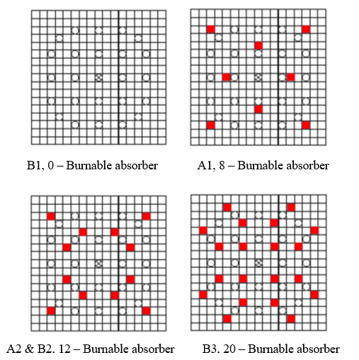

*Fig. 2. Fuel assemblies' burnable absorbers locations.*

*Table II Fuel assembly models' specifications*

|  |  |  |
| --- | --- | --- |
| Assembly model | No. of burnable absorbers | enrichment |
| A1 | 8 | < 3 wt% |
| A2 | 12 |
| B1 | 0 | <5 wt% |
| B2 | 12 |
| B3 | 20 |

II. Methodology

***II.A. Computational tools***

The calculation performed in this study used DeCART2D/MASTER codes, two-step core design system. has been developed in Korea Atomic Energy Research Institute (KAERI). The process starts with generating a homogenized group constants (HGCs) for each fuel assembly, radial reflector, and axial reflector using DeCART2D. Another two codes PROLOG and PROMARX are used to convert HGCs of the fuel assemblies and the reflectors to MASTER cross section library format as showed in Figure. (3). Burnup calculations at hot full power for cycle 1 are performed using MASTER.

DeCART2D (Deterministic Core Analysis based on Ray Tracing) **[4]**, is a 2D deterministic neutron transport code, its main purpose is to generate assembly-wise and reflectors homogenized condensed group constants used in MASTER (Multi-purpose Analyzer for Static and Transient Effects on Reactors) **[5]**, which is a neutron diffusion nodal code for PWR core design with various calculation capabilities **[6]**. Such as the ones performed in this study, neutron multiplication factor, power peaking factors, maximum fuel temperature, burnup calculation and gas production.

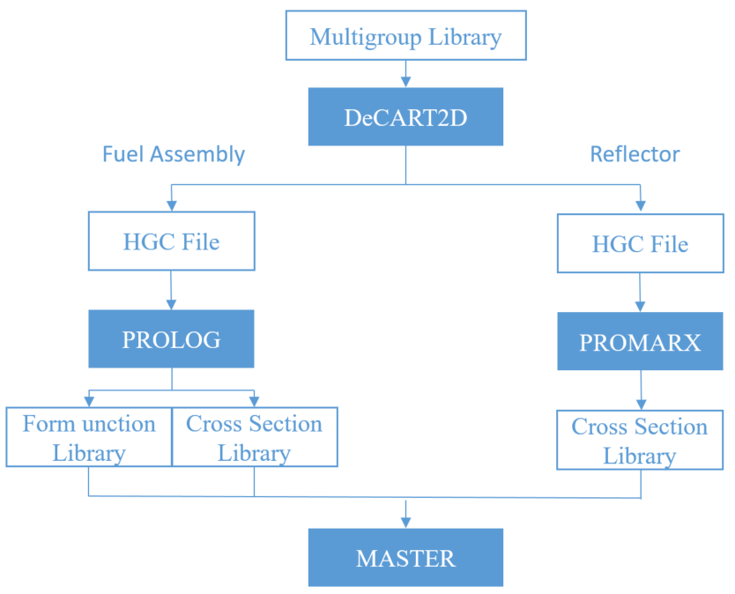

*Fig. 3. DeCART2D/MASTER codes system.*

***II.B. Investigated fuels***

The study investigates the effects of introducing central hole in the SMART fuel design, while maintaining the same amount of fissile material 235U. Other options for compensating for the missing material from the center of the fuel pin in the annular geometry include increasing the fuel pin length or increasing the fuel pellet outer radius. However, these options would require major changes to the reactor parameters, such as the fuel-to-coolant ratio and the core configuration. This would deviate from the objective of the study, which is to investigate the effects of the annular geometry on fuel performance while minimizing changes to the reactor core design. Therefore, these options were excluded from the study.

The approach adopted in this study is to keep the outer diameter of the fuel pellet the same as in the SMART fuel design. Since the fuel mass is decreased with the introduction of the central hole, the enrichment of the UO2 fuel is increased as shown in Table III. The study was extended to investigate the annular fuel designs using MOX fuel PuO2. MOX fuel contains plutonium, which has a higher neutron fission cross-section than uranium. This means that MOX fuel can produce more energy per unit mass than uranium fuel, which could compensate for the missing material from the central hole.

***II.C. Fuel rod geometry design***

SMART fuel rods design consisted of a uniform cylindrical pellet stacked together within a Zircaloy-4 clad tube. Between the fuel stack and the cladding, a gap is provided in order to accommodate the fuel swelling due to the accumulation of fission products. The gap is filled with helium gas to improve heat conduction from fuel to cladding **[7]**, see Figure. (4). This study adopts the VVER-1000 central hole design geometry in the fuel with a radius of 0.75mm **[8]**, keeping the same outer diameters of the fuel, gap and clad of SMART design, Figure. (5) shows an example of the annular design. In order to study the effect of the central hole on the reactor performance efficiently, two additional fuel rod designs / central hole diameters were included in the study which are 0.5mm and 0.9 mm, as shown in Table III.

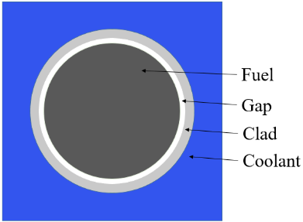

*Fig. 4. SMART fuel rod design.*

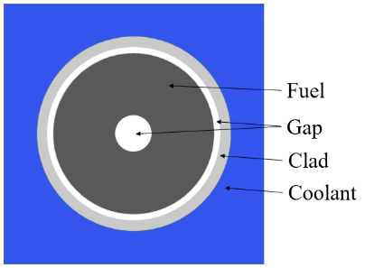

*Fig. 5. Annular fuel rod design.*

*Table III Investigated fuel designs*

|  |  |  |
| --- | --- | --- |
| Designs | Central hole radius (mm) | Fuel Material |
| SMART | 0 | < 5 wt% UO2 |
| R0.5 | 0.5 |
| R0.75 | 0.75 (VVER-1000) |
| R0.9 | 0.9 |
| MOX_R0.0 | 0.0 | < 5 wt% UO2, < 3 wt% PuO2 |
| MOX_R0.5 | 0.5 |
| MOX_R0.75 | 0.75 (VVER-1000) |
| MOX_R0.9 | 0.9 |

III. Results and discussion

***III.A. Neutron multiplication factor***

K-effective value of the reactor core was calculated for the different designs, while boron concentration was kept at a fixed value of 500 PPM for the burnup calculation throughout the cycle. Figure. (6) shows K-effective value among the 1st cycle for different central holes radii of the fuel rods using the original fuel. The annular design R0.9 has the highest value at all burnups (EFPD) starting with 1.07929 and ending with 0.9619, while the annular design R0.5 has the lowest values of K-effective during all burnups (EFPD), starting with 1.072645 and ending with 0.96132. Table. (IV) shows neutron multiplication factor at BOC, MOC and EOC.

*Fig. 6. K-effective values for the core of different annular fuel designs.*

*Table IV K-effective values for different annular fuel radii in BOC, MOC and EOC*

|  |  |  |  |
| --- | --- | --- | --- |
| Design | BOC | MOC | EOC |
| SMART | 1.072645 | 1.023440 | 0.961325 |
| R=0.5 (mm) | 1.072645 | 1.023440 | 0.961325 |
| R=0.75 (mm) | 1.075747 | 1.025317 | 0.961572 |
| R=0.9 (mm) | 1.078351 | 1.026890 | 0.961910 |

***III.B. Power peaking factor***

Power distribution within the reactor core is evaluated for the annular and MOX fuel designs. Both Radial Power Peaking Factor (RPPF) and 3D Power Peaking Factor (3DPPF) are calculated, in order to ensure that annular and MOX fuel designs will not violate materials integrity nor safety margins. The annular design R0.9 has the highest values of RPPF, on 0 EFPD R0.9 RPPF is 1.3905 and peaks at 495 EFPD with a value of 1.3892 on, while the reference design values seems to be less than all other designs starting with 1.3876 and at 495 EFPD is 1.3836 as shown in Figure. (7). The RPPF value for annular designs have an effect that undergoes a rapid decrease at 600 EFPD, where R0.9 design becomes the lowest until the EOC with an RPPF of 1.3178 and the reference design becomes the highest value until the EOC with an RPPF of 1.3203. Figure. (8) shows the 3DPPF which is more accurate, the annular design R0.9 has the highest value from the BOC with a 3DPPF of 1.6763 until it reaches its maximum value at 390 EFPD with a 3DPPF of 1.7795. The effect of rapid decreasing values of annular designs for the 3DPPF begins earlier than RPPF, specifically at 450 EFPD. Overall, the values for all the designs do not differ significantly from the reference design, yet the annular design R0.9 has the highest values, then R0.75, then R0.5 and the reference design.

Figure. (9) and Figure. (10) show RPPF and 3DPPF results of the MOX fuel designs. For the RPPF the values are more than 1.6, and for the 3DPPF are more than 2.1, both results violates the reactor's safety margins. This is due to the selection of MOX compositions. Thus, more studies and analysis are needed to solve this issue in future work, such as analyzing different MOX fuel compositions or rearranging different loading pattern configurations to meet all safety requirements.

*Fig. 7. RPPF values of different designs.*

*Fig. 8. 3DPPF values of different designs.*

*Fig. 9. RPPF values of MOX fuel designs.*

*Fig. 10. 3DPPF values of different designs.*

***III.C. Maximum fuel temperature***

The safety and efficiency of the reactor operation highly depends on the maximum fuel temperature, Figure. (11) shows the behavior of the reactor using annular fuel designs in comparison with the reference design. The graph shows a complete alignment performance of the maximum fuel temperature during the BOC and EOC, except between 250-500 EFPD, where the annular design R0.9 has the highest temperature of 622.41 Co at 420 EFPD. On the other hand, the reference design's maximum temperature between 250-500 EFPD is 618.75 at 450 EFPD, and it has resulted as the minimum value among other designs. The shift in temperature degradation among designs occurs due to the change of geometry, as the increase of the size of central hole increases its effect.

*Fig. 11. Maximum fuel temperature of the core for different designs.*

***III.D. Fuel Burnup***

Increased annular fuel design inner radius resulted in a decrease of total fuel mass of the reactor core, which led to higher burnup. Table V present the total fuel burnup for the 1st cycle for each design. The difference between the highest burnup design R0.9 and the lowest burnup designs (the reference and R0.5) is equal to 786.4 KWD/Kg.

*Table V Total fuel burnup for the 1st cycle.*

|  |  |
| --- | --- |
| Design | Total Burnup (MWD/kg) |
| SMART | 22.4234 |
| R=0.5 (mm) | 22.4234 |
| R=0.75 (mm) | 22.8555 |
| R=0.9 (mm) | 23.2098 |

***III.E. Gas production (Xenon- 135 and Samarium-149)***

The annular fuel designs affect the gas production. The production of non-actinides elements, which have a high neutrons absorption cross-section, mainly 135Xe and 149Sm. Fig. 12 and Fig. 13, shows the amount of the 135Xe and 149Sm produced through the 1st cycle of the reactor respectively. The graphs shows that trends of the designs starts to diverge from early stage in 1st cycle (at 120 EFPD for the 135Xe and 165 EFPD for the 149Sm). The reference design produces the highest amount of 149Sm throughout the cycle with an amount of 2.8E-08 Atoms/(cm∙barn) at 435 EFPD. While the designs with central hole produces less amounts throughout the cycle as the central hole’s radius increase. Where the lowest peak value of 149Sm is 2.77E-08 Atoms/(cm∙barn) at 375 EFPD for central hole with radius R0.9. For 135Xe, the highest production was at the reference design with a value of 2.69E-9 (Atoms/(cm∙barn)) at 165 EFPD. For the design with a central hole R0.9, the peak value is 2.68E-9 Atoms/(cm∙barn) at 165 EFPD.

The reduced production of 135Xe and 149Sm in the annular fuel design (Fig. 12 and Fig. 13) can be attributed directly to the reduction in the mass of heavy metals in the fuel rod. This is because 135Xe and 149Sm are both fission products, and the rate of fission is directly proportional to the mass of heavy metals in the fuel rod. The fission of the fissile materials in the fuel results in production of those non-actinides elements, leading to negative reactivity, and consequently decreases the reactor's neutron multiplication factor, reactor power and temperature.

*Fig. 12. Average production of 135Xe for different designs.*

*Fig. 13. Average production of 149Sm for different designs.*

IV. Conclusions

In this study, the feasibility and performance of using annular fuel designs for the SMART reactor were investigated. The results showed a slightly higher values for the annular designs (R0.75 and R0.9) than the reference design, in all key parameters calculated in this paper except for the gas production values are quite less than the reference, which explains the increment for the annular designs' values as mentioned in the discussion. Overall, the annular fuel designs (R0.75 and R0.9) have the potential to significantly improve the performance and safety of the SMART reactor. However, further research and development is needed to address the challenges of implementing these designs, such as mitigating the increased RPPF and 3DPPF values. Additionally, the annular fuel designs also introduce new challenges related to fuel fabrication and licensing. Further research and development in this area is warranted to address these challenges.

In conclusion, this study was based on the assumptions and limitations inherent in the DeCART2D/MASTER deterministic codes, which are the same codes used to design SMART reactor. Future work should focus on validating the findings through experimental measurements and utilizing more advanced modeling techniques, such as Monte Carlo simulation codes.

Acknowledgments

Special thanks to King Abdullah City for Atomic & Renewable Energy and the Korean Atomic Energy Research Institute for support of this research.

References

1. Choi, J.Y. and Hong, S.G., 2019, May. A small modular reactor core design with annular UO2 and FCM fuel rods. In Trans Kor Nucl Soc Spring Meeting (pp. 23-24).
2. Seo, J.K., Yoon, J.H., Kim, J.P., Lee, D.J. and Chang, M.H., 1997. Advanced integral reactor (SMART) for nuclear desalination. In Nuclear desalination of sea water. Proceedings of an international symposium.
3. C, B. (2022) ‘SMART (KAERI, Republic of Korea and K.A.CARE, Kingdom of Saudi Arabia)’, in C. A.R. (ed.) Advances in Small Modular Reactor Technology Developments. 2022nd edn. Vienna , Austria: IAEA, pp. 55–56.
4. J. Y. Cho, et al., "DeCART2D v1.1 User's Manual," KAERI/UM-40/2016, 2016.
5. J. Y. Cho, et al., "MASTER v4.0 User's Manual," KAERI/UM-41/2016, 2016.
6. Shim, C.B., Cho, J.Y. and Lee, K.H., 2017. Core Follow Calculation for a VVER-1000 Reactor in Cycles 1 through 6 using DeCART2D/MASTER. TVS, 20(312), pp.2-0.
7. Ramdhani, R.N., Prastyo, P.A., Waris, A. and Kurniadi, R., 2017, July. Neutronics Analysis of SMART Small Modular Reactor using SRAC 2006 Code. In Journal of Physics: Conference Series (Vol. 877, No. 1, p. 012067). IOP Publishing.
8. Mohsen, M.Y., Abdel-Rahman, M.A. and Galahom, A.A., 2021. Integrated analysis of VVER-1000 fuel assembly fueled with accident tolerant fuel (ATF) materials. Annals of Nuclear Energy, 159, p.108330.