**A Neutronic Study on Safety Characteristics of Fast Spectrum Stable Salt Reactor (SSR)**

Mazen Bushnag a, Taesuk Oha, Yonghee Kima*

aNuclear & Quantum Engineering Department, Korea Advanced Institute of Science and Technology,

291 Daehak-ro, Eoeun-dong, Yuseong-gu, Daejeon

\**Corresponding author:* [*yongheekim@kaist.ac.kr*](mailto:yongheekim@kaist.ac.kr)

**Abstract**- *This is a preliminary investigation of safety characteristics of the Stable Salt Reactor (SSR), which is a fast-spectrum molten salt reactor proposed by Moltex Energy. The reference Moltex fuel composition and other publicly released information have been utilized in this work. Regarding the liquid salt fuel, two more TRU (transuranics) compositions are also considered for improved core performances. Since the SSR concept adopts an on-power refueling scheme, a pseudo-equilibrium state was envisioned based on the linear reactivity model. It was found that reactivity change induced by withdrawal or insertion of fuel assembly could exceed 2 $, which insinuates possible safety or operational issues pertaining to the on-power refueling scheme that has not yet been thoroughly investigated. This work finds that the coolant temperature coefficient (CTC) is clearly positive ~ 2 pcm/K, the Doppler effect of the fuel salt is ~ -0.5 pcm/K and its temperature-dependent expansion coefficient is about -10 pcm/K, leading to fuel temperature coefficient (FTC) of the SSR to be around -10.5 pcm/K. Through point kinetic analyses coupled with a simplified lumped heat balance model, the transient behavior of the SSR system was estimated based on the evaluated temperature coefficients of the reactivity. Although the change in the reactivity is expected to be significant, the feasibility of on-power refueling strategy for the SSR has been found. All of the neutronic calculations were performed using the SERPENT 2 Monte Carlo code with nuclear data library ENDF/B-VII.1.*

# Introduction

In this paper, an overview of the SSR system, which includes both information provided by Moltex Energy and assumptions made by the authors, is presented along with the transient analysis results based on point-kinetic equations (PKE). Note that information regarding the original SSR design by Moltex Energy is available only up to a limited extent. Whereupon, assumptions had to be made to appraise the safety features of the SSR such as coolant and fuel temperature coefficients.

The major objective of this study is to evaluate the feasibility of the on-power refueling scheme that incorporates both fuel unloading and loading for a representative SSR core. If a sudden insertion of external reactivity occurs, the reactor core must accommodate it through feedback effects while maintaining a tolerable change in its constituent temperatures. A lumped point reactor model was envisioned to assess such capability of the SSR core, where the details and result are depicted in this manuscript.

1. Study Design

In this section, the SSR study design model is discussed, including geometry, salt and material considerations, and operating conditions [1].

## SSR Core Structural Design

The design concept studied in the thesis is based on as much information and data available from the Moltex design ‎[2]. The available information spans fuel salt and coolant salt compositions, fuel pins per assembly, fuel tube height and diameter. However, many others are not accessible to the public. Therefore, an improvisation had been made for investigating the safety characteristics of a fast spectrum SSR, e.g., fuel temperature coefficient (FTC), coolant temperature coefficient (CTC), and axial expansion coefficient, to investigate its intrinsic safety.

Table I: Fuel tube design parameters.

|  |  |
| --- | --- |
| Parameter | Value |
| Pitch to diameter ratio | 1.1 |
| Pellet radius | 0.5 cm |
| Tube Thickness | 0.06 cm |
| Pin pitch | 1.232 cm |
| Active fuel height | 160 cm |
| Gas plenum length | 20 cm |

Sufficient information was only viable related to the fuel tube design although an appropriate assumption had to be made for gas plenum height, pin-pitch, and pitch-to-diameter ratio. The numerals considered in the presented study are enumerated in Table I.

The fuel assembly is a typical hexagonal assembly, however, since essential information including the gap and duct thickness were not available in the reference ‎[2], typical values of hexagonal assemblies were adopted. The fuel assembly information applied in this study is provided in Table II. The reflector and shield assemblies configurations were also assumed to be the same as the fuel assemblies. The structure materials that have been considered are provided in Table III.

Table II: Fuel assembly design parameters.

|  |  |
| --- | --- |
| Parameter | Value |
| Gap between two FAs | 0.4 cm |
| Duct Thickness | 0.1 cm |
| FA Pitch | 21.544 cm |
| Pins per Assembly | 271 |
| Assemblies number | 100 |
| Assembly Size | 20.944 cm |

Table III: Structure materials.

|  |  |
| --- | --- |
| Structure | Material |
| Radial reflector Assemblies | PbO |
| Radial shield Assemblies | B4C (95% B10) |
| Fuel tubes | Nimonic PE16 |
| Fuel Assembly Cladding | Steel (SS304) |
| Vessel | Steel (SS304) |

The reactor core is comprised of hexagonal assemblies arranged in a cylindrical manner as shown in Fig. 1, where 100 fuel assemblies, 7 control assembly slots, 2 layers of reflector assemblies, and 1 layer of shielding assemblies are considered. The reactor core is submerged within a coolant pool contained in a stainless steel 304 vessel. Note that top or bottom reflectors are not modelled in this study.

## Salt & Material Considerations

The fuel salt composition considered in this study is NaCl-TRUCl3-UCl3 (60 %, 20%, 20% in mole percent respectively) under the eutectic condition. Note that a major element of TRU is considered as plutonium.

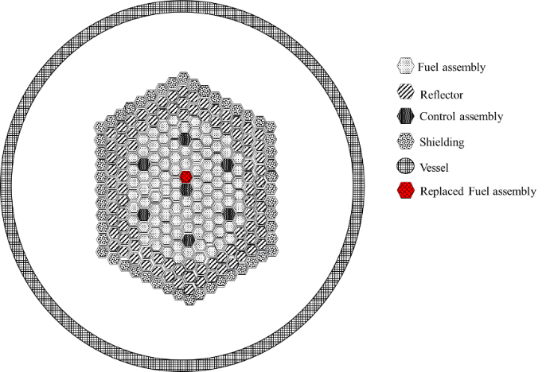

Fig. 1. SSR study core design arrangement representation

‎ The plutonium composition that is universally considered in the current SSR model has a typical PWR spent fuel composition. The change of fuel density with different TRU% can be evaluated by exploiting proper correlations ‎‎[3].

The Cl in the fuel mixture is enriched with 99 atom% of Cl-37 to stifle the neutron absorption by Cl-35, which produces Cl-36 that decays to S-36 or Ar-36. As for the uranium used in the study, a natural uranium composition was considered.

The coolant salt applied is that of the Moltex reference, which is KF-ZrF4-NaF (48 %, 42%, 10% in mole percent respectively), where the density of such mixture can be evaluated according to known correlations ‎[4, 5]‎.

## Operating Conditions and Power

The average coolant and fuel temperature were assumed to be 773.15 K and 1200 K respectively, along with the power density of 150 kW/l, which corresponds to 510 MWth for the net power. Note that the power density was taken from the Moltex design as a reference.

1. Methods and Results

The neutronics calculations were conducted using SERPENT Version 2.1.25 and ENDF-VII.1 data library with cycle-wise neutron history of 500,000 for 200 active cycles, and 100 inactive cycles.

* 1. *Core Depletion Analysis*

The depletion calculation has been conducted in order to estimate the pseudo-equilibrium core for the evaluation of SSR safety parameters and on-power refueling feasibility. Also, a linear reactivity model has been exploited to evaluate the discharge burnup.

|  |  |  |
| --- | --- | --- |
|  | $$B_{d}=\frac{2n}{n+1}B_{1}\underset{→}{∞}2B_{1}$$ | (3.1) |

where notation *Bd* denotes discharge burnup, *n* is the number of fuel batches, and *B1* defined as the single-batch burnup. For on-power refueling, the number of fuel batches is regarded as infinity, i.e., n →ꝏ.

Figure 2 shows the depletion curve for a single batch calculation, where discharge burnup is found to be 89.42 (MWd/Kg) with a conversion ratio of about 0.21. 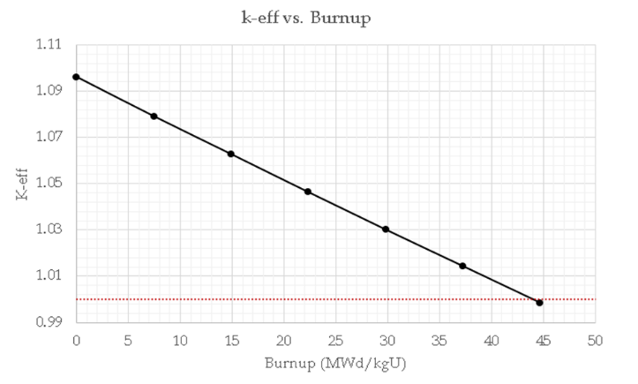

Fig. 2. k-eff vs. Burnup for 20 % TRU composition

## SSR Safety Characteristics

### Doppler-only Fuel Temperature Coefficient

To appraise the change in the reactivity due to Doppler broadening, operation temperature of the SSR fuel salt was perturbed, and its associated reactivity was calculated. From the premise of linear change in the reactivity, one could estimate the extent of its change with respect to the fuel temperature variation, i.e., Doppler-only FTC. Table IV shows the evaluated Doppler-induced FTC values at several temperature points, where +100 K of perturbation was uniformly applied.

### Axial Expansion Coefficient of Salt Fuel

The axial expansion coefficient is evaluated at a perturbation of a 100 K increase over the reference operating temperature in the simulation. The clad thermal expansion effect on volume change within the fuel tube is found to be negligible, compared to the molten salt fuel expansion within the tube. Assuming constant mass within the fuel tube, the fuel expansion resulted in an increase of about ~ 5.2 cm in active fuel height, which leads to strongly negative reactivity feedback about ~10 ±0.2 pcm/K. This is only due to the change in the fuel salt density mixture.

Table IV: Fuel temperature coefficient (Doppler only) pcm/K.

|  |  |  |  |  |
| --- | --- | --- | --- | --- |
| Doppler Coefficient [pcm/K] at different temperature points for 20% TRU | | | | |
| 800 K | 1000 K | 1200 K | 1400 K | 1600 K |
| - 0.80  ± 0.09 | -0.50  ± 0.19 | - 0.50  ± 0.19 | -0.43  ± 0.19 | -0.43  ± 0.09 |

### Coolant Temperature Coefficient

The CTC of the SSR system was evaluated by increasing the coolant temperature about 30 K, where the same approach as if for the FTC was applied. The CTC is found to be positive of 1.73 ± 0.63 pcm/K.

### Reactivity Change due to Single Fuel Assembly Replacement

In order to assess the reactivity change in the core during the on-power refueling situation, the replacement of a single fuel assembly on-power was envisioned, which corresponds to most reactive fuel assembly in the SSR core. Since the estimation of a certain fuel assembly’s burnup status at the time of refueling is quite difficult, an average burnup was postulated using the discharge burnup evaluated from the linear reactivity curve model. i.e., pseudo-equilibrium core was considered. In the case of loading a fresh fuel assembly, a reactivity change about 800 pcm is expected, which may raise an extreme safety concern. The location of the replaced fuel assembly in the core is shown Fig. 1.

## Description of Transient Analyses for SSR

To appraise the transient behavior of the SSR subjected to such perturbations, point kinetic model coupled with a lumped heat balance equation was devised.

|  |  |  |
| --- | --- | --- |
|  | $$\frac{dp}{dt}=\left[\frac{ρ\left(t\right)- β\left(t\right)}{Λ_{0}}\right]p\left(t\right)+\frac{1}{Λ_{0}}\sum_{k}{λ_{k}ξ_{k}\left(t\right)}$$ | (3.2) |

|  |  |  |  |  |
| --- | --- | --- | --- | --- |
|  | | | (3.3) | |
| $$M_{cl}c_{cl}\frac{dT_{cl}}{dt}=\frac{1}{R_{g}}\left[T_{f}\left(t\right)-T_{cl}\left(t\right)\right]-\frac{1}{R_{c}}\left[T_{cl}\left(t\right)-T_{c}\left(t\right)\right],$$ | | | (3.4) | |
| $$M_{c}c_{c}\frac{dT_{c}}{dt}=\frac{1}{R_{c}}\left[T_{cl}\left(t\right)-T_{c}\left(t\right)\right]-2Wc_{c}\left[T_{c}\left(t\right)-T_{i}\left(t\right)\right]$$ | | | (3.5) | |
| $$R_{c}=\frac{1}{hA_{cl}},$$ | | | (3.6) | |
|  | $$T_{c}=\frac{T_{i}+T_{e}}{2},$$ | (3.7) | |

where subscripts *f*, *cl*, and *c* refer to fuel, cladding, and coolant, respectively, and all the other notations are that of the convention. Note that a constant inlet temperature was considered throughout the analyses, and its associated Neutronics physical parameters are shown in Table V.

|  |  |  |  |
| --- | --- | --- | --- |
| parameter | Value | parameter | Value |
| β | 0.003033 [sec] | Λ | 2.3736e-06 [sec] |
| β1 | 9.13E-05 [sec] | λ1 | 0.013380 s-1 |
| β2 | 0.000673 [sec] | λ2 | 0.030593 s-1 |
| β3 | 0.000458 [sec] | λ3 | 0.115555 s-1 |
| β4 | 0.001047 [sec] | λ4 | 0.301933 s-1 |
| β5 | 0.000578 [sec] | λ5 | 0.8675 41s-1 |
| β6 | 0.000186 [sec] | λ6 | 2.898039 s-1 |

Table V: Neutronics physical parameters

### Description of Perturbations Cases

The cases considered for positive reactivity insertion simulating the refueling process shown in Table VI.

Table VI: Insertion of positive reactivity cases.

|  |  |  |  |
| --- | --- | --- | --- |
| Case | Insertion Type | Speed (cm/s) | Reactivity Worth |
| 1 | Step | - | + 2.62 $ |
| 2 | Ramp up | 2 | + 9.91 pcm/s |
| 3 | Ramp up | 10 | + 49.55 pcm/s |
| 4 | Ramp up | 20 | + 99.12 pcm/s |

### Results

The transient behaviours of the SSR core under step reactivity insertion case are shown in Figs. 3 throughout 6 where the power peaks up and plummet back within few milliseconds due to the strongly negative FTC. The power is then stabilized with a +16.4% increase in its original value. The fuel temperature also promptly surges up to about 120 ℃ above its initial value, and then gradually dwindles and remains 40 ℃ above the reference temperature within 1.5 seconds.

In the positive ramp up reactivity insertion cases, the power experiences a prompt increase in power, up to +10% at the start of the insertion and then it increases gradually as reactivity still being inserted, then the power experiences a sharp exponential decrease once the reactivity stopped being inserted and maintain stability. The simulated transient behaviours for such a case are exhibited in Figs. 7 throughout 10.

A special reactivity phenomenon is observed at the beginning and end of the external reactivity insertion in the core, which stems from the reactivity feedback competition between the strongly negative FTC and positive CTC.



v

Fig. 3. Normalized power change in positive reactivity step insertion with temperature feedback.



v

Fig. 4. Reactivity change with and without feedback for the positive step reactivity insertion case.



Fig. 5. Fuel mean temperature change for the positive step reactivity insertion case.



Fig. 6. Coolant outlet temperature change for the positive step reactivity insertion case.

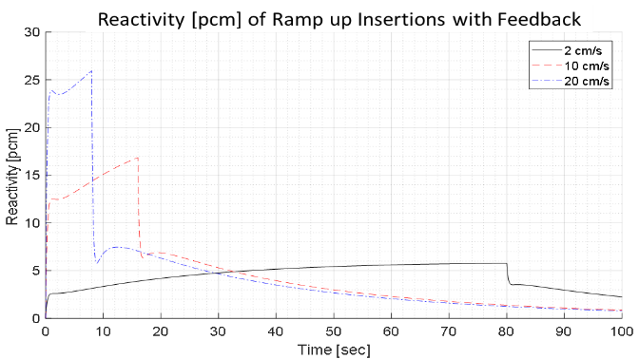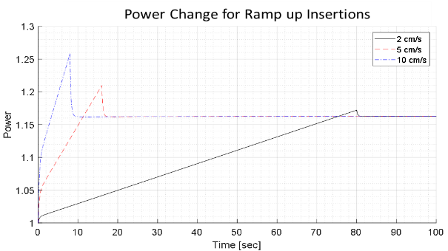

Fig. 7. Normalized power change for the positive ramp up reactivity insertion cases.

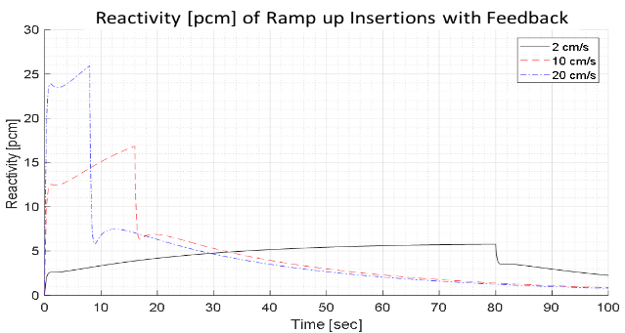

Fig. 8. Reactivity change for the positive ramp up reactivity insertion cases.

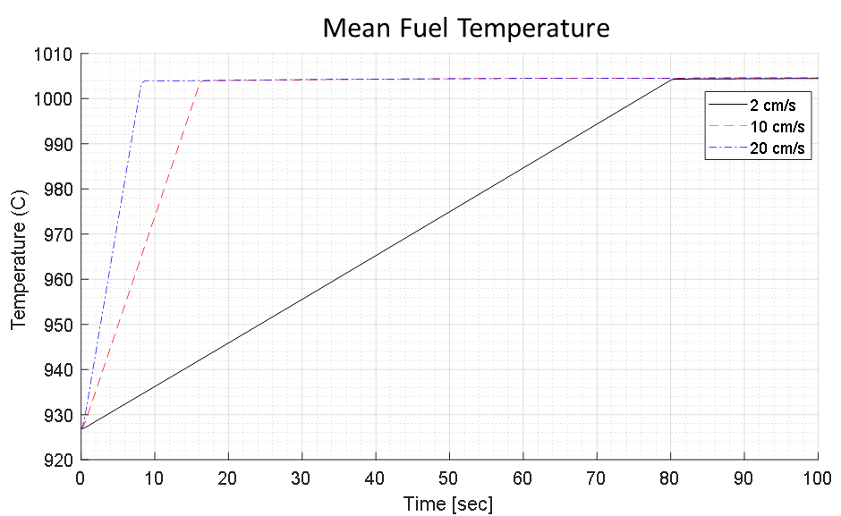

Fig. 9. Fuel mean temperature change for the positive ramp up reactivity insertion cases.

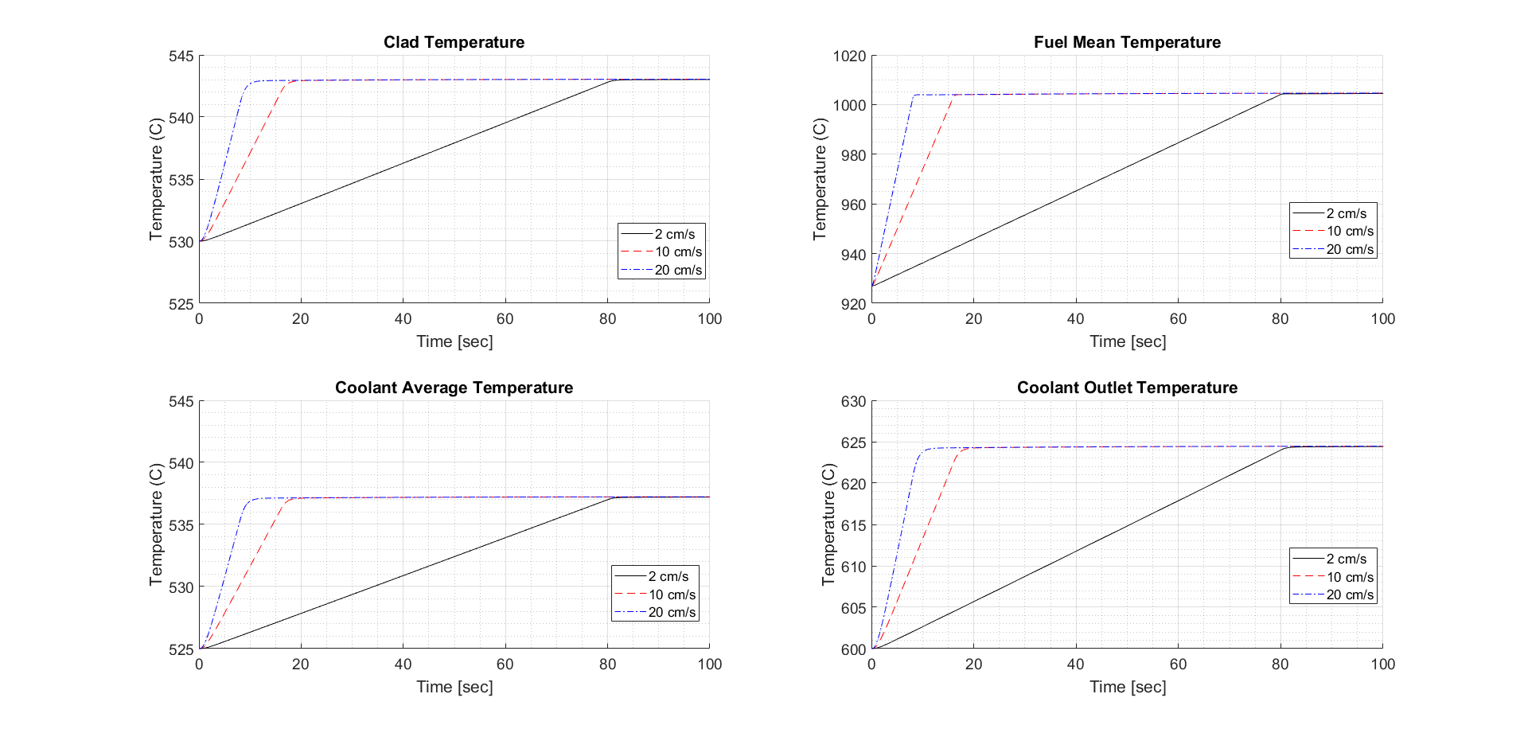

Fig. 10. Coolant outlet temperature change for the positive ramp up reactivity insertion cases.

1. Conclusions

It is noteworthy to mention that both the Doppler effect and axial expansion contribute to FTC, where the latter one incurs strong negative feedback. The Doppler effect of the salt fuel is only about -0.5 pcm/K and its temperature-dependent expansion coefficient is about -10 pcm/K, leading to a FTC for the SSR of about -10.5 pcm/K. The CTC value is found to be 1.5 ~ 2 pcm/K. The on-power refueling may seem feasible with a reactivity control system to accommodate the resulting power change and maintain operational stability.

These findings indicate that the on-power replacing of fuel assemblies is possible with some application of reactivity control or system in the SSR. The SSR may survive the hypothetical step-wise loading of a fresh FA during the presumed on-power refueling, albeit quite challenging.

Acknowledgments

This research was supported by Korea Atomic Energy Research Institute (NTIS-1711139325) and National Research Foundation of Korea (NRF) Grant funded by the Korean Government (MSIP) (2021M2D2A207638311)

References

1. Bushnag, M. ‶A Neutronic Study on Safety Characteristics of Fast Spectrum Stable Salt Reactor‶ (Master thesis, Korea Advanced Institute of Science and Technology, Daejeon, South Korea) (2021)
2. Scott I.R. ‶The Stable Salt Reactor—A Radically Simpler Option for Use of Molten Salt Fuel,‶ *In: Nayak A., Sehgal B. (eds) Thorium—Energy for the Future. Springer, Singapore.* (2019)
3. Desyatnik, V.N., Katyshev, S.F., Raspopin, S.P. et al. ‶Density, surface tension, and viscosity of uranium trichloride-sodium chloride melts,‶ At Energy 39, 649–651 (1975)
4. Janz, G. J., ‶Thermodynamic and Transport Properties for Molten Salts,‶ United States. National Bureau of Standards, American Chemical Society, & American Institute of Physics. American Chemical Society and the American Institute of Physics (1988)
5. P. M. Nasch & S. G. Steinemann ‶Density and Thermal Expansion of Molten Manganese, Iron, Nickel, Copper, Aluminum and Tin by Means of the Gamma-Ray Attenuation Technique,‶ Physics and Chemistry of Liquids, 29:1, 43-58 (1995)
6. ‘A Neutronic Study on Safety Characteristics of Fast Spectrum Stable Salt Reactor (SSR)’ Korean Nuclear Society. CECO, South Korea, October 20-22, 2021