Comparative study of deep learning and machine learning techniques for corrosion and cracks detection in nuclear power plants

Malik Al-Abed Allah¹, Afaque Shams^{1,2,} Ihsan Ul Haq Toor^{1,3}, Naveed Iqbal^{4,5}
¹Mechanical Engineering Department, King Fahd University of Petroleum & Minerals (KFUPM), Saudi Arabia
²Interdisciplinary Research Center for Renewable Energy and Power Systems (IRC-REPS), KFUPM, Saudi Arabia
³Interdisciplinary Research Center for Advanced Materials (IRC-AM), KFUPM, Saudi Arabia
⁴Electrical Engineering Department, KFUPM, Saudi Arabia
⁵Interdisciplinary Research Center for Communication Systems and Sensing (IRC-CSS), KFUPM, Saudi Arabia
Malik Al-Abed Allah: g202211320@kfupm.edu.sa, Afaque Shams: afaque,shams@kfupm.edu.sa
Ihsan Ul Haq Toor: ihsan@kfupm.edu.sa, Naveed Iqbal: naveediqbal@kfupm.edu.sa

Abstract – The detection of corrosion and cracks in nuclear power plants is a critical task that requires accurate and efficient monitoring systems. Traditional inspection methods can be time-consuming and may not be able to detect defects in hard-to-reach areas. Machine learning and deep learning have shown promising results as replacements for conventional ways of detecting corrosion and cracks in nuclear power reactors in recent years.
This paper compares the latest research on machine / deep learning techniques for corrosion and crack detection in nuclear power plants. It includes an overview of the different machine / deep learning algorithms that have been applied in this field. Furthermore, this paper also investigates the effect of different input features and transfer learning techniques on the accuracy of corrosion and crack detection models. Finally, a systematic review of publicly available datasets for corrosion and crack detection in nuclear power plants is presented.
.

Keywords: machine learning, deep learning, corrosion, cracks, nuclear power plants.

I. Introduction

Deep learning is a type of machine learning that uses neural networks with multiple layers to analyze and make predictions based on large amounts of data. In the context of nuclear power plants, deep learning can be used to improve the safety and efficiency of these facilities. For example, deep learning algorithms can be used to analyze sensor data from the plant to detect potential issues before they become critical. Additionally, deep learning can be used to optimize the operation of the plant, such as by predicting the performance of the reactor and adjusting the control systems accordingly. This can help to reduce the risk of accidents and improve the overall efficiency of the power generation process.
The use of deep learning in the nuclear power industry has gained significant attention in recent years due to its potential to enhance safety and efficiency in power plant operations [1]. With their ability to process and analyze large amounts of data, deep learning algorithms have the potential to improve the accuracy of system monitoring and diagnosis [2], as well as optimize energy production and reduce costs.
However, the implementation of deep learning in the nuclear power industry has some challenges. One major challenge is the limited availability of high-quality data, particularly in the case of nuclear power plants, which are tightly regulated and require strict security measures [3]. Moreover, the specialized and complex nature of nuclear power plants can create difficulties in the deployment of deep learning algorithms that are designed for more general applications.
Despite these challenges, the use of deep learning in nuclear power plants offers several key benefits and opportunities. For example, deep learning algorithms can be used to improve the accuracy of system monitoring and diagnosis [4], reducing the risk of equipment failure and ensuring safe and efficient operation. Additionally, deep learning algorithms can be used to optimize energy production, reduce costs, and improve the competitiveness of the nuclear power industry.

II. Types of Deep Learning Models and Methods

There are several types of deep learning models and methods that have been applied in the nuclear power industry. These include neural networks, convolutional neural networks (CNN), and recurrent neural networks (RNN). Neural networks are a type of machine learning algorithm that are inspired by the structure and function of the human brain. CNNs are a type of neural network that is particularly well-suited for image analysis, and RNNs are used for sequential data such as time series data. For example, CNN is widely used for image recognition, analysis, and classification. In addition, it is expanding into other applications, such as fault detection and weather forecasting. For these reasons, various attempts are also being made at nuclear applications [5-7].

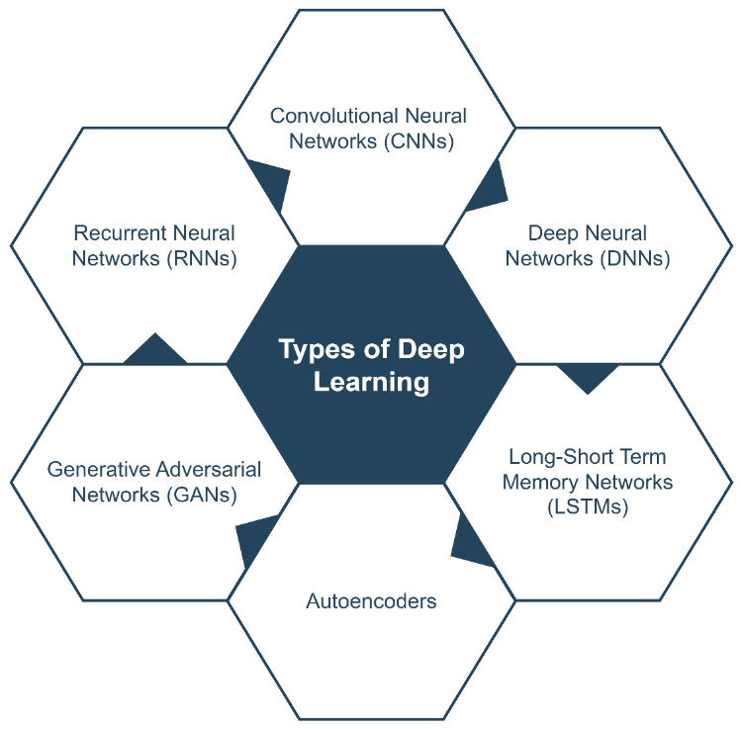

Fig 1: The various types of deep learning algorithms.

III. Applications of Deep Learning in Nuclear Power Plants

The safety assessment of a nuclear power plant is a systematic process that includes the safety analysis of the plant. To verify the power plant design satisfies the applicable safety requirements established by the operating organization and regulators, a safety evaluation is conducted. To determine and verify the reliability of the power plant and its parts, the safety analysis employs the necessary numerical techniques (system analysis code, computational fluid dynamics (CFD) programs, engineering level code, etc.). Traditional numerical tools used for safety in plants are based on expensive empirical models derived from limited experimental data, which hampers their applicability to new system conditions and configurations. The availability of big experimental data can help overcome these deficiencies.
Modern deep learning techniques offer an alternative to conventional empirical models by identifying functional relationships within large experimental datasets. These data-driven models can effectively substitute for traditional methods. The current application of deep learning techniques for analyzing power plants is summarized in Figure 2. Additional information is provided in the following points:
- Image analysis: Deep learning can be used to analyze images [8,9] from cameras and other sensors to detect corrosion, cracks, and other signs of damage in the power plant. This can help operators identify potential problems early before they lead to equipment failure or a nuclear accident.
- Predictive maintenance [10]: Deep learning can be used to analyze sensor data, maintenance records, and other data to predict when equipment is likely to fail. This can help operators schedule maintenance and repairs more efficiently, reducing downtime and costs.
- Control systems: Deep learning can be used to improve the control systems of the power plant, such as the systems that control the flow of coolant [11]. This can help operators optimize the performance of the power plant, increasing efficiency and reducing costs.
- Radiation Detection: Deep learning can be used to detect and classify different types of radiation and radioactive materials in the power plant and its surroundings, which can help to prevent and mitigate the effects of a nuclear accident or sabotage [12].
- Flow accelerated corrosion (FAC) prediction [13,14]: Deep learning can be used to analyze the coolant pH, flow velocity, temperature, and thickness of the pipe walls, which can help predict the likelihood of FAC, and reduce the risk of equipment failure.
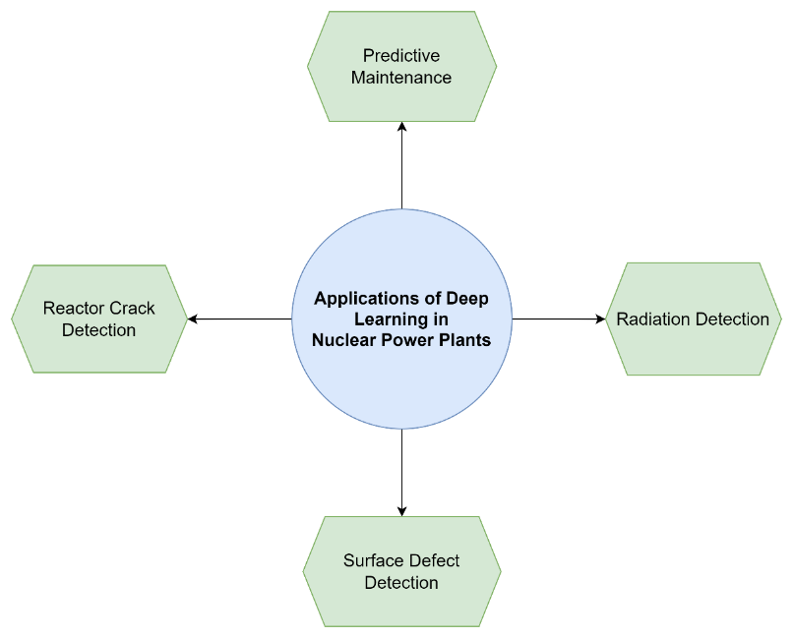

Fig 2: Applications of Deep Learning in Nuclear Power Plants.

III.A. Computer Vision in Nuclear Power Plant

Teaching computers to comprehend and make sense of visual data like photos and movies is the goal of computer vision deep learning. Computer vision deep learning has many potential applications in the nuclear power industry, including inspection, monitoring, anomaly identification, and radiation analysis.
Computer vision deep learning algorithms can be used for real-time monitoring and inspection of equipment since they can be trained to recognize specific features, patterns, and anomalies. Computer vision algorithms can inspect pipes, valves, and other vital parts for damage to assist prevent costly breakdowns and maintain reliable service.
The process of finding anomalous patterns or events in a system can be accomplished with the help of computer vision deep learning. Anomaly detection can assist in reducing the risk of equipment failure and increase safety in the nuclear power industry by identifying concerns with equipment and processes before they escalate.

IV. Deep learning for crack detection

Deep learning's widespread application in image processing has led to significant advancements in the usage of convolution neural networks (CNN) for picture categorization and target recognition. Li et al. [15] used YOLOv3 for crack identification on the surface of a dam, whereas Cha et al. [16] coupled sliding windows with a CNN to perform crack detection. [17] Xu et al. presented a fusion CNN to find cracks in the steel box girder of bridges. Cracks in a shield tunnel's lining were extracted using the quicker RCNN by Xue et al. [18], while Zhang et al. [19] developed the RNN-based CrackNetR network, which outperforms CrackNet in road crack detection. The technologies are more efficient and precise in their detection of cracks than conventional image processing methods.
On the hand, the cooling of nuclear reactors involves submerging them in water due to their high temperature and radiation risks, which renders direct manual periodic inspection of reactor components unfeasible. Consequently, conventional inspection practices for detecting reactor cracks typically entail technicians conducting time-consuming, cumbersome, and subjective remote evaluations and manual detections using video recordings of the submerged reactors [20]. Advancements in artificial intelligence (AI) have prompted the introduction of numerous crack detection approaches for nuclear reactors based on traditional machine learning methods. However, due to the limited visibility of minute cracks with low contrast and varying brightness, machine learning-based crack detection methods often erroneously identify non-crack features such as scratches, welds, and wear marks.
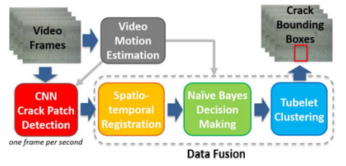
Numerous studies on nuclear reactor crack detection using DL were conducted. For nuclear reactors in particular, Chen and Jahanshahi [21] proposed a fracture detection approach in 2017 using Naive Bayesian data fusion scheme and CNN (called NB-CNN). To do this, the proposed NB-CNN method makes use of convolutional neural networks (CNNs) to extract visual features from individual video frames acquired in nuclear reactor movies, and the naïve Bayesian data fusion scheme to combine the information gained from these individual frames. Figure 3 illustrates the Overview of the NB-CNN framework that is being proposed, the NB-CNN technique has a 98.3 percent success rate with only 1.1 percent false positives per frame.

Fig 3: outline of the proposed NB-CNN framework in Ref [21].

In addition, A novel method for fracture identification on metallic surfaces is proposed by Chen and Jahanshahi [22], which combines Local Binary Patterns (LBP), Support Vector Machine (SVM), and Bayesian decision theory. The method combines data from multiple video frames to make fracture detection more accurate and reliable. Figure 4 shows an overview of the proposed method. Several inspection videos were used to test the effectiveness of the suggested technology, and the findings showed that it is accurate and robust even when conventional crack identification techniques fail. Bayesian data fusion was shown to increase the approach's hit rate by 20%, resulting in an 85% success rate with only one false positive per frame in the studies. In sum, this method has the potential to be an effective tool for detecting cracks in the nuclear sector and other relevant contexts.
Other related work for same authors, A similar method for identifying cracks in nuclear reactor components using inspection cameras in real-time was developed by Chen and Jahanshahi [23]. This approach combines the power of Full Convolutional Networks (FCN) with the simplicity of Naive Bayes (NB). While FCN is a popular deep learning architecture for image segmentation and object detection, Naive Bayes is a machine learning technique for estimating the likelihood of an event based on prior knowledge. Using a dataset of inspection videos, the suggested technique, NB-FCN, was found to have good accuracy in detecting reactor cracks. The success percentage was 98.6 percent. In conclusion, the technology proved to be a reliable and successful strategy for detecting cracks in nuclear reactors in real-time.

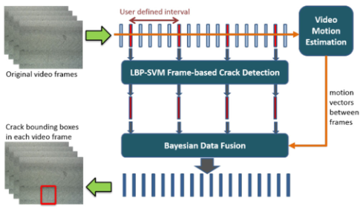

Fig 4: Overview of the proposed method in Ref [22].

The hit rate and processing times (T) of DL-based reactor crack detection algorithms are compared in Figure 5 and 6. The detection accuracy of reactor cracks is greatly enhanced by DL-based NB-CNN [21] and NB-FCN [23], compared to the classical LBP-SVM [22]. Moreover, the NB-FCN ,[16] achieves the best performance on the processing times, needing just 0:02 seconds for a 720×540 frame and 0:10 seconds for a 1920×1080 frame. The results of the experiments show that the DL-based approaches for detecting cracks in the reactor represent a significant step forward in the direction of precise and real-time video processing for autonomous NPP inspection.

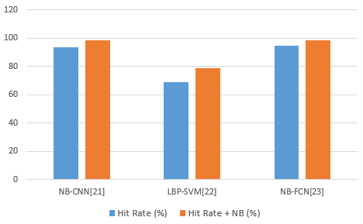

Fig 5: Comparison of hit rate of reactor crack detection methods based on machine learning and deep learning. “Hit rate + NB” refers to the hit rate results of methods with Naive Bayes
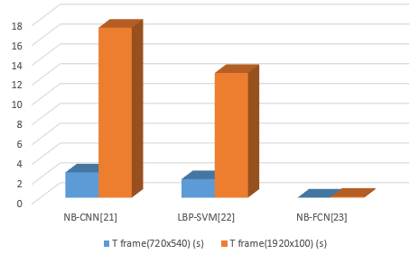
.

Fig 6: Comparison of processing times of reactor crack detection methods based on machine learning and deep learning.

Schmugge et al. [24] proposed a method for detecting cracks in nuclear power plants using a combination of spatial-temporal grouping of local patches and machine learning algorithms. The method extracted local patches from an inspection video, grouped them spatially and temporally, used the features to train a machine learning algorithm like SVM or random forest classifier, and tested it on a dataset of inspection videos from a nuclear power plant. The method was able to achieve a true positive rate of 0.86, meaning that it correctly identified cracks in 86% of the instances where they were present. This method is a robust and effective approach for crack detection in nuclear power plants.
Lang et al. [25] introduced the knowledge distillation method to make a simple student network imitate the complex teacher network for model compression. The proposed method improves the defect detection accuracy and maintains high real-time performance, simultaneously. The results show that the knowledge distillation method greatly reduces the computational and memory consumption of deep neural networks while balancing accuracy and speed. Moreover, experiments show that the presented knowledge distillation method is appropriate for industrial applications of surface defect detection.

In order to more effectively recognize small objects, pan et al. [26] suggest an enhanced network by fusing the feature maps of networks with different depths to improve noise resistance and employ a new loss function. CrackU-net+ segmentation abilities are compared to those of other methods on a dataset consisting of 3,240 images of cracks in nuclear containment. The experimental results in both the nuclear containment crack dataset and the public road crack dataset reveal that the suggested method has a faster detection speed and higher detection accuracy.

V. Conclusions

In conclusion, the application of deep learning techniques for crack detection in nuclear power plants holds great potential and offers significant advantages. Through the utilization of convolutional neural networks (CNN) and other advanced models, researchers have made substantial progress in accurately identifying cracks in critical components of nuclear power plants. The integration of deep learning with image processing methodologies has yielded faster and more accurate results compared to traditional approaches. This advancement enables early detection and timely intervention, mitigating the risks associated with crack propagation and potential structural failures. Moreover, deep learning models can adapt and learn from vast amounts of data, improving their performance over time and enhancing the overall reliability of crack detection systems in nuclear power plants. However, it is important to continue refining and validating these deep learning models, ensuring their robustness, reliability, and adaptability to various operating conditions and environmental factors specific to nuclear power plants. With further advancements and continued research, deep learning-based crack detection systems have the potential to significantly enhance the safety and efficiency of nuclear power plants, minimizing downtime and maximizing the integrity of critical infrastructure.

References

- Worrell, C., Luangkesorn, L., Haight, J., and Congedo, T. "Machine learning of fire hazard model simulations for use in probabilistic safety assessments at nuclear power plants". Reliability Engineering & System Safety, 183, 128-142 (2019).‏
- Tolo, S., Tian, X., Bausch, N., Becerra, V., Santhosh, T. V., Vinod, G., and Patelli, E. "Robust on-line diagnosis tool for the early accident detection in nuclear power plants". Reliability Engineering & System Safety, 186, 110-119 (2019).

- Abdar, M., Pourpanah, F., Hussain, S., Rezazadegan, D., Liu, L., Ghavamzadeh, M., and Nahavandi, S. "A review of uncertainty quantification in deep learning: Techniques, applications and challenges". Information fusion, 76, 243-297 (2021).

- Mell, Peter, and Tim Grance. "The NIST definition of cloud computing." (2011).‏

- Kim, Seung Hyun, and Su Chang Lim. "Intelligent intrusion detection system featuring a virtual fence, active intruder detection, classification, tracking, and action recognition." Annals of Nuclear Energy, 112 845-855 (2008).
- Lee, Daeil, Poong Hyun Seong, and Jonghyun Kim. "Autonomous operation algorithm for safety systems of nuclear power plants by using long-short term memory and function-based hierarchical framework." Annals of Nuclear Energy 119 287-299 (2018).‏

- Phung, Viet-Anh, et al. "Prediction of in-vessel debris bed properties in BWR severe accident scenarios using MELCOR and neural networks." Annals of Nuclear Energy 120 461-476 (2018).‏

- Szegedy, C., Zaremba, W., Sutskever, I., Bruna, J., Erhan, D., Goodfellow, I., & Fergus, R. (2013). Intriguing properties of neural networks. arXiv preprint arXiv:1312.6199(2013).‏
- Nguyen, A., Yosinski, J., & Clune, J. Deep neural networks are easily fooled: High confidence predictions for unrecognizable images. In Proceedings of the IEEE conference on computer vision and pattern recognition (pp. 427-436) (2015).‏

- Gohel, H. A., Upadhyay, H., Lagos, L., Cooper, K., & Sanzetenea, A. Predictive maintenance architecture development for nuclear infrastructure using machine learning. Nuclear Engineering and Technology, 52(7), 1436-1442 (2020).
‏
- Liu, Y. K., Xie, F., Xie, C. L., Peng, M. J., Wu, G. H., & Xia, H. Prediction of time series of NPP operating parameters using dynamic model based on BP neural network. Annals of Nuclear Energy, 85, 566-575 (2015).‏

- Song, Y., Li, X., Wang, K., Zhang, Z., Luo, W., Zhu, Z., & Zhao, Y. Study on optimization of shielding structure in marine reactor. Chinese Journal of Nuclear Science and Engineering, 37(3), 355-361 (2017).‏

- Lee, G. G., Lee, E. H., Kim, S. W., Kim, K. M., & Kim, D. J. Modeling of flow-accelerated corrosion using machine learning: comparison between random forest and non-linear regression. Corrosion Science and Technology, 18(2), 61-71 (2019).‏

- Moon, S., Kim, K., Lee, G. G., Yu, Y., & Kim, D. J. Pipeline wall thinning rate prediction model based on machine learning. Nuclear Engineering and Technology, 53(12), 4060-4066 (2021).‏

- Li, L., Zhang, H., Pang, J., & Huang, J. "Dam surface crack detection based on deep learning". In Proceedings of the 2019 International Conference on Robotics, Intelligent Control and Artificial Intelligence (pp. 738-743) (2019).‏

- Cha, Y. J., Choi, W., & Büyüköztürk, O. "Deep learning‐based crack damage detection using convolutional neural networks". Computer‐Aided Civil and Infrastructure Engineering, 32(5), 361-378 (2017).‏

- Xu, Y., Bao, Y., Chen, J., Zuo, W., & Li, H. "Surface fatigue crack identification in steel box girder of bridges by a deep fusion convolutional neural network based on consumer-grade camera images". Structural Health Monitoring, 18(3), 653-674 (2019).‏

- Xue, Y., and Li, Y. "A fast detection method via region‐based fully convolutional neural networks for shield tunnel lining defects". Computer‐Aided Civil and Infrastructure Engineering, 33(8), 638-654 (2018).‏

- Zhang, A., Wang, K. C., Fei, Y., Liu, Y., Chen, C., Yang, G and Qiu, S. "Automated pixel‐level pavement crack detection on 3D asphalt surfaces with a recurrent neural network". Computer‐Aided Civil and Infrastructure Engineering, 34(3), 213-229 (2019).‏

- A. Veit, M. J. Wilber, and S. J. Belongie, "Residual networks behave like ensembles of relatively shallow networks", in Proc. Advances in Neural Information Processing Systems, Barcelona, Spain, 2016, pp. 550–558.

- F. C. Chen and M. R. Jahanshahi, "NB-CNN: Deep learning-based crack detection using convolutional neural network and Na¨ıve Bayes data fusion", IEEE Trans. Ind. Electron., vol. 65, no. 5, pp. 4392–4400 (2017).

- Chen, Fu‐Chen, et al. "A texture‐based video processing methodology using Bayesian data fusion for autonomous crack detection on metallic surfaces." Computer‐Aided Civil and Infrastructure Engineering 32.4 271-287(2017).‏

- Chen, Fu-Chen, and Mohammad R. Jahanshahi. "NB-FCN: Real-time accurate crack detection in inspection videos using deep fully convolutional network and parametric data fusion." IEEE Transactions on Instrumentation and Measurement 69.8 5325-5334 (2019).‏

- Schmugge, Stephen J., et al. "Detection of cracks in nuclear power plant using spatial-temporal grouping of local patches." 2016 IEEE Winter Conference on Applications of Computer Vision (WACV). IEEE, 2016.‏

- Lang, J., Tang, C., Gao, Y., & Lv, J. "Knowledge distillation method for surface defect detection". In International Conference on Neural Information Processing pp. 644-655 (2021).

- Pan, P., Xu, Y., Xing, C., & Chen, Y. "Crack detection for nuclear containments based on multi-feature fused semantic segmentation". Construction and Building Materials, 329, 127137 (2022).‏

