**Safety Analysis During Low-Pressure Case in VVER-1000 with ASYST**

Fabiano Gibson Daud Thulu1*, Hailemichael Guadie Mengsitu2 and Upile Chitete Mawenda1

*1 Department of Physics and Biochemical Sciences, Malawi University of Business and Applied Science, Blantyre, 312225, Malawi.*

*2 College of Nuclear Science and Technology, Harbin Engineering University, 145 Nantong Street, Nangang*

*District, Harbin, P. R. China.*

*\*Corresponding author. Tel.: +265993948971. E-mail address: fthulu@mubas.ac.mw*

Abstract – *This study evaluates the reactor degradation* *progression in VVER-1000 due toa low pressure case as a result of loss of coolant accident (LOCA) and total station blackout (SBO). The simulation evaluation was carried out using the adaptive SYStem Thermal-hydraulics (ASYST) program. The low-pressure scenario was simulated by modelling 80 mm small break LOCA (SBLOCA) in the hot pressurizer leg during SBO. This double ended break size was selected to cause a significate faster depressurization during low-pressure simulation and a longer borated cold-water injection from the passive hydro accumulators (HAs). This enabled evaluating the times required to attain critical set points during the transient progression. The investigation looked into loss of coolant circulation, fuel and clad heating up, commencement of hydrogen generation, the activation of the passive safety system, changes in pressure, and primary circulation. Simulation results showed that the modelled break area was enough to allow primary loop depressurization. The results revealed that the fuel damage decreases after the introduction of HAs. Actuation of HAs at their actuation set-points provided core cooling by injecting water into reactor core. These kinds of analyses assist in estimating the time available to perform operator safety actions. This in turn aids in emergency planning and severe accident management.*

**Keywords:** Nuclear Safety Analysis, VVER-1000, Passive Safety System, Nuclear Reactor.

I. Introduction

Despite using the highest degree of engineering, accidents have ever occurred with NPPs. Severe accidents (SA) are those in which the reactor core sustains significant damage. Some of the factors that contribute to SA include station blackouts (SBO) and coolant loss accidents (LOCA) [1]. SBO accident accounts for 26% of the total core damage frequency (CDF). To limit radioactive release in such accidents, severe accident mitigation guidelines and emergency response are required [2]. The likelihood of a small break LOCA (SBLOCA) and SBO accident happening in VVER-1000 is low, yet such an accident might result in fuel and clad melting which might endanger personnel and the environment in danger. In order to enforce such safety in NPPs, the adoption of thoroughly tested thermal hydraulic programs is crucial [3].

The primary goal of this study was to evaluate thermal hydraulic degradation progression, primary pressure fluctuations, and hydrogen (H2) generation in VVER-1000 during total SBO together with SBLOCA postulated case. The Adaptive SYStem Thermal-hydraulics (ASYST) application was used to perform calculations for both steady state and transient scenarios. Researches have demonstrated the reliability of the ASYST program as a simulation tool. This is due to the fact that it functions well and generates results that concur with those of other safety models. The International Atomic Energy Agency (IAEA) has also recommended it as a method for assessing safety in both operational and NPPs that are still in the design phase [4].

The low pressure (SBO) case was simulated by modelling a doubled ended SBLOCA of 80 mm in the cold hot which also connected to the pressurizer. This double ended break size was selected to cause a significate faster depressurization during low-pressure simulation and a longer borated cold water injection from the passive hydro accumulators (HAs) through direct injection lines [5]. Reactor transient progression was evaluated without the intervention of an operator. This enabled estimating the time required to reach the critical set points during the accident progression. Trends in steam generator (SG) dry-out, loss of natural circulation leading to core uncover and heat up, start of hydrogen (H2) generation, and actuation of HAs were investigated.

Many studies have been done on thermal hydraulic safety analysis so to SBLOCA and SBO in VVER-1000, however, there is no literature in studies related reactor safety analysis due to LOCA in hot legs. Also, it is important to validate the studies from literature with different models. ASYST has not being used to understand the reactor after maths as a result of the prostituted events in this work. Studies show that the transient progression vary the type and location of break. No work has been done on double ended break of this type, hence is can cause a faster depressurization. This work has looked it this. Sensitive and exact safety precautions need to considered to avoid nuclear accidents that may lead to excessive radiation releases to the occupation, public and the environment. These calculations may be useful in making judgments on prospective occupational, general public and environmental radiation exposure [4]. They could also serve as a blueprint for future modifications reactor core geometry and safety systems. This study can be used as needed to prepare Gen V and SMR safety systems and modify Gen IV safety systems.

II. A Brief Description of VVER-1000

The VVER-1000 pressurised light water reactor design is based on several key principles, including: making the best possible use of existing technologies; keeping costs low and construction times short; balancing the use of both passive and active safety systems to mitigate beyond design based accidents; and minimizing the impact of man errors on reactor safety [6]. The safety concept reflected in this type of reactor deploys a full scope range of both passive and active safety to give sufficient core safety functions that complex handling DBAs [7].

The VVER-1000 core circuit's layout shows four coolant loops. On each loop, it has a horizontal steam generator (SG) and reactor coolant pumps (RCP). The pressurizer (PRZ), surge and spray lines, and the pulse safety facility make up the primary pressure system (PRS). Four nozzles serve as the intake and exit of a reactor pressure vessel (RPV). Through the RPV, a common flow channel connects the four principal coolant loops [8]. The PRZ is attached to both cold and hot primary loops. SGs are cylindrical horizontal units in which U-shaped tube bundles are submerged [9].

III. ASYST Application in Light Water Reactors

The pressurized water reactor systems' performance is forecasted by the ASYST computer program in both steady-state and transient situations. Reactor Excursion and Leak Analysis Program (RELAP) and Severe Core Damage Analysis Package (SCDAP) are complementary sections of it [10]. The RELAP5 calculates the thermal-hydraulic responses on all coolant systems as well as the kinetic conditions of system elements such as pumps and valves. The SCDAP calculates changes in the core and vessels. Additionally, it also computes the production of debris and molten pools, interactions between debris and vessels, creep rupture and structural failure during serious incidents [11]. As a result, ASYST is a reliable thermal hydraulics program that may be used to explain progression in VVER-1000 due to loss of coolant accident (LOCA) and total station blackout (SBO) [12].

IV. Modelling and Transient Simulation

1. ***Plant Geometrical Modelling***

The ASYST input was divided into four categories: hydrodynamics, heat structures, control systems, and neutronics. The solid parts of the modelled reactor were represented by hydrodynamic structures and heat components. The reactor vessel, core barrel, and heat structures were represented by plate and vessel walls in the core. Heat structures represented piping, steam shells and generator tubes, piping and pump suction. Figure 1 depicts the nodalization for the VVER-1000 used in this study.

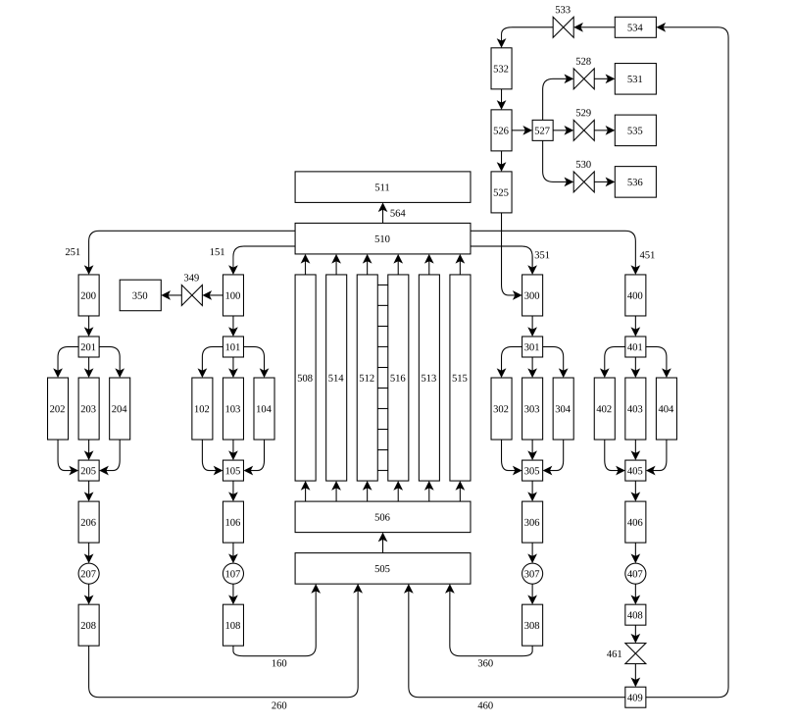

*Fig. 1. VVER-1000 nodalization diagram*

VI. Steady State Calculation

Before transient simulation of the postulated accident, the commencement and boundary reactor conditions had to be equal or close to those of the real VVER-1000 design. This helped to attain credible transient results from the simulation scenario. To achieve these reactor conditions, a steady-state preliminary calculation was performed. The input model was run on ASYST until the plant values stabilized around the nominal values. The simulation of stationary calculation in this work lasted 100 seconds (s). The results were equal or close when compared to the design specifications of the VVER-1000 design data [13 , 14]. Thereafter, it was convincing to carry out accident analyses using on the built VVER-1000 ASYST program. Table 1 shows the stead state calculated results. During the simulation, the cladding temperature in the upper node of core region attained the set point of 923 K. This node measurement for core exit temperature in the NPP are usually located at the upper part of the fuel assemblies in the reactor core.

*Table I. Nodalization qualification at steady state level*

|  |  |  |  |  |
| --- | --- | --- | --- | --- |
|  | Design value | Steady State Value | Error | Acceptable Criteria |
| Reactor Power (MWth) | 3000 | 3000 | - | 2.0% |
| RC Pressure (MPa) | 15.7 | 15.7 | 0.06 | 0.1% |
| SG Pressure (MPa) | 6.8 | 6.9 | 0.16 | 2.0% |
| Hot Leg Temp (K) | 594.15 | 595 | 0.14 | 0.5% |
| Col Leg Temp (K) | 564.15 | 565 | 0.15 | 0.5% |
| Core inlate flow rate (kg/s) | 16,400 | 16,387 | 0.08 | 2.0% |
| Coolant level PRZ (m) | 8.17 | 8.20 | 0.37 | 0.5% |
| SG level (m) | 2.40 | 2.399 | 0.0416 | 0.2% |

III. Transient Results and Discussion

Table 2 presents ASYST calculated transient results and in comparison, with their ASTEC counterparts under similar scenarios. After the initiation of SBO with SBLOCA of 80mm, all the RCPs tripped at 0.0 s. The reactor SCRAM (Safety Control Rod Axe Man) signal was generated at 0.0 s. The reactor trips with a delay of 1.6 s and ASTEC reported the same. In SBLOCA with SBO conditions, the opening of SGs SVs occurred at 84.1 s. This was due to loss of coolant gushing out through the break, causing the primary pressure to decrease with respect to time run.

Due to the heat transfer violation between primary and secondary side, the primary pressure started to increase and reached the set point of the PRZ safety valve, 18 MP, opening at 6340 s while ASTEC reported the opening at 6221 s. This led to depletion of the primary inventory along the transient. Total dry-out of the RPV was not observed in the simulation time. Similar, occurrence of slump of corium with fission products (FPs) into lower plenum was not recorded in the simulation time, meaning that fuel melting had not occurred.

*Table 2. Sequence of main events (s)*

|  |  |  |
| --- | --- | --- |
| Events | SBO with SBLOCA case with ASYST | SBO with SBLOCA case SBO with ASTEC |
| Transient Initiation | 0.0 | 0.0 |
| RCPs trip | 0.0 | 0.0 |
| SCRAM signal | 1.6 | 1.6 |
| Turbine trip | 2.0 | 2.0 |
| Feed water stop | 5.1 | 5.0 |
| SG-1 safety valve open | 93.0 | 87.5 |
| SG dry out | N/A | N/A |
| PRZ safety valves open | N/A | N/A |
| Loss of natural circulation | 1302 | 1221 |
| Core coolant exit Temp reaches 650 °C | 13964 | 5776 |
| HA-1 and 2 actuate | 1484 | 1451 |
| HA-3 and 4 actuate | 1490 | 1464 |  |  |
| End of calculation | 15000 | - |

Figure 2 to 5 show the trends of the most important reactor parameters during reactor transient. The primary coolant discharged caused primary pressure to decreased. Coolant gashed out from RCS was greater than 100 kg/s. Due to the primary depressurization, the passive HAs start to inject borated water into the downcomer and the upper volume of the RPV after primary pressure reaching 5.88 MPa. This prevented the early heat up of reactor core to temperature above 923 K. The HAs 1 and 2 started to inject at 1484 s, while Has 3 and 4 followed at 1490 s while ASTEC reported at 1451 and respectively 1464. PRZ was totally dried out at 130 s and natural circulation was lost at 1302 s into transient. This situation caused violation of heat transfer from the primary to secondary side, hence causing all SGs ineffective. Fuel was covered during the simulation due to the action of the HAs.

After the HAs actuation, at the beginning of the transient, the fuel temperature decreased for a short period. This affirms that fission in the fuel was stopped by the reactor safety control. It was observed that once the HAs dry out, fuel the temperature then slowly continuously increased due to low water levels in the primary loop in presence of heat decay decrease up the end of ASYST run (Figure 2). This underscores the importance of passive HAs safety systems in nuclear power plants. HAs are reliable to mitigate or delay core damage during SBLOCA and SBO transient conditions in power reactors.

The primary pressure sharply decreased due to continuous inventory loss in PCS and the water level in the PRZ also decreased with time (Figure 3). Depletion of coolant in the reactor core led to core heating up. H2 was generated from Zr, Fe and B4C oxidation in the presence of steam. After attaining conditions for the steam-zirconium reaction, generation of hydrogen commenced, with an increment with respect to time (Figure 4). H2 generation started around 6500 s with an increasing amount with time. Simulated results from both codes showed that with HAs injection, hydrogen generation was found higher than that of without HAs injection. This is consequence due to higher steam inventory present in the core during oxidation phase for HAs injection.

Figure 5 show that the decay power declined significantly from the point of scram. Early in the transient, higher decay power decay heat occurred as a result of core heat increase, and the corium mass was produced with equal contributions from low decay power and oxidation power.

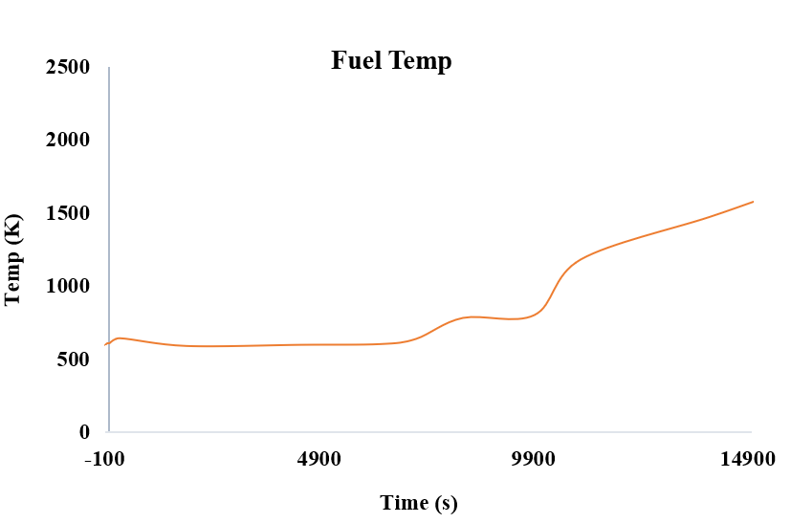

*Fig. 2. Fuel Temp – SBO with LBLOCA case*

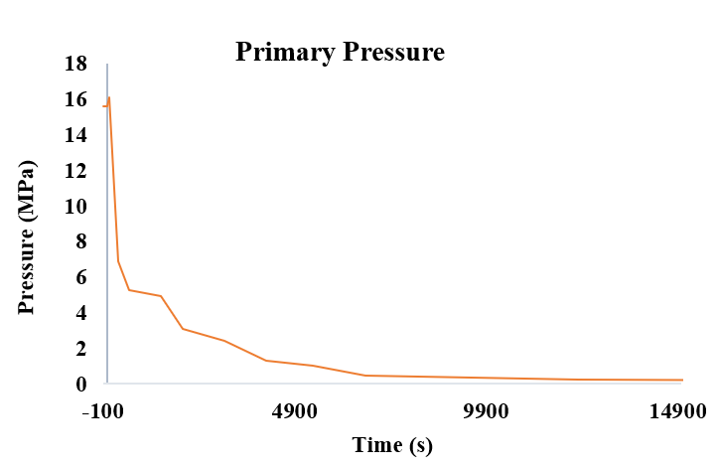

*Fig. 3. Primary Pressure – SBO with LBLOCA case.*

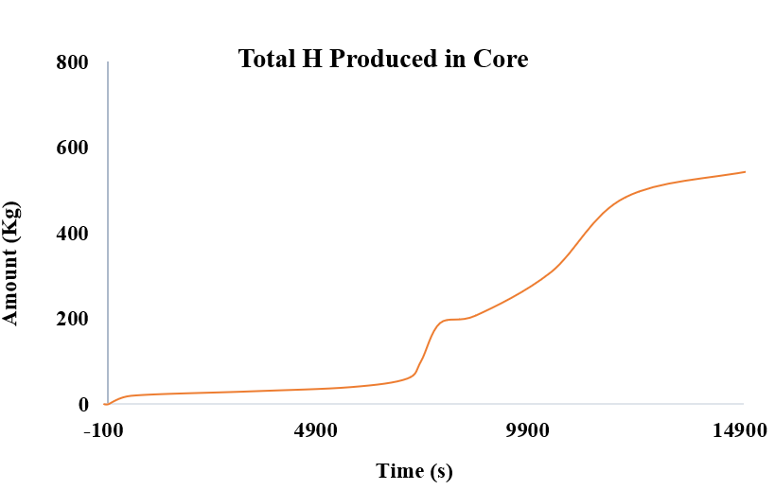

*Fig. 4. Total H2 mass in the core – SBO with LBLOCA case.*

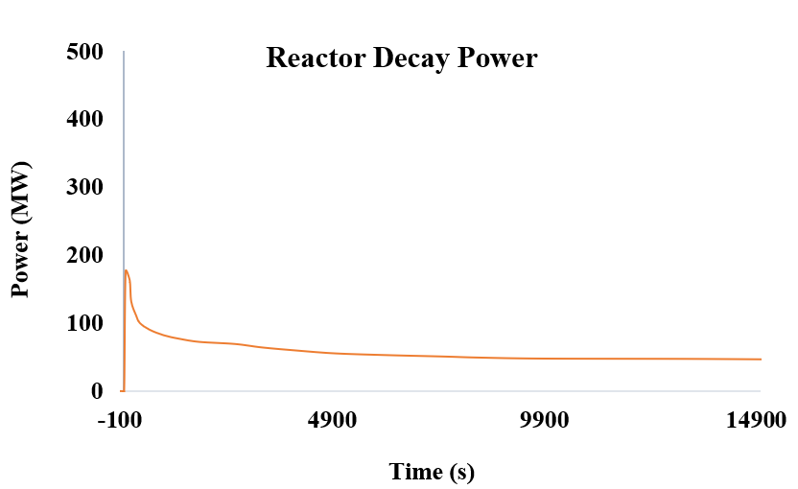

*Fig. 10. Decay Power for – SBO with SBLOCA.*

IV. Conclusions

This work expands the body of knowledge regarding the behaviour of the VVER 1000 caused by a ruptured hot leg connected to the PRZ. In order to allow the algorithm to anticipate any expected or unexpected core cooling phenomena, the transient time was increased to 15,000 seconds. Steady state results were consistence with the real VVER-1000 design. The 80 mm break size was big enough for fast depressurization of the primary loops. It allowed faster core degradation. The actuation of the HAs delayed the reactor malfunctions. The loss of primary coolant circulation and core heat up were observed. During the simulation time, it was observed that the reactor inherent control systems decreased the primary pressure to aid core reliable cooling. HAs were effective in delaying the core uncovering and the total dry out of the RPV. ASYST demonstrated effectiveness in calculating natural circulation, core heating up, the start of hydrogen generation, the activation of the passive safety system, changes in pressure, and primary circulation for both low- and high-pressure cases.

Acknowledgments

The authors would like to thank the Innovative System for let ASYST thermal hydraulic program be used in this work.

References

1. M. Mohsendokht, K. Hadad, and M. Jabbari, “Reducing the loss of offsite power contribution in the core damage frequency of a VVER-1000 reactor by extending the house load operation period,” *Ann. Nucl. Energy*, vol. 116, pp. 303–313, 2018.

2. F. G. D. Thulu, A. Elshahat, and M. Hassan, “Safety Analysis in VVER-1000 Due to Large-Break Loss-of-Coolant Accident and Station Blackout Transient Using RELAP5/SCDAPSIM/MOD3.5,” *Nucl. Sci. Eng.*, vol. 196, no. 5, pp. 568–583, 2022.

3. IAEA, “Assessment of Defence in Depth for Nuclear Power Plants,” *Saf. Reports Ser.*, no. 46, 2005.

4. International Atomic Energy Agency, “IAEA SAFETY STANDARDS SERIES Safety of Nuclear Power Plants: Design,” vol. NS-R-1, 2000.

5. S. Lee, K. S. Ha, H. Y. Kim, and S. J. Kim, “Validation of RCS depressurization strategy and core coolability map for independent scenarios of SBLOCA, SBO, and TLOFW,” *J. Nucl. Sci. Technol.*, vol. 51, no. 2, pp. 181–195, 2014.

6. M. S. Dwiddar, A. A. Badawi, H. H. Abou-Gabal, and I. A. El-Osery, “From Vver-1000 To Vver-1200: Investigation of the Effect of the Changes in Core,” vol. 2006, 2014.

7. J. Vojackova, F. Novotny, and K. Katovsky, “Safety analyses of reactor VVER 1000,” *Energy Procedia*, vol. 127, no. 2016, pp. 352–359, 2017.

8. ARIS, “Status report 93 - VVER–1000,” vol. 1000, 2011.

9. A. Pirouzmand, A. Ghasemi, and F. Faghihi, “Safety analysis of LBLOCA in BDBA scenarios for the Bushehr’s VVER-1000 nuclear power plant,” *Prog. Nucl. Energy*, vol. 88, no. April, pp. 231–239, 2016.

10. N. R. C. Job and W. Code, “RELAP5 / MOD3 Code Manual,” vol. 5, 1995.

11. C. M. Allison and J. K. Hohorst, “Role of RELAP/SCDAPSIM in nuclear safety,” *Sci. Technol. Nucl. Install.*, vol. 2010, 2010.

12. C. Jönsson, G. Grandi, J. Judd, G. Dominicus, and H. Bergersen, “Severe reactivity initiated accidents with SIMULATE-3K and SIMULATE-3K/RELAP5 in Forsmark-3 BWR,” *LWR Fuel Perform. Meet. Fuel/WRFPM 2010*, pp. 383–398, 2010.

13. F. G. D. Thulu, A. Elshahat, and M. H. M. Hassan, “Simulation of VVER-1000 Guillotine Large Break Loss of Coolant Accident Using RELAP5/SCDAPSIM/MOD3.5,” *J. Nucl. Eng.*, vol. 2, no. 4, pp. 516–532, 2021.

14. A. Kumar, “Application of RELAP / SCDAPSIM for Severe Accident and Safety Analysis of Nuclear Reactor Systems Indian Institute of Technology Kanpur,” no. June, 2017.