Understanding Stress Corrosion Cracking (SCC), Affecting Variables and Prevention Strategies in Nuclear Power Plants-A review

Ali Ahmad Amiri¹, Ihsan Ul Haq Toor^{1,2} and Afaque Shams^{1,3}
¹Mechanical Engineering Department, King Fahd University of Petroleum & Minerals (KFUPM), Saudi Arabia
²Interdisciplinary Research Center for Advanced Materials (IRC-AM), KFUPM, Saudi Arabia
³Interdisciplinary Research Center for Renewable Energy and Power Systems (IRC-REPS), KFUPM, Saudi Arabia

Ali Ahmad Amiri: Amiri163@yahoo.com, Ihsan Ul Haq Toor: Ihsan@kfupm.edu.sa; Afaque Shams: Afaque.shams@kfupm.edu.sa

Abstract – This study aims to investigate the issues related to stress corrosion cracking (SCC) in nuclear power plant systems. The study will explore the relationship between materials and environmental variables which cause the onset and progression of SCC in different materials commonly used in piping systems and related infrastructure. Stress corrosion cracking is a significant issue in the nuclear power industry, leading to costly downtime and repair, and can have serious safety implications. The findings of this study can provide insights into the mechanisms underlying SCC and inform the development of strategies for preventing and mitigating its effects on piping systems. By understanding the factors that contribute to SCC and how it can be mitigated, industries can develop strategies to prevent corrosion-related failures and ensure safe and reliable operation. The results of this study will contribute to the ongoing efforts to improve the reliability and safety of nuclear power plants and other industries that face similar corrosion-related challenges.

Keywords: Stress corrosion cracking, nuclear power plant, corrosion mitigation;
reliability; corrosion

I. Introduction

In nuclear power plants (NPP), structural components must operate consistently. These components, such as steam generator piping, reactor coolant piping, and reactor vessel welds, operate under challenging conditions, including corrosive environments, high pressures and elevated temperatures. However, environmental degradation and obsolescence present the main problems for the long-term use of NPP. Despite regular maintenance and strict operating procedures, boiling water reactors (BWR) as well as pressurized water reactors (PWR) have encountered issues that could potentially shorten their operational lifetimes [1]. The harsh conditions and exposure to various environmental factors contribute to material degradation and structural aging, imposing significant hurdles for safe operation of NPP. The aging issues in NPP can greatly influence their components. These problems involve irradiation-related damages like hardening, softening, creep, and swelling. Moreover, thermal fatigue, flow-induced vibration, and chemical-induced corrosion, including SCC, are also substantial concerns in NPP [2]. Different NPP components are susceptible to various damage mechanisms influenced by factors like material type, manufacturing methods, and exposure conditions. For example, steam generator tubes in NPP may face challenges such as thermal fatigue due to the corrosive and irradiated environment, high temperatures and high pressures of water irradiation damages as well as SCC.
A common degrading mechanism in light water reactors (LWR) is SCC, has the potential to result in offsite radiological consequences. The difference between SCC and overall crack is not considerable in NPP [3], thus proper understanding and mitigation of these aging processes are essential to maintain the optimal performance and long-term safety of NPP [4].
The SCC degradation process, has emerged as a crucial consideration in the safety analysis of components of NPP [5][6], particularly in the heat affected zones, where austenitic stainless steels (SS) are present [7]. The basic concept of SCC is illustrated in Fig. 1.

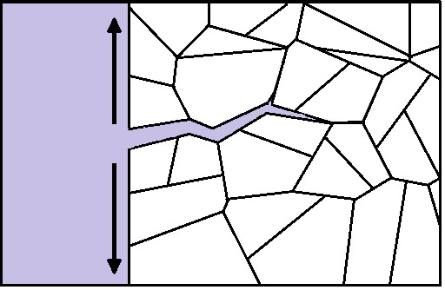
Tensile Stress
Corrosive Environment
Material
Fig. 1. Schematic of SCC

The SCC has been identified as a significant cause of tube defects in NPP, accounting for approximately 60-80% of cases [8]. It is a complex phenomenon characterized by crack propagation and expansion within a material as a result of the combined impact of a corrosive environment and constant tensile stress (see Fig. 2).

SCC
Susceptible Material

Corrosive Environment
Tensile Stress

Fig. 2. Factors affecting SCC

Initially observed in large-capacity ships during their construction and operation, SCC was primarily attributed to prolonged exposure to corrosive seawater. Over time, its impact extended to power components of NPP, where the influence of radiation on structural materials also became a contributing factor [9].

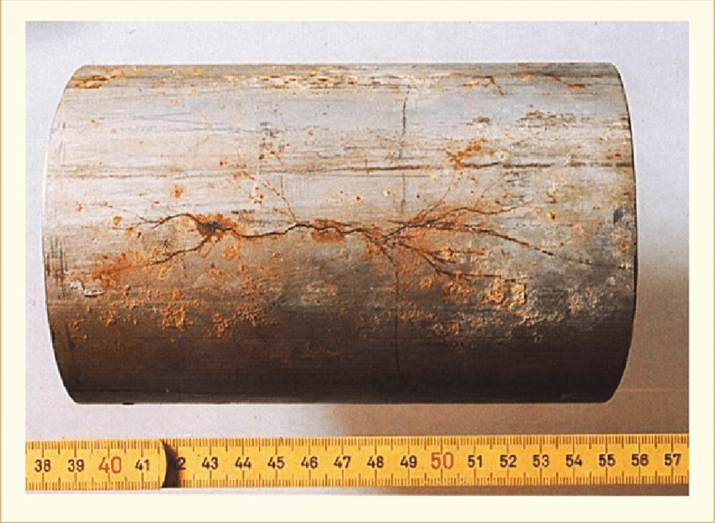
Fig. 3. SCC in type 316 stainless steel [10]
Indeed, SCC is a highly complex phenomenon, characterized by intricate interactions between environmental factors, mechanical stresses (residual or applied stress) [11], and the materials used [12]. Its multifaceted nature makes it difficult to fully understand, and the element of time further complicates the situation. Furthermore, SCC has the potential to cause the release of radioactive materials into the environment if it is not properly managed and controlled, causing severe core damage and emitting harmful radioactive substances.
This research endeavors to examine the correlation between materials, environmental factors, and the initiation and advancement of SCC in NPP systems. Through comprehensive investigation, the study aims to uncover the fundamental mechanisms of SCC, offering valuable guidance for formulating strategies to prevent and mitigate its impacts.

II. Mechanisms of Stress Corrosion Cracking

SCC is a complicated mechanism impacted by numerous mechanisms and factors. It is characterized by abrupt failures that often lead to minimal or imperceptible material loss [13]. Effective management of SCC in NPP requires a comprehensive comprehension of the fundamental mechanisms and factors. Numerous mechanisms have been proposed to describe SCC as shown in Fig. 4, but each model has its limitations and can only be applied to specific metal-environment systems.

Fig. 4. Various SCC mechanisms
Active Path Dissolution and Film Rupture refer to a phenomenon in which SCC accelerates along specific pathways within the material due to the separation of corrosion-resistant elements during manufacturing, commonly observed in SSs. Furthermore, EAC, encompasses various SCC mechanisms like hydrogen embrittlement, intergranular SCC (IGSCC), and transgranular SCC (TGSCC) all of which are influenced or facilitated by specific environmental conditions. IGSCC, occurs along the grain boundaries in SSs, and TGSCC taking place within the grain boundaries of the material (see Fig. 5).

Fig. 5. TGSCC and IGSCC in 316L stainless steel [14]

Additionally, PWSCC is specific to PWR systems, where SCC occurs in SSs components, particularly in the primary water environment. IASCC is another significant mechanism that results from the combined effects of radiation exposure and corrosive medium on materials, leading to crack initiation and propagation. IASCC is especially pertinent in nuclear reactor environments, where materials endure neutron irradiation and corrosive conditions, such as high-temperature water in PWR.
It is important to acknowledge that there is currently no unified mechanism that can comprehensively explain SCC for all combinations of metal and environment. Over the past decades, researchers have dedicated significant efforts to developing mechanistic models aimed at gaining a deeper understanding of SCC initiation and propagation rates. Among the various proposals, the hydrogen-assisted cracking mechanism and the active path dissolution and film rupture have emerged as focal points within the SCC research community [2].

II.A. Active Path Dissolution and Film Rupture
The active path dissolution SCC mechanism has undergone significant development and application in NPP [15]. Active path dissolution and film rupture refer to a corrosion-related phenomenon that accelerates cracking along specific pathways within a material [16]. These pathways become more vulnerable to corrosion compared to the surrounding material due to the segregation of corrosion-resistant elements during the manufacturing process. One common alloy where this phenomenon occurs is SS.
In SSs, active path dissolution primarily occurs along the grain boundaries. This phenomenon arises from sensitization, which involves chromium carbides segregating and precipitating along the grain boundaries. Sensitization makes grain boundaries less resistant to corrosion attacks. The harsh conditions of corrosive medium in NPP can accelerate this process, thereby increasing the susceptibility to SCC and other forms of corrosion-induced failures.

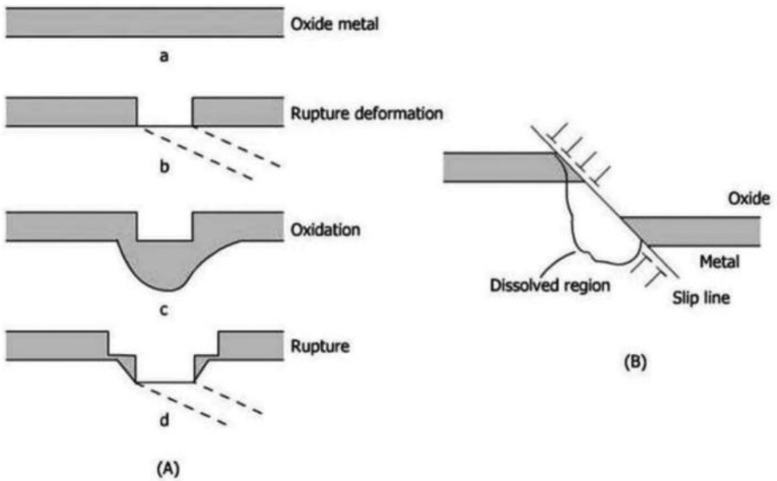
Fig. 6. Active path dissolution mechanism. (A) Film rupture model, (B) Dissolution model [17]

The investigation of active path dissolution holds particular significance in the context of NPP. Peter Ford and Peter Anderson were among the pioneers who proposed an initial model for this process [18]. They established a correlation between SCC rate and the dissolution rate at the crack tips. Based on their experimental observations, they suggested the following relationship for crack growth rate:

$\dot{a}=\frac{da}{dt}=\frac{M}{ZρF}i_{t}^{a}$ (1)

Here, $Z$ and $M$ represent the oxidation number and atomic mass of dissolved alloy, respectively. $F$ presents Faraday constant (96500 C/mol), $ρ$ represents density, and $i_{t}^{a}$ is anodic current density at time t and given by Eq.2.

$i_{t}^{a}=i_{0}^{a}{(\frac{t_{0}}{t})}^{n}$ (2)

Where, the $i_{0}^{a}$ is a parameter representing the rate of dissolution of base metal and $t_{0}$is the scaling parameter of the repassivation time.

II.B. Hydrogen Embrittlement Mechanism

Hydrogen embrittlement is a sophisticated corrosion process that occurs when hydrogen atoms become trapped within the lattice structure of a metal, particularly in areas experiencing significant internal tensile stress [19]. This trapped hydrogen contributes to the development of small, localized cracks. In these areas, the lattice structure experiences dilation, causing an increase in the local pressure. As a consequence, the cohesive energy of the material is reduced. This reduction in cohesive energy at the hydrogen-entrapped sites further elevates the likelihood of brittle fracture (see Fig. 7). The intricate interactions between hydrogen and the metal lattice in regions of stress concentration contribute to the embrittlement process, making hydrogen embrittlement a critical concern in materials engineering and structural integrity assessments.
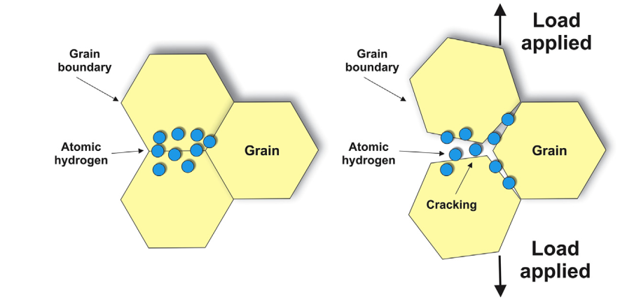
Fig. 7. Hydrogen embrittlement SCC mechanism [20]

Hall and Symons developed a hydrogen embrittlement SCC model in their 2001 research, that was specifically designed for Ni-Cr-Fe alloy intended for exposure to aqueous environment on the primary side of pre PWR [21]. The crack propagation rate is expressed by Eq. 3.

$\dot{a}=\frac{r_{c} {\dot{ε}}_{cfz}}{ԑ_{f_{0}}}{(\frac{C_{0}}{C_{gb}})}^{1/2}$ (3)

In Eq.3, the ${\dot{ε}}_{cfz}$denotes rate of strain at the creep fracture area, while $r_{c}$represents the radius of the fracture. The term $ԑ_{f_{0}}$represents the fracture strain at the grain boundary, and $C_{0}$ refers to the hydrogen concentration. Additionally, $C_{gb}$represents the rate of concentration of hydrogen at the grain boundary.

III. Result and Discussion

The SCC in the components of NPP is influenced by several factors, including type of material, corrosive medium, and tensile stress. The brittle-like appearance of SCC and its limited macroscopic plastic deformation during crack propagation further contribute to its sophistication, making early detection challenging and raising substantial concerns about the structural integrity of components in NPP.
Despite the occurrence of SCC, the metallurgical properties of the affected alloy, such as yield strength and tensile strength, typically remain within acceptable limits. However, it is important to note that SCC can lead to catastrophic failures even in the absence of significant changes in the metal properties.

III.A. Material

The susceptibility to SCC is heavily influenced by material properties, such as chemical composition, microstructure, and mechanical characteristics. Different alloys exhibit varying levels of resistance to SCC. SSs are typically defined as having a chromium content of at least 14% [22], and widely utilized in NPP [23]. The presence of chromium in SS contributes to its hardening and enhances its corrosion resistance [24].
Despite the fine protective film, which covers SS surface, SCC can still occur when exposed to aggressive ions such as chlorides, polythionic acid and caustic substances [25].
The passive film formation in SSs play a crucial role in their corrosion resistance [26]. The high presence of chromium in stainless steels leads to a reaction with oxygen in the environment, resulting in the formation of a protective layer known as the passive film. This film acts as a barrier, effectively halting any further corrosion of the underlying metal. This film is primarily composed of chromium oxide or a combination of iron oxide with chromium oxide [27]. Upon exposing the SSs to an oxygen-rich environment, a layer of chromium oxide develops due to high attraction of chromium for oxygen (see Fig. 8).

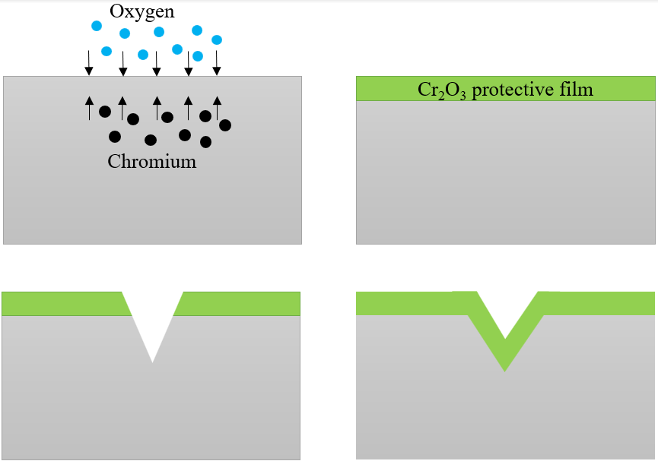
(a)
(b)
(c)
(d)

Fig. 8. (a) Oxygen reacts with chromium content of stainless steel (b) formation of Cr₂O₃ passive film (c) rupture of passive film (d) repair of passive film in contact with oxygen

Although the passive film offers excellent corrosion protection under normal conditions, it can be vulnerable to rupture under certain conditions. Factors leading to the rupture of passive film include mechanical stresses, exposure to corrosive media, and high temperatures [28].
The high temperatures experienced by components within NPP can trigger sensitization in SSs containing more than 0.03wt.% carbon [29], increasing the vulnerability of materials to SCC and causing formation of chromium carbides along grain boundaries. However, adopting SSs with low carbon content (0.03 wt.%), and ensuring a minimum ferrite content in weld metals can effectively diminish the risk of SCC occurrence in BWR systems.
Indeed, cold work during fabrication can also contribute to IGSCC in BWR components. In some cases, initial cracking occurs in a transgranular mode before later transitioning to an intergranular mode. SCC failures in BWR components have been associated with the presence of severe bulk cold worked material and the development of a surface layer induced by grinding or other machining techniques. These cold work-induced conditions can create vulnerable regions in the material, increasing the risk of SCC initiation and propagation.
Consequently, it underscores the significance of meticulous management of fabrication processes and conducting comprehensive inspections to effectively prevent SCC-related failures in BWR components.
Conversely, PWR systems exhibit a lower frequency of IGSCC problems compared to BWR. The SCC issues observed in PWR are mainly linked to the unintentional entrapment of oxygen in stagnant regions, as well as cold work and thermal sensitization [30]. Additionally, SCC occurrences in PWR are less commonly associated with weld heat-affected zones, as the majority of cracking is typically observed away from these specific regions.
To mitigate susceptibility PWR components to SCC, the use of alloy 600 has been phased out for new and replacement components, favoring the adoption of nickel-based alloy 690 [31]. Additionally, higher chromium weld metal alloys 52 and152 are now used in the welding of new alloy 690 components [32] due to their exceptional resistance against initiation of primary water stress corrosion cracking (PWSCC) and their capacity to withstand high temperatures. These alloys stand out with a higher chromium content.

III.B. Stress

When a component is exposed to tensile stress as well as a corrosive environment in a nuclear power plant, SCC results. Mitigating either the stress or the corrosive surroundings can prevent SCC initiation. In NPP components, tensile stresses can deteriorate protective oxide films, rendering cracks more likely to occur, especially near welds where residual stresses from welding play a significant role. Welding is used in components installation. According to Donghai, welding in proximity to the heat-affected zones can lead to residual strains ranging from 15% to 25% [33].
The high stress concentration at the material surface serves as a trigger for crack initiation, and the presence of flaws and imperfections intensifies local stress, providing potential starting points for SCC. Furthermore, specific manufacturing techniques like grinding, machining, or surface finishing can induce cold work, leading to high surface residual stresses that promote crack initiation [34]. The crack development is influenced by the combined stresses from manufacturing and operational conditions.
The assessment of stress-state in welds is more complicated compared to the base metal, and measurements of residual stresses are considerably more challenging due to the anisotropic nature of the weld metal microstructure. Failure analyses have shown that one of the contributing factors to SCC in piping of NPP system is the thermal sensitization of non-stabilized SS during welding.

III.C. Environment

The susceptibility of materials to SCC is notably influenced by the operating environment. The presence of corrosive substances in the water chemistry, such as sulfides, chlorides, and dissolved oxygen, causes an accelerated crack growth rate [33]. The primary contributors to SCC growth related to chloride and dissolved oxygen are changes in pH within the crack and the chloride-induced degradation of the protective layer at the crack tip. Thus, controlling the environment at the crack front in NPP, particularly the pH becomes essential [35].
In BWR service environments, several measures have been introduced to mitigate SCC, including hydrogen injection, noble metal technologies, and treating surfaces with colloidal silica slurry [36]. These techniques have proven effective in preventing SCC occurrences. However, before implementing any changes in water chemistry, it is crucial to conduct a thorough evaluation of their potential adverse effects on radiation exposure and structural integrity.
Furthermore, the SCC in the primary systems of PWR is also strongly influenced by various environmental parameters, including high temperature, hydrogen concentration, Li-content, and interior-related pH-value. Research indicates that the resistance to cracking increasing as the hydrogen content decreases. However, no peak susceptibility is observed, indicating a gradual improvement in resistance with reduced hydrogen levels. Furthermore, studies have indicated that removing atomic hydrogen from the metal surface can hinder other stress corrosion-related processes. With atomic hydrogen no longer serving as the primary contributor, the overall SCC phenomenon is anticipated to be reduced [9]. However, the optimization of hydrogen concentration remains a crucial area of research and consideration to enhance the resistance of PWR components to SCC.
The impact of lithium (Li) on PWSCC has attracted attention due to extended fuel cycles with higher Li contents and pH during the initial stages. Based on previous data, it has been observed that moderate increases in Li content may lead to a slight reduction in the initiation time of PWSCC. However, when it comes to the impact of Li on crack growth rates, the current data indicate minimal or negligible effects.

III.D. Stress Corrosion Cracking prevention

Stress corrosion cracking presents a very complicated challenge in NPPs. To ensure safe operations of NPP, proactive monitoring of components is essential for operators to swiftly respond to emerging issues. Implementing appropriate strategies is crucial in decreasing SCC and maintaining the cost-effectiveness of NPP operations.
To prevent SCC, targeted techniques are utilized to mitigate residual tensile stresses. One method is Post Weld Heat Treatment (PWHT) involves subjecting the welded structure to specific temperature and duration, reducing tensile stresses and strengthening metallurgical properties within the welded zones, thereby enhancing the resistance of metal to SCC [37].
Another effective preventive approach is Impressed Current Cathodic Protection (ICCP). By applying an external electric current, ICCP forms a protective film on the metal surface, preventing corrosion in various environments [38]. The electric current directed towards the metal surface, resulting in a more negative potential compared to the surrounding metal. However, its effectiveness may be limited in non-conductive atmosphere [39].
Additionally, increasing the nickel content in the alloy improves its resistance against SCC in NPP. Alternatively, the use of inhibitors, such as high concentrations of phosphate, has shown promise in mitigating SCC by reducing corrosive effects on components and ensuring a safer operational environment.
SCC testing is a vital preventive measure in NPPs, allowing the assessment of material vulnerability to SCC. The acquired data from SCC testing contributes to design, maintenance, and safe operation of NPP. The objectives of SCC testing encompass various aspects, including alloy development, environment assessment, quality assurance, and mechanism investigation [40]. These preventive measures proactively improve NPP safety by identifying and addressing potential SCC concerns.
Moreover, coatings play a critical role in protecting metal surfaces from SCC within NPPs; acting as a protective barrier against corrosive agents. This protective layer significantly reduces the risk of SCC, ensuring the lasting integrity of critical NPP components.
In conclusion, by applying a comprehensive range of prevention and mitigation methods, NPPs can effectively address the complexities of SCC, enhance operational safety, and extend the lifespan of vital components.
IV. Conclusion

After conducting the analysis, several important measures have been identified to prevent further failures due to SCC and enhance the reliability of NPP.
- Enforce strict chemical control of the environment to avoid the concentration of aggressive substances in areas with limited circulation.
- Conduct regular inspections of tubes, especially in critical regions, such as near steam inlets and randomly selected locations.
- Apply heat sink welding and Post Weld Heat Treatment during welding to effectively reduce residual stress.
- Employ ICCP for buried pipelines in the NPP.
- Increase the nickel and chromium content in SSs to enhance protection against SCC.
- Apply coatings to minimize the risk of SCC.
References

[1] N. Maeda, S. Nakagawa, G. Yagawa, and S. Yoshimura, “Optimization of operation and maintenance of nuclear power plant by probabilistic fracture mechanics,” Nucl. Eng. Des., vol. 214, no. 1–2, pp. 1–12, 2002, doi: 10.1016/S0029-5493(02)00009-2.
[2] S. Mohanty, S. Majumdar, and K. Natesan, “A Review of Stress Corrosion Cracking / Fatigue Modeling for Light Water Reactor Cooling System Components,” Nucl. Energy, no. June, 2012.
[3] R. Bashir, H. Xue, R. Guo, Y. Bi, and M. Usman, “Interaction of Cyclic Loading (Low-Cyclic Fatigue) with Stress Corrosion Cracking (SCC) Growth Rate,” Adv. Mater. Sci. Eng., vol. 2020, 2020, doi: 10.1155/2020/8026372.
[4] S. J. Zinkle and G. S. Was, “Materials challenges in nuclear energy,” Acta Mater., vol. 61, no. 3, pp. 735–758, 2013, doi: 10.1016/j.actamat.2012.11.004.
[5] T. Moss, W. Kuang, and G. S. Was, “Stress corrosion crack initiation in Alloy 690 in high temperature water,” Curr. Opin. Solid State Mater. Sci., vol. 22, no. 1, pp. 16–25, 2018, doi: 10.1016/j.cossms.2018.02.001.
[6] J. Riznic, “Steam generators for nuclear power plants,” Steam Gener. Nucl. Power Plants, pp. 1–563, 2017, doi: 10.1016/C2015-0-01340-5.
[7] M. B. Anoop, K. Balaji Rao, and N. Lakshmanan, “Safety assessment of austenitic steel nuclear power plant pipelines against stress corrosion cracking in the presence of hybrid uncertainties,” Int. J. Press. Vessel. Pip., vol. 85, no. 4, pp. 238–247, 2008, doi: 10.1016/j.ijpvp.2007.09.001.
[8] S. M. Hoseyni, F. Di Maio, and E. Zio, “Condition-based probabilistic safety assessment for maintenance decision making regarding a nuclear power plant steam generator undergoing multiple degradation mechanisms,” Reliab. Eng. Syst. Saf., vol. 191, 2019, doi: 10.1016/j.ress.2019.106583.
[9] A. R. Khasanova, “Corrosion cracking under main pipelines stress,” J. Phys. Conf. Ser., vol. 2176, no. 1, p. 012051, Jun. 2022, doi: 10.1088/1742-6596/2176/1/012051.
[10] P. Rudling, “Welding of Zirconium alloys,” Skultuna Adv. Nucl. Technol. Int. Eur. AB, pp. 8–9, 2007.
[11] C. A. Loto, “Stress corrosion cracking: characteristics, mechanisms and experimental study,” Int. J. Adv. Manuf. Technol., vol. 93, no. 9–12, pp. 3567–3582, 2017, doi: 10.1007/s00170-017-0709-z.
[12] M. Wang, M. Song, C. R. Lear, and G. S. Was, “Irradiation assisted stress corrosion cracking of commercial and advanced alloys for light water reactor core internals,” J. Nucl. Mater., vol. 515, pp. 52–70, Mar. 2019, doi: 10.1016/j.jnucmat.2018.12.015.
[13] J. Rajaguru and N. Arunachalam, “A comprehensive investigation on the effect of flood and MQL coolant on the machinability and stress corrosion cracking of super duplex stainless steel,” J. Mater. Process. Technol., vol. 276, p. 116417, 2020.
[14] A. R. Khalifeh, A. Dehghan Banaraki, H. Daneshmanesh, and M. H. Paydar, “Stress corrosion cracking of a circulation water heater tubesheet,” Eng. Fail. Anal., vol. 78, pp. 55–66, 2017, doi: 10.1016/j.engfailanal.2017.03.007.
[15] P. L. Andresen and F. P. Ford, “Fundamental modeling of environmental cracking for improved design and lifetime evaluation in BWRs,” Int. J. Press. Vessel. Pip., vol. 59, no. 1–3, pp. 61–70, 1994, doi: 10.1016/0308-0161(94)90142-2.
[16] A. R. Despic, R. G. Raicheff, and J. O’M Bockris, “Mechanism of the acceleration of the electrodic dissolution of metals during yielding under stress,” J. Chem. Phys., vol. 49, no. 2, pp. 926–938, 1968, doi: 10.1063/1.1670162.
[17] A. Khalifeh, “Stress Corrosion Cracking Damages,” in Failure Analysis, IntechOpen, 2019. doi: 10.5772/intechopen.80826.
[18] P. L. Andresen and F. Peter Ford, “Life prediction by mechanistic modeling and system monitoring of environmental cracking of iron and nickel alloys in aqueous systems,” Mater. Sci. Eng., vol. 103, no. 1, pp. 167–184, 1988, doi: 10.1016/0025-5416(88)90564-2.
[19] R. A. Cottis, “Hydrogen embrittlement,” Shreir’s Corrosion, 2010. https://www.metallurgyfordummies.com/hydrogen-embrittlement.html
[20] A. Del-Pozo, J. C. Villalobos, and S. Serna, “A general overview of hydrogen embrittlement,” Curr. Trends Futur. Dev. Membr. Recent Adv. Met. Membr., pp. 139–168, 2020, doi: 10.1016/B978-0-12-818332-8.00006-5.
[21] M. M. Hall and D. M. Symons, “Hydrogen assisted creep fracture model for low pential stress corrosion cracking of Ni-Cr-Fe alloys,” Proc. Staehle Symp. Chem. Electrochem. Corros. SCC, pp. 447–467, 2001.
[22] P. B. Pawar and A. A. Utpat, “Effect of Chromium on Mechanical Properties of a487 Stainless Steel Alloy,” Int. J. Adv. Res. Sci. Eng., pp. 112–118, 2018, [Online]. Available: https://www.researchgate.net/publication/325810468
[23] M. Kamaya, “Failure assessment curve for austenitic stainless steel pipes of nuclear power plants,” Eng. Fract. Mech., vol. 238, 2020, doi: 10.1016/j.engfracmech.2020.107283.
[24] G. S. Was and P. L. Andresen, “Mechanisms behind irradiation-assisted stress corrosion cracking,” Nucl. Corros. Res. Prog. Challenges, pp. 47–88, 2020, doi: 10.1016/B978-0-12-823719-9.00003-2.
[25] A. Khalifeh, “Stress Corrosion Cracking Behavior of Materials,” Eng. Fail. Anal., 2020, doi: 10.5772/intechopen.90893.
[26] A. Hemmasian Ettefagh, S. Guo, and J. Raush, “Corrosion performance of additively manufactured stainless steel parts: A review,” Addit. Manuf., vol. 37, 2021, doi: 10.1016/j.addma.2020.101689.
[27] A. Fattah-alhosseini, M. A. Golozar, A. Saatchi, and K. Raeissi, “Effect of solution concentration on semiconducting properties of passive films formed on austenitic stainless steels,” Corros. Sci., vol. 52, no. 1, pp. 205–209, 2010, doi: 10.1016/j.corsci.2009.09.003.
[28] M. J. Carmezim, A. M. Simões, M. F. Montemor, and M. Da Cunha Belo, “Capacitance behaviour of passive films on ferritic and austenitic stainless steel,” Corros. Sci., vol. 47, no. 3 SPEC. ISS., pp. 581–591, 2005, doi: 10.1016/j.corsci.2004.07.002.
[29] J. F. Gülich, “Selection of Materials Exposed to High Flow Velocities,” in Centrifugal Pumps, Springer, Berlin, Heidelberg, 2008, pp. 777–856. doi: 10.1007/978-3-540-73695-0_14.
[30] G. O. Ilevbare, F. Cattant, and N. K. Peat, “SCC of stainless steels under PWR service conditions,” in 7th International Conference on Contribution of Materials Investigations to Improve the Safety and Performance of LWRs, 2010, pp. 26–30.
[31] Z. Jiamei Wanga, Tianyu Zhua, Yichen Baob, Xiaoqiang Liub, Xiuqiang Shi b, Xianglong Guoa and L. Z. * Hana, Peter L. Andresena, c, Kai Chena *, “Insights into the stress corrosion cracking propagation behavior of Alloy 690 and 316L stainless steel in KOH versus LiOH oxygenated water,” p. 34, 2023, doi: https://dx.doi.org/10.2139/ssrn.4485381.
[32] P. M. Scott and P. Combrade, “General corrosion and stress corrosion cracking of Alloy 600 in light water reactor primary coolants,” J. Nucl. Mater., vol. 524, pp. 340–375, 2019, doi: 10.1016/j.jnucmat.2019.04.023.
[33] D. Du et al., “Effects of chloride and oxygen on stress corrosion cracking of cold worked 316/316L austenitic stainless steel in high temperature water,” Corros. Sci., vol. 110, pp. 134–142, 2016, doi: 10.1016/j.corsci.2016.04.035.
[34] N. Matsubara, T. Kobayashi, K. Fujimoto, Y. Nomura, N. Chigusa, and S. Hirano, “Research programs on SCC of cold-worked stainless steel in Japanese PWR N.P.P,” Fontevraud 7 - Contrib. Mater. Investig. to Improv. Saf. Perform. LWRs, p. A099, 2011.
[35] B. H. Choi and A. Chudnovsky, “Observation and modeling of stress corrosion cracking in high pressure gas pipe steel,” Metall. Mater. Trans. A Phys. Metall. Mater. Sci., vol. 42, no. 2, pp. 383–395, 2011, doi: 10.1007/s11661-010-0384-2.
[36] L. Dong, X. Zhang, Y. Han, Q. Peng, P. Deng, and S. Wang, “Effect of surface treatments on microstructure and stress corrosion cracking behavior of 308L weld metal in a primary pressurized water reactor environment,” Corros. Sci., vol. 166, 2020, doi: 10.1016/j.corsci.2020.108465.
[37] J. A. Francis, H. K. D. H. Bhadeshia, and P. J. Withers, “Welding residual stresses in ferritic power plant steels,” Mater. Sci. Technol., vol. 23, no. 9, pp. 1009–1020, 2007, doi: 10.1179/174328407X213116.
[38] Y. Song, C. Du, and X. Li, “Electrochemical corrosion behavior of carbon steel with bulk coating holidays,” J. Univ. Sci. Technol. Beijing Miner. Metall. Mater. (Eng Ed), vol. 13, no. 1, pp. 37–43, 2006, doi: 10.1016/S1005-8850(06)60011-X.
[39] X. G. Zhang, “Galvanic Corrosion,” Uhlig’s Corros. Handb. Third Ed., pp. 123–143, 2011, doi: 10.1002/9780470872864.ch10.
[40] W. Dietzel, P. Bala Srinivasan, and A. Atrens, “Testing and evaluation methods for stress corrosion cracking (SCC) in metals,” Stress Corros. Crack. Theory Pract., pp. 133–166, 2011, doi: 10.1533/9780857093769.2.133.

