**Thermal Hydraulic Performance Analysis of a Printed Circuit Steam Generator (PCSG) in Innovative SMART Plus Reactor: A Proof of Concept Study”**

Abdulrahman Altayeb a*, Sultan Al Faifi a, Joo Hyung Moon b

*a King Abdullah City for Atomic and Renewable Energy, P.O. Box 2022, Riyadh 11451, Kingdom of Saudi Arabia*

*b Korea Atomic Energy Research Institute, 111, 989beon-gil, Daedeok-daero, Yuseong-gu, Daejeon, 34057, Republic of Korea*

\**Corresponding author: a.tayeb@energy.gov.sa*

Abstract – The Printed Circuit Steam generator (PCSG) is a kind of Printed Circuit Heat Exchanger (PCHE) designed for steam generation applications. The PCSG manufacturing process is similar to the PCHE. The PCSG was suggested to be used in the innovative SMART-Plus reactor. Two PCSG designs were considered, one incorporating monitoring channel plates and the other without monitoring channel plates. The design with monitoring channels was introduced due to the inherent challenges in conducting in-service inspections with the design lacking these channels. To validate the PCSG concept and verify its thermal hydraulic performance, several tests were conducted using two mockups in the SMART Integral Test Loop (ITL) facility. The tests simulated the operating conditions of SMART Plus reactor and its thermal hydraulic parameters such as temperature and pressure. The test facility comprised a primary circulation loop representing the hot side, and a secondary circulation loop representing the cold side. The two mockups were designed and manufactured to mirror the two PCSG concepts: one with monitoring channel plates and the other without monitoring channel plates. The results demonstrated the viability of the PCSG design as a superheated steam generator. Hence, it was concluded that introducing the PCSG to the SMART Plus design is a viable option

**Keywords:** PCSG, SMART Plus, Thermal Hydraulic Performance

I. Introduction

The Printed Circuit Steam Generator (PCSG) is a new concept steam generator that is based on the Printed Circuit Heat Exchanger (PCHE). The PCSG is created by “printing” flow channels into thin plates of stainless steel or nickel-alloys through chemical etching. Several of these plates are then stacked so the plates alternate between the hot and cold fluid streams. This stack is then compressed in a vacuum furnace at high temperature to fuse the plates together through a diffusion bonding process to form a block. Headers and pipe stand-offs are then welded to the diffusion-bonded block.

The PCSG was suggested to be designed as part of the Preliminary Study for Innovative Next Generation SMART Plus project conducted in the joint research and development center between King Abdullah City for Atomic and Renewable Energy (K.A.CARE) and Korea Atomic Energy Research Institute (KAERI).

Due to the design complexity of the PCSG and uncertainties in header and flow distribution in the channels as well as the inherent design of the PCSG which obstructs in-service inspection, two PCSG designs were developed and manufactured to test the concept. One with monitoring channels and one without it. Monitoring channels are introduced to the PCSG in the form of Monitoring Channels Plates (MCP) and are installed between the primary and secondary plates as shown in Fig. 1.

In normal operation, the flow in the MCP is stagnant. When a rapture occurs in the primary or secondary plates, the pressure change in the MCP enabling leakage detection.

To validate the PCSG concept and verify its thermal hydraulic performance, several tests were conducted using two mockups in the SMART Integral Test Loop (ITL) facility. The tests simulated the operating conditions of SMART Plus reactor and its thermal hydraulic parameters such as temperature and pressure. The test facility comprised a primary circulation loop representing the hot side, and a secondary circulation loop representing the cold side. The two mockups were designed and manufactured to mirror the two PCSG concepts.

The following sections will discuss the specifications of the PCSG mockups, the test setup as well as findings and discussion.

II. PCSG models specifications

Both PCSG models contain hot and cold side plates (hereafter primary and secondary side plates). However, only the first model contains monitoring channels plates (hereinafter model 1 and model 2). The primary, secondary and monitoring channels plates are shown in Fig. 2 to 4 respectively. Each model contains end plates which are added at the top and bottom side to achieve structural integrity of the model and provide welding spaces for headers and nozzles. 33 plates are stacked together to form model 1. And 12 plates are stacked together to form model 2. The plates stacking order can be seen in Table I

The PCSG models stack configuration is shown in Fig. 1. While the PCSG models configuration with headers and inlet nozzles is shown in Fig. 5.

Table *II* shows the PCSG Test Models Pressure & Temperature specifications.

The primary plates contains straight flow channels which are shown in Fig. 6. The Secondary side plates flow channels have a zigzag pattern to maximize heat transfer as shown in Fig. 7. The monitoring channels are shown in Fig. 8. They are made in a rectangular shape so that the center line of the primary channels and the centerline of every 4 monitoring channels align. Fig. 9 shows the alignment of the plates in model 1 and 2 which has been designed to maximize heat transfer by aligning primary side channels on top of the zigzag secondary side channels.

To evaluate the integrity of the PCSG models, dummy flow channels were designed on each plate of model 1 and were extracted.

After close examination, the model integrity was confirmed. The dummy channels were designed on the side of the plates and are not connected to the main flow channels. They can be seen in Fig. 2, Fig. 3, and Fig. 4 circled in red.

*Table I Plate stacking orders in test models 1 and 2 from top to bottom*

|  |  |  |  |
| --- | --- | --- | --- |
| Model 1 | | Model 2 | |
| Layer No | Plate type | Layer No | Plate type |
| 1 | End Plate | 1 | End Plate |
| 2 | Primary side | 2 | Primary side |
| 3 | Monitoring channel | 3 | Secondary side |
| 4 | Secondary side | 4 | Primary side |
| 5 | Monitoring channel | 5 | Secondary side |
| 6 | Primary side | 6 | Primary side |
| 7 | Monitoring channel | 7 | Secondary side |
| 8 | Secondary side | 8 | Primary side |
| 9 | Monitoring channel | 9 | Secondary side |
| 10 | Primary side | 10 | Primary side |
| 11 | Monitoring channel | 11 | Secondary side |
| 12 | Secondary side | 12 | End Plate |
| 13 | Monitoring channel |  |  |
| 14 | Primary side |  |  |
| 15 | Monitoring channel |  |  |
| 16 | Secondary side |  |  |
| 17 | Monitoring channel |  |  |
| 18 | Primary side |  |  |
| 19 | Monitoring channel |  |  |
| 20 | Secondary side |  |  |
| 21 | Monitoring channel |  |  |
| 22 | Primary side |  |  |
| 23 | Monitoring channel |  |  |
| 24 | Secondary side |  |  |
| 25 | Monitoring channel |  |  |
| 26 | Primary side |  |  |
| 27 | Monitoring channel |  |  |
| 28 | Secondary side |  |  |
| 29 | Monitoring channel |  |  |
| 30 | Primary side |  |  |
| 31 | Monitoring channel |  |  |
| 32 | Secondary side |  |  |
| 33 | End plate |  |  |

*Table II PCSG Test Models Pressure & Temperature specification.*

|  |  |  |
| --- | --- | --- |
| Hot Side | Fluid | Water |
| Pressure | 17.2 MPa |
| Temperature | 360 ⁰C |
| Cold Side | Fluid | Water |
| Pressure | 17.2 MPa |
| Temperature | 360 ⁰C |

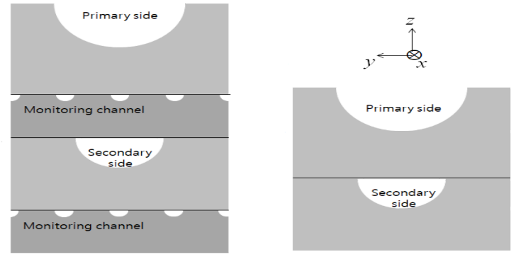

*Fig. 1. PCSG models stack configuration with MCP on the left and without MCP on the right.*

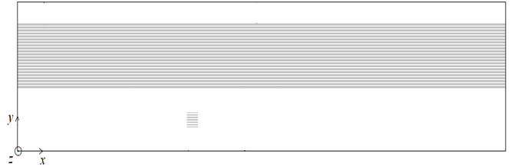

*Fig. 2. Primary side channel Plate*

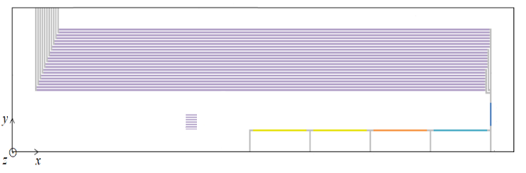

*Fig. 3. Secondary side channel Plate (heat transfer region is shown in violet)*

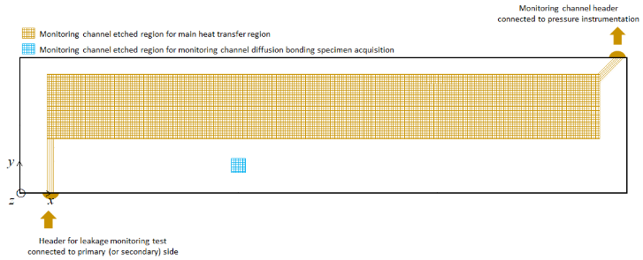

*Fig. 4. Monitoring channel Plate*

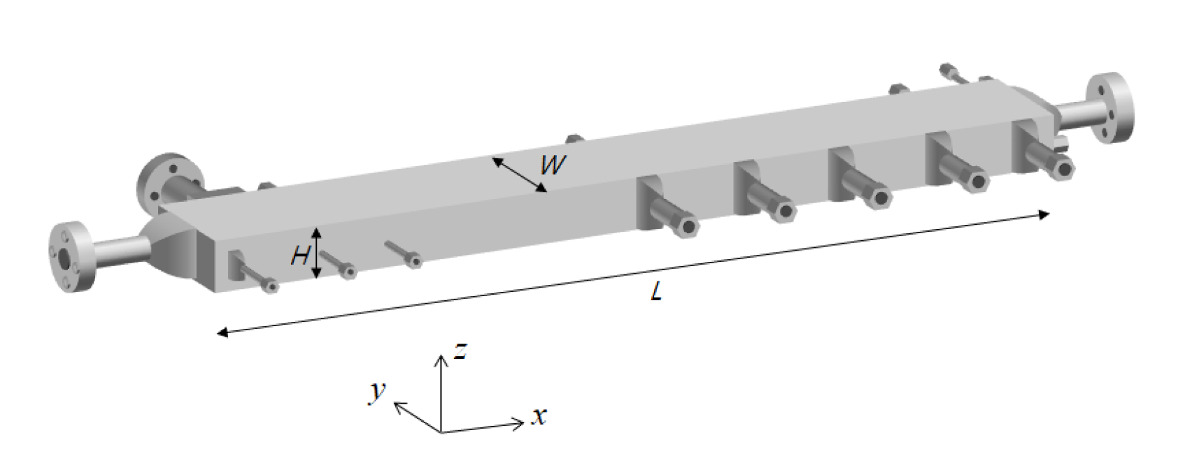

*Fig. 5. PCSG models configuration with headers and inlet nozzles*

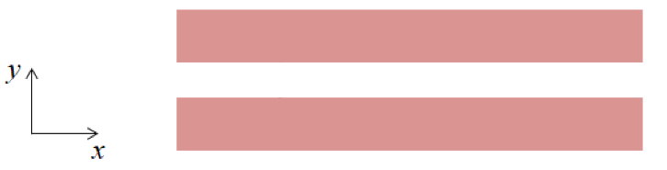

*Fig. 6. Primary side plate flow path*

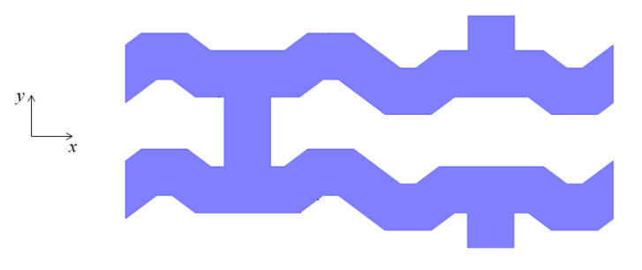

*Fig. 7. Secondary side plate flow path*

**

*Fig. 8. Monitoring channels plate flow path*

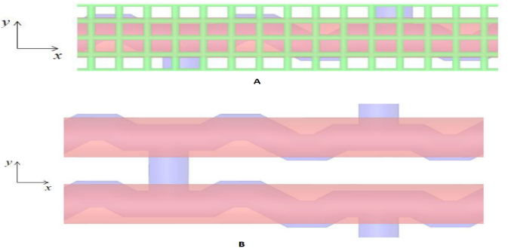

*Fig. 9. A. Alignment of primary, secondary and monitoring channels in model 1. B. Alignment of primary and secondary channels in model 2.*

III. Tests design and parameters

The tests were designed to simulate the operating conditions of the SMART Plus reactor design to test if the PCSG models would operate as intended. The tests measured thermal hydraulic variables such as temperature, pressure, differential pressure as well as flowrate.

The tests setup was divided into a primary loop and a secondary loop. Each loop contained pipes, valves as well as instruments. The primary loop included pressurizers and heaters for high temperature high pressure conditions. The secondary loop included a condenser for steam condensation and a heater to control the condensation temperature and pressure, a heat exchanger and a separate recirculation loop. Table III shows the types and locations of the instruments used in the tests.

The tests were divided into 6 groups. Each test comprised of 5 runs. Each run using a different inlet header. except for test C which was only conducted once. Table IV shows the operating conditions for the tests on PCSG models 1&2. Fig. 10 shows the PCSG models configuration.

*Table III Types and Locations of Instrumentations*

|  |  |  |
| --- | --- | --- |
| Instrument Location | Variable/cycle | |
| Outside the test models | Ambient Temperature | |
| Surface Temperature | |
| Insulation Surface Temperature | |
| Inside the Test models | Temperature | Primary Side |
| Secondary Side |
| Pressure | Secondary Side |
| Deferential Pressure | Secondary Side |
| Primary Side | Temperature | Test Model Inlet |
| Test Model Outlet |
| Pressure | Test Model Inlet |
| Deferential Pressure | Test Model Outlet |
| Flowrate | Pump Outlet |
| Secondary Side | Temperature | Test Model Inlet |
| Test Model Outlet |
| Pressure | Test Model Inlet |
| Test Model Outlet |
| Deferential Pressure | Test Model Inlet and Outlet |
| Flowrate | Pump Outlet |
| Monitoring pipe | Temperature | |
| Pressure | |

*Table IV Test operating conditions.*

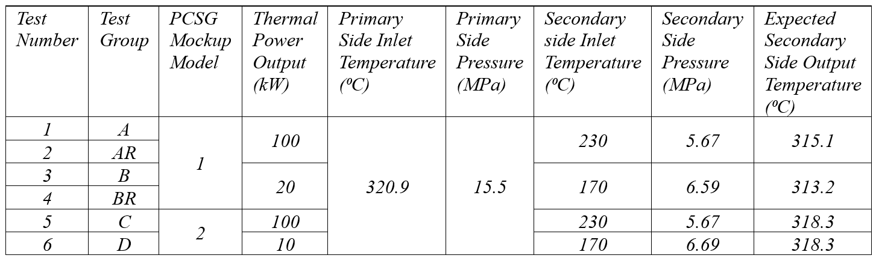

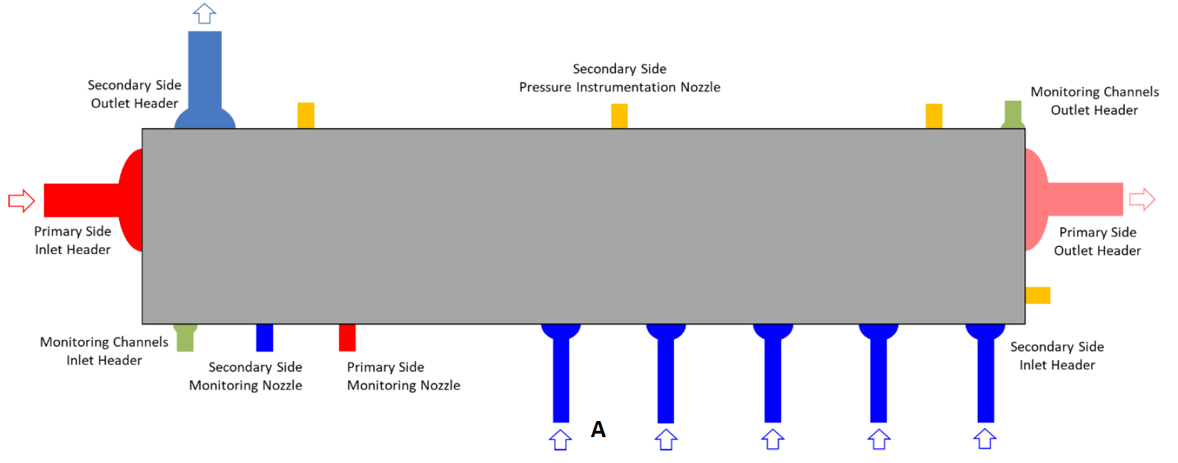

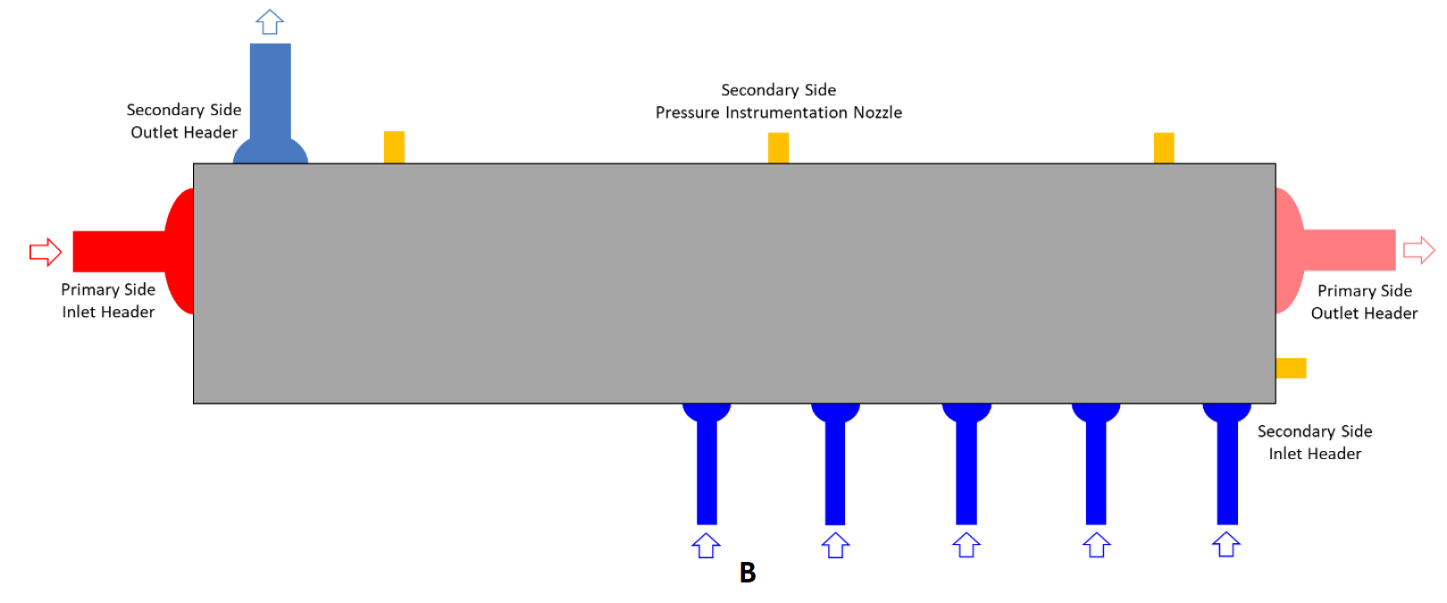

*Fig. 10. PCSG models configuration with MCP (A) and without MCP (B).*

III. Results and discussion

***III.A. Temperature results***

This section will discuss the results of the tests which are listed in Table IV for the secondary side temperature. Test groups A, B, C & D (tests AR & BR are a rerun of tests A and B respectively) secondary side temperature graphs are shown in Fig. 11 to 15.

Each graph contains temperature information acquired from the temperature gauges installed in the top plate of the PCSG.

For test groups A&AR (model 1, 100 kW), from Fig. 11 and Fig. 12, it can be seen that the change in temperatures for both tests are similar. The temperature increases gradually from the inlet to the outlet reaching saturation temperature.

For test groups B&BR (model 1, 20 kW), from Fig. 13 and Fig. 14, it can be seen that the temperature increases gradually from the inlet to the outlet reaching super-heated steam temperatures.

For test groups C&D (model 2, 100 kW, 10 kW), test C exhibits similar behavior to test groups A and AR where temperature increases gradually from the inlet to the outlet reaching super-heated steam temperature as shown in Fig. 15. However, before reaching the outlet, it suddenly dropped to the saturated state. The rise in temperature which resulted in the production of the super-heated steam came from the increased inlet temperature which can be seen in Fig. 15. Test D exhibits similar behavior to test groups B and BR where temperature increases gradually from the inlet to the outlet reaching super-heated steam temperatures as shown in Fig. 16.

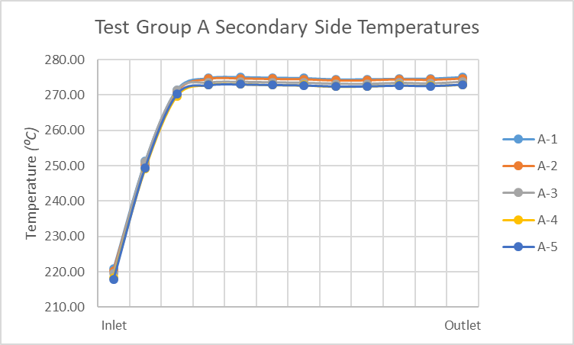

*Fig. 11. Test group A Secondary Side Temperatures.*

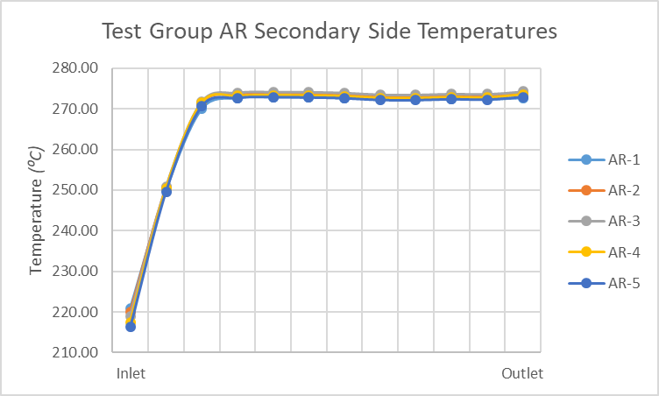

*Fig. 12. Test group AR Secondary Side Temperatures.*

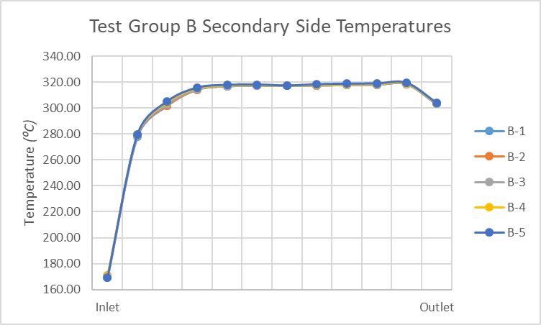

*Fig. 13. Test group B Secondary Side Temperatures.*

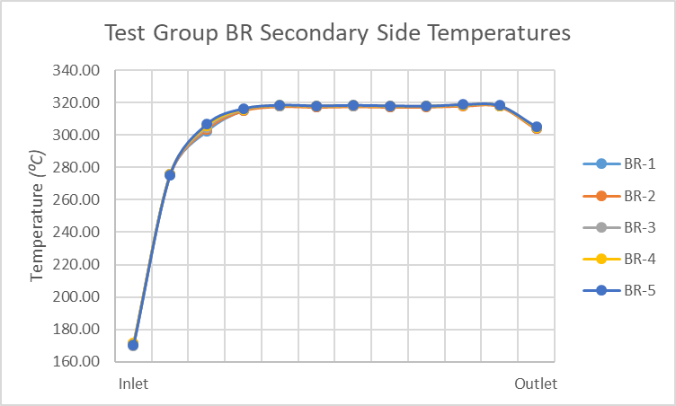

*Fig. 14. Test group BR Secondary Side Temperatures.*

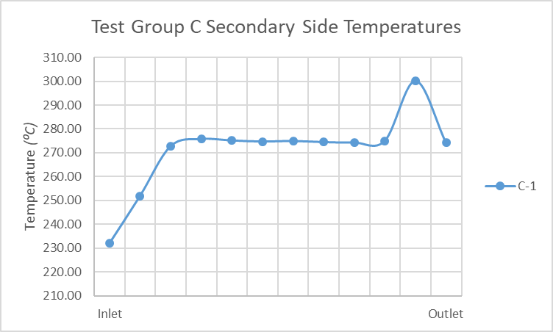

*Fig. 15. Test group C Secondary Side Temperatures.*

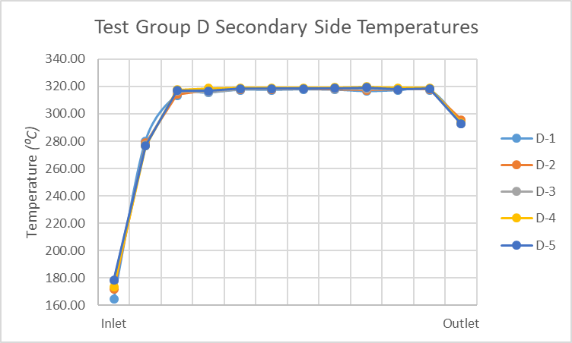

*Fig. 16. Test group D Secondary Side Temperatures.*

***III.B. discussion***

The results have shown that for test groups A, AR and C, two-phase flow was observed at the secondary side outlet but the outlet temperature did not meet the expected outlet temperature shown in Table IV. While test groups B, BR and D, super-heated steam was produced and the outlet temperature met the expected outlet temperature results.

IV. Conclusions

By performing the tests on the PCSG models 1&2, it was demonstrated that the PCSG is capable of generating super-heated steam and thus it is viable to introduce the PCSG to the SMART Plus reactor design.

However, further studies are necessary to enhance and optimize the design. Furthermore, modifications to the PCSG are suggested. Both PCSG models need to be adjusted due to the imbalance of heat distribution which occurred due to final plates of heat transfer being secondary side plates as mentioned in Table I which leads to unnecessary heat losses. This heat loss is the most probable reason of why super-heated steam was not generated at the high power tests.

Acknowledgments

The authors express their appreciation to King Abdullah City for Atomic and Renewable Energy for facilitating this study in the field of atomic and renewable energy.

This research was supported by King Abdullah City for Atomic and Renewable Energy (K.A.CARE) and the Korea Atomic Energy Research Institute (KAERI).

References

1. J. H. Moon, A. Altayeb. Thermal Hydraulic Performance Test Results of PCSG Mockup for SMART PLUS, KAERI, 2022.
2. CFD aided approach to design printed circuit heat exchangers for supercritical C02 Brayton cycle application, Annals of Nuclear Energy, Vol. 92, pp. 175-185, 2016.
3. Study on local thermal-hydraulic performance and optimization of zigzag-type printed circuit heat exchanger at high temperature, Energy Conversion and Management, Vol. 104, pp. 55-66, 2015.