Model-Driven Engineering for Optimal Project Delivery: Introducing the Project Delivery Model (PDM)

El Mehdi AZZOUZI, Jeremy BOURDON, Robert PLANA

Assystem Engineering & Operation Services
Tour Egée - 11 Allée de l’Arche - 92400 Courbevoie – France
emazzouzi@assystem.com
jbourdon@assystem.com
rplana@assystem.com

Abstract – Energy Transition acceleration coupled to geopolitical stakes has translated into a major worldwide attention for nuclear sector mainly thanks to its capacity to produce stable electricity in a souverain way. Hence, in order to keep up with the high demand of nuclear power plants, it is fundamental to have an efficient project management in order to successfully deliver nuclear projects while ensuring high regulatory requirements.
Nuclear sector faces a major challenge, which paradoxically lies in the fact that despite all the accumulated experience in product design, it struggles with managing the associated organizations, which is becoming as complex as designing the product itself.
The aim of this paper is to present a new methodology called PDM, which stands for Project Delivery Model. PDM provides a digital framework that harnesses the power of model-driven engineering capabilities to enhance and optimize project delivery. Unlike traditional project tools that are restricted to having interfaces with KPIs, PDM offers a digital framework that enables the dynamic association and modelling of various dimensions of a project with each other. This enables project managers to make well-informed decisions regarding their projects throughout the entire lifecycle, from planning to implementation. By leveraging digital technology and artificial intelligence, the methodology offers several benefits, including the ability to accelerate the initialization of projects, to conduct simulations on the project organization, on the supply chain optimization, and to perform impact analysis of a specific decision.

Keywords: Energy Transition, Nuclear sector, project management, project delivery, digital methodology, complex systems modelling, Supply Chain Optimization

- Introduction

The nuclear sector has gained significant global attention in recent years, driven by its crucial role in producing stable electricity and supporting the ongoing energy transition. However, effectively managing the associated organizations within the nuclear sector has become a complex and challenging endeavor. Despite the decades of experience in nuclear product design, efficient project delivery remains a very complex task.

To address these challenges and navigate the complexities of the nuclear sector, this paper proposes a new methodology called the Project Delivery Model (PDM). PDM offers a comprehensive framework for project management in the nuclear sector, leveraging the power of digital technology and artificial intelligence. By integrating modeling, simulation, and real-time connectivity with the organization, PDM aims to optimize various aspects of project management and enhance overall performance.
The PDM methodology goes beyond traditional project Key Performance Indicators (KPIs) by helping project managers to accelerate their project initialization, enabling faster project kick-off, and reducing time-to-market. By streamlining the project initiation process, PDM allows organizations in the nuclear sector to quickly adapt to changing market demands and improve their competitive edge. Additionally, PDM provides stakeholders with the ability to conduct simulations on their project organization, offering a valuable opportunity to explore different scenarios and optimize the organizational structure for enhanced performance.
Moreover, the PDM methodology supports supply chain optimization, ensuring efficient resource allocation and streamlined project operations. By leveraging digital technology and AI, PDM enables organizations to make data-driven decisions regarding the allocation of resources, reducing waste and enhancing productivity. This optimization extends to the entire project lifecycle, from procurement to construction and operation, resulting in cost savings and improved project outcomes.
By viewing the organization as a system, the PDM methodology capitalizes on existing methodologies and digital tools for studying and designing complex systems. It offers the potential to create a Digital Twin of the project organization, providing a real-time connected digital cockpit for project management. This innovative approach not only encompasses traditional KPIs but also allows for simulating decisions and observing their impacts at different project levels.

- Background

Nuclear projects have witnessed escalating complexity and are now considered as mega projects. These mega projects are characterized by having multiple stakeholders, enduring long lifecycles with high investments, and involving complex physical systems that must adhere to stringent regulatory requirements. These complex projects frequently face significant budget overruns and delays due to:

- Insufficient incorporation of operational requirements in initial project phases;
- Inconsistencies between the planned project execution model and actual implementation;
- Poor risk management, and inadequate control and reduction measures;
- Immature design at the construction start, leading to numerous changes complicating the project;
- Poor anticipation of the execution phase, resulting in inadequate organization and interface control;
- Difficulty in structuring the right project tracking data, complicating decision-making.
Unfortunately, the classical approaches to project management often fall short when dealing with these issues. Traditional project management methodologies, developed for simpler, smaller scale projects, encounter several limitations when applied to the larger, more complex context of mega projects (Doherty, 1998). These conventional methodologies lack the capacity to efficiently handle the unique characteristics and unexpected challenges that arise in the lifecycle of a mega project.
The move towards systems engineering in the management of mega-projects is a response to the limitations of traditional methodologies. Indeed, the problem with these methodologies lies in their linear and rigid nature, which struggles to adapt to the dynamic and complex aspects of mega-projects. They are often limited when it comes to managing multiple stakeholders with diverse interests and expectations (Azzouzi, 2022). In addition, their lack of flexibility poses a problem when dealing with extended timeframes, particularly in the nuclear sector where facilities have long life cycles. Traditional methodologies do not give the possibility to quickly adapt to unforeseen events, which complicates the decision-making process in such situations (e.g. a change in regulations within the design or operation phases).
By adopting systems engineering and the model-based approach to project management and engineering, mega-projects can overcome these limitations by embracing a more flexible, adaptable, and holistic approach. Systems engineering enables better understanding and management of the complex interactions between stakeholders, project requirements, and changing environmental factors. It offers a methodological framework that integrates the different dimensions of the project, from technical to organizational aspects, while fostering collaboration between teams and stakeholders.
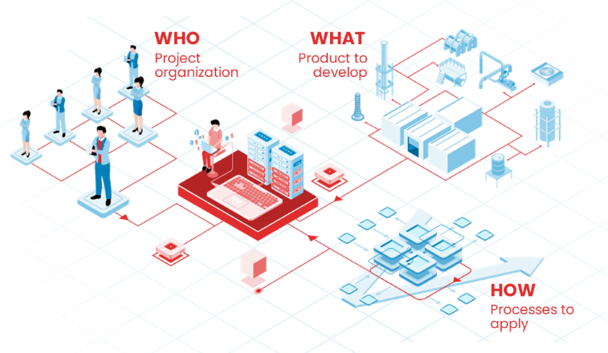
Indeed, models bring many benefits during project management and engineering activities. These benefits include: (1) improving understanding and communication between stakeholders through a shared vocabulary and representation modes (Sillitto, 2010); (2) enhancing efficiency through a rigorous methodology of modeling, verification, and validation, reducing rework; (3) ensuring traceability management and consistency control; (4) facilitating the automation of certain activities; (5) improving knowledge capitalization and reusability; (6) making data creation and manipulation easier.
Indeed, models bring many benefits during project management and engineering activities. These benefits include: (1) improving understanding and communication between stakeholders through a shared vocabulary and representation modes (Sillitto, 2010); (2) enhancing efficiency through a rigorous methodology of modeling, verification, and validation, reducing rework; (3) ensuring traceability management and consistency control; (4) facilitating the automation of certain activities; (5) improving knowledge capitalization and reusability; (6) making data creation and manipulation easier.
However, despite the promising advantages offered by model-based project management and engineering, the nuclear industry lacks approaches that link not only the product domains (requirements, organizational, functional, safety, business aspects, etc.) but also the organizational domain (processes, resources, means, planning, skills). This integration would create a complete, interconnected, and executable ecosystem that would improve the management of complexity in the nuclear industry.
The limitations of the classical approaches underline the need for innovative methodologies like the Project Delivery Model (PDM), designed to address these specific challenges.

- The Project Delivery Model (PDM)

The Project Delivery Model (PDM) is a methodical approach that uses digital and model-driven engineering to handle the complexity of the management of large projects.
The PDM is based on the deployment of a collaborative digital environment which allows to model the main dimensions of the project and to have a dynamic traceability between all its elements.
In practice, engineering digital tools are used to represent the organization of the project. Then, they are linked with the models of the system to design and construct. And finally, traceability links are made with processes and activities. The digitals tools are based on international standards such as Archimate (Josey, 2016) and BPMN (J.Mendling, 2012).

Fig. 1. The main project dimensions modeled with PDM

This overall model of the project enables to describe and visualise the relationships between the various structuring elements of the project which can be:
- Stakeholders: Designer, Operator, Regulator, etc.
- Roles: Project Manager, Planning Manager etc.
- Business interfaces: email, shared workspaces, etc.
- Subsystems: Subsystems that compose the main system.
- Processes: Work Breakdown Structure, business processes.
- Digital tools: PLM, ERP, etc.

III.A. PDM – The metamodel
In order to set out the creation of the Project Delivery Model (PDM) framework, it was necessary to identify the critical objects that should be included and to understand the intricate relationships between them. These considerations led to establishing a metamodel, which essentially serves as a blueprint for the PDM environment. This metamodel is an essential tool for users of the PDM, guiding them in navigating the large number of objects involved in the project's ecosystem.
The metamodel comprises two core blocks: the "Project Delivery Model Project" and the "Project" block. The "Project Delivery Model Project" block is symbolic of the PDM's application to a specific project, indicating its representation of the latter.
Embedded within the "Project" block are several fundamental entities that are essential components of the PDM. These include:
System of Interest: The main focus of the project, which could be a product, service, or any combination thereof.
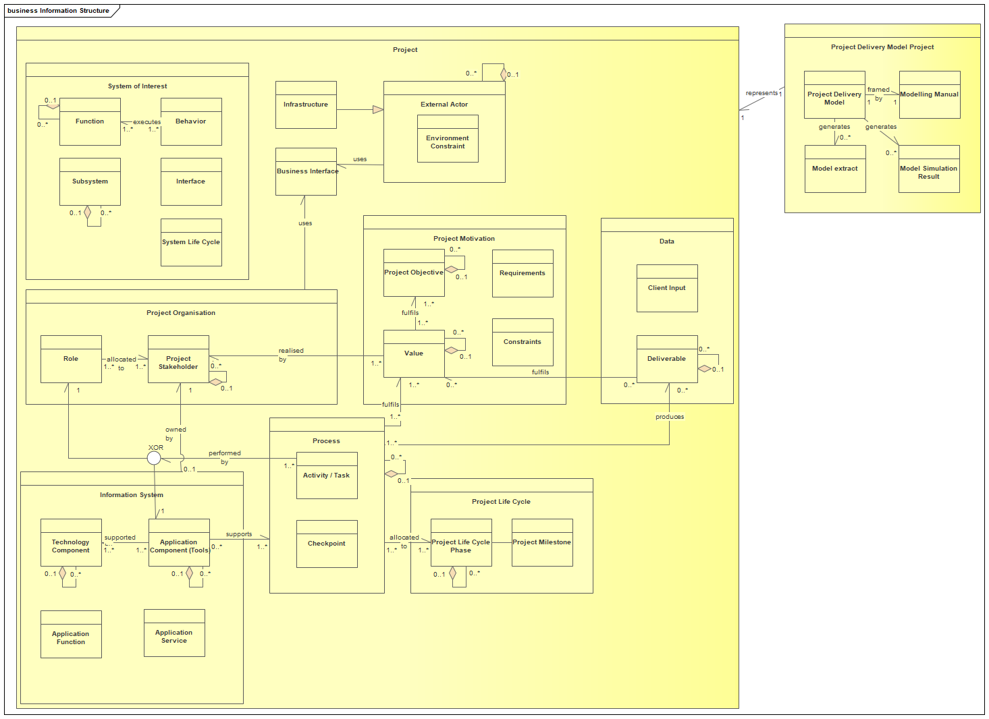
Project Motivation: The driving forces, goals, and objectives behind the project.
Fig. 2. PDM Metamodel
Project Organisation: The structure, roles, and responsibilities governing the project execution.
External Actor: Stakeholders outside the core project team but influence or are influenced by the project.
Data: Information accumulated, processed, or transmitted throughout the project lifecycle.
Process: Sequences of interrelated tasks that transform inputs into outputs.
Information System: Tools, software, and technologies utilized to manage and process data within the project.
Project Lifecycle: The various phases that a project goes through, from initiation to closure.
The PDM metamodel provides users with a holistic view of manipulated concepts of the PDM and the complex relationships between them. It does not only guides navigation but also stimulates innovative thinking by allowing users to explore various connections. With its adaptable structure, users can customize their PDM to align with their project contexts, improving project performance and decision-making efficiency.

III.B. MBSE for PDM

Model-Based Systems Engineering (MBSE) is an engineering methodology emphasizing the use of models over traditional documents to support a system's entire lifecycle, while using systems engineering processes.
According to the INCOSE, Systems Engineering (SE) is “an interdisciplinary approach and means to enable the realization of successful systems. It focuses on defining customer needs and required functionality early in the development cycle, documenting requirements, then proceeding with design synthesis and system validation while considering the complete problem: Operations, Performance, Test, Manufacturing, Cost & Schedule, Training & Support, and Disposal.” (David D. Walden, 2015)
The Project Delivery Model (PDM), with its multi-faceted nature, aligns closely with the principles of MBSE. By embracing this methodology, PDM ensures comprehensive modeling of various project aspects, from technical details to organizational structures. This alignment with MBSE allows PDM to guarantee the global model's consistency, fostering a unified and holistic perspective of both the product and the overarching project (Jérémy Bourdon, 2023).
Several advantages and insights emerge from this integration:
Comprehensive Representation of the Project: Having a unique model gathering all the facets of the project ensures a holistic view, and allows to ensure the consistency and traceability between the objects
Enhanced Communication and Collaboration: By bridging different project domains and having a clear overview of interfaces, an improved communication and a shared understanding emerges between stakeholders.
Optimized Resource Allocation and Project Planning: The interconnected modeling, supported by MBSE tools, aligns project planning with the system's technical requirements.
Enhanced Traceability: The consistent integration extends the innate traceability of MBSE across the entire PDM, ensuring efficient change management and risk mitigation.
Lifecycle Considerations: The synergy ensures a seamless transition between different project phases, from conception to operational maintenance.
Continuous Improvement: The integrated approach ensures learnings from past projects can be seamlessly incorporated into the current modeling.

III.C. Artificial Intelligence (AI)

Digital technology and Artificial Intelligence (AI) play a pivotal role in the optimization and effectiveness of the Project Delivery Model (PDM). Particularly when implementing PDM in existing projects, where there are large amounts of data scattered across various platforms. The AI, with deep learning capacities steps in as a critical tool for the aggregation, summarization, and digitization of this information. These technologies expedite and optimize processes that have traditionally been time-consuming. By employing AI for tasks like risk prediction and resource allocation, we can streamline project management operations, providing insightful data analytics, and facilitating real-time decision-making.

Within the Assystem group, a set of AI tools were developed to support various use cases within the PDM, thereby leveraging the power of AI to accelerate and streamline complex projects. These include:

Optimizio (Ajit Rai, 2020) - Scheduling Optimization Solution: Optimizio focuses on managing complexity and promoting agility in project scheduling. Optimizio effectively handles scheduling tasks of high complexity while adeptly managing numerous project constraints such as co-activity issues, availability of limited resources, and time constraints. Its flexibility allows easy integration into existing Information System environments, thereby supporting the agility and efficiency of PDM. This collaboration ultimately promotes optimal planning, efficient resource allocation, and better reactivity to project uncertainties, leading to improved project delivery.
DeepFinder (Kabbadj, 2020) - Data Extraction and Classification: DeepFinder uses Natural Language Processing to swiftly extract, classify, and index pertinent data from numerous document types that were produced within the lifecycle of a complex industrial projects. Crucially, DeepFinder helps modelers by streamlining the data collection process, which is often a time-consuming aspect of developing comprehensive project models. With its ability to automatically classify vast amounts of data, DeepFinder facilitates quicker and more efficient modeling processes. Especially when dealing with large databases, this speeds up the creation of data-informed project views in the context of PDM. As a result, access to relevant data in short time is enhanced, and opportunities for optimization are easier to identify, contributing to the overall agility and effectiveness of project management.
Emoby (Z. Bouhoun, 2023) - Resource Optimization and Talent Management: Emoby is an AI-driven solution designed to automate and optimize the process of talent and skills management in large and complex organizations. Within the framework of the Project Delivery Model (PDM), Emoby serves as a powerful tool for creating an intelligent database of company resources along with a detailed map of their competencies. This allows for rapid identification and optimal allocation of resources for various project tasks, thereby enhancing the efficiency of the PDM in managing complex projects. By offering a clear view of available resources and competencies, Emoby supports informed decision-making in resource planning, further improving project outcomes.
In conclusion, digital technology and AI are revolutionizing PDM, streamlining project management, optimizing resource allocation, and enhancing decision-making processes. The integration of tools like Optimizio, DeepFinder, and Emoby into the PDM framework enables more effective and efficient management of complex projects.

III.D. PDM - Going Beyond Traditional KPIs

Traditional project management often relies on Key Performance Indicators (KPIs) as metrics to evaluate a project's success. These KPIs, often focused on cost, time, and scope, provide a snapshot of the project's status at a given moment. However, with the evolving complexity of mega-projects, it's clear that a simple KPI-focused approach may no longer suffice.

The Project Delivery Model (PDM) is not merely an advanced set of KPIs. It offers a broader, more dynamic perspective on project management:
Simulative Analysis: PDM enables project managers to simulate various scenarios, testing the waters before making any real-world changes. For instance, should a major supplier delay their delivery, PDM allows the project team to simulate the ripple effect of that delay, helping them to identify potential resource clashes in advance.
Dynamic Impact Assessment: Rather than merely tracking deviations once they happen, PDM provides the tools to predict the impact of potential changes. This means, if there's a shift in a deadline or an unforeseen resource unavailability, project managers can swiftly assess the potential ramifications and adjust accordingly.
Optimization of Alternatives: When faced with a challenge or a bottleneck, traditional approaches might prompt a team to find a workaround or a fix. PDM, on the other hand, encourages exploring various alternatives. For instance, if a specific process is causing delays, PDM might be used to simulate different ways of executing that process, comparing their outcomes, and then selecting the most efficient one.
Automated Planning and Resource Allocation: PDM can automate the generation of project schedules based on the project's model, and dynamically allocate resources in response to changes. It can continuously update the project plan and resources in real-time, adapting to changes in project dynamics and thereby ensuring efficient execution of tasks.
Real-time Decision Making: Traditional KPIs often look in the rear-view mirror, telling managers what went wrong. PDM, with its forward-looking approach, facilitates proactive decision-making. Managers can anticipate challenges and make informed choices in real-time.

In essence, the Project Delivery Model empowers project managers with a 360-degree view, giving them not just data but actionable insights. It's a step towards a more holistic, responsive, and adaptive project management paradigm, where decision-making is rooted in foresight rather than hindsight.

- Implementation of PDM

The implementation of the PDM is a flexible process that is adaptable to the specific characteristics of individual projects, considering the varying needs of stakeholders and the phase of the project at which the PDM is applied. Depending on these factors, the PDM can either be fully implemented or partially deployed.
To facilitate a flexible yet structured approach towards PDM implementation, a modelling guide has been developed. This guide, represented as a matrix illustrated in Fig. 3, outlines the different models to be created for establishing a comprehensive digital twin of the organization. The matrix essentially has two dimensions:
Modelling Levels, which encompass various aspects of a project, including:
- Project Scoping: environment, life cycle, and objectives
- Activities: project execution processes
- Organization: internal project stakeholders
- Data: business and application data, input and output of the project
- Information System: the project's tool ecosystem
Modelling Aspects, which includes:
- Breakdown Structure: hierarchical decomposition of a project aspect into manageable parts or work packages.
- Architecture: structure and the interrelationship between different components
- Sequence: order or progression of tasks and activities within the project
- Mapping: correlation or alignment between different aspects or components of the project.
This matrix provides a methodological framework for users to navigate through the PDM process. It enables them to:
- Define target organizational models, according to the major milestones of a complex infrastructure project
- Describe the organization at different levels of abstraction including the functions of the organization, the different roles required, the different entities, and their links with the processes
- Link organizational models to system models
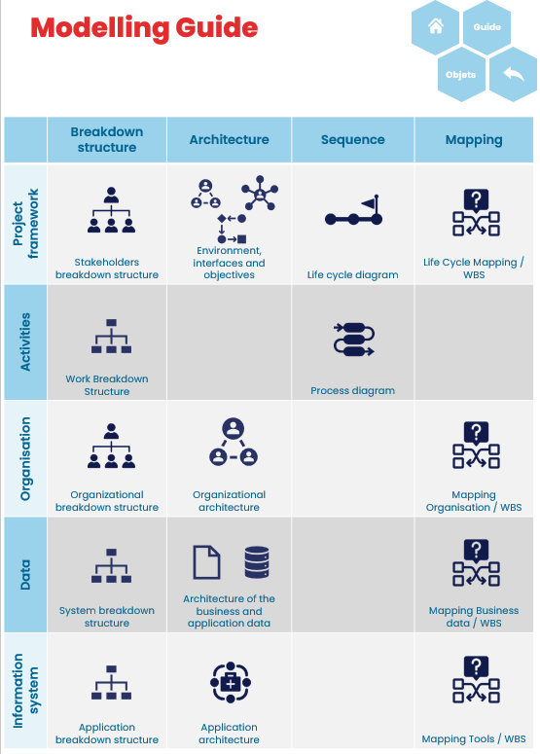
- Analyze interfaces and adapt models
As the creation of a PDM is an iterative process, each diagram lives and is likely to evolve throughout the project. In addition to this modelling grid, each proposed diagram is described in a descriptive sheet for further clarity and understanding.

- PDM building blocks

At the heart of the PDM lies a structured system designed to assist project execution, primarily aided by the interconnected building blocks shown in Fig. 4.
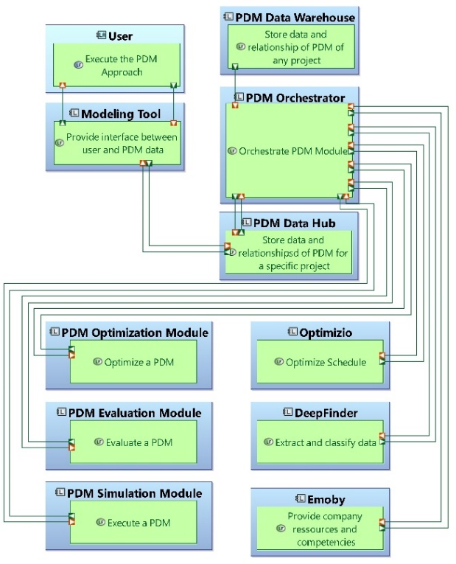
Fig. 3. Modelling guide
Fig. 4. PDM Building blocks

First, the user serves as the executor of the PDM approach. This user interacts directly with the modeling tool, a sophisticated interface facilitating the interaction between the user and the stored PDM data. This data, specific to individual projects, is secured within the PDM Data Hub.
Acting as a channel between stored data and modules, the PDM Data Hub channels information to the PDM Orchestrator, which harnesses the comprehensive PDM Data Warehouse which archives the data and relationships of PDM across a myriad of projects.
Furthermore, the orchestrator interacts bidirectionally with the specialized AI modules introduced earlier in the paper. These include Optimizio to optimize schedules; DeepFinder, which delves deep into data pools to extract valuable insights; and Emoby, tailored to optimize resources and competencies. Simultaneously, the orchestrator also interfaces with the Optimization, Simulation, and Evaluation modules, ensuring comprehensive project analysis.

- PDM benefits for a nuclear projects and discussion

In the complex realm of nuclear projects, the PDM can be a key instrument for effective management. The PDM can help project managers to accelerate the initiation phases of nuclear projects as they have access to pre-existing models, enriched with valuable feedback from past experiences. This ensures that from day one, managers are equipped with a detailed task list alongside the requisite resources, positioning them to initiate the project without delay.
PDM also ensures project resilience against unexpected challenges, ensuring consistent progress. This is possible thanks to the datacentric models with simulation capacities enabling to assess different possible organization scenarios, helping to make quick but well-informed decisions.
However, PDM is not without its challenges. The reliance on past models could result in neglecting unique challenges of a new project. AI-driven tools, while powerful, do not always ensure the accuracy of their input data. Inaccurate or biased data could lead to misinformed decisions. Lastly, PDM's effective implementation requires important resource commitment in terms of human and financial aspects.

- Conclusions

As we conclude, it's clear that the innovative Project Delivery Model (PDM) framework, equipped with the power of Artificial Intelligence, has a pivotal role in managing complex infrastructure projects. This technology promises a strategic shift from traditional project management models, facilitating optimization, risk management, and overall improved delivery.
Moving forward, there are several promising perspectives for PDM. Firstly, it would be beneficial to develop a dedicated tool environment that could guide and frame users during the PDM implementation process. A well-structured, user-friendly platform would help maximize the benefits of PDM, promoting its wider adoption.
Secondly, exploring new use cases for PDM. The flexibility and adaptability of the framework make it applicable across diverse projects that can be in the nuclear sector on in other fields with complex infrastructures, each presenting unique opportunities for optimization and efficiency gains.
In conclusion, Project Delivery Modeling can bring a great added value to the way we manage complex infrastructure projects. It gathers digital technology, AI, and flexible implementation to provide a superior project management model. However, this field is still evolving and little explored. Therefore, there is room for further research and development to maximize its potential. This paper should serve as a starting point for future developments and implementations of PDM.
Acknowledgments

Gratitude is given to Assystem for their support and funding of this project.
References
- Ajit Rai, V. A.-G. (2020). A Dynamic Heuristic Optimization for Condition-based Maintenance Planning. easychair.org.
- Azzouzi, E. a.-Y. (2022). A Model-Based Engineering Methodology for Stakeholders Coordination of Multienergy Cyber-Physical Systems. IEEE Systems Journal, 16(1), 219-230.
- David D. Walden, G. J. (2015). Systems Engineering Handbook.
- Doherty, N. F. (1998). The consideration of organizational issues during the systems development process: an empirical analysis. Behaviour & information technology, 17(1), 41-51.
- J.Mendling, M. (2012). Business Process Model and Notation (BPMN). Lecture Notes in Business Information Processing. Berlin, Heidelberg: Springer Berlin Heidelberg, 125.
- Jérémy Bourdon, P. C. (2023). Model-based architecting evaluation method for the delivery of complex nuclear projects. INCOSE Systems Engineering, 1-21.
- Josey, A. L. (2016). An introduction to the ArchiMate® 3.0 specification. White Paper from The Open Group.
- Kabbadj, A. a. (2020). Artificial Intelligence a D and D Enabler - 20552. Conference: WM2020: 46. Annual Waste Management Conference, Phoenix, AZ (United States.
- Sillitto, H. G. (2010). Design principles for Ultra-Large-Scale (ULS) Systems. INCOSE International Symposium, 20(1), 63–82.
- Z. Bouhoun, T. G. (2023). Information Retrieval Using Domain Adapted Language Models: Application to Resume Documents for HR Recruitment Assistance. Computational Science and Its Applications -- ICCSA 2023 Workshops.

