**SPACE Validation on a Steam Generator Tube Rapture Experiment with SMART-ITL Facility**

Eslam Bali a*, Sultan Al-Faifi a , Kyung Doo Kimb

*aKing Abdullah City for Atomic and Renewable Energy, Riyadh 12244, Saudi Arabia*

*bKorea Atomic Energy Research Institute, 989-111 Daedeokdaero, Yuseong, Daejeon, 305-353, Korea*

\**Corresponding author:* [*e.bali@energy.gov.sa*](mailto:e.bali@energy.gov.sa)

Abstract – Validation of Thermal-Hydraulic (T-H) codes is highly important in Nuclear Power Plants (NPPs), particularly in transient accidents and for new designs that have integrated and passive safety systems. These codes simulate and predict the behavior of the coolant, fuel, and core during various operational scenarios, enabling engineers to make informed decisions and ensure the safety and efficiency of the plant. Validation involves comparing the results of the code calculations with experimental data from real-world tests and operational experience to ensure that the models accurately capture the complex phenomena occurring within the system.

This study aims to validate the Safety and Performance Analysis CodE (SPACE) for analyzing thermal hydraulics in integral reactors, specifically the System Integrated Modular Advanced Reactor with 100 MWe (SMART100). Using the SMART-Integral Test Loop (SMART-ITL), a facility designed to observe and understand thermal-hydraulic phenomena in the SMART100 system, the researchers conduct a Steam Generator Tube Rupture (SGTR) experiment to validate the SPACE code. This process helps in identifying potential areas of improvement and enhancing the accuracy of the models. The paper presents the steady state condition, sequence of events and the nodalization of SMART-ITL with the main components and systems involved in the experiment. Results and discussions cover various parameters such as core inlet and outlet temperature, pressurizer pressure, primary and secondary SG flow rate, main steam pressure, and water level of passive safety tanks.

The validation results demonstrate the accuracy of the SPACE code in predicting various thermal hydraulic phenomena and behaviors of SMART100. This validation provides confidence in the code's capability to analyze thermal hydraulics in integral reactors like SMART100. The validated SPACE code can be a valuable tool for future analyses and safety assessments in the field of integral NPPs.

Keywords: SPACE, SMART100, SMART-ITL, SGTR, T-H

1. **Introduction**

Evaluation of Nuclear Power Plants (NPPs) performances during accident conditions has been the main issue of the research in nuclear fields during the last 40 years. Therefore, several complex system thermal-hydraulic codes have been developed for simulating the transient behavior of NPPs. Safety and performance analysis codes validation is required and important work that should be performed to obtain reliable results for simulating the NPPs behaviors during the steady state or transients.

SMART100 is System Integrated Modular Advanced Reactor with 100 MWe and fully Passive Safety Systems (PSSs). The design of SMART100 was upgraded from the standard design of SMART and developed by Korean Atomic Energy Institute (KAERI). Unlike loop-type commercial reactors, the SMART100 plan adopts a helically coiled steam generator, an internal pressurizer, inside the Reactor Pressure Vessel (RPV). To simulate the thermal hydraulic behavior well at SMART100 plant under various conditions includes Steam Generator Rapture (SGTR), it is necessary to develop and validate safety and performance system analysis codes that reflect the characteristic of SMART100. In general, developing physical models and validation work for separate effect and integral effect tests are required to enhance the reliability of the simulation results of a system analysis code.

The purpose of this study is to validate the Safety and Performance Analysis CodE (SPACE) based on steam generator tube rapture experiment with SMART-ITL (SMART-Integral Test Loop) in order to predict and identify the capability of SPACE for analyzing thermal hydraulics in integral reactors.

1. **Methodology**
   1. ***A. Overview of SPACE***

SPACE is a safety and performance analysis code for use in nuclear power plant design applications. Based on the Nuclear Safety and Security Commission (NSSC) approved the use of SPACE code for licensing applications of Korean Pressurized Water Reactors (PWRs) in 2017. The SPACE code is capable of high fidelity simulations of such accidents as the loss of coolant, the main steam line break, the main feed water line break, and the steam generator tube rupture that are required in the safety analyses of PWRs. In addition, it adopts advanced physical modeling of two-phase flows, mainly two-fluid three-field models that consist of gas, continuous liquid, and droplet fields **[1]**. Development of certain physical models of SPACE has been modified and added to the code for simulating the thermal hydraulic behavior of SMAERT-ITL.

* 1. ***B. Overview of SMART-ITL***

SMART-ITL is an integral test loop facility that has been constructed by the Korean Atomic Energy Research Institute (KAERI) and finished its commissioning tests in 2012, to observe and understand the thermal hydraulic phenomena that occur in the systems of SMART during normal operation or transients **[2]**. SMART-ITL has been designed to preserve and represent the same height ratio, time scale, pump head and pressure drop of the reference plant SMART100. While the diameter has been scaled down to 1/7 and each of the area, volume, core power, and flow-rate have been scaled down to 1/49 compared with the reference plant **[3]**. Table I shows the major scaling ratio parameters of SMART-ITL.

*Table I: Major Scaling Ratio Parameters of SMART-ITL.*

|  |  |
| --- | --- |
| Design Parameter | Ratio (SMART/ITL) |
| Length | 1/1 |
| Time | 1/1 |
| Pump head | 1/1 |
| Pressure drop | 1/1 |
| Diameter | 1/7 |
| Area | 1/49 |
| Volume | 1/49 |
| Core power | 1/49 |
| Flow-rate | 1/49 |

* 1. ***C. Overview of SGTR***

In SMART100, the steam generator is installed inside the Reactor Pressure Vessel (RPV), while in SMART-ITL, the steam generator is separated from the RPV and connected to the upper and bottom hemispheres parts of RPV through a cylindrical pipe as shown in Figure 1. In addition, the reference reactor has eight steam generators, and each steam generator has 376 heat exchanger pipes while SMART-ITL has four steam generators with 15 heat exchanger pipes for each. The area and volume ratio of a single actual SMART-ITL steam generator is 2:49 because the ratio is 1:49 for two generators of reference reactor.

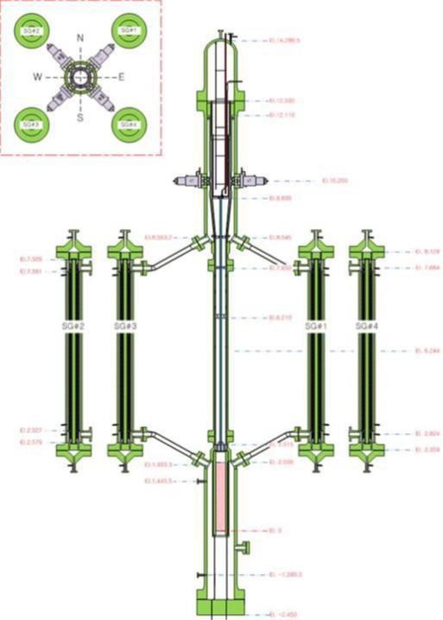

*Fig. 1. Setup between the Steam Generators and the Reactor Pressure Vessel in SMART-ITL*

* 1. ***D. Steady State Condition***

Firstly, the steady state condition of this SGTR has been applied on 25% of full scaled thermal core power of SMART-ITL, the full thermal core power in SMART PPE design equals 365 (MWth). Therefore, the thermal core power with SMART-ITL as mentioned in Eq. (1).

$\frac{365}{49}$ (25%) = 1.862 (𝑀𝑊𝑡ℎ) (1)

Secondly, the total primary flow-rate in SMART PPE design equals 2,507 (Kg/s). Therefore, the total RCS flow-rate with SMART-ITL as mentioned in Eq. (2).

$\frac{2,507}{49}$ (25%) = 12,791 ($\frac{kg}{s}$) (2)

In addition, the bypass flow rate through the core equals 0.51 (kg/s), almost 4% of the total flow rate. Thus, the actual core flow rate is 12.281 (kg/s). In addition, the bypass flow rate of SG primary side equals 0.77 (kg/s). Which means the total flow rate of SG in primary side is 12.021 (kg/s). Table II and Table III shows that steady-state condition of 25% Core Power between SMART PPE Design and SMART-ITL Target Value for the primary and secondary systems.

*Table II: Steady-state Reference and Target Ratios for the Primary System of 25% Core Power*

|  |  |
| --- | --- |
| Parameter | Ratio (SMART/ITL) |
| Core power (MWth) | 1/196 |
| Operating pressure (MPa) | 1/1 |
| Flow-rate (kg/s) | 1/196 |
| Core inlet temp. (⁰C) | 1/1 |
| Core outlet temp. (⁰C) | 1/1 |

*Table III: Steady-state Reference and Target Ratios for the Secondary System of 25% Core Power*

|  |  |
| --- | --- |
| Parameter | Ratio (SMART/ITL) |
| Flow-rate (kg/s) | 1/196 |
| Feedwater pressure (MPa) | 1/1 |
| Feedwater temp. (⁰C) | 1/1 |
| Main steam pressure (MPa) | 1/1 |
| Main steam temp. (⁰C) | 1/1 |

* 1. ***E. Sequence of Events***
  2. ***F. SMART-ITL Nodlization and Break Line Modeling***

Firstly, there are two types of SGTR accidents, first one called single-end, which means the reactor coolant of the primary system will contact and mix with the coolant of secondary system to the main steam line. While, the second type called double-ended which means the reactor coolant of the primary system will contact and mix with the coolant of secondary system to the main steam line and feed water line. Therefore, in this test we have assumed that there is a single- end of SGTR with a maximum break size equals 1.7 (mm) in SMART-ITL, which equals 12 (mm) in the prototype of SMART. Secondly, all the PSSs that includes Passive Safety Injection System (PSIS), Passive Residual Heat Removal System (PRHRS), and Automatic Depressurization System (ADS) have been modeled and added in SPACE. Thirdly, the SGTR was modeled by an opining valve, break nozzle, and two pipe components that directly connected the primary side of steam generator and main steam line. Finally, we have multi reactor trip signals for SGTR accident which are Low Pressurizer Pressure (LPP) and Low Pressurizer Water level (LPL), both of them have the same sequences but the only major difference between them is the time delay of actuation signal response and we have followed the LPL set point as shown in Table IV.

*Table IV: SGTR Sequence of Event due to the LPL Set Point*

|  |  |
| --- | --- |
| SOE | Set point / Trip signal |
| Break | - |
| Reach LPL | LTPZR = 45% = 2(m) |
| Reactor trip signal | LPL + 1.1 s |
| CVCSIAS | LPL + 1.45 s |
| PRHRAS | LPL + 1.45 s |
| CMTAS | PRHRAS + 1.45 s |
| CVCS stop | CVCSIAS + 1.45 s |
| CMT injection start | CMTAS + 1.45 s |
| PRHRS IV open | PRHRAS + 5 s |
| MSIV and FIV close | PRHRAS + 5 s |
| SITAS | PTPZR = 1.78 MPa  + 1.45 s |
| SIT injection start | SITAS + 1.45 s |
| ADS #1 open | CMT level < 31% |
| ADS #2 open | SIT level < 14% |
| Reach safety shutdown  condition | RCS temp. = 215 ⁰C |

Figure 2 shows the SMART ITL nodlization with main components and systems. In addition, the break line model consists of an opening valve, break nozzle, and two pipe components that directly connect between the primary side of SG and steam line as shown in Figure 3.

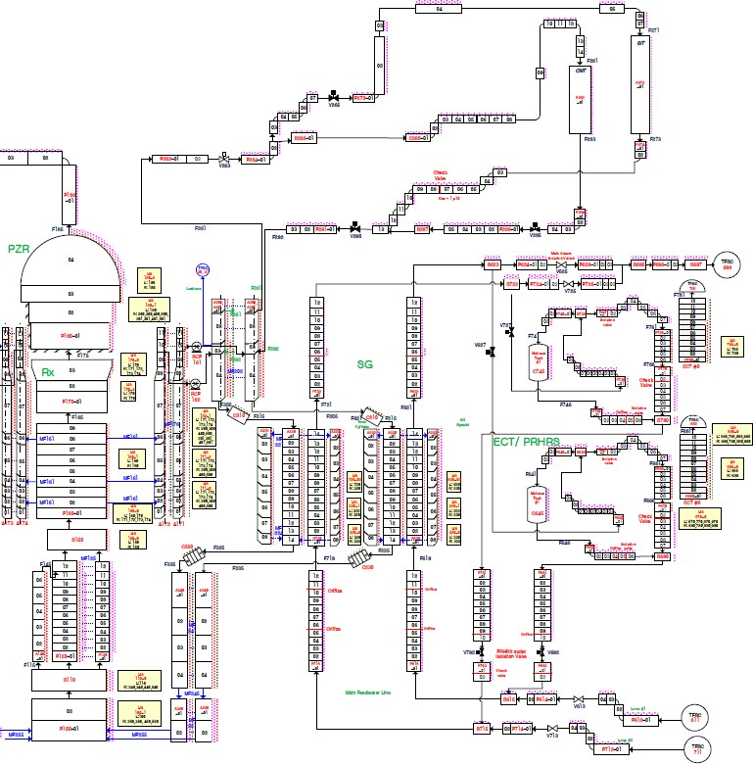

**PSIS**

**RPV**

**SG**

**PRHRS**

*Fig. 2. SMART-ITL Nodalization*

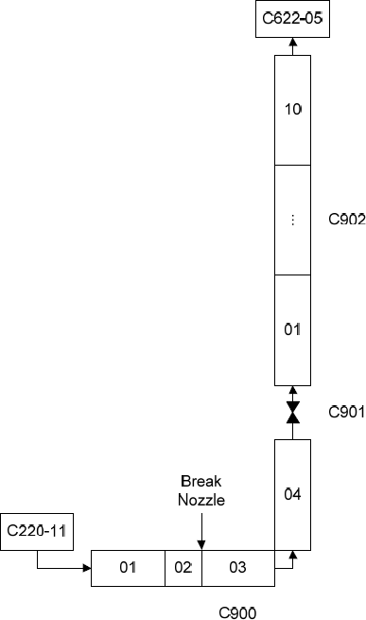

*Fig. 3. SGTR Break Line Modeling*

1. **Results and Discussion**
   1. ***A. Core Inlet and Outlet Temperature***

When the steam generator raptured is occurred and the reactor trip signal is actuated due to the LPL. (1) The core inlet and outlet temperatures started decreasing due to the dropped of core power. This means the capacity of thermal power to heat up the RCS is decreased due to the start injection of CMTs and removing heat by PRHRSs.

(2) In addition the RCS reached the safety shutdown condition when temperature was 215 (C) at time of almost 3.1 (hr) as shown below in Figure 4.

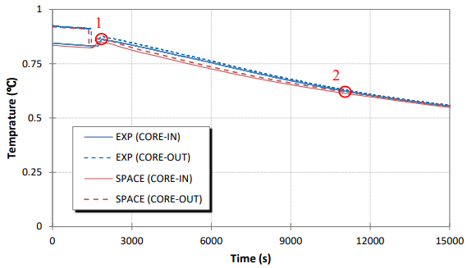

*Fig. 4. Shows the Normalized Core Inlet and Outlet Temperature for the SGTR Accident.*

* 1. ***B. PZR Pressure and Water Level***

From Figure 5 and 6, when the steam generator raptured is occurred, the PZR pressure and PZR water level started decreasing gradually and immediately respectively. (1,2) The PZR pressure took longer time than the PZR water level to reach the set point with 25 minutes different in between. (3) PZR water level started to recover faster in SPACE with the CMTs injection.

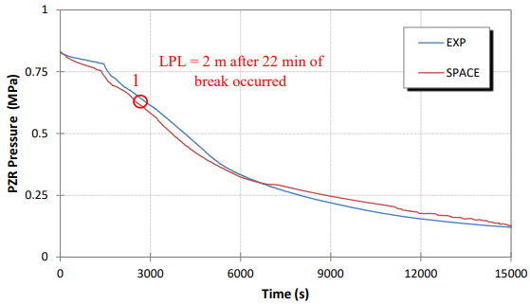

*Fig. 5. Shows the Normalized PZR Pressure of SGTR.*

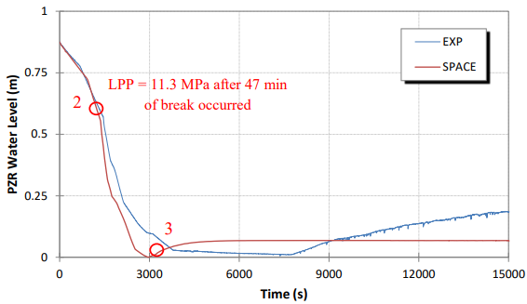

*Fig. 6. Shows the Normalized PZR Water Level for the SGTR Accident.*

* 1. ***C. Primary and Secondary SG Flow Rate***

From Figure 7 and 8, the SG primary and secondary flow-rate dropped rapidly after the trip signal as shown at points (1,3). (2) Primary SG mass flow-rate started to increase again due to the PSIS especially the CMTs injection.

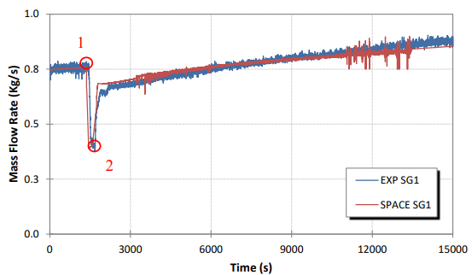

*Fig. 7. Shows the Normalized Primary SG Flow-rate for the SGTR Accident.*

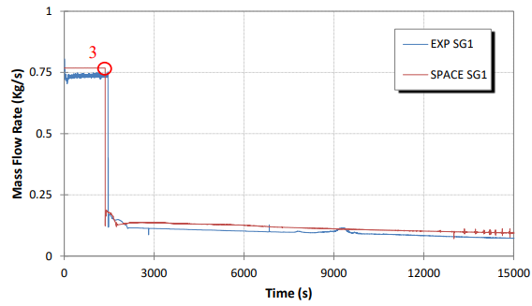

*Fig. 8. Shows the Normalized Secondary SG Flow-rate for the SGTR Accident.*

* 1. ***D. Main Steam Pressure***

The main steam pressure was 5.63 (MPa) before the SGTR accident. (1) After the reactor signal trip is actuated in the plant, the condenser part is totally isolated from the steam generators by closing the main steam and feed water isolation valves. Therefore, the pressure of steam started increasing because there is no way to remove that amount of steam from SG. (2) At the same time the PRHRS is actuated and started to remove the heat from secondary system through the steam line, that way the pressure of main steam started to decrease after it reached a maximum pressure of 12.33 (MPa) at the effected SG as shown in Figure 9. In addition, PRHRS is responsible to condense the main steam and inject it again through the feed-water line to secondary system of SG.

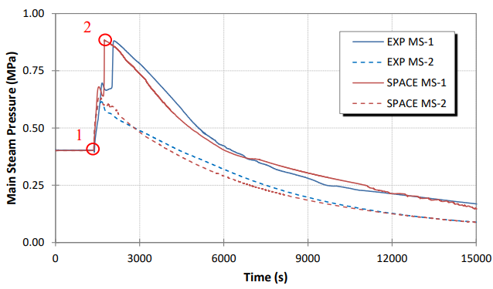

*Fig. 9. Shows the Normalized Main Steam Pressure for the SGTR Accident.*

* 1. ***E. CMT Water Level***

Water of CMT started to be injected to RCS after almost 62 minutes of break occurred as shown in Figure 10 at point (1).

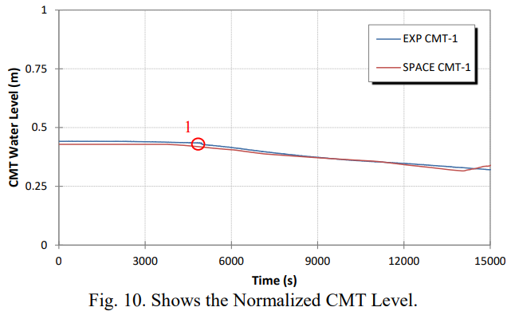

*Fig. 10. Shows the Normalized CMT Level.*

1. **Conclusion**

Firstly, SPACE analysis and validation on a steam generator tube rapture experiment with SMART-ITL facility has been performed. Secondly, the validation results show that the overall thermal hydraulic behaviors such as the core inlet and outlet temperatures, the pressurizer pressure and water level, flow rate of primary and secondary sides of steam generator, main steam pressure, and the water level of core makeup tank were predicted well. Therefore, SPACE has the capability for analyzing thermal hydraulics in integral reactors specially SMART100. Finally, SPACE would improve the pressurizer water level predictability associated with the end phase.

**Acknowledgments**

This research was supported by King Abdullah City for Atomic and Renewable Energy (K.A.CARE), Kingdom of Saudi Arabia, and KAERI within the Joint Research and Development Center

**References**

1. SPACE 3.0 MANUAL VOLUME 2, S06NX08-K-1-TR-36, Rev.0, 2017.
2. K. K. Kim, et al., SMART: The First Licensed Advanced Integral Reactor, Journal of Energy and Power Engineering, 8, 94-102, 2014.
3. H. S. Park, S. J. Yi, and C. H. Song, SMR Accident Simulation in Experimental Test Loop, Nuclear Engineering International, November 2013, 12-15.