**Source Term Determination Of Containment By-Pass Accidents Using Results Of Thermal Hydraulic System Codes**

Adam Kecek, Jan Klouzal, Pavel Kral

# UJV Rez, a. s.

*Hlavni 130, 250 68 Husinec-Rez, The Czech Republic*

[adam.kecek@ujv.cz](mailto:adam.kecek@ujv.cz), [jan.klouzal@ujv.cz](mailto:jan.klouzal@ujv.cz), [*pavel.kral@ujv.cz*](mailto:pavel.kral@ujv.cz)*,*

Abstract – *Determination of a source term is an essential part in the chain of nuclear safety analyses and serves as a cornerstone to following analyses of radiological consequences. Aside the design basis accidents like large break LOCA, events where primary coolant bypasses the containment may be of high importance. Such accidents are steam generator tube ruptures, where a flow of activities from primary to the secondary circuit and consequently through the steam dump to atmosphere directly into the environment surrounding the power plant may cause non negligible radiological consequences. Within EU R2CA project, UJV developed a methodology and computational tool, which uses existing or new results of relevant transients from thermal hydraulic codes such as RELAP5 or ATHLET and with application of balance equations calculates the source term. The methodology incorporates several typical physical phenomena occurring during the transport of activities between the primary and secondary circuit such as partitioning and flashing. In this paper, basics of the methodology will be presented, including sample application on a steam generator tube rupture of a VVER-1000/V-320 unit calculated with RELAP5.*

**Keywords:** SGTR, RELAP5, R2CA, source term

I. Introduction

Operation of a nuclear power plant is bound by legislative limits, both for operational and accidental situations. Within the frame of the postulated accidental conditions, the main issue is the radioactive fission product release and following radiological consequences, which are strictly limited to ensure that the risk associated with the operation of the nuclear power plant are acceptably low. To prove that these limits are met within the plant’s safety case, computational analyses are conducted for various scenarios, covering DBA (design basis accident), DEC-A (design extension conditions without fuel melt) and DEC-B (design extension conditions with fuel melt) events. A strong focus is often given to LOCA (loss of coolant accident) accidents **[10]**, which are expected to have the worst radiological consequences due to maximization of coolant loss and possible fuel deterioration. On the other hand, such accidents take place in a containment, which serves as an effective barrier preventing the release of radioactivity into the environment. Unfortunately, some scenarios without postulated fuel degradation beyond the operational limits may have even more significant radiological consequences. A typical example is SGTR (steam generator tube rupture) accident, where a rupture of a steam generator tube provides direct flow of contaminated water from the primary circuit into the secondary circuit. Due to the injection of the primary water, the secondary side pressure rises, which may lead to opening of SDA (steam dump to atmosphere), providing direct flow of the contaminated water into the environment. Even though as a result of this event fuel cladding failures are not expected, significant activity may be present in the primary coolant due to loss of hermeticity of some of the fuel elements already during normal operation before the postulated event. To quantify the consequences of such event correctly, special computer codes must be used. Numerous codes dedicated to severe accidents such as ASTEC and ATHLET-CD could be used for this type of analyses, but due to lack of validation data for DBA transients with fission product transport in the primary circuit, the applicability is limited. Furthermore, modification or development of input decks and appropriate validation is demanding on manpower. This lack of easily applicable tool was the motivation for UJV to develop within the R2CA project a new methodology as well as standalone tool based on balance equations, which can determine the source term based on thermal hydraulic calculation only.

II. Activity transport during SGTR

The transport of the activities from the primary to the secondary side depends on the nature of the chemical specie, i.e. different behavior is expected for noble gasses and for iodine and other volatile species. Based on the information provided in **[1 – 3]**, three main transport phenomena for aerosols and iodine during SGTR can be observed, cf. Fig 1.

*Fig. 1. Iodine transport model from Attwood [1]*

During the SGTR, the hot water from the primary side may enter the steam generator both as water and steam, transporting activities equivalent to the transported water mass from the primary to the secondary side. The fraction of activities entraining the secondary side with steam is expected to be transported to the steam line and further. This process is called bypass. The fraction of the activities which enter the steam generator with water which flashes immediately is called flashing. The last fraction assumes immediate mixing of the entraining primary water and activities with steam generator bulk water. The third activity transport phenomenon is related to evaporation of water from steam generator, where the evaporating water may transfer fraction of the activities equivalent to the evaporated water mass.

If the steam generator tube rupture is below the water level, the steam bubbles may rise through water column above the rupture and the transported fission products may interact on the interface. This process is called scrubbing and may lead to reduction of activities carried by bypassing and flashing phenomena. **[2]**

For noble gasses, due to the chemical nature, simplified approach can be adopted **[2, 3]** assuming all activity entraining the steam generator to be transferred directly to the steam line and to the environment consequently.

***II.A. Partition coefficient***

The fraction of activities transported with steam is defined by partition coefficient **[2]**, cf. Eq. (1). If the partition coefficient is equal to one, all activities equivalent to the evaporated water mass entrain the steam phase. For PC = 100, 1 % of the activities equivalent to the evaporated water mass enter the steam phase, leaving 99 % in the water.

$PC=\frac{mass of I_{2} per unit mass of liquid}{mass of I_{2} per unit mass of gas}$ (1)

The partition coefficients, depending on transport process, depends on numerous boundary conditions such as pH, temperature, boric acid concentration etc.

Report **[5]** summarizes different approaches in Belgium, France, Germany, UK and Italy. The partition coefficient ranges from 10 to 100. In France the lower value is used to incorporate flashing phenomena, the second should be used for intact steam generator. Belgium use the same 100 partitioning coefficient for iodine. For non-volatile species the Italian approach assumes partition coefficient to be 1000.

Document **[4]** recommends use of PC = 35 due to the pH values in SGs (steam generators). This value is valid for recirculating SGs. Document **[7]** notices that the partition coefficient depends on boric acid concentration rather than on pH. The partition coefficients should be between 1000 and 14000. Document **[8]** summarizes that for pH 6-10 and temperatures 118°C, 143°C and 179°C with pressure below 1 MPa reaches values between 17 to 25000. These experimental values were obtained after several hours, i.e. stable conditions were achieved. Unfortunately, this time frame may exceed the duration of the investigated SGTR event. Paper **[8]** mentions that with pH 6.5 the partitioning coefficient is 197.

Generally lower values of partition coefficients should be used for DBA events, where conservative approach is demanded **[9]**. For DEC-A events, where realistic approach should be adopted, the value can be chosen according to the conditions within the steam generator.

***II.B. Chemical forms of iodine***

Iodine behavior is very complex. Within the primary and secondary circuit, iodine can react with various materials and undergo numerous chemical reactions due to changing boundary conditions such as pH, pressure, temperature and dose rate. For radiological consequences, the chemical form of released iodine must be defined. For PWRs the documents **[2-3]** recommend for iodine release into the environment to be composed of 97 % elemental (I2) and 3 % organic form (CH3I).

***II.C. Implemented models***

Based on the literature review, following approach was adopted. The approach is based on balance equations, where in each time step a water mass and activity is solved both in primary and secondary circuit. The water mass is calculated by the system code and serves as an initial and boundary condition. The balance models account injection and release of water as well as injection and release of the activities. A simplified scheme of the approach is presented in Fig. 2.

In general, the balance of mass and activity is governed by conservation laws, i.e. for mass in the primary circuit applies:

$m_{I.O, t+1}= m_{I.O, t}- {\dot{m}}_{break, t}∆t_{t, t+1}-{\dot{m}}_{rem, t}∆t_{t, t+1}+ {\dot{m}}_{ECCS, t}∆t_{t, t+1}$ (2)

Where $m_{I.O, t}$ is mass of the PC coolant at time t in kg, $m_{I.O, t+1}$ is mass of the PC coolant at time t + 1 in kg, ${\dot{m}}_{break, t}$ is total SGTR break mass flow at time t in kg.s-1, is total mass release through primary relief systems at time t in kg.s-1, is total primary coolant injection at time t kg.s-1 and is time step length t, t+1 in s.

Activity in the primary is as follows:

$A_{I.O, t+1}= A_{I.O, t}-{\dot{A}}_{break, t}∆t_{t, t+1}-{\dot{A}}_{rem, t}∆t_{t, t+1}$ (3)

Where $A_{I.O, t}$ is activity of the primary coolant at time t in Bq, $A_{I.O, t+1}$ is activity of the primary coolant at time t+1 in Bq, ${\dot{A}}_{break, t}$ is activity release through SGTR at time t in Bq.s-1, is activity removed by primary relief systems at time t in Bq.s-1, and is time step length t, t+1 in s.

Further description of the implemented models can be found in **[12]**.

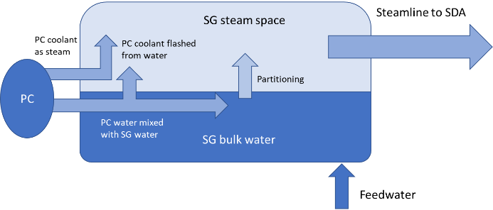

*Fig. 2. Mass and activity transfer in the affected steam generator*

***II.C. Methodology***

The methodology developed for DBA SGTR transients comprises an extensive list of assumptions, which define approach to phenomena such as spiking, scrubbing as well as description of the partition coefficients governing the transport of activities. In general, the methodology is aimed towards conservative release of activities. The complete list of assumptions is presented below:

1. Conservative initial inventory of primary and secondary activities (e.g. corrosion products, leaked fission products from fuel).
2. Spiking phenomena is assumed.
3. Radioactive decay may be modelled.
4. Activities are homogenously distributed between the volumes and phases.
5. Release of the activities from the primary circuit to the secondary circuit is equivalent to the coolant mass release through the steam generator tube rupture, where:
   1. Fraction of the primary coolant entraining the secondary side as steam (bypass), carrying 100 % of the activities of the evaporated water, i.e. PC = 1.
   2. Fraction of the primary coolant entraining the secondary side flashes immediately once it reaches the secondary side (flashing). It is assumed that 100 % of the activities of the evaporated water are further carried by the evaporated steam, i.e. PC = 1.
   3. The activities in the steam generator bulk water are increased by the activities leaked with water from the primary circuit.
6. Pool scrubbing is not modelled.
7. Retention of activities in the SG structures are not modelled.
8. Release through SDA (steam dump to atmosphere)
   1. Main steam line is not modelled, i.e. the release from steam generator goes directly to the SDA.
   2. Noble gasses – If the SDA is opened, the available activities in the SG are released into the environment. If the SDA is closed, it is assumed that the activities are transported further to the secondary side.
   3. Other fission products – If the SDA is opened, the activities from the steam space are released into the environment. If the SDA is closed, it is assumed that the activities are transported further to the secondary side. The steam evaporated from the steam generator water (partitioning) takes fraction of the activities of the equivalent water mass, where the maximum value of the PC should be 100.
   4. The released iodine is composed of 97 % elemental and 3 % organic form.

***II.C. Computational tool***

The methodology and models were implemented into a VBA macro. This macro enables the user to load desired thermal hydraulic data from system code, provide input on activities present in the primary and secondary circuit together with partition coefficients. Afterwards, the macro uses the balance equations to calculate the source term. Furthermore, the macro can create an XML file, which can be directly loaded into the JRODOS code, which calculates the radiological consequences. A screenshot of the main control sheet is presented in Fig. 3.

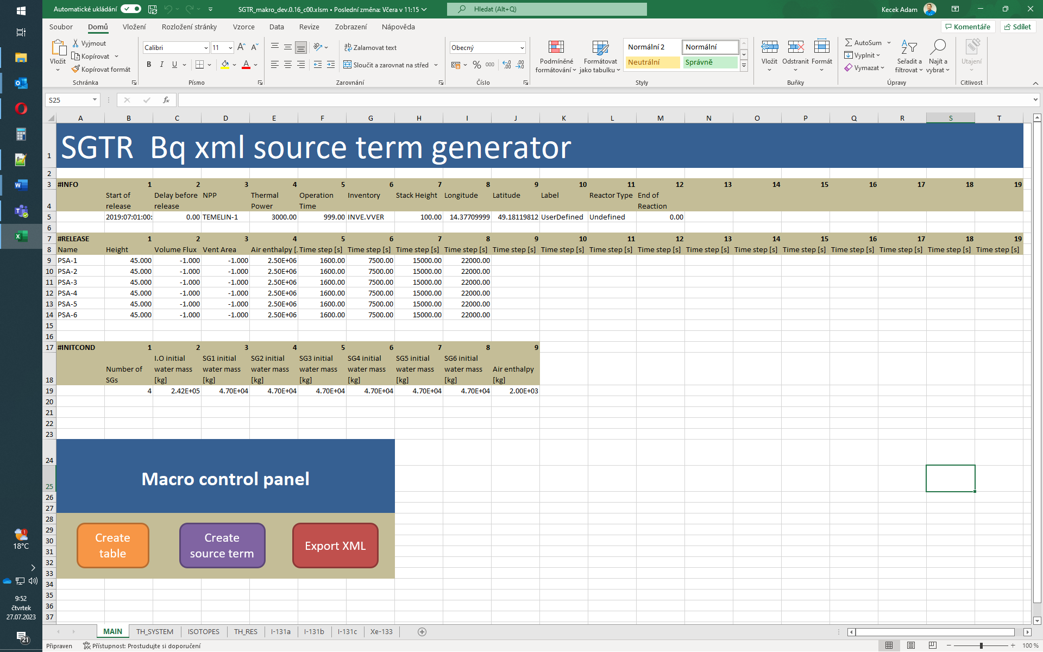

*Fig. 3. Screenshot of the VBA macro main control sheet*

The tool was developed to work with different types of NPPs, i.e. it can handle up to six steam generators, so it can be easily used both for VVER-1000/V320 as well as for VVER-440/V213 and other types of NPPs.

The number of calculated isotopes is not limited. In current setup the macro calculates transport of 140 isotopes, which are used by the JRODOS tool.

Further information about the tool can be found in **[12].**

III. Sample application on 1 tube SGTR at VVER-1000/V320

For application of the methodology, an SGTR accident calculated with RELAP5 was chosen. The initiating event is a single steam generator tube rupture with double ended leak with diameter of 2x13 mm. Before the accident, the reactor is operated at 104 % of the nominal power.

***III.A. Initial and boundary conditions***

The initial and boundary conditions are set up conservatively towards the fission product release, i.e. the partition coefficient was set to 10, to increase the activities entraining the steam part of the SG due to evaporation.

***III.B. Results***

From the thermal hydraulic point of view, the most important result is the mass flow through SDA, which is shown in Fig. 4. The SDA opens around 1600 s and remains opened throughout the whole process. At the same time, the reactor SCRAM occurs. The mass flow rate decreases in time, as the pressure in the primary and secondary side is decreasing.

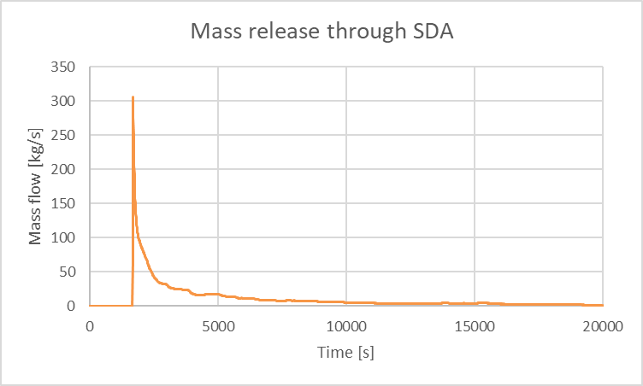

*Fig. 4. Mass release through SDA*

For evaluation of activity transport, xenon and iodine were chosen for reference. The primary circuit iodine inventory decreases in time due to the leak through the ruptured tube, cf. Fig. 5. At the end of the calculation, more than 60 % of the initial inventory entrain the secondary side.

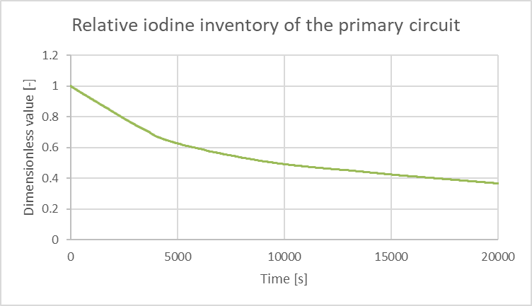

*Fig. 5. Relative iodine inventory of the primary circuit*

The integral iodine release starts at 1600 s approximately and exhibits nearly linear trend up to 8 000 s approximately. Afterwards, the trend starts to slow down due to reduction of the mass flow through SDA, cf. Fig. 6. At the end of the simulation, nearly 30 % of the initial iodine inventory reached the environment.

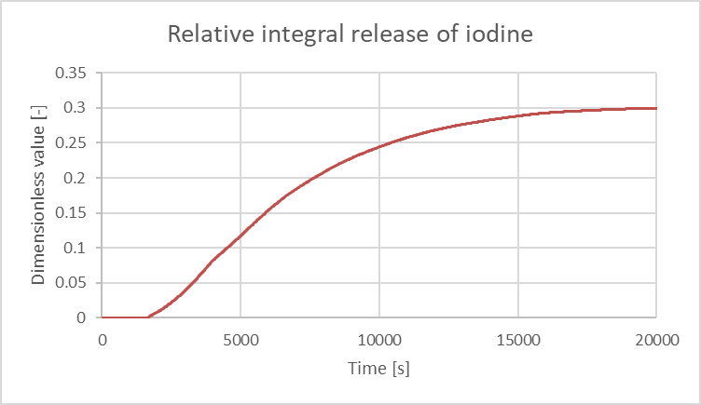

*Fig. 6. Relative release of iodine into the environment (fraction of total inventory).*

Xenon exhibits similar decrease of the primary inventory as iodine. At the end of the simulation, more than 60 % of the initial inventory leaked to the secondary side, cf. Fig 7.

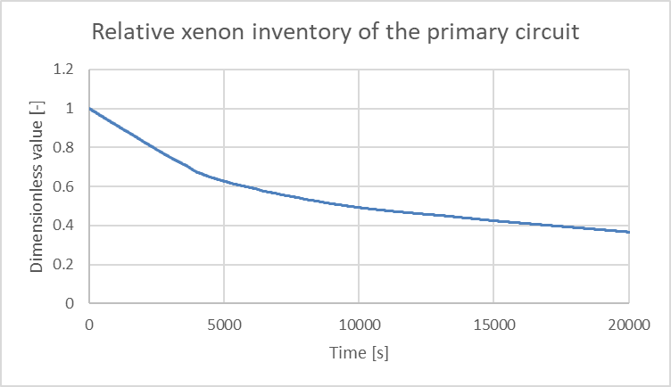

*Fig. 7. Relative xenon inventory of the primary circuit.*

The integral release of xenon is governed by the leak rate between the primary and secondary side. As it was discussed in chapter II, the activities entraining the secondary side are directed into the environment, which means that the mass flow through SDA has no effect on noble gas release into the environment. That is the reason why the xenon does not exhibit the visible slow-down of release as iodine, cf. Fig. 8. At the end of the simulation, nearly 50 % of the initial xenon inventory entrained the environment.

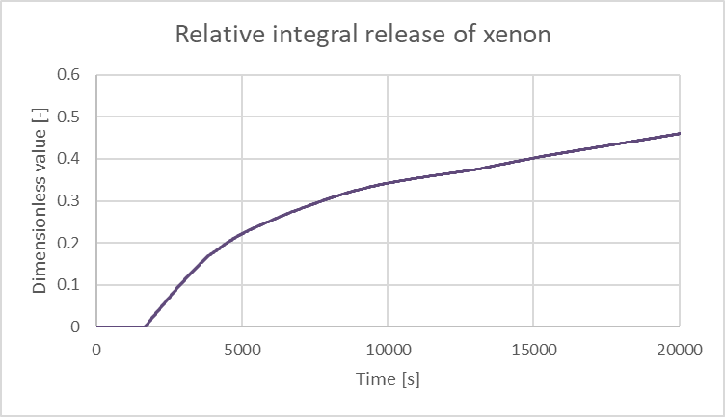

*Fig. 8. Relative release of xenon into the environment (fraction of total inventory).*

IV. Conclusions

Determination of source term during various loss of coolant accidents can be done in many ways. In some cases, application of complex system codes are not favorable option and simplified tools may be more suitable.

The paper summarizes the effort on application of simple balance approach to determination of source term during SGTR accident. The developed approach and methodology are in consonance with the conservative character of DBA analyses. With some modifications of initial and boundary conditions it can be used for DEC-A events as well.

Regarding the initial and boundary conditions, future effort should be aimed at precise estimation of partition coefficient. This coefficient affects the transport of fission products significantly. For bypass and flashing, a PC = 1 is currently used as a conservative choice. For partitioning, the proposed value of partition coefficient may reach up to 100. In this paper, a more conservative value of PC = 10 was used. Further development of the tool may incorporate precise estimation of the partition coefficient in each time step based on current boundary conditions. This improvement may in general lead to more realistic estimation of the activity release into the environment.

The sample application was illustrated on VVER-1000/V320 SGTR accident. The evaluation aimed at two different chemical species - iodine and xenon. Both exhibited behavior which could be easily explained based on the thermal hydraulic results provided by the RELAP5 code. The source term itself is not limited by any acceptance criteria, so for complete evaluation of the accident, a following radiological consequence calculation must be done.

The VBA tool can generate the source term in XML file format, which can be directly used for the JRODOS radiological consequence calculation.

Currently, the VBA tool is versatile and can be used to other NPPs as well. Future development may aim to incorporate other bypassing accidents, for example a DEC-A SGTR+SLB scenario.

Acknowledgments

A part of this work was conducted within the framework of the EU R2CA project.

This project has received funding from the Euratom research and training programme 2014-2018 under grant agreement No 847656.

References

1. James P. Adams. Iodine release during a steam generator tube rupture. Nuclear Technology, August 1994.
2. US NRC: Regulatory Guide 1.183, Alternative Radiological Source Terms for Evaluating Design Basis Accidents at Nuclear Power Reactors, U.S. Nuclear Regulatory Commission, July 2000
3. US NRC: Regulatory Guide 1.195, Methods and Assumptions for Evaluating Radiological Consequences of Design Basis Accidents at Light Water Nuclear Power Reactors, U.S. Nuclear Regulatory Commission, July 2003
4. Gorman, R., 2000. FOIA/PA-2000-0255 – Resolution of GI 67.5.1, ''Reassessment of SGTR Radiological Consequences'', 6-30-94 E. S. Beckjord memo, Letter, ML003720028. Humphreys, 1998. <https://www.nrc.gov/docs/ml0037/ML003725812.pdf>
5. Dutton, L. M. C.; Smedley, C.; Handy, B. J.; Herndlhofer, S.R.: Realistic methods for calculating the release of radioactivity following steam generator tube rupture faults, A consensus document, Report EUR 15615 EN, European Commission, 1994
6. USNRC, “Iodine Behavior in a PWR Cooling System Following a Postulated Steam Generator Tube Rupture Accident,” NUREG-0409, May 1985.   
   <https://www.nrc.gov/docs/ML1926/ML19269F014.pdf>
7. Clinton, S D, and Simmons, C M. 1987. "Iodine partition coefficient measurements at simulated PWR steam generator conditions: Interim data report". United States <https://www.nrc.gov/docs/ML2023/ML20236K038.pdf>
8. Hopenfeld, J. (1985). Radioactivity transport following steam generator tube rupture (NUREG--1108). United States <https://www.nrc.gov/docs/ML2010/ML20100E507.pdf>
9. SÚJB (2020). Safety guide BN-JB-2.10 (Rev. 0.0) deterministic safety analyses of abnormal operation and design basis accidents, Bezpečnostní návod BN-JB-2.10 (Rev. 0.0) Deterministické bezpečnostní analýzy událostí abnormálního provozu a základních projektových nehod. State Office for Nuclear Safety, Prague, Czechia.
10. Denk, L.; Kecek, A.; Král, P.: Evaluation of Source Term of Various Loss-of-Coolant Accidents at CzechVVER-1000/V-320. 8th International Conference VVER 2022, Řež, October 2022
11. Kecek, A.; Kral, P.: Summary report on VVER 1000/V320 SGTR calculations, R2CA Consortium, February 2023
12. Herranz, L.E.; Iglesias, R.; Zimmerl, R.; Bittan, J.; Kremer, F.; Kecek, A.; Dmytro, G.: D4,1 Final Report on experimental database reassessment and on model/code improvements for fission product releases during a SGTR transient, R2CA Consortium, July 2023