Neutronic Analysis of the AP1000 Pressurized Water Reactor

Mikolaj Brzezinski¹, Jakub Sierchula^{1,2}

¹Poznan University of Technology, ²National Centre for Nuclear Research in Poland
Poznan, Poland
mikolaj.brzezinski.144917@gmail.com

Abstract
The purpose of this paper is to present the neutronic analysis of the AP1000 reactor prepared by using OpenMC code. The principle of the code mentioned above is based on the Monte Carlo methods. Research included determining the neutron effective multiplication factor, analyzing of the evolution of fuel composition during the reactor’s operation, and verifying the effects of the boric acid in the coolant based on the parameters mentioned above. The final part of the paper is a summary which includes the conclusion of the analysis. The experiments confirmed the effectiveness of using OpenMC code for similar neutron-physics analyses. The yielded results overlap with experimental and literature data, indicating that a high level of consistency has been achieved.

Keywords: AP1000, PWR, OpenMC, Neutronic Analysis, Monte Carlo

I. Introduction

By the end of 2021, 437 nuclear power reactors were online in 32 different countries around the world. Among them, Light Water Reactors (LWRs) constituted the largest group, with a total number of 375 units. Those can be further divided into of 303 Pressurized Water Reactors (PWRs), 61 Boiling Water Reactors (BWRs), and 11 Light Water Graphite Reactors (LWGRs) [1].
Current pressurized water reactor technologies, offered by various companies around the world, can differ from each other in terms of the implemented technical solutions. However, despite design differences, PWRs share a lot of common features, one of which is the lack of coolant boiling in the primary circuit. This is achieved by using a pressurizer that keeps the pressure within a fixed range. To ensure that there is no water boiling in the pressure vessel, a high pressure of approximately 16 MPa is needed. Another shared feature of PWR units is that the primary and secondary loops are physically separated from each other to prevent mixing of the coolant flowing through the reactor with the feed water. In the event of an accident, this type of design minimizes the likelihood of a radioactive leak outside the containment building. However, dividing the nuclear unit into two separate circuits requires additional equipment, such as feedwater pumps, steam generators, and a pressurizer. Finally, the common feature of PWRs is their principle of operation. In PWRs, the average kinetic energy of fission neutrons must be decreased from 2 MeV so that it can interact with a higher probability with the nuclei of the fissile U-235, which is a key element in nuclear fuel. This type of reactor uses neutrons with thermal energies of approximately 0.0253 eV to initiate fission. To achieve this in PWRs, light water (H₂O) with the required chemical composition is used as a coolant and neutron moderator [2, 3].
One of the unique designs in the PWR subgroup is Westinghouse Electric Company’s AP1000, which will be considered in this paper. In 2005, the U.S. Nuclear Regulatory Commission deemed Westinghouse's AP1000 nuclear reactor as a standards-compliant, safety-certified design approved for further production. The development of the AP1000 design focused primarily on the use of multiple passive safety systems, the reduction of the required construction materials in relation to the maximum electrical power, the modularity of the design, and the limitation of the area occupied by a single nuclear unit. Currently, one American (Vogtle-3) and four Chinese (Sanmen-1, Sanmen-2, Haiyang-1 and Haiyang-2) AP1000 units are in commercial operation. Moreover, another American unit (Vogtle-4) is undergoing start-up tests and its in-service date is planned for the end of the fourth quarter of 2023 or the first quarter of 2024 [4,5].

Table 1 AP1000 units based on [4,5].
Unit | Country | Commercial date
Sanmen-1 | China | 2018-09-21
Sanmen-2 | China | 2018-11-05
Haiyang-1 | China | 2018-10-22
Haiyang-2 | China | 2019-01-09
Vogtle-3 | USA | 2023-07-31
Vogtle-4 | USA | Planned 2023/2024

II. AP1000 Reactor Core Model

II.A. The OpenMC Monte Carlo Code

Modelling the phenomenon taking place inside a reactor’s pressure vessel is an important matter during both the design and the operation phases. It provides an opportunity to obtain the data necessary for assessing whether the reactor is operating correctly. Specifically, neutronic and thermal-hydraulic analyses are a crucial part of the process. This paper focuses on the former.
One of the examples of codes used in core neutronics-related simulations is OpenMC, which was developed by members of the Computational Reactor Physics Group at the Massachusetts Institute of Technology in 2011 [6]. The OpenMC code and nuclear data libraries are both publicly available and continuously developed by laboratories and universities around the world. The principle of its operation is based on the Monte Carlo statistical methods, which allow for simulating complex processes in multidimensional systems. For neutronic analyses, the Monte Carlo method relies on a system for monitoring the behavior of particles from the time they appear in the system until the end of their life-cycle. Simulations are performed using pseudo-random numbers that allow the results to be interpreted according to a familiar distribution [7].

II.B Model Development

The AP1000 reactor model described in this paper was prepared using above mentioned OpenMC code. Geometric and material parameters of the core were prepared based on the publications "Simulations of the AP1000-based reactor core with Serpent code" [8] and “AP1000 Design Control Document” [9].
The basic elements of nuclear fuel in AP1000 reactors are fuel pellets made of low-enriched uranium dioxide UO₂. For simplification, the nuclear fuel in the model was created in the form of homogeneous cylinders with no division into fuel pellets. Cylindrical fuel rods, control rod guide thimbles, and in-core instrumentation guide thimbles were modelled first. The parameters of the cladding were set in order to simulate ZIRLO material - proprietary, optimized zirconium-based alloy that was developed by the Westinghouse Electric Company. The same material was used to simulate the cladding for the guide thimbles. The gap between the fuel and cladding layer was filled with helium.
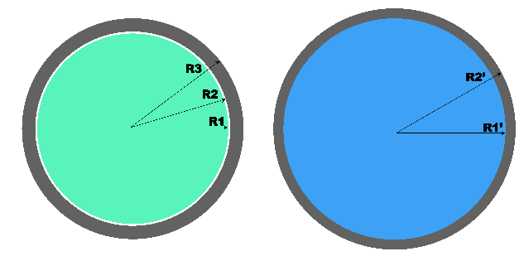
Fig. 1. Cross-section in the xy plane of the fuel rod and the control rod/instrumentation guide (green – fuel, white – helium, blue – water, gray – ZIRLO).

Afterwards, fuel assemblies based on the RFA-2 design were added. The presented core model uses one type of fuel assemblies for the lattice, which is referred to as "0 IFBA, 0 Pyrex," with a square shape 17x17 rod array. It comprises 264 fuel rods with appropriate enrichment, 24 rod cluster control thimbles, and 1
in-core instrumentation thimble, which is located in the central part of the assembly. In addition to the most elementary lattice, the technology provider recognizes the other 8 fuel assembly lattices that are used during the first fuel cycle. At the beginning of the first fuel cycle, IFBA rods with burnable absorbers, such as borosilicate glass tubes, are inserted into selected guide thimbles. These provide better control of excess reactivity at the beginning of the cycle. For simplification, the model did not involve specific rod geometries such as IFBA and Pyrex.

Fig. 2. Cross-section in the xy and xz planes of the fuel assembly (green – fuel, blue – water, gray – ZIRLO).

The core model consists of 157 fuel assemblies divided into three enrichment regions. At the first reactor cycle, assemblies with the highest enrichment at 4.45% are placed in the peripheral region of the core. The inner part of the core uses a checkerboard pattern and consists of assemblies with enrichments at 2.35% and 3.40%. The peripheral part of the core was surrounded with a core basket with simplified geometry and did not include baffle plates and bolts. This simplification was performed due to time constraints and the lack of their use does not affect the simulation results. The height of the active part of the core is 426.720 cm, while its width measures 304.038 cm. Above the lower and upper parts of the active core, three layers consisting of an inlet and outlet region, lower and upper reflectors, and water were modelled sequentially. The reflectors were developed as a mixture of 50% water and 50% 304 stainless steel. Similarly, the inlet and outlet regions consist of 70% water and 30% SS304. The total height of the model is 630.00 cm, and the outer radius of the pressure vessel is 222.25 cm. The reactor pressure vessel was created with the use of SA-508 Cl. 3. Because the model is in a finite-sized environment, the outside surfaces were defined by vacuum boundary conditions.

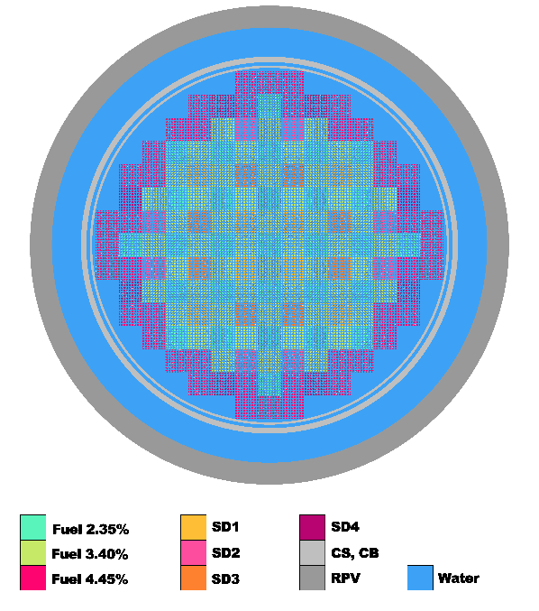
Fig. 3. Model of the AP1000 reactor core.

III Simulations

The investigation involved 4 simulation runs using two nuclear data libraries - ENDF/B-VII.1 and JEFF-3.3, which contain information on cross sections and thermal dissipation at specific temperatures. The libraries contain some slightly different information on cross-sections, and therefore, a comparison was made to show the relationship between them. The ENDF/B-VII.1 library was considered a reference library used to validate the model. The control rods were fully extended from the active part of the core during the simulation. The research was divided into two types:
"WBA" - without the boric acid in the coolant and "BA" - with the addition of boric acid set in the proportions found in naturally-occurring boron - B-10 (19.4%) and B-11 (80.6%). Simulations were performed with a configuration of 250 active cycles and 25 inactive cycles at 10000 neutrons per cycle, which allowed the convergence of the source. The total calculation time was 26 hours. The simulation was run on a virtual machine with parameters set to 8 logical processors and 12 GB of RAM.
Reactor conditions were set to Hot Full Power operation with an average coolant temperature of 303.4℃ and a pressure of 15.513 MPa. The thermal power of the reactor was set at 3400 MW_{th} - identical to the units used in Sanmen-1 and Sanmen-2.

IV. Simulation Results

IV.A. Effective Multiplication Factor

Tables 2 and 3 show values of the neutron effective multiplication factor for time t₀, which represents the initial operation start of the AP1000 reactor. The averaged k_{eff} value obtained using the
ENDF/B-VII.1 and JEFF-3.3 libraries for the WBA cases was 1.323. The high value of the k_{eff} factor was caused by excess reactivity, characteristic for the first fuel cycle, as it was the result of loading the core with fresh fuel. Furthermore, the high k_{eff} value is due to the lack of boric acid in the coolant, since boric acid strongly absorbs neutrons.
The validity of the reactor model was then confirmed by comparing the values obtained from simulations and those provided by the United States Nuclear Regulatory Commission [9]. The k_{eff} difference of 0.005 was deemed to be the consequence of the simplification of the model geometry. The averaged k_{eff} value obtained for simulations with boric acid was 1.097. This value is significantly lower than for WBA cases. This confirms the hypothesis that by applying the appropriate concentration of boric acid, reactivity changes can be controlled. For higher boric acid concentration in the coolant, successively lower initial k_{eff} values would be obtained. During the investigation, the concentration of boric acid was constantly kept at an equal level for the entire simulation and the control rods were not inserted into the core. In actual reactor operating conditions, the concentration of boric acid is altered to compensate for long-term reactivity changes that occur during fuel burnup.

Table 2 Calculation results without boric acid
Name | k_{eff} | Error | Library
WBA 1 | 1.32237 | +/- 0.00066 | ENDF/B-VII.1
WBA 2 | 1.32280 | +/- 0.00063 | JEFF-3.3
U.S. NRC | 1.32800 | - | ENDF/B-V

Table 3 Calculation results with boric acid
Name | k_{eff} | Error | Library
BA 1 | 1.09650 | +/- 0.00057 | ENDF/B-VII.1
BA 2 | 1.09725 | +/- 0.00058 | JEFF-3.3

Figure 4 presents changes in the neutron multiplication factor as a function of time and fuel burnup. To confirm the results, the characteristics obtained from two nuclear libraries were compared. The slight deviations in the curves are due to differences in information regarding cross-sections between ENDF/B-VII.1 and JEFF-3.3. Regardless of the type of WBA or BA cases, k_{eff} values decrease dynamically at the beginning of the simulation at t₀. This is associated with the intense accumulation of fission products, which increase the probability of neutron absorption. There is also an increase in the amount of Xe-135, affecting the reduction of the reactivity reserve due to its large cross-section for thermal neutron absorption. On the subsequent days of the simulation, k_{eff} decreases smoothly. With time, the amount of fissile material in the core is decreasing due to the depletion of U-235. This results in a burnup and a corresponding decrease in excess reactivity.
For the WBA simulations, k_{eff} reaches a value of k_{eff} < 1 at 700 days, corresponding to a burnup of 25 MWd/kgU. In the case of BA, the same transition point is 200 days and 7.5 MWd/kgU. It means that in the case of not using boric acid in the coolant, the chain reaction would have been sustained for about 23 months, and the reactor would have been able to operate. The manufacturer of the AP1000 expects the duration of the first fuel cycle to be 18 months with a burnup of 21 MWd/kgU. The difference in simulation results and parameters given by Westinghouse Electric Company is likely due to the absence of use of burnable absorbers in the model and the lack of change in boric acid concentration during the cycle.
The obtained k_{eff} uncertainty is at the level of
one part per ten thousand. This is the result of the initial condition taken to be 10000 neutrons per calculation cycle. Increasing the number of neutrons and calculation cycles would likely allow to obtain lower uncertainties, however, it would require a significant increase the computing power required to run the simulation.

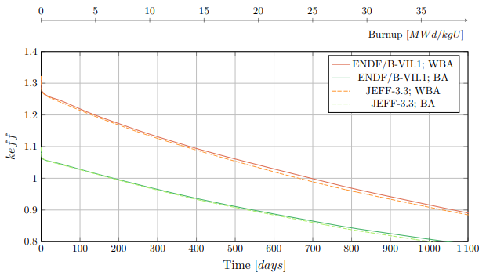
Fig. 4. Changes in neutron effective multiplication factor as a function of time and fuel burnup.

IV.B. Neutron Spectrum

Figure 5 shows the neutron flux density as a function of neutron energy. The curve characterization was based on data from WBA and BA using the ENDF/B-VII.1 library. The neutron spectrum obtained is consistent with typical trends for PWR reactors presented in other studies [10]. Using a greater concentration of H₃BO₃ would result in a higher neutron flux density in the energy range from 10⁻⁷ MeV to 10 MeV. Despite the addition of low-concentration boric acid to the coolant in the simulation, its effect on the spectrum of neutrons with thermal energies can be clearly seen. The addition of boric acid results in a reduction of neutron flux density for energies below 1 eV.
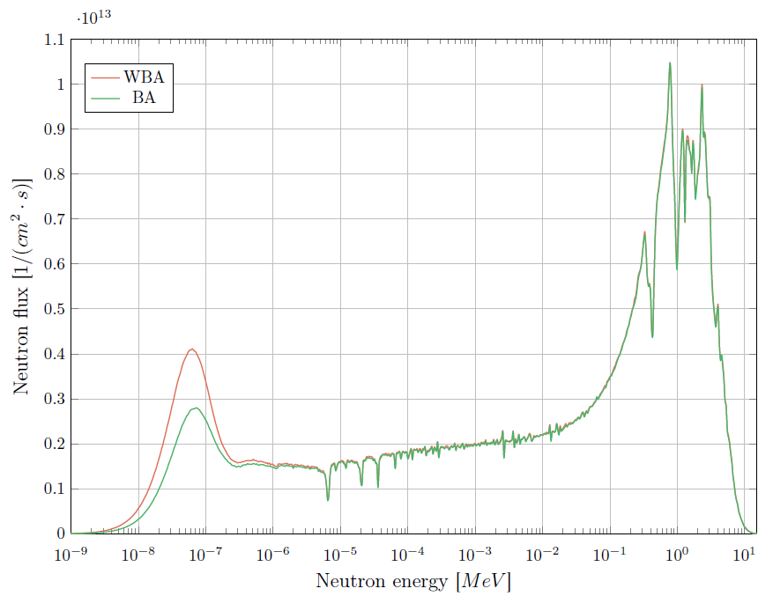
Fig. 5. Neutron flux as a function of neutrons energy.

IV.C. Uranium Isotopes

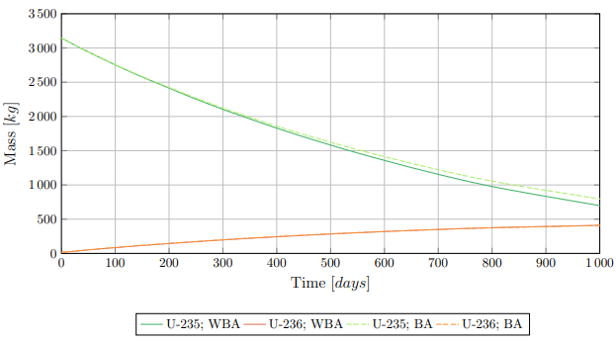
Fig. 6. Mass changes of uranium isotopes U-235 and U-236 as a function of time.

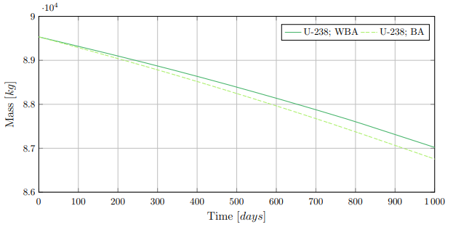
Fig. 7. Mass changes of uranium isotope U-238 as a function of time.

In PWR reactors, the key component in nuclear fuel is the fissile isotope U-235. Fission products are generated as a consequence of U-235 fission by neutrons. The subsequent evolution of the generated fission products is determined by the total mass of uranium, which is changing in time with its burnup. Figure 6 shows the mass change of the uranium isotopes U-235 and U-236 as a function of time. At the beginning of the fuel cycle, regardless of the WBA or BA simulations, the mass of U-235 was set to 3146 kg. In the WBA case, the final mass of the U-235 was 576 kg, while for the BA simulation it reached 681 kg. Thus, the total consumption of U-235 for WBA was 2570 kg, and for the BA simulation was 2465 kg.
The addition of neutron absorbers effectively reduced the number of fission reactions. This is caused by the absorption of thermal neutrons by H₃BO₃. The neutron flux density in the thermal energy spectrum is reduced, resulting in a lower probability of a U-235 fission event.

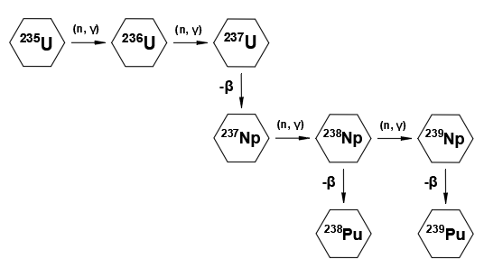
Fig. 8. U-235 decay chain based on [3].

Simultaneously with the U-235 burnup,
a corresponding increase in the mass of the U-236 can be observed. Generation of U-236 is linked to the neutron absorption (n, γ) by U-235. The mass growth of U-236 in the BA and WBA cases behaves identically, and the trend curves overlap. The amount of U-236 in burned fuel is in direct proportion to its level of burnup and also depends on the initial enrichment of thU-235. In both cases, the mass of the U-236 at the end of the simulation was 425 kg. This isotope was being considered primarily in terms of spent fuel management and the possibility of its further reprocessing because the half-life of U-236 stands at 23.42 million years. The U-236 is neither a fissile nor a fertile isotope. Because U-236 is a neutron absorber, it must be taken into consideration during the use of reprocessed fuel [11].

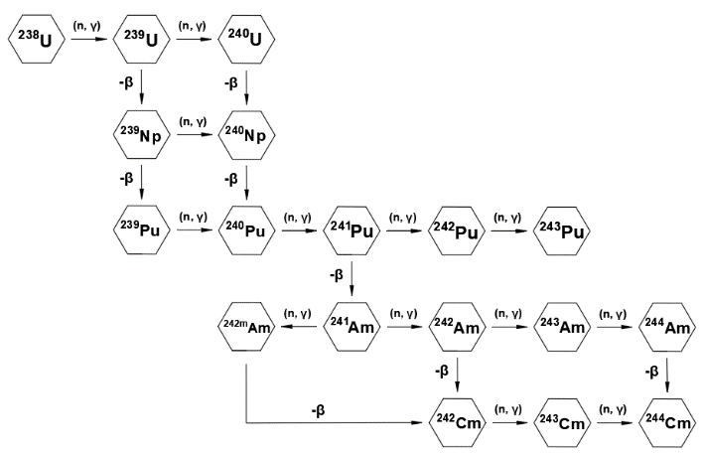
Fig. 9. U-238 decay chain based on [3].

Figure 7 shows the mass changes of the uranium U-238 as a function of time. A decreasing tendency can be observed for U-238 from 89.50 to 86.75 tons for WBA and to 86.47 tons for BA respectively. The mass loss of U-238 is caused either by its transmutation to fissile isotopes of plutonium, such as Pu-239 and
Pu-241, or by its splitting by fast neutrons. A quicker mass drop of U-238 is observed for the BA cases. The probability of U-238 fission is significantly higher when it absorbs fast neutrons. The use of H₃BO₃ reduces the neutron flux density at lower energies, which corresponds to a higher contribution of fast neutrons in the total balance.

IV.D. Plutonium Isotopes

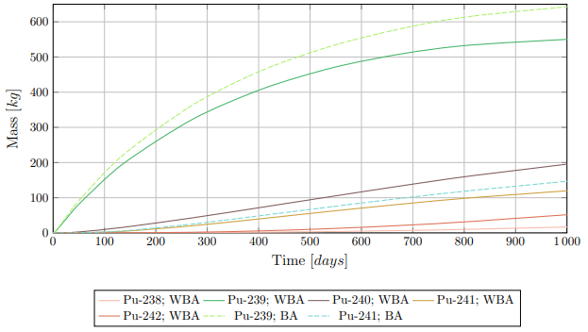
Fig. 10. Generation of plutonium isotopes as a function of time.

Figure 10 shows the generation of plutonium isotopes as a function of time. To keep the figure clear, only Pu-239 and Pu-241 are shown for the BA case. The characteristics of the other isotopes overlapped for BA with WBA simulations. The highest mass generation is observed for the Pu-239 isotope, which can participate in fission with both thermal and fast neutrons. For the WBA simulation, the final mass of Pu-239 was 557 kg, while for BA it was 655 kg. The higher generation in BA cases is due to the changes in neutron flux, which lead to an increased probability of U-238 absorption, and its further transmutation to Pu-239. This actinide is the most important part of the fuel reproduction process because it can be extracted and reused. Due to the fact that it has a high cross-section for fission by fast neutrons, it is used in fast reactors or MOX fuel [2]. Moreover, it has a significant role at the end of the fuel cycle because it generates heat in the reactor as a result of fission. Mass increases are also observed for the remaining plutonium isotopes. The production of Pu-240 by the transmutation of Pu-239 was 200 kg at the end of the fuel cycle. Neutron capture by Pu-240 results in the production of Pu-241 fissile. The production of fissile isotopes is also associated with changes in neutron fluence.

IV.E. Xenon and Samarium Isotopes

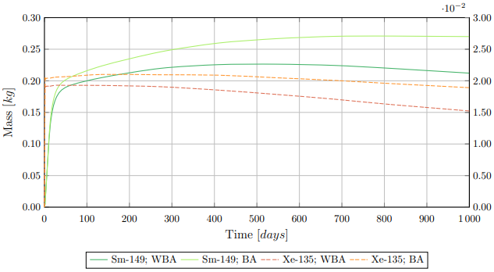
Fig. 11. Generation of Xenon and Samarium isotopes as a function of time.

Xe-135 and Sm-149 are considered reactor poisons. They are generated as a result of the fuel burnup. In addition, their concentration can be affected by changes in neutron flux related to changes in reactor’s power. Both reactor poisons have a significant effect on the thermal neutron utilization factor, and therefore on the changes in the neutron effective multiplication factor and reactivity. One example of a reactor's transient state could be its start-up at t₀ to nominal power. Figure 11 shows the generation of reactor poisons. In a very short time after start-up, the generation of Xe-135 and Sm-149 increases significantly, which affects the quick initial drop in reactivity excess. As can be observed, the reactor poison generation is greater in the BA simulation than for the WBA case. This is related to the use of the neutron-absorbing H₃BO₃ which affects the initial reactivity reserve and reactor power. Operating at reduced power results in slower removal of poisons from the core and a greater generation of Xe-135 and Sm-149.

V. Conclusions

The paper describes development of the AP1000 reactor model in OpenMC and its application to fuel burnup calculations. To confirm the validity of the results, calculations were performed using 2 nuclear data libraries: ENDF/B-VII.1 and JEFF-3.3. The following configurations were used: BA – with boric cases acid in the coolant and WBA - without boric acid. The ENDF/B-VII.1 library was chosen as the reference library because of its general comparability. This library has been used in a wide range of scientific and technical papers and documents, allowing effective comparison of the results obtained and those presented in other papers.
The results of the neutron effective multiplication factor confirmed the high compatibility of the model with the data presented by the United States Nuclear Regulatory Commission. The encountered differences are the result of the simplifications in the investigated model. Simulations that included boric acid confirmed the decrease in k_{eff} due to the insertion of highly neutron-absorbing medium into the coolant. It can be concluded that for higher boric acid concentration in the coolant, proportionally lower initial k_{eff} values would be obtained. Moreover, based on figures 4 and 11, it can be observed that the generation of Xe-135 and Sm-149 is strongly dependent on reactor transient states, such as its start-up. The initial high generation of these isotopes significantly affected the decrease in the neutron effective multiplication factor. Furthermore, the addition of H₃BO₃ resulted in lower reactor power, and thus a slower removal of poisons from the core.
The obtained figure of neutron flux density
as a function of neutron energy (Fig. 5) agrees with the characteristics provided in the literature. It can be concluded that the introduction of boric acid into the coolant reduces the flux density of neutrons with thermal energies.
Based on the results from fuel burnup calculations, it can be observed that at the end of the fuel campaign, most of the material in the core consists of uranium isotopes while fission products and transuranic elements constitute only a small percentage. Moreover, the effect of added boric acid to the coolant on the total mass changes of some isotopes can be observed.
The obtained results verified the correctness of the AP1000 reactor model. Furthermore, the performed analysis shows that the OpenMC neutron code is an effective tool for performing burnup calculations. It also provides an easy way to obtain a visualization of the geometry so that effective changes can be made.
In the future, the presented model of the AP1000 reactor can be used for further neutronic analyses related to, among other issues, the impact of the insertion of control rods into the active part of the core and their effect on the change in reactivity.
The geometry of the shutdown rods (SD1, SD2, SD3 and SD4) is already included in the model, but the research specifications in this paper made it necessary to move them completely extracted out of the guide thimbles located in the core.
References

- International Atomic Energy Agency, Nuclear Power Reactors in the World, Reference Data Series No. 2, page 9-10, IAEA, Vienna (2022).

- J. Kubowski, Elektrownie Jadrowe, Chapter 10 and 11, Wydawnictwo Naukowo-Techniczne, Warszawa (2020).

- L. Dobrzynski, Podstawy fizyki reaktorow jadrowych, chapter 5, Narodowe Centrum Badan Jadrowych w Swierku oraz Wydzial Matematyczno-Fizyczny Uniwersytetu Kardynala Stefana Wyszynskiego w Warszawie, Swierk (2013).

- International Atomic Energy Agency, Operating Experience with Nuclear Power Stations in Member States, page 201-206; 267-272, IAEA, Vienna (2022).

- www.georgiapower.com/company/plant-vogtle.html
(access: 13.08.2023).

- P. K. Romano, N. E. Horelik, B. R. Herman, A. G. Nelson, B. Forget, K. Smith, “OpenMC: A State-of-the-Art Monte Carlo Code for Research and Development, Annals Nuclear Energy”, 82, 90–97 (2015).

- A. Boettcher, Analiza procesow neutronowo-fizycznych reaktora energetycznego EPR metoda Monte Carlo, appendix 1 , Otwock-Swierk/Katowice (2018).

- P. Darnowski, P. Ignaczak, P. Obrebski, M. Stepien, G. Niewinski, “Simulations of the AP1000-Based Reactor Core with SERPENT computer code”, Archive of Mechanical Engineering, Vol. 65 No 3, p. 297-311, Polish Academy of Sciences, Committee on Machine Building, (2018).

- Westinghouse Electric Company, Westinghouse AP1000 Design Control Document Rev. 19, Tier 2 Chapter 4, United States Nuclear Regulatory Commission, United States of America (2011).

- J. Sierchula, “Analysis of reactivity changes during the operation of a nuclear power plant”, 2018 International Interdisciplinary PhD Workshop (IIPhDW), p. 61-66, IEEE, Swinoujscie, Poland (2018).

- International Atomic Energy Agency, Management of Reprocessed Uranium, IAEA TEDOC No. 1529, chapter 2, IAEA, Vienna (2007).

