**Preliminary Design of NDP-400: Economical Heat Generation for Efficient Desalination**

H.J. Jeong1)*, J.S. Song1), G.M. Lee1), H. Cho1), S.W. Lim1), E. Yasser2), M. Albooq2), J.J. Choi3), Y.H. Jeong3), and H. Kwon1)

# 1) Korea Atomic Energy Research Institute (KAERI), 2) King Abdullah City of Atomic and Renewable Energy (K.A.CARE), 3) Korea Advanced Institute of Science and Technology (KAIST)

*1) 111 Daedeok-daero 989beon-gil, Yuseong-gu, Daejeon 34057, Republic of Korea, 2) King Abdullah City of Atomic and Renewable Energy, AlAkaria Plaza, Olaya Street, Riyadh 11451, Saudi Arabia, 3) 291 Daehak-ro, Yuseong-gu, Daejeon 34141, Republic of Korea*

*\*hjeong@kaeri.re.kr*

Abstract – Heat is the world’s largest energy end use, accounting for almost half of global energy consumption in 2021. For most major industrial heat applications, nuclear energy is the only credible non-carbon option. One attractive use for nuclear generated heat is desalination because the process requires lower-temperature heat than other industrial processes. As such, heat from light water reactors is suitable for desalination. The NDP-400 (Nuclear Desalination Plant) is a small advanced integral reactor that produces 400 MW of thermal power at a system pressure of 15 bar. The reactor’s coolant temperature is below 200 °C, which is relatively low compared with those of conventional pressurized water reactors (PWRs) for heat production. The NDP-400 offers economic benefits through system simplification—it has compact printed circuit heat exchangers, a reduced component size, and a lightweight design made possible by the low system pressure. Many of the main components and reactor core of the NDP-400 have been proven in the development of Korea’s SMART. The fuel cycle is 36 months, and the core power peaks and power distributions are comparable to conventional PWRs. Safety features include a multi-loop system, gravity-driven safety injection system, and low system pressure. These features maximize the inherent safety of the NDP-400.

**Keywords:** Desalination, process heat, NDP-400

I. Introduction

Accounting for almost half of global energy consumption in 2022, heat is the world’s largest energy end use **[1]**. Half of the produced heat is used in industrial processes, and half is used in buildings for space and water heating. For most major industrial heat applications, nuclear energy is the only credible non-carbon option.

Saudi Arabia is the world’s largest desalination market, with the SWCC (Saline Water Desalination Corporation) producing a total 2.2 billion cubic meters in 2021 **[2]**. In this market, most desalination plants have been operated as fossil plants such as gas/oil and combined gas. Recently, Saudi Arabia has fulfilled the commitments of COP26 to combat climate change and for environmental protection following the national initiative of 2030 strategy to diversify the economy away from dependency on oil. Nuclear power has emerged as an important alternative to realize this policy.

Desalination is one attractive use for nuclear generated heat because the process requires lower-temperature heat than other industrial processes. Accordingly, heat from light water reactors (LWRs) is suitable for desalination. A feasibility study of nuclear desalination in Saudi Arabia showed that a reverse osmosis (RO) system and a multi-effect distillation (MED)/RO hybrid system are economical methods **[3]**. The nuclear power plant in the feasibility study was a conventional pressurized water reactor (PWR) type with 480 MWth. In another work, KAIST (Korea Advanced Institute of Science and Technology) conducted a study to develop a heat-only LWR and apply it to desalination in the UAE **[4]**. This study indicated that operating a small-sized nuclear heat-only plant at low pressures coupled with MED was a considerably competitive option.

Based on this previous research **[3,4]**, the NDP-400 (nuclear desalination plant) is currently under development with design features of a small advanced integral reactor that produces 400 MWth at a low system pressure. The present study mainly describes an overview of the preliminary conceptual design of the NDP-400 reactor including the core design, fluid systems, and component design. In addition, the inherent safety of the NDP-400 reactor is demonstrated in a total loss of coolant flow accident, the major accident scenario.

II. Core Design

Among the options for the core, the NDP-400 adopts a LWR, of which the operating pressure and temperature are lower than those of conventional PWRs in electricity generation as shown in Table I.

*Table I NDP-400 System Parameters*

|  |  |
| --- | --- |
| Parameter | Value |
| Core thermal power (MWth) | 400 |
| Primary system pressure (bar) | 15 |
| Core inlet coolant temperature (⁰C) | 150.2 |
| Core outlet coolant temperature (⁰C) | 180.2 |
| Inlet mass flux (kg/m2-sec) | 1850 |
| Average heat flux (kW/m2-sec) | 430.2 |

***II.A. Nuclear Design***

The nuclear design bases of the NDP-400 are adopted considering the status of current technology development and the required system parameters.

1. Fuel assembly: 17x17 array with UO2 fuel rods used in typical PWRs
2. Active core height: 200 cm
3. Number of fuel assemblies in the core: 69
4. Core reactivity control: Soluble boron in the coolant, control rods using Ag–In–Cd neutron absorbers, and burnable poisons in the fuel
5. Cycle length: 3 years
6. Moderator temperature coefficient: Negative at hot zero power (HZP)

The fuel assembly model is based on the SMART100 core **[5]**. To account for the higher excess reactivity control capability due to the lower operating temperature, additional burnable poison rods are used in the core, where the resulting higher power peaking factor is compensated by the lower core average power density. Also, a concentration of 12 w/o is applied to improve the performance of the excess reactivity control as core burnup goes on, by the judgment that the lower operating temperature allows lower thermal conduction in the fuel pellets.

The core loading patterns are designed following a partial two-batch fuel management scheme using 40 feed fuel assemblies for each reload core. Fig. 1 shows the fuel loading patterns of the initial and reload cores. Blank boxes represent once-burned fuel assemblies, and batch F indicates the feed fuel assemblies.

For reactivity control, 16 regulating banks and 4 shutdown banks are arranged in the core, as depicted in Fig. 2. During power operation, each regulating bank moves in sequence, maintaining an overlapping distance up to the bank limit insertion.

 

*Fig. 1. NDP-400 fuel loading patterns.*



*Fig. 2. Control rod arrangement.*

The major core nuclear design parameters from initial to equilibrium cycles are obtained using the DeCART2D/MASTER code **[6,7]** developed by KAERI and used for the analyses.

The moderator temperature coefficients (MTCs) at the HZP condition are evaluated to be sufficiently negative, with a maximum MTC of –3.6 pcm/°C. Also, the critical boron concentration is found to be low enough to maintain a negative MTC at HZP.

The maximum radial, axial, and three-dimensional power peaking factors at the hot full power (HFP) all rod out (ARO) condition through all cycles are 1.50, 1.33, and 1.89, respectively. Considering that the core average power density is lower than that in typical PWRs operating at higher temperatures, the peaking factors are low enough to satisfy safety and design margin concerns. These resulting power peaks are comparable to commercial PWRs **[8]**.

***II.B. Thermal-Hydraulic Design***

In the thermal margin analysis, a lumped channel core model is used, which is a typical core thermal-hydraulic analysis model applied to the thermal margin analysis of large PWRs. The conservatism and applicability of the lumped channel core model is estimated by comparison with a detailed whole core model. The two models (lumped channel core and whole core) are performed using the MATRA-S code **[9]**, which was developed by KAERI for the design and analysis of the detailed reactor core thermal-hydraulic field. Here, LUT 1995 is used for the minimum departure from nucleate boiling ratio (MDNBR) of the thermal margin model. The critical heat flux (CHF) model is known to be reliable for low pressure conditions like the NDP operating range. Parameters taken into consideration are axial power shape, fuel pin power distribution, grid type, and other operating conditions as shown in Table II.

*Table II Thermal and Hydraulic Models Applied in the Thermal Margin Model*

|  |  |
| --- | --- |
| Model and Correlation | Unit |
| Grid type | Mixing/IFM grid |
| Subcooled boiling | Saha–Zuber |
| Saturated boiling | Chexal–Lellouche |
| Turbulent mixing | Equal mass |
| CHF correlation | LUT 1995 |

A reference calculation using the whole core model was conducted to compare with the lumped channel core model. In Fig. 3, the enthalpy distributions located at the exit and MDNBR planes are shown for the whole core with 20,248 subchannels and 18,216 rods.

Based on the whole core model, the lumped channel core model for conducting a thermal margin analysis is developed with 40 lumped channels: 1 hot channel and 39 surrounding channels. The conservatism of the lumped channel core model is maintained in comparison with the MDNBR by the whole core channel model. As shown in Fig. 4, the MDNBR of the lumped channel core model is always lower in both initial and equilibrium cycles. The estimated MDNBR value from the lumped channel core model is about 7.0 over all cycles. This means that the thermal margin of the NDP-400 is sufficient in regard to the MDNBR.

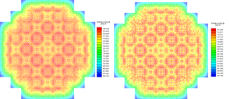

*a) Exit plane b) Plane at MDNBR occurrence*

*Fig. 3. Enthalpy distribution by whole core analysis.*



*Fig. 4. Comparison of MDNBR between whole core and thermal margin models over initial and equilibrium cores.*

III. Nuclear Steam Supply System Design

***III.A. Reactor Coolant System Design***

The NDP-400 is a small-sized integral type PWR with a rated thermal power of 400 MW. A three-loop system was adopted that combines an MED facility using thermal vapor compression technology and small-size nuclear power plants dedicated to thermal desalination. The primary system components such as the reactor core, intermediate heat exchangers (IHXs), reactor coolant pumps (RCPs), and pressurizer (PZR) are integrated into the reactor pressure vessel (RPV). It is a novel concept to employ printed circuit heat exchanger (PCHX) technology in the integral reactor design process owing to its advantages of compactness and great structural integrity. The NDP-400 adopts PCHXs for the IHXs, being printed circuit intermediate heat exchangers (PCIHXs). A total of 36 PCIHX blocks are installed in the RPV annulus. The core support barrel (CSB) is surrounded by the PCIHX blocks along the circumferential direction of the reactor vessel, as shown in Fig. 5. The RCP concept also adopts a vertical canned motor pump. Table III lists the reactor coolant systems (RCS) design parameters.

*Table III RCS design parameters*

|  |  |
| --- | --- |
| Parameter | Value |
| Average core flow rate (kg/s) | 3,063.5 |
| Reactor coolant pump head (m) | 20.5 |
| Pressurizer pressure (MPa) | 1.5 |
| Pressurizer saturated temperature (°C) | 198.3 |
| PCIHX primary side inlet temperature (°C) | 180.2 |
| PCIHX primary side outlet temperature (°C) | 150.2 |
| Flow rate per PCIHX block (kg/s) | 85.1 |

The NDP-400 PCIHX blocks are fabricated by chemically etching primary side and intermediate loop channels on each plate, as shown in Fig. 6, and then merging multiple plates together using diffusion bonding. The NDP-400 PCIHXs operate under counter-flow conditions within the flow paths of the printed circuited channels, as shown in Figs. 5 and 6. The primary coolant flows inside the PCIHX channels horizontally in the outer lateral direction of the RPV, and the intermediate loop feedwater flows horizontally in the internal lateral direction of the RPV. Thermal energy is transferred from the primary side to the intermediate loop side across the walls of the diffusion-bonded plates. The intermediate loop then transfers the thermal energy to a steam generator (SG) that produces the required motive steam to drive the desalination plant.

The RCPs in the NDP-400 consist of 4 canned motor pumps. The direction of installation is vertical, and the pump suction and discharge parts are located on the cold side of the primary coolant, as shown in Fig. 7.

Pressurizers are generally located above the reactor coolant flow path because the higher position has advantages in pressurizing the reactor coolant in subcooled conditions. A steam PZR is adopted here for its advantage in reducing the pressure fluctuations by phase change.

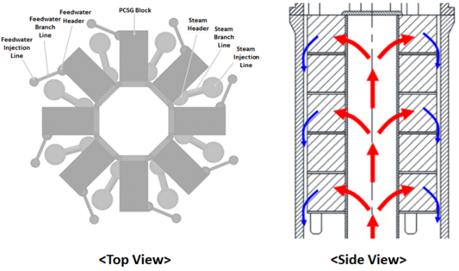

*Fig. 5. Conceptual drawings of the PCIHX.*

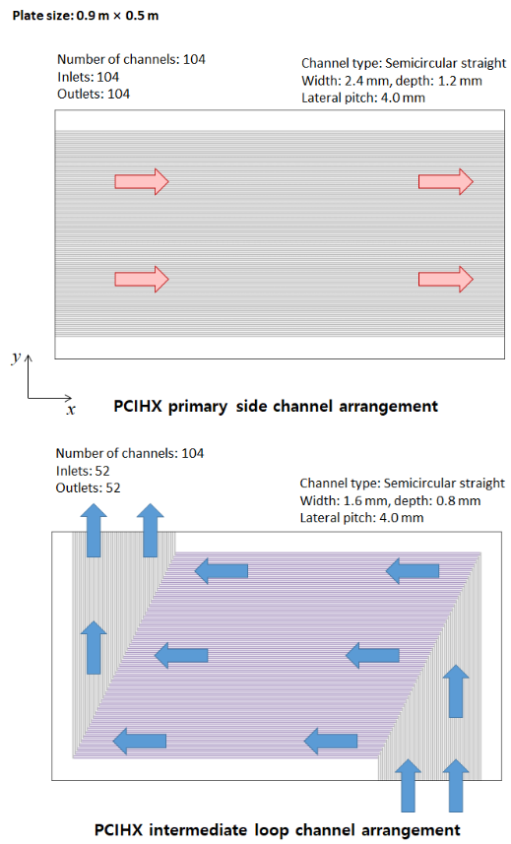

*Fig. 6. Conceptual drawings of a PCIHX unit block.*

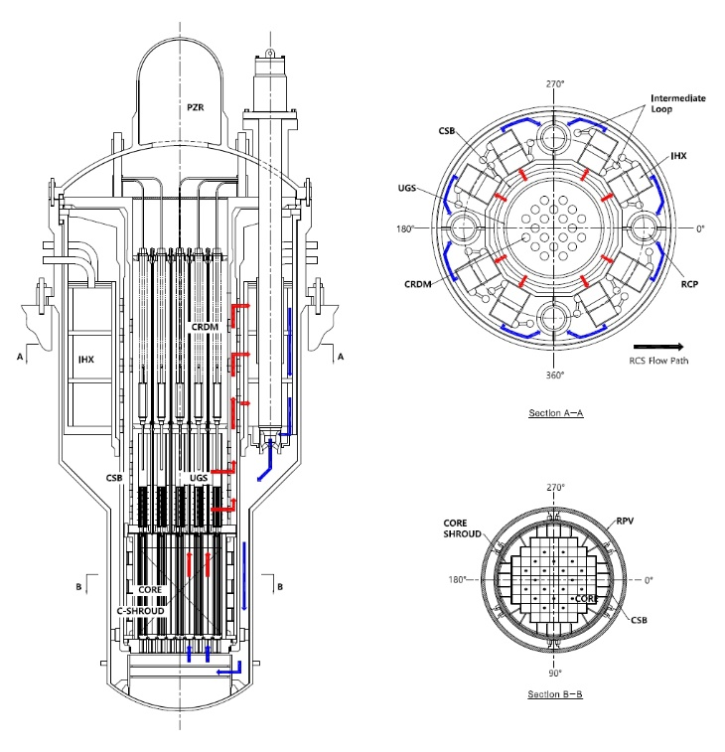

*Fig. 7. Preliminary general layout of the RCS and RVA arrangement (overview).*

***III.B. Mechanical Design***

The Reactor Vessel Assembly Arrangement (RPV), reactor closure head (RCH), and stud bolts function to maintain the pressure boundary of the reactor coolant. The reactor vessel assembly (RVA) supports and protects reactor internals, 20 in-vessel control rod drive mechanisms (CRDMs), a PZR, 69 fuel assemblies, 36 IHXs, and 4 RCPs. The general arrangement of the RVA is shown in Fig. 7.

The major structure of the reactor internals is the CSB assembly that consists of a CSB, lower core support plate, and core shroud assembly. The CSB assembly surrounding the upper part of the upper guide structure (UGS) assembly provides support to the core and the reactor coolant flow path. It guides the reactor coolant between the reactor core and the IHX.

The core shroud assembly accommodates the projected cross-sectional shape of the reactor core, provides an envelope for the core including 69 fuel assemblies, and limits the reactor coolant bypass flow. The core shroud assembly also prevents excessive lateral movement of the core during an accident. The core shroud assembly is fixed at the bottom of the CSB and thus is handled together with the CSB.

The UGS assembly installed inside the upper part of the CSB provides guidance for the reactor coolant from the core to the IHXs. It also guides and protects the CRDMs from the reactor coolant flow. The UGS assembly prevents an uplifting of the fuel assemblies due to the reactor coolant flow, as well as supports and aligns the fuel assemblies. The stud bolts in conjunction with the RPV and RCH flanges fix the UGS assembly.

The printed circuit IHX, or PCIHX, is a plate-type heat exchanger formed into blocks by alternately stacking primary and secondary coolant channel plates. The low temperature of the secondary coolant converts to high temperature by passing through the IHX flow channels. The flow channel on each plate is manufactured by chemical etching, and all channel plates are bonded together using diffusion bonding technology in a high-temperature and high-pressure environment. The IHXs consist of blocks, headers and piping for the isolation loop coolant, and a support structure.

As shown in Fig. 7, a total of 8 IHXs and 4 RCPs are arranged on a single plane, where 2 IHXs are arranged between every 2 RCPs. A total of 3 layers of 36 IHXs are accommodated in the RPV. The IHXs are placed in the spaces between the CSB and the RPV at the top of the core, and they are fixed to the RPV flange through the IHX support cylinder.

The dedicated cavity at the upper side of the RPV top flange is filled with saturated steam and water; this cavity performs the function of the PZR. The PZR cover furnishes nozzles for the pressurizer safety valve (PSV) and heaters. The PSV prevents over-pressurization of the RCS. Thermal equilibrium in the PZR is maintained by heater control to compensate the PZR heat loss. The PZR cover acts as the reactor coolant pressure boundary.

The 4 total RCPs are mounted vertically on the RCH by stud bolts. Each RCP consists of a hydraulic part, shaft assembly, motor, and pressure container. They are mixed-flow pumps operated by canned motors. There is no mechanical seal device to prevent leakage through the pressure container of the pump. All of the pump parts are submerged in reactor coolant except the pressure boundary parts. A cooling system is included to remove not only the motor heat but also the pump internal heat. Component cooling water and an auxiliary impeller are the main parts of the cooling system. The auxiliary impeller circulates the reactor coolant located in the pump, and the component cooling water is supplied from the plant site. Heat exchange occurs between the component cooling water and motor.

The 20 total CRDMs are installed inside the RPV, where the CRDMs and extension shaft assembly (ESA) are supported by the reactor internal structures. The CRDM is an electromechanical equipment that drives the control rod assembly (CRA) vertically via electromagnetic force. The CRDMs can withdraw or insert the CRA vertically within 2040 mm (204 steps) according to drive signals, maintain it at the current position, or insert it urgently regardless of the withdrawn position of the CRA within the core. Each CRDM consists of a motor assembly, motor housing, coil assembly, and rod position indicator, which is a solenoid-type position sensor that provides the current position information of the CRA. The rod position indicator generates two-channel rod position signals. The ESA connects the CRDMs and CRA to allow the CRDMs to withdraw or insert the CRA.

The reactor coolant circulates through the reactor core, UGS assembly, CBS assembly, IHXs, and the RCPs, which are installed in the RPV as shown in Fig. 4. The reactor coolant is heated by the core and flows up along the lower region of the UGS assembly, between the UGS barrel and the CSB barrel, and then passes through the IHXs for heat exchange with the isolation loop feedwater and flows into the RCPs. The reactor coolant from the RCPs then flows into the annular region between the CSB and the RPV, flows down to the lower plenum of the RPV, and finally flows into the core. The circulation of the reactor coolant is activated by 4 RCPs that are vertically installed through the nozzles on the RCH. The rotational shaft is extended to the bottom of the IHXs, and the impeller is located in the lower region of the IHXs.

IV. Safety Analysis

The safety of the NDP-400 has been assessed through a preliminary safety analysis conducted using the SPACE (Safety and Performance Analysis Code for Nuclear Power Plants) code **[10]**.

***IV.A. ESF***

The PRHRS (passive residual heat removal system) is an important safety system for long-term cooling. It uses natural circulation to remove residual heat from the core when the pumps are not available. In the case of the NDP-400, the PRHRS is connected to 4 IHX sections and removes the decay heat from the intermediate loop. One of the main objectives of the PRHRS is to bring the primary coolant condition to a shutdown cooling system operation condition within 72 h with 2 out of 4 trains of the PRHRS.

The ECCS (emergency core cooling system) provides core cooling under loss of coolant accident (LOCA) conditions to limit fuel cladding damage. The NDP-400 has four gravity-driven cooling system (GDCS) pools to provide a pressure coolant injection mode of the residual heat removal system. Also, two passive safety valves are available to automatically depressurize the core. The GDCS pool contains coolant for the initial core uncovery in the event of a LOCA, and coolant spilled during a LOCA is replenished to the GDCS pools via the passive containment cooling system (PCCS). When the pressure in the containment and the pressure in the core become equal, the pressure valve connected to the GDCS and primary loop is opened to inject it.

The PCCS, one of the main passive safety systems in the NDP-400, utilizes vapor condensation to remove heat released from the reactor to the environment during postulated design basis accidents for preventing the overpressure of the containment. The open pool above the containment is the ultimate heat sink, and a passive containment cooling heat exchanger (PCCX), which is a tube heat exchanger, is used to cool the vapor inside the containment with water. The PCCX is installed in an open pool and is depressurized a residual heat removal.

***IV.B. Total Loss of Reactor Coolant Flow Accident***

Fig. 8 shows the nodalization of the NDP-400 for safety analysis. The NDP-400 has 4 trains of IHXs and PRHRS loops and 2 trains of SG loops for redundancy. In the figure, the heat structures are expressed in red: the fuel rods and IHXs, the PRHRS and SGs, and the PCCS. Water pools are expressed in blue: the GDCS for safety injection, and the cooling pools (heat sink) for PRHRS and PCCS operation. The valves include trip valves opened by pressure and isolation valves that operate immediately in the event of an accident. The circles represent the temporal face boundary condition (TFBC), where feedwater on the SG side is the flow boundary and motive steam is the pressure boundary.

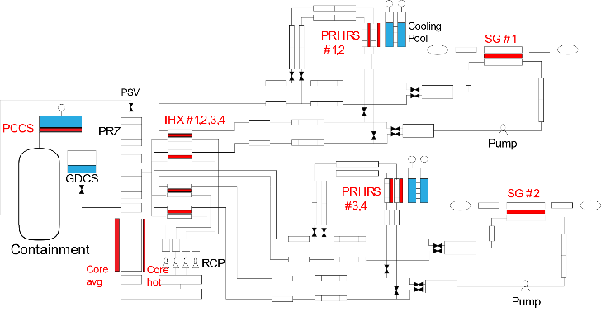

*Fig. 8. Nodalization of the NDP-400.*

To evaluate the thermal margin of the core design during normal operation, the MDNBR must be calculated. Calculation of the critical heat flux was performed using the 2006 AECL-UO CHF lookup table embedded in the SPACE code.

For a total loss of coolant flow event, the initial occurrence is the stoppage of all RCPs. Then the reactor trips and the isolation valves of the SG loops and the isolation valves of the PRHRS loops are aligned. In this analysis, a single failure of an isolation valve at the outlet of the PRHRS is assumed. Thus, only 3 out of the 4 PRHRS trains are available for a conservative analysis.

Fig. 9 shows the normalized core power after reactor trip. The generated decay heat follows a general PWR decay heat curve. All subsequent safety analyses have the same core power distribution after reactor trip. Upon reactor trip, the power decreases by 7 % of full power.

Fig. 10 shows the coolant temperature at the core inlet and the outlet temperature for 72 h after reactor trip, as well as the saturated temperature. The core outlet temperature is about 8 °C lower than the saturated temperature at the minimum point, indicating that the core has not reached the boiling point. After 72 h following reactor trip, the coolant temperature is maintained at 150 °C.

Fig. 11 plots the PRZ pressure, which increases to about 1.66 MPa immediately after reactor trip and then decreases to about 1.02 MPa. The pressure of the PRZ does not reach 2.25 MPa, the pressure at which the PSV is opened, and the pressure stabilizes with residual heat removal. In this case, the RCS temperature and pressure are higher than the 4 trains of PRHRS operation.

The preliminary safety analysis confirmed that the core has a high MDNBR due to the low-temperature and low-pressure operating conditions of the NDP-400. In addition, no severe accident scenarios such as core melting occurred in the preliminary safety analysis.



*Fig. 9. Normalized core power after reactor trip.*



*Fig. 10. RCS coolant temperature after reactor trip.*



*Fig. 11. PRZ pressure after reactor trip.*

V. Conclusions

The NDP-400 is currently under development to provide a nuclear desalination plant with 400 MW of thermal power at a system pressure of 15 bar and a low temperature operating condition. A partial two-batch fuel management plan was established for a 36-month operational period. The resulting power peaks and distributions are comparable to commercial PWRs. The thermal margin of the NDP-400 is evaluated to have sufficient margin regarding MDNBR.

A conceptual design of the RPV has been conducted along with the arrangement of the main internal structures of the NDP-400. A three-loop system was adopted that includes multi-effect distillation. IHXs, RCPs, and a PZR are integrated into the RPV as the primary system components. Also, PCHXs are adopted in the NDP-400 as the IHXs. The RCP concept adopts a vertical canned motor pump.

For the engineered safety features, the PRHRS, ECCS, and PCCS are considered. As the worst accident scenario, a total loss of coolant flow was chosen for preliminary safety analysis, and it was confirmed that the core maintains a high MDNBR owing to the low-temperature and low-pressure operating conditions of the NDP-400.

The NDP-400 has been designed for economic operating conditions, and its safety has been verified through a preliminary safety analysis. In future work, an advanced desalination reactor is expected to be developed through a detailed design that reflects localized characteristics.

Acknowledgments

This research was supported by the joint R&D project “Preliminary Conceptual Development for Nuclear Desalination Plant” performed by the Korea Atomic Energy Research Institute (KAERI) and King Abdullah City for Atomic and Renewable Energy (K.A.CARE). Dr. S.J. Kim and Y.I. Kim at KAERI are recognized for their valuable contribution to the core thermal-hydraulic analysis and fluid design.

References

1. IEA, Renewables 2022 Analysis and forecasts to 2027, International Energy Agency (2023).
2. ARAB News, “The rise and rise of water desalination in Saudi Arabia”, Sep. (2022).
3. N. Y. Mansouri, A. F. Ghoniem, “Does nuclear desalination make sense for Saudi Arabia,” Desalination, 406, 37,43 (2017).
4. Y. H. Jung, Y. H. Jeong, J. Choi, A. F. Wibisono, J. I. Lee, H. C. No, “Feasibility study of small-sized nuclear heat-only plant dedicated to desalination in the UAE,” Desalination, 337, 83-97 (2014).
5. “SMART Units 1&2 Preliminary Safety Analysis Report,” Korea Atomic Energy Research Institute and King Abdullah City for Atomic and Renewable Energy, 2018.
6. C. Y. Cho et al., “DeCART2D v1.1 User’s Manual,” Korea Atomic Energy Research Institute, KAERI/UM-40 /2016.
7. C. Y. Cho et al., “MASTER v4.0 User’s Manual,” Korea Atomic Energy Research Institute, KAERI/UM-41/2016.
8. “Shin-Hanul Units 1&2 Final Safety Analysis Report,” Korea Hydro and Nuclear Power Co., 2022.
9. Y. J. Yoo, D.H. Hwang, and D.S. Sohn, “Development of A Subchannel Analysis Code MATRA Applicable to PWRs and ALWRs,” J. Korean Nuclear Society, 31, 314 (1999).MATRA-S
10. KHNP, KEPCO E&C, KAERI, SPACE Theoretical Manual, S06NX08-K-1-TR-36, Rev. 0, 2017.