Turbulent heat flux modelling by using elliptic-blending k-ε-ζ-f RANS model

M. Hadžiabdićª, A. Hodžaª, B. Ničeno^{b}

ª International University of Sarajevo, Hrasnička cesta 15, Sarajevo, 71000, Bosnia and

Herzegovina, mhadziabdic@ius.edu.ba

^{b} Scientific Computing, Theory and Data, Paul Scherrer Institute, Villigen, PSI, CH-5232, Switzerland

Abstract – We report on the results for two buoyancy-driven benchmark cases, heat-driven square cavity at Ra = 10¹¹, and Rayleigh-Bénard convection at Ra = 10⁹, by using the elliptic-blending eddy viscosity k-ε-ζ-f model (or just ζ-f), and three different formulations of the turbulent heat flux, namely the Simple Gradient Diffusion Hypothesis (SGDH), the General Gradient Diffusion Hypothesis (GGDH) and the Algebraic Flux Model (AFM). The ζ-f model is well-posed for computing turbulent heat transfer since it contains an approximation of the normal Reynolds stress in the wall-normal direction that is needed in GGDH and AFM formulations. Furthermore, the modeling of the wall-blocking effect by using the elliptic-relaxation approach is physically more sound than the commonly used damping functions. This work is motivated by the recently held 17th ERCOFTAC SIG15/MONACO2025 workshop on turbulent natural convection flows in differentially heated cavities, Manceau (2023), which demonstrated superior performance of the ζ-f model in predicting the main flow features for the selected cases.

Keywords: Turbulent Heat Flux; RANS; Turbulent Heat Convection

I. Introduction

Modeling of turbulent heat flux in buoyancy-driven flows is in a focus of scientific community for decades. The relevance of buoyancy influenced flows is high as the turbulent heat transfer is dominant in many engineering applications, including heating and cooling of buildings, heat exchangers, cooling of electronics, safety applications, but also in natural systems such as atmosphere and oceans. Buoyant flows pose a challenge, particularly when prediction of Nusselt number is in question, due to direct coupling of the energy and momentum equations. While the effect of buoyancy on the mean flow is well-understood, the nature of turbulence-buoyancy interaction is still matter of discussion. It is no surprise that modeling of the turbulent heat flux is a considerable task. The modeling approaches vary from the basic isotropic eddy diffusivity hypothesis, known as the Simple Gradient Diffusion Hypothesis (SGDH), to the differential stress/flux model that consists of 17 transport equations. Between these two extremes, the number of approaches were tried with varying success, most notably the General Gradient Diffusion Hypothesis (GGDH) proposed by Daly and Harlow (1970), and Algebraic Heat Flux Models (AFM) discussed by Kenjereš and Hanjalić (2006), Hanjalić and Launder (2022), Doel et al. (1997) among others. Although the shortcomings of SGDH are known, it is still widely used in industrial computations. This is partly because of robustness of the model. However, another reason is that both GGDH and AFM require Reynolds stress tensor, which normal components are poorly predicted by the eddy viscosity models. Ince and Launder (1989) included the damping function f_{μ} in the definition of the GGDH coefficient in order to get the right level of the normal stresses close to the wall. Kenjereš et al. (2005), and more recently Jameel et al. (2019), used an elliptic-relaxation based eddy viscosity model with GGDH and AFM formulations of the turbulent heat flux. Kenjereš et al. (2005) used original Durbin’s v²-f model with AFM, and Jameel et al. (2019) used BL-v²/k model along with Launder and Sharma, and k-ω-SST eddy viscosity models. While Kenjereš et al. used a standard definition of the Reynolds stress tensor based on the Boussinesq approximation, Jameel et al. modified the model coefficient in the GGDH and AFM formulation in the same way as Ince and Launder (1989) did, but using the new velocity scale instead of the damping function.
Unlike Kenjereš et al. (2005) and Jameel et al. (2019), who defined $\overline{u_{i}u_{i}}=2/3k-2ν_{t}{∂U_{i}}/{{∂x}_{i}}$, we approximated the normal stresses by using a normalized velocity scale ζ from the elliptic-blending linear eddy viscosity model k-ε-ζ-f (or just ζ-f) which approach the value of the normal stress in the wall-normal direction close to the wall. The model is used for computing heat transfer in two standard buoyancy-driven benchmark cases, namely Rayleigh-Bénard convection and heat-driven square cavity, both at high Ra number. We present a unique feature of the ζ-f model (ζ variable) that contains approximation of the normal Reynolds stress component, needed for GGDH and AFM formulation of the turbulent heat flux. The model is verified and validated at the 17th ERCOFTAC SIG15/MONACO2025 workshop on turbulent natural convection flows differentially heated cavities, Manceau (2023), where the ζ-f model outperformed the tested eddy-viscosity models for the selected cases.

II. Modeling rationale

One of the most interesting and useful improvement in the last decades within the eddy-viscosity concept was introduced by Durbin in 1991 by applying the elliptic relaxation approach to model the wall blocking effect. The originally proposed model solves two additional equations in addition to the equations for k and ε. A transport equation is introduced for a new variable υ², and in addition an elliptic relaxation equation is solved for the variable f₂₂. The variable υ² is used as a new velocity scale, representing the normal component in the wall-normal direction of the Reynolds-stress tensor. The variable f₂₂ provides the wall-modification of the pressure-velocity correlation and is used to define the anisotropic part of the ε₂₂ component of the dissipation tensor ε_{ij}. The elliptic equation is used to represent the wall blocking effect originating from the impermeability constraint. As the wall blocking effect is non-viscous and non-local, its modeling by elliptic equation is physically more sound compared to the common practice of using damping functions. Since the effect is mainly responsible for the strong flow anisotropy in the near-wall region, the impact on the heat transfer prediction is also significant.
The ζ-f model, used in this work, is proposed by Hanjalić et al. 2004, and it originates from the Durbin’s υ²-f model. The model is more robust than the original one, without jeopardizing the model’s accuracy. The main novelty of the model is a transport equation for the velocity scale ratio $ζ={υ^{2}}/k$ that replaced υ². A transport equation for ζ appeared to be numerically more robust with less stiff boundary condition. The equation is derived directly from the υ² and k equations of the Durbin’s model.
The Reynolds-averaged Navier-Stokes and energy conservation equation can be written as:

$$\frac{∂U_{i}}{∂x_{i}}=0$$ | (1)
$$\frac{DU_{i}}{Dt}=-\frac{1}{ρ}\frac{∂P}{∂x_{i}}+\frac{∂}{∂x_{j}}\left[ν\left(\frac{∂U_{i}}{∂x_{j}}+\frac{∂U_{j}}{∂x_{i}}\right)-\overline{u_{i}u_{j}}\right]+g_{i}$$ | (2)
$$ρc_{p}\frac{DΘ}{Dt}=\frac{∂}{∂x_{j}}\left[λ\frac{∂Θ}{∂x_{j}}-ρc_{p}\overline{θu_{j}}\right]+Q$$ | (3)

where U_{i} is the velocity vector, ρ is the fluid density, g_{i} is the gravity vector, ν is the kinematic viscosity, θ is the temperature, λ is the thermal conductivity, c_{p} is the specific heat capacity, and Q is the heat source.
The momentum equation is closed by the linear eddy-viscosity formulation:

$$\overline{u_{i}u_{j}}=-ν_{t}S_{ij}+\frac{2}{3}kδ_{ij}$$ | (4)

where $S_{ij}$ is the rate of strain tensor.
These are coupled to the following set of the ζ-f model’s equations:
$$\frac{Dk}{Dt}=D_{k}+ P_{k}+G_{k}-ε$$ | (5)
$$\frac{Dε}{Dt}=D_{ε}+\frac{C_{ε1}\left(P_{k}+G_{k}\right)-C_{ε2}ε}{τ}$$ | (6)
$$\frac{Dζ}{Dt}=D_{ζ}+f-\frac{ζ}{k}P_{k}$$ | (7)
$$L^{2}∇^{2}f-f=\frac{1}{τ}\left(c_{1}+C_{2}^{'}\frac{P}{ε}\right)\left(ζ-\frac{2}{3}\right)$$ | (8)
$$τ=\max\left[\min\left(\frac{k}{ε},\frac{0.6}{\sqrt{6}C_{μ}\left|S\right|ζ}\right), C_{τ}{\left(\frac{ν}{ε}\right)}^{\frac{1}{2}}\right]$$ | (9)

$$L=C_{L}max\left[\min\left(\frac{k^{\frac{3}{2}}}{ε},\frac{k^{\frac{1}{2}}}{\sqrt{6}C_{μ}\left|S\right|ζ}\right), C_{η}{\left(\frac{ν^{3}}{ε}\right)}^{\frac{1}{4}}\right]$$ | (10)
$$ν_{t}=C_{μ}ζkτ$$ | (11)

where k is the turbulent kinetic energy, ε is its dissipation rate, $P_{k}=\overline{u_{i}u_{j}}\frac{{∂U}_{i}}{{∂x}_{j}}$ is the production rate of turbulent kinetic energy, $G_{k}=-βg_{i}\overline{θu_{i}}$ is the production term due to buoyancy force with the volumetric thermal expansion coefficient beta, $ζ={υ^{2}}/k$ is the velocity scale ratio, f is an elliptic relaxation function and $D$ is the total (molecular plus turbulent) diffusion defined as:
$$D_{Φ}=\frac{∂}{∂x_{k}}\left[\left(\frac{ν}{σ_{Φ}}+\frac{ν_{t}}{σ_{t}}\right)\frac{∂Φ}{∂x_{k}}\right]$$ | (12)
A thermally perfect fluid is assumed, i.e. enthalpy depends on the temperature only and the buoyancy term is modelled with the Boussinesq approximation.
The simplest way to model the turbulent heat flux is based on eddy-diffusivity model, where heat flux components are defined in terms of temperature gradients. The shortcomings of the SGDH model are widely discussed and reported in the literature (Hanjalić and Launder, 2022, among others). Both the GGDH and the AFM formulations of the turbulent heat flux are more complete and physically justified compared to the SGDH.
Definitions of turbulent heat flux by SGDH, GGDH and AFM read as follows:
$$\overline{θu_{j}}=-\frac{ν_{t}}{{Pr}_{t}}\frac{∂Θ}{∂x_{j}}$$ | (13)
$$\overline{θu_{j}}=-c_{θ}τ\overline{u_{i}u_{j}}\frac{∂Θ}{∂x_{j}}$$ | (14)
$$\overline{θu_{j}}=-c_{θ}τ\left(\overline{u_{i}u_{j}}\frac{∂Θ}{∂x_{j}}+ξ\overline{u_{j}θ}\frac{∂U_{i}}{∂x_{j}}+ηβg_{i}{\overline{θ}}^{2}\right)$$ | (15)
where Pr_{t} is the turbulent Prandtl number set to its standard value of 0.9, τ is the turbulent time scale defined by Eq. (9), ${\overline{θ}}^{2}$ is the turbulent temperature variance, and c_{θ}, ξ and η are the model constants.
The transport equation for $θ^{2}$, needed in AFM, is defined as:
$$\frac{Dθ^{2}}{Dt}=P_{θ}-2\frac{ϵθ^{2}}{k}+\frac{∂}{∂x_{j}}\left[\left(ν+\frac{ν_{t}}{σ_{θ}}\right)\frac{∂θ^{2}}{∂x_{j}}\right]$$ | (16)

in which $P_{θ}=-2\overline{θu_{j}\frac{∂Θ}{∂x_{j}}}$ is the gradient production of temperature variance. We remark that in the above equation it is implicitly assumed a constant thermal-to-mechanical time scale ratio $R={\left({θ^{2}}/{ϵ_{θ}}\right)}/{\left(k/ϵ\right)}=0.5$ with $ϵ_{θ}$ being the dissipation of turbulent temperature variance.
GGDH and AFM require the Reynolds stress tensor. While the shear stresses are usually well predicted by the Boussinesq approximation (Eq. 4), the normal stresses are severely overestimated close to the wall due to the strong turbulence anisotropy. Ince and Launder used a damping function in the formulation of c_{θ} in order to correct the level of the normal stresses in the near wall region. However, the damping functions suffer from the lack of universality, and their validity is questionable when the buoyancy is involved in turbulence generation. The ζ-f model is well-posed for using the GGDH and AFM formulations as the variable ζ represents the normalized velocity fluctuations in the wall-normal direction, and as the wall is approached, it approaches the normal component of the Reynolds-stress tensor. Instead of using Eq. 4, we estimate the normal stresses by using ζ as follows:
$$\overline{u_{i}u_{i}}=ζk$$ | (17)
The coefficient c_{θ} in Eqs. (14, 15) is set equal to ${c_{μ}^{v}}/{{Pr}_{t}}$ in order to restore the eddy-viscosity formulation in a horizontal shear flow, in which the principal velocity and temperature gradients are aligned in the wall-normal direction. The value of c_{θ} is 0.24, which is close to the common value of 0.2. In a case of the forced convection over a heated flat plate, both GGDH and AFM reduce to the standard SGDH formulation which would not be a case if the normal stresses are defined as 2/3k. This is a convenient feature of the proposed model, as it does not negatively affect the accuracy in the forced convection cases. Further, we changed value of ξ and η coefficients in the AFM model from 0.6 to 0.1. The original value of 0.6 overestimates the turbulent heat flux, which results in overestimation of the Nu number. The reason for this is not obvious and it requires analysis that is out of scope of the present work.
Figure 1 shows comparison of the normal stress by using Eq. 4, and newly proposed Eq. 17, for the heat-driven square cavity and Rayleigh-Bénard convection. The wall-normal stress in the thermal boundary layer is better approximated by ζ k for both cases, while its values are underestimated further from the wall. The 2/3k exhibits wrong distribution of $\overline{uu}$ in the wall vicinity, severely overestimating values of $\overline{uu}$ as shown in Fig. 1.

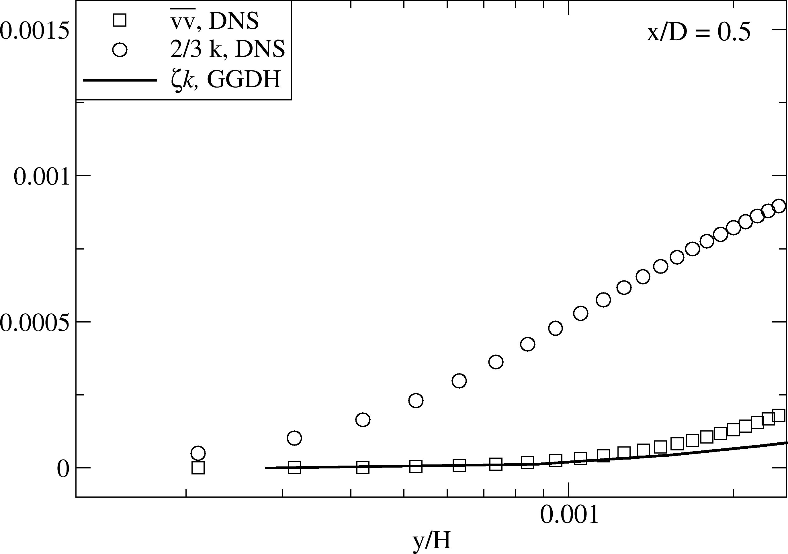
(a)
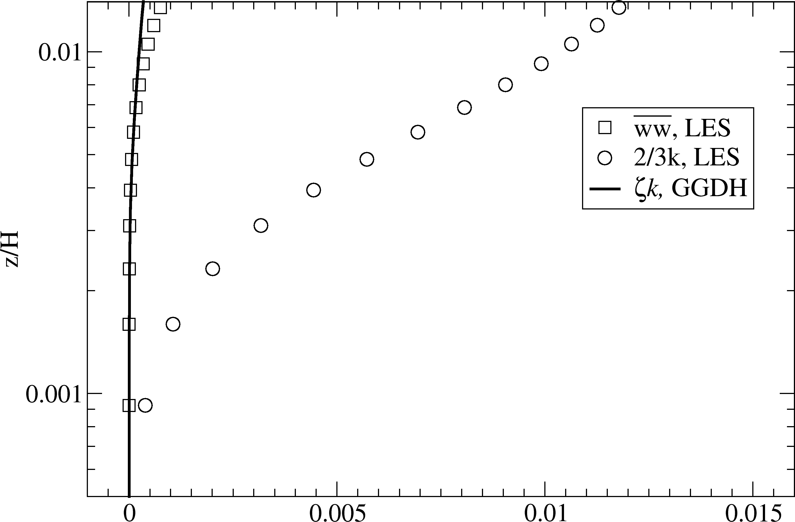
(b)
Figure 1 Distribution of normal stress, 2/3k and ζk in thermal boundary layer for (a) heat-driven square cavity, and (b) Rayleigh-Benard convection
The AFM model is known to be numerically challenging as numerical instabilities are often reported. We experienced numerical instabilities when the Reynolds stresses are expanded by a buoyancy-related term which is omitted here. The transport equation for θ² diverged when the Rayleigh-Bénard convection was computed, if the turbulent heat flux in the production term of θ² is defined by Eq. 15. In order to stabilize the computations we used SGDH for defining the production term in Eq. 16. We did not notice any significant difference in the results. Further, the buoyancy-related source term G_{k} is used in the equations for k and ε, while it is omitted in the equations for f and ζ as it is noticed that the omitting G_{k} in these equations improves prediction of the Nusselt number. As the role of buoyancy in turbulence generation and dynamics is not fully understood, the treatment of G_{k} in the RANS framework varies a lot. More on the treatment of G_{k} can be found in Markatos et al. [1982], Worthy et al. [2001], among others.
We conclude this subsection with a table summarizing the model’s coefficients.
$$C_{μ}^{υ}$$ | $$C_{ε1}^{'}$$ |  | $$C_{ε2}$$ | $$C_{1}$$ | $$C_{2}$$
0.22 | $$1.4(1+\frac{0.012}{ζ})$$ |  | 1.9 | 0.4 | 0.65
$$σ_{k}$$ | $$σ_{ε}$$ | $$σ_{ζ}$$ | $$C_{T}$$ | $$C_{L}$$ | $$C_{η}$$ | $$c_{θ}$$
1 | 1.3 | 1.2 | 6.0 | 0.36 | 85 | 0.24

III. Results

We test the model for two standard benchmark cases for the buoyancy-driven flows: heat-driven square cavity and Rayleigh-Benard convection.

III.A. Differentially heated square cavity

A three-dimensional rectangular cavity with differentially heated vertical walls and periodic boundary condition in the third direction is a well known benchmark case. The vertical walls are kept at different temperatures which generates the fluid flow. A recent DNS data of Sebilleau et al. (2018) makes the case a good benchmark for buoyancy-driven flows. It is a challenging case for RANS models as three different flow regimes are simultaneously present: steady laminar flow, unsteady laminar flow and fully turbulent flow. We used SGDH, GGDH and AFM for modeling of the turbulent heat flux with the wall integration approach (no-slip condition applied for the momentum). The computational domain, shown in Fig. 2(a), is three-dimensional with H × 0.15H × H in x, y and z directions respectively.
A constant temperature is imposed on the vertical walls (Θ_{hot} and Θ_{cold}), as well as to the top and bottom walls where temperature varies linearly $(Θ_{wall}=Θ_{hot}-∆Θx/L)$ following the set-up used in DNS of Sebilleau et al. (2018). The Rayleigh number is 10¹¹, defined as:
$$Ra=\frac{ρgβ∆ΘL^{3}}{μα}$$ | (18)
where ρ is air density, g is gravitational constant, β is coefficient of thermal expansion, L is a characteristic length scale, in this case square’s side, μ is the dynamic viscosity, α the thermal diffusivity. Air Prandtl number of 0.71 is used.
The number of cells used in x, y and z direction are Nx = 100, Ny = 20 and Nz = 100, with a wall clustering in x and z directions. The $n_{max}^{+}$ is kept below one. The computations are conducted as unsteady, by keeping the Courant number around one, as natural instabilities are present in the flow.

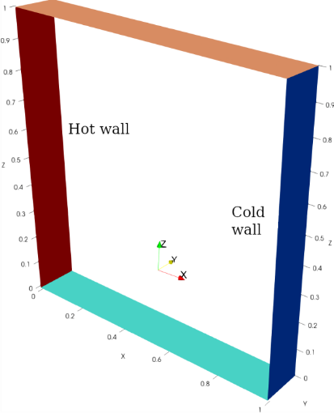
(a)
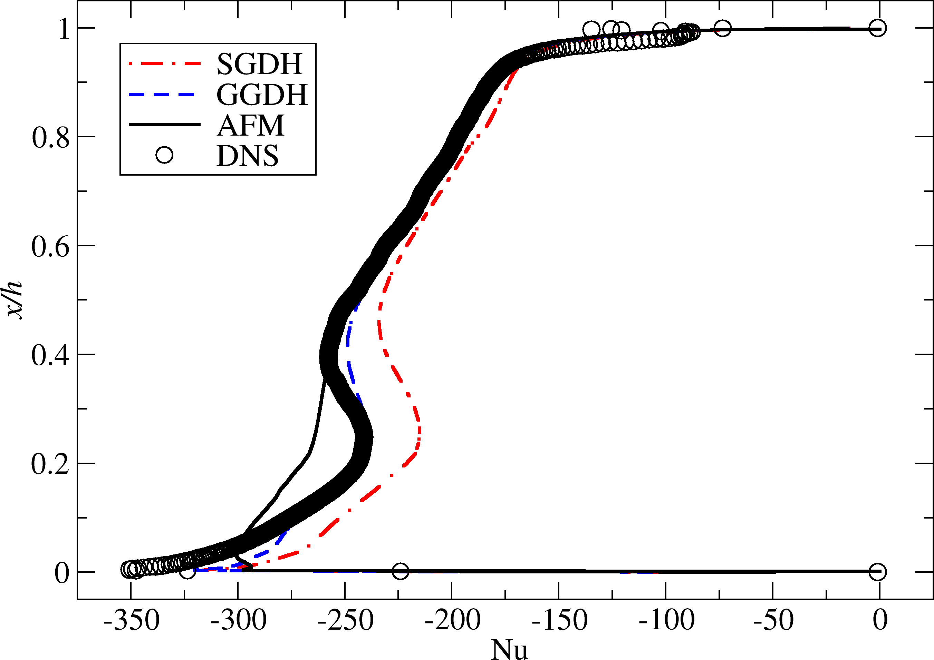
(c)
(b)
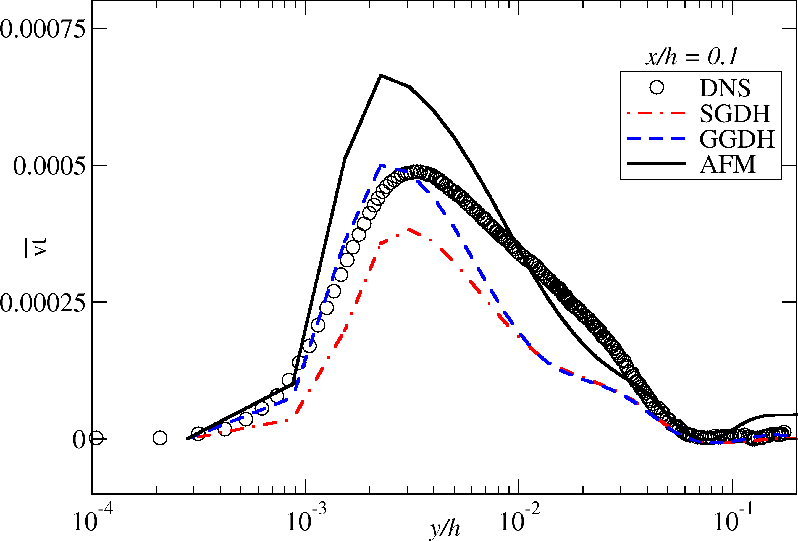
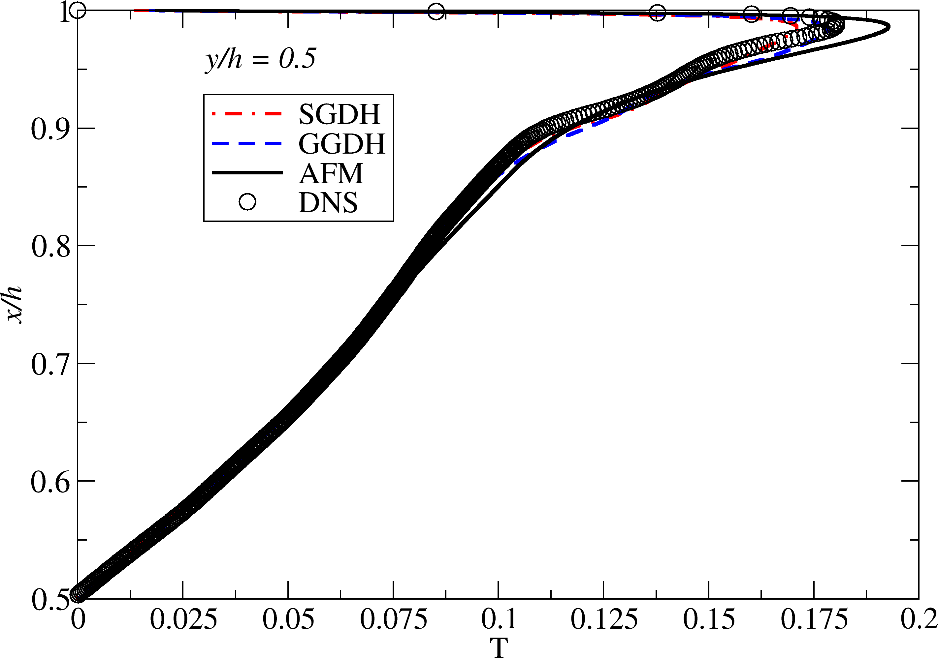
(d)
Figure 2 (a) Computational domain of square cavity, (b) Mean temperature profile at mid vertical line compared to DNS data of Sebilleau et al. (2018), (c) $\overline{vθ}$ along horizontal line at mid height, (d) Mean Nusselt number along hot wall
Figures 2(b), (c), (d) show selected results that demonstrate differences between three turbulent heat flux formulations. Overall, GGDH gives the best prediction of the mean temperature and turbulent heat flux; see Figs. 2(b), (c) and consequently the Nusselt number distribution along the hot wall shown in Fig. 2(d). The AFM result is better than SGDH, but the shape of the Nu number is not as good as obtained by GGDH. As AFM tends to increase a modeled component of the turbulent heat flux, versus the resolved part, the modeled turbulent kinetic energy is increased as well. It seems that a delicate balance of the turbulent and laminar regions that coexist in the heat-driven square cavity at Ra = 10¹¹ is disturbed by the increased turbulent kinetic energy produced by AFM model. This seems to be the main reason for somewhat worse results of AFM compared to GGDH. Figure 2(c) shows that $\overline{vθ}$ is best predicted by GGDH, while the value of $\overline{vθ}$ SGDH and AFM underpredicts and overpredicts it respectively.

III.B. Rayleigh-Bénard convection

The Rayleigh-Bénard convection is a standard test case for the buoyancy-driven flows. The flow has some complex features although the geometry is very simple. A fluid, bounded by upper cold, and lower hot, wall with constant temperature, is buoyancy driven. A periodic boundary condition is imposed at the lateral sides. The three-dimensional domain is simulated with unsteady RANS (URANS) approach. The domain is 4H $×$4H $×$ H, where H is the distance between the top and bottom wall. We computed the case with Ra = 10⁹ and Pr = 0.71 as it is the most frequently reported in literature. The mesh has 80 $×$ 80 $×$ 72 cells, where the mesh is uniform in the lateral directions, x and y, and stretched in the wall normal direction, z, resulting in $n_{max}^{+}$ < 1. The average Nusselt number is the main integral parameter of the flow. A recent DNS data of Blass et al. (2021), considering the same case of laterally unconfined domain, reports Nu of 61.83, which is somewhat lower compared to the DNS results of a confined cylindrical cell (Nu$≈$65) reported by Bailon-Cuba et al. (2010). We performed the LES simulation of the flow on the mesh with 240$×$240$×$128 cells which produced satisfactory results compared to the DNS data of Blass et al. (2021) (4% error in prediction of Nu number).
Figure 3 shows the mean temperature and turbulent heat flux profiles compared to the reference LES. The SGDH and GGDH give almost identical results which is not surprising knowing that both models suffer from the same flaw which is zero turbulence transport of heat when the temperature gradient in the direction of the heat flux is zero. The mean Nu number predicted by SGDH and GGDH is 51.5, with 16% error compared to the DNS result. The AFM model significantly improved the Nusselt number, Nu = 58.2, reducing the error to 5%. As it was the case in the square cavity, the AFM model produces larger modeled turbulent kinetic energy compared to the SGDH and GGDH.

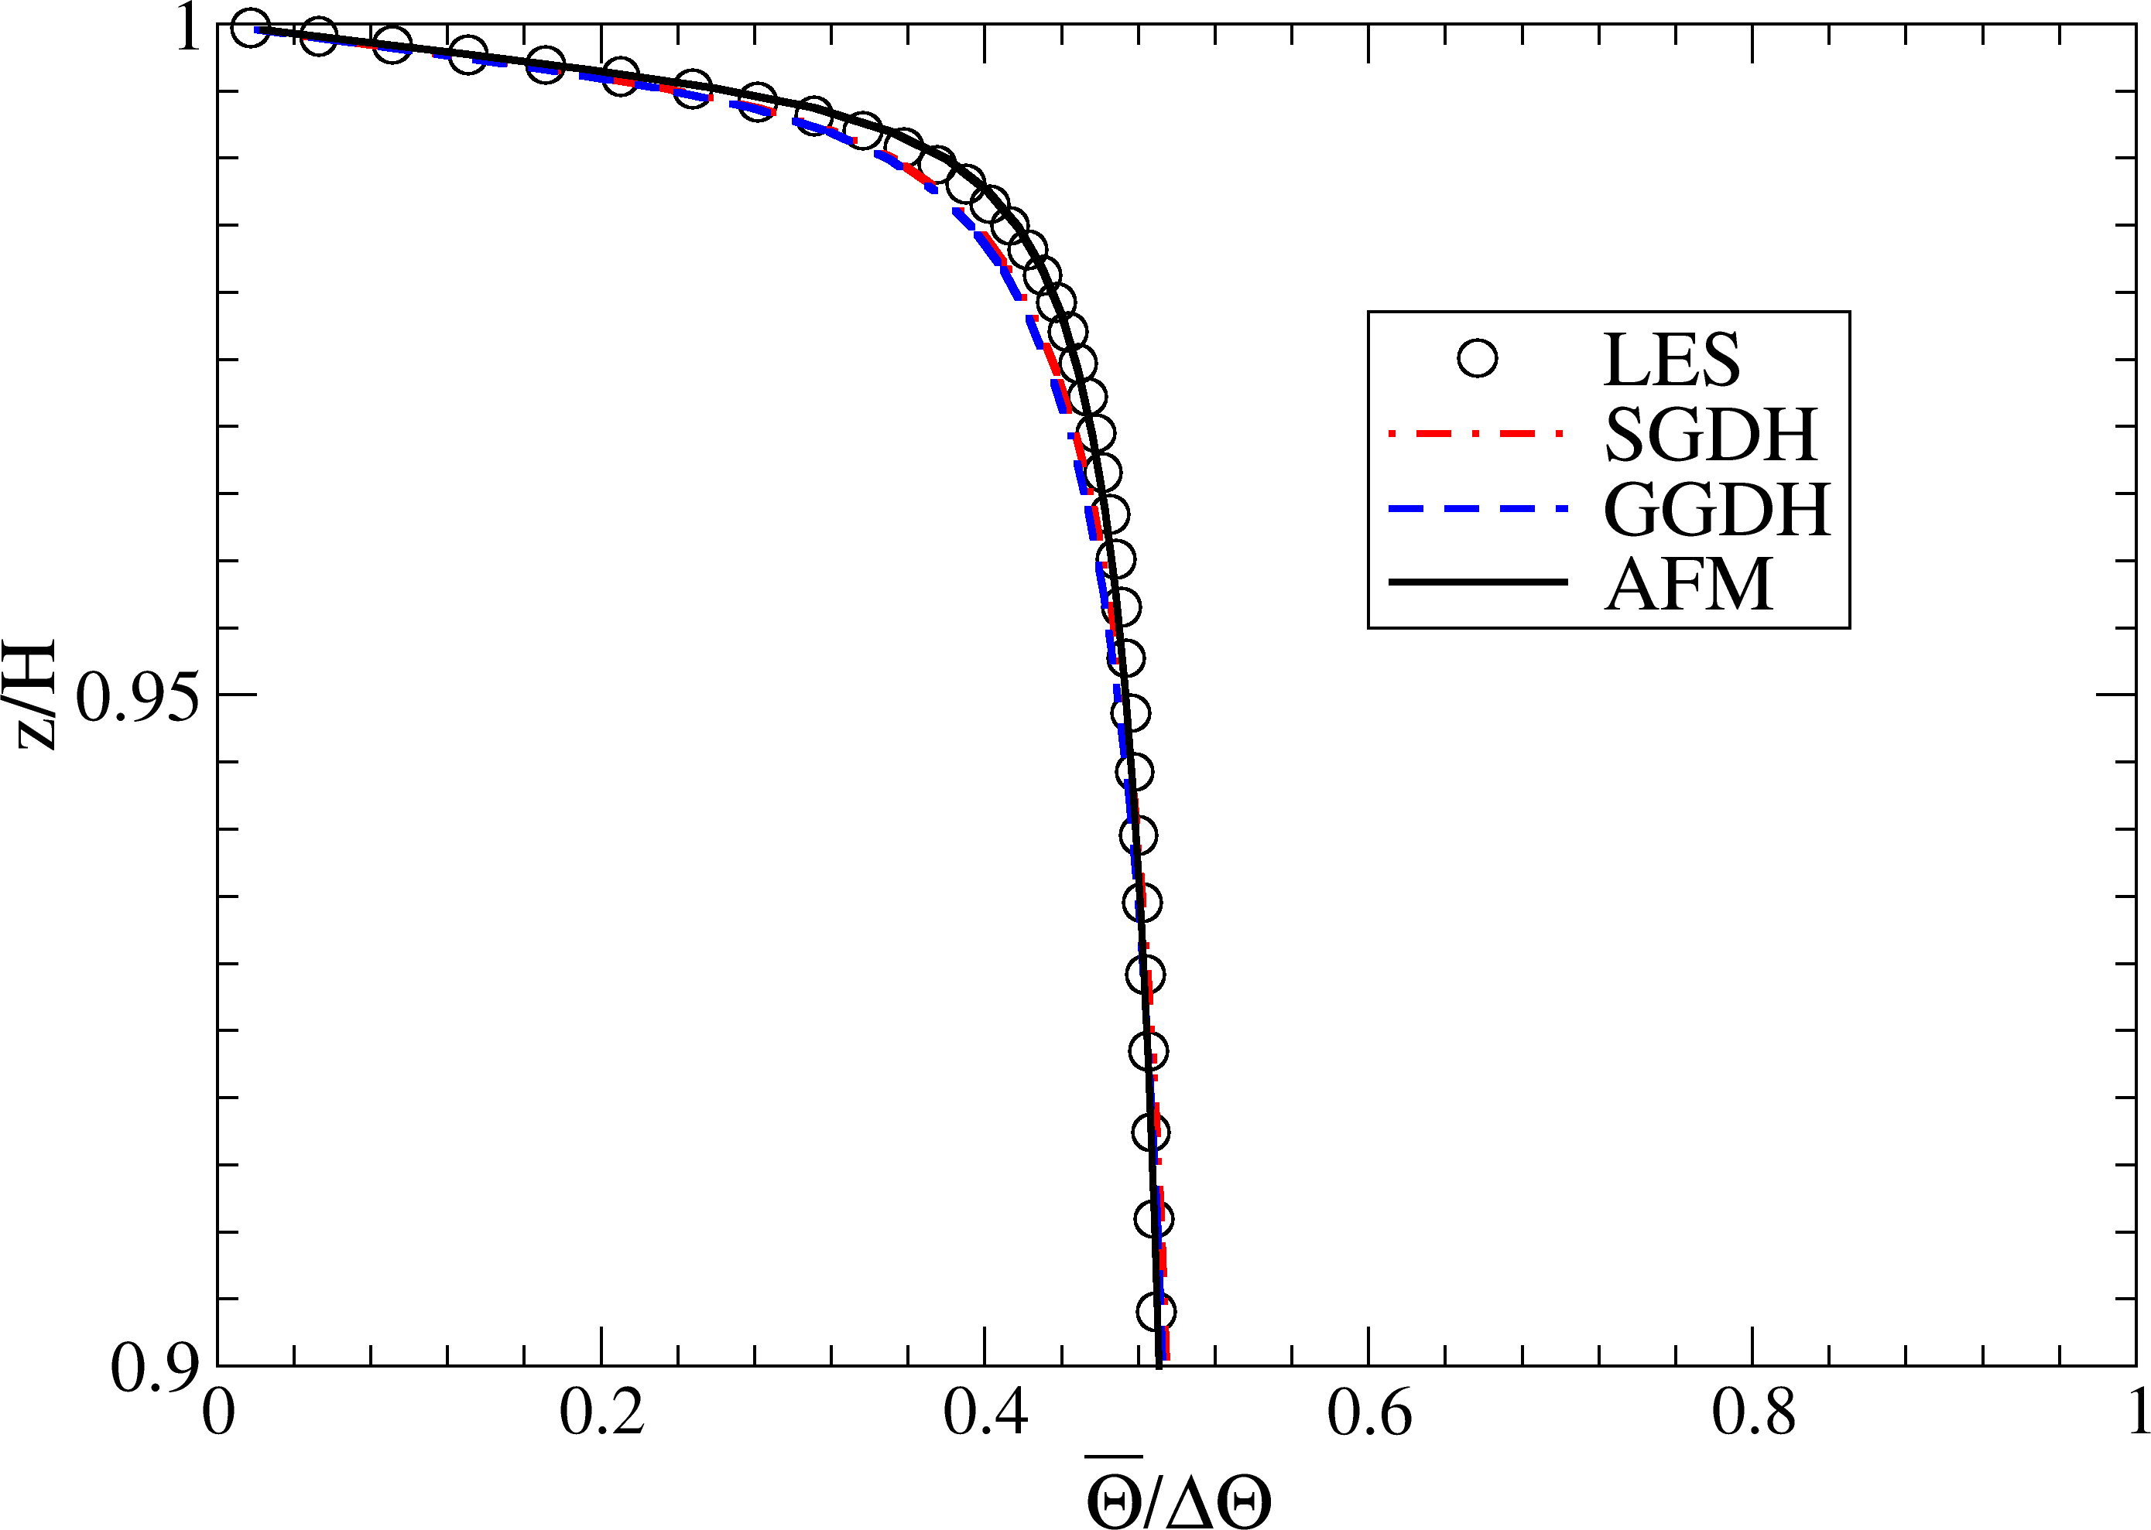
(a)
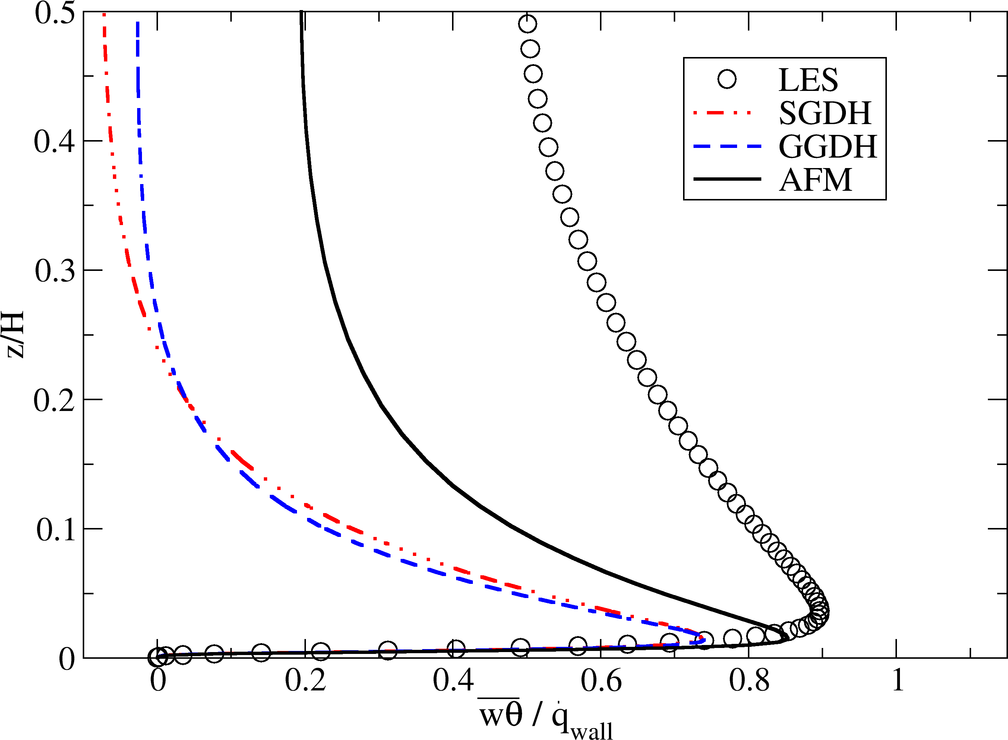
(b)
Figure 3 (a) Mean temperature profiles and (b) turbulent heat flux obtained by SGDH, GGDH and AFM compared to LES

IV. Conclusions

We demonstrate a unique potential of the elliptic-blending eddy viscosity model for more sophisticated modeling of the turbulent heat flux by using the GGDH and AFM formulations since the ζ–f model contains an approximation of the Reynolds stress component in the wall-normal direction. The model is tested for two standard benchmark cases, heat-driven cavity where vertical walls are heated, and Rayleigh-Bénard convection with the heat transfer direction normal to the horizontal walls. The Rayleigh-Bénard convection results show limitation of the GGDH formulation since the model has the same problem as SGDH, namely the turbulent heat flux is only a function of the temperature gradient. This results in an underestimation of the modeled component of the turbulent transport of heat in the core of the domain where the mean temperature gradient is zero. However, the Nu number in the heat-driven cavity is somewhat better predicted by GGDH due to a fine balance of the turbulent and laminar regions which is disturbed by an excessive modeling energy produced by the AFM model through the buoyancy-driven production of the turbulent kinetic energy G_{k}. The AFM coefficients ξ and η had to be reduced from 0.6 to 0.1. This emphasis a need to re-examine the AFM coefficients by using a recent DNS and LES data of the canonical cases with high Rayleigh number. The ζ-f model combined by the GGDH or AFM formulations of the turbulent heat flux is a promising new approach to complex, industry-relevant fluid flows with heat transfer at high Rayleigh number.

References

- Bailon-Cuba, J., Emran, M.S., Schumacher, J., 2010. Aspect ratio dependence of heat transfer and large-scale flow in turbulent convection. Journal of Fluid Mechanics 655, 152–173
- Blass, A., Verzicco, R., Lohse, D., Stevens, R.J.A.M., Krug, D., 2021. Flow organization in laterally unconfined Rayleigh–Benard turbulence. Journal of Fluid Mechanics 906, A26.
- Dol, H., Hanjalić, K., Kenjereš, S., 1997. A comparative assessment of the second-moment differential and algebraic models in turbulent natural convection. International Journal of Heat and Fluid Flow 18, 4–14.
- Hanjalić, K., Launder, B., 2022. Modelling Turbulence in Engineering and the Environment: Second-Moment Routes to Closure. Cambridge University Press; 2nd edition.
- Ince, N., Launder, B., 1989. On the computation of buoyancy-driven turbulent flows in rectangular enclosures. International Journal of Heat andFluid Flow 10, 110-117.
- Jameel, S.M.S., Manceau, R., Herbert, V., 2019. Sensitization of eddyviscosity models to buoyancy effects for predicting natural convection flows, in: HEFAT 2019 - 14th International Conference on Heat Transfer, Fluid Mechanics and Thermodynamics, Wicklow, Ireland. URL: https://hal.science/hal-02129153.
- Kenjereš, S., Gunarjo, S., Hanjalić, K., 2005. Contribution to elliptic relaxation modelling of turbulent natural and mixed convection. International Journal of Heat and Fluid Flow 26, 569–586. CHT’04.
- Kenjereš, S., Hanjalić, K., 2006. LES, T-RANS and hybrid simulations of thermal convection at high Ra numbers. International Journal of Heat and Fluid Flow 27, 800 – 810.
- Manceau, R., 2023. Comparison of turbulence models for the case of a differentially heated square cavity, in: 17th ERCOFTAC SIG15/MONACO2025 workshop: Turbulent natural convection flows in differentially heated cavities Pau, France. URL: https://inria.hal.science/hal-03970025.
- Sebilleau, F., Issa, R., Lardeau, S., Walker, S.P., 2018. Direct numerical simulation of an air-filled differentially heated square cavity with Rayleigh numbers up to 1011. International Journal of Heat and Mass Transfer 123, 297–319.

