**Numerical Evaluation of Crack in the Nuclear Reactor Pressure Vessel Using Extended Finite Element Method Technique**

Muhammad Moazam Aslam1, Atique Ahmad1, HaseebYaqoob2, *, Hafiz Muhammad Ali2,3, *

*1 Department of Mechanical Engineering, PIEAS Nilore, 45650, Islamabad, Pakistan*

*2 Mechanical Engineering Department, King Fahd University of Petroleum and Minerals (KFUPM), Dhahran, Saudi Arabia*

*3 Interdisciplinary Research Center for Renewable Energy and Power Systems (IRC-REPS), King Fahd University of Petroleum and Minerals, Dhahran, Saudi Arabia*

*Corresponding Author:* [*hafiz.ali@kfupm.edu.sa*](mailto:hafiz.ali@kfupm.edu.sa)*;* [*haseeb.yaqoob@kfupm.edu.sa*](mailto:haseeb.yaqoob@kfupm.edu.sa)

Abstract – *This study presents the computation of stress intensity factor (SIF) due to mechanical stress generated under tensile loading regarding a semi-elliptic surface crack initiated inside a finite plate. The analysis is further extended to study the effect of mechanical stresses on SIF for a reactor pressure vessel (RPV) having an elliptic corner surface crack at the location of the cylinder-nozzle intersection, which is considered the point of highest stress concentration. The specimen considered for the finite plate having a semi-elliptic surface crack is stainless steel under tensile loading of 200 MPa, and for RPV having an elliptic corner surface crack at the location of cylinder-nozzle intersection under design pressure of 17.16 MPa, the material parameters correspond to SA-533 Grade B Class-1. The crack propagation depends upon the material's fracture toughness; if SIF under mechanical loading exceeds the material's fracture toughness, the crack propagates, leading to failure. The results obtained regarding SIF for a finite plate having a semi-elliptic surface crack considering worst case scenario is 56 MPa√𝑚 and for RPV with elliptic surface crack is 141.7 MPa√𝑚, which is below the fracture toughness of the material showing safe design. This study uses the extended finite element method (XFEM) in open-source software (SALOME MECA) to exemplify its application and accuracy. The results are validated for both cases with a difference of less than 4% for the finite plate and 6 % for RPV. The difference in results is due to limitations in computational power and mesh refinement.*

**Keywords:** Extended Finite Element Method (XFEM), Semi-Elliptic Crack, SALOME MECA, Stress Intensity Factor, Reactor Pressure Vessel, Westinghouse RPV

I. Introduction

It is extensively recognized that flaws associated with the material can lead to catastrophic letdowns for engineering structures that include pre-cracks and fatigue-associated cracks originating at a point with the highest stress concentration. The semi/quarter elliptic crack is used to illustrate surface cracks. Surface cracks related to finite geometries can be studied using analytical techniques. However, infinite geometries require techniques associated with numerical and experimental regimes [1-3]. Analytical techniques haven't been able to deliver information regarding SIF due to larger stress gradients and changing stress fields at existing crack areas. Practical applications include a large library of components subjected to mechanical and thermal loadings, i.e., reactor pressure vessels (RPV) exposed to high pressure and temperatures causing mechanical and thermal stress. Fracture analysis associating these components is considerably more complicated than the erratic behavior of cracks under mechanical and thermal stresses [4]. Considering these complicities, techniques like the finite element (FEM) method or extended finite element (XFEM) method for analysis provide a better understanding of predicting crack behavior and calculating stress intensity factors along the complete crack front. Taking inspiration from the study of Irwin [5], numerous scholars have studied surface cracks associated with diverse geometries and loading environments in the passage of the past few decades. Few of the primary approaches involved methods such as the boundary method [6-8], the alternating method [9-11], the line spring method [12, 13], the virtual crack extension method [14, 15], and the weight function method [16-19]. Subsequently, the advancements in the processing power of computers and accessibility of finite element method. FEM and XFEM are prioritizing the study associated with surface cracks. The study of surface cracks inside RPVs has been given more importance as its failure could lead to catastrophic failures and loss of property and precious lives [20-22]. The researchers have performed multiple structural integrity analyses of RPV under normal and inadvertent conditions, including thermal shocks and high-pressure loadings [21, 23, 24]. XFEM is also called the partition of unity or generalized finite element method. This technique is an extension of FEM, which uses different equations with discontinuous functions. The main idea was to solve the problem that easily requires mesh refinement; one of its applications is in Fracture Mechanics. XFEM's advantage over FEM is that the mesh doesn't need to be updated to keep track of moving interface-like cracks. This method proved to be more general in solving moving interfaces like cracks, holes, or biomaterial interfaces with the help of suitable basis functions. XFEM is mostly used for two problems with weak and strong discontinuities. Strong discontinuities like displacements of nodes in crack analysis and weak discontinuities are represented as derivatives of strong discontinuities like strains [25, 26].

A prior study has been made in calculating SIF for a typical Westinghouse pressurized water reactor (PWR) under fracture mechanics study. The reactor pressure vessel (RPV) is a cylindrical pressure vessel containing two loops with a hemispherical top head and bottom. Reactor coolant is light water which is highly pressurized that enters RPV through two set-in nozzles; following its design path, it flows through the core of the reactor to remove heat without causing any bubble formation (see Fig. 8). After heat removal, the coolant flows out from RPV through two set-out nozzles. To prevent heat loss to surroundings from RPV, isolation called reactor vessel insulation is provided (RVI). The pressure inside RPV is maintained at 15.2 MPa to avoid any bubble formation due to the high temperature of the coolant. A fracture mechanics analysis regarding RPV has been performed under thermal and mechanical loadings considering a semi-elliptic surface crack at a nozzle-cylinder intersection which is considered a point of highest stress concentration (HSCP) using the finite element method (FEM) in ANSYS [27]. This same study has been performed using the extended finite element method (XFEM) in an open-source software named SALOME MECA to validate the effectiveness and accuracy of this method by comparing the results and the effectiveness of SALOME MECA.

II. System dEscription

Several solutions exist regarding calculating SIF for semi-elliptic surface cracks inside finite plates. Among those, an empirical relation projected through Newman and Raju [28] is accessible and extensively utilized for evaluation and authentication objectives. The empirical relation proposed in ref. [28] is demonstrated here.

$K_{I}=(S_{t}+HS_{b})\sqrt{π\frac{a}{Q}F(\frac{a}{t_{p}},\frac{a}{c},\frac{c}{b},ϕ})$ (1)

Where Q is taken as $Q ≅1+4.593{(\frac{a}{c})}^{1.65}$. F and H are given through Newman and Raju [28].

The calculation of SIF of the finite plate having semi-elliptic surface crack under uniform tensile loading is done initially, followed by computation of SIF for RPV containing semi-elliptic surface crack at nozzle cylinder interface considered HSCP.

***II.A. Semi-elliptic surface crack inside finite plate***

The purpose was to analyze the accuracy of the approach using the XFEM technique. A finite rectangular plate was considered made of steel with dimensions 2h=2000 mm, 2b=1000 mm, and tp=500 mm having a semi-elliptic edge crack at the middle with a/tp=0.05. A force of tension T=100 MN is being applied on the upper and bottom faces. Showing this is the case of mode one opening. All parameters are demonstrated in Fig. 1 (a) and (b).

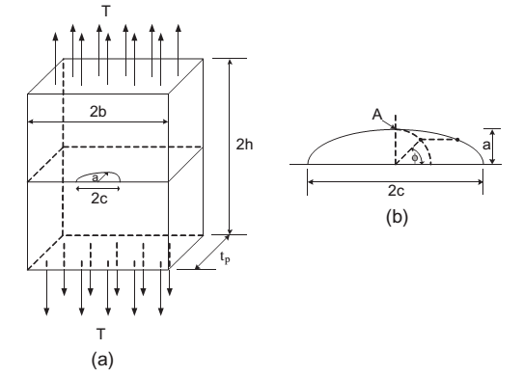

*Fig. 1. (a) finite plate having a semi-elliptic surface crack. (b) Enlarged view of crack parameters*[27]

***II.A.A. Geometry Modeling***

The geometry of the finite plate is modeled according to the parameters shown in Fig. 1(a), and later semi-elliptic surface crack plain is modeled according to Fig. 1(b). The semi-elliptic crack geometry is placed at the specified location shown in Fig. 1(a). The following specimen is structural steel with Poisson's ratio ν=0.30 and E=200 GPa. The extended finite element model prepared in SALOME MECA for fracture analysis under mode-1 opening is shown in Fig. 2.

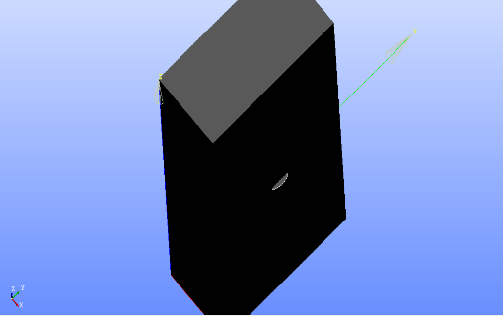

*Fig. 2. Geometry modeled in SALOME MECA*

***II.A.B. Meshing***

Tetrahedral mesh is used for the entire geometry, and refinement is done with the help of code in SALOME MECA. The code requires the initial size of the mesh and the final size of choice to be achieved in the crack zone. This software runs several iterations during the refinement until the final size of the mesh is achieved. These number of iterations are calculated inside the code using the following formula.

$n=(log\left(h_{0}\right)-log⁡(h_{c}))/log⁡(2)$ (2)

Where 'ho' is the initial size, 'hc' is the final size of the mesh and 'n' is number of iterations required to achieve the final mesh size . Meshing, along with refinement, is shown below in Fig. 3.

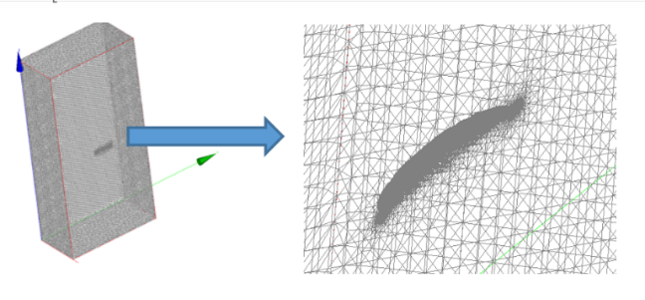

*Fig. 3. Tetrahedral mesh with refined crack zone*

The accuracy of the solution is very much dependent upon the refinement of the crack zone.

***II.A.C. Validation of the fracture model***

To validate the fracture model, the computation of SIF for a semi-elliptic surface crack inside a finite plate is done initially. The study of SIF for semi-elliptic surface cracks inside finite plates under tensile loading is done under several different approaches in various literature. Among the literature, the empirical solution (Eq. 1) proposed by Newman and Raju [28] is still extensively used for validation and verification.

The main area of interest in crack analysis is the stress intensity factor. As mentioned before this is the case of mode 1 opening so the value of K2 (mode 2) and K3 (mode 3) are so small that they can be neglected and only value considered here is K1.

Fig. 4 shows the comparison between empirical solution of Newman and Raju with the later study done in research paper [27] using FEM in ANSYS. Fig. 5 shows the study done using XFEM in an Open-Source software SALOME MECA. The SIF calculation along the whole crack front from ɸ = 0o to 180o for crack size varying between 0.2<a/c<0.4 shows good agreement with the results of prior studies shown in Fig. 4 with a difference of less than 4 % showing the accuracy of the current study model, thus validating the current fracture model. The result can be more refined in SALOME MECA, making it more accurate as it depends on mesh size and refinement, which require more computational power and time.

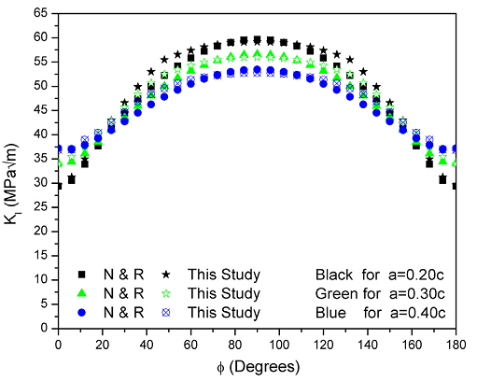

Kmax=58 MPa $\sqrt{m}$

*Fig. 4. Results obtained from Newman and Raju (N&R) & Murtaza, U.T. and M.J. Hyder (this study)* [27]

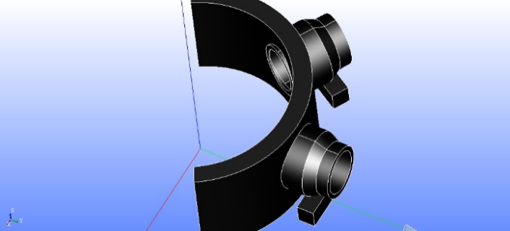

*Fig. 5. Stress intensity factor (mode 1) obtained from SALOME MECA*

***II.B. Semi-elliptic surface crack in RPV***

The analysis can now be extended to a reactor pressure vessel with a semi-elliptic surface crack at the highest stress concentration point (HSCP), a nozzle-cylinder interface. Westinghouse RPV with set-in and set-out nozzle was considered for the analysis under the mechanical design inner pressure of 17.16 MPa. Instead of considering the entire pressure vessel, only the part of the pressure vessel (Fig. 6) containing the nozzle was considered for the analysis here; this reduced the computation time and memory.

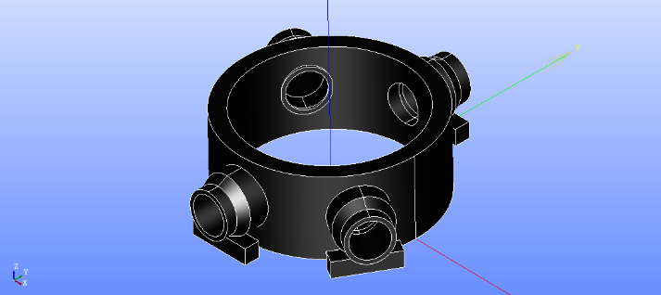

*Fig. 6. Section of the pressure vessel under consideration*

Applying the symmetry principle, it can be further reduced to Fig. 7. This further helps reduce computational time and provides an opportunity to increase further mesh refinement, which is a key component for extended finite element method XFEM for achieving accurate results. The modeling parameters are shown in Fig. 8 and Fig. 9, which include the reactor pressure vessel's parameters and the nozzles' location.

*Fig. 7. Symmetrical View*

All Parameters shown in Fig. 8 and Fig.9 are in millimeters (mm)

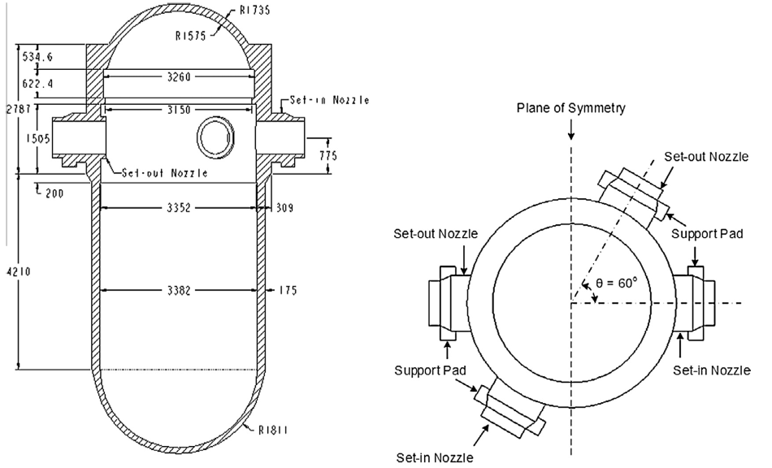

*Fig. 8. Reactor Pressure Vessel standard diagram* [27]

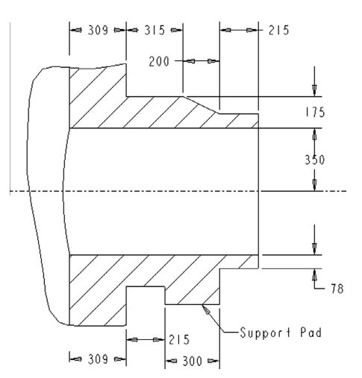

*Fig. 9. Nozzle dimensions* [27]*.*

***II.B.A. Meshing***

Tetrahedral mesh is used for the finalized geometry, and mesh refinement is done on the same principle as Eq.2. The detail of several elements created as a result of the final mesh can be seen in the following Fig. 10. SALOME MECA automatically refines the mesh around crack geometry accordingly. The refinement around crack geometry is also the key parameter for accurate results. The placement of a semi-elliptic surface crack in a reactor pressure vessel and refined mesh around crack geometry can be seen in Fig. 14, with a better view of crack mesh refinement in Fig. 15.

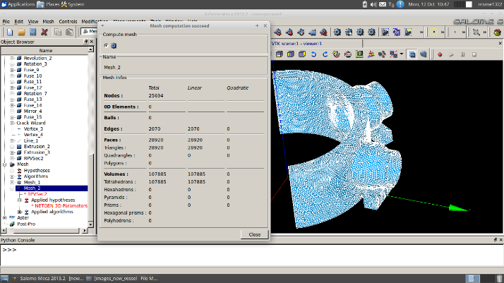

*Fig. 10: Tetrahedral mesh and interface of SALOME MECA*

***II.B.B. Boundary condition and loading***

An inner pressure of 17.16 M Pa is being applied on this RPV with a pressure plane visible in Fig. 11, which is its designed pressure.

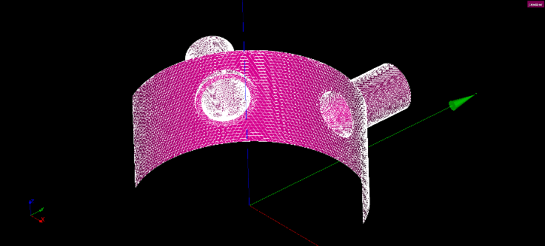

*Fig. 11: Pressurized face view*

Applying the symmetrical boundary conditions, the highlighted part is considered fixed in Fig. 12.

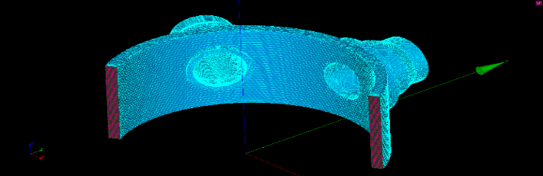

*Fig. 12: Symmetrical Conditions*

***II.B.C. Material***

Steel is used as a default material for the linear elastic analysis with Poisson's ratio of ν=0.3, elasticity modulus E= 187 GPa with a fracture toughness of 153 MPa $\sqrt{m}$.

***II.B.D. Semi elliptic crack***

Semi elliptic edge crack is introduced at the location of RPV and nozzle intersection, which is also considered as the point of HSCP to analyze the integrity of the design pressure vessel and whether it could withstand the crack or stop it from propagating further.

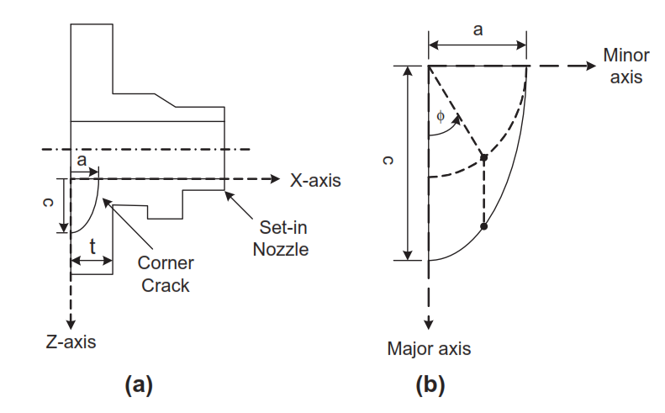

*Fig. 13: (a) Edge crack's orientation, (b) parameters of crack* [27]

Semi elliptic surface edge is introduced in the set-in nozzle of RPV. Regarding fracture mechanics linear elastic analysis, 48 surface cracks based on variable sizes were introduced in RPV at the cylinder and set-in nozzle intersection. Location and crack's orientation can be seen in Fig. 13(a) and its parameters in Fig. 13(b) having the following limits, 0.33<a/c<1.0 and 0.01<a/t<0.25 where "a" represents the semi-minor axis of the crack and "b" represents the semi-major axis of the crack and "t=309 mm" is the thickness of a section of the nozzle where the crack is introduced (Fig. 15). Crack limits are designed such that these include the crack with worst-case scenario permitted by Appendix G ASME III, Div. 1 [27] with dimensions a=0.33c and a=0.25t. Stress intensity factors SIFs under mode-1 opening is the main focus of interest which is calculated for all 48 cracks based on variable dimensions leading to the last worst-case scenario crack. SIF provides information regarding crack propagation under applied pressure conditions. Results obtained from all 48 cracks for stress intensity factors (SIF) under mode-1 opening K1 can be seen in Fig. 16 (i-vi).

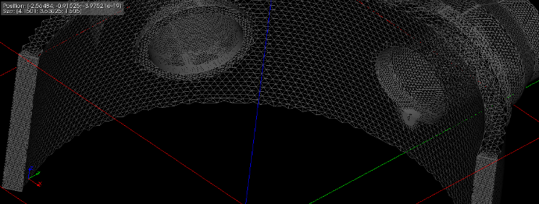

*Fig. 14: Crack location and mesh enrichment around the crack*

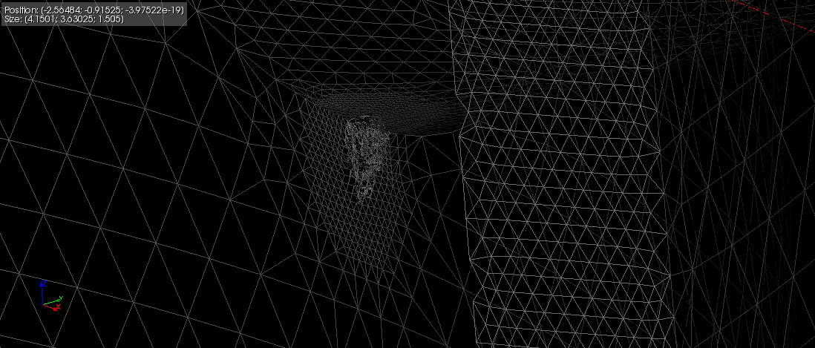

*Fig. 15: Enlarged view of the crack enrichment area*

***II.B.E. Results***

The SIF solutions include an entire crack front for 48 complete elliptic cracks under solely pressure loading ($K_{I}^{p}$) are shown in Fig. 16. it's visible in Fig. 16 (i-vi) that. as the ratio a/c keeps on increasing (for entire values of a/t), at ǿ=0o also keeps on increasing whereas at ǿ=90o it decreases.

It can be seen clearly in Fig. 16(i-vi) that the SIF corresponding to all 48 cracks is lesser as compared to the steel's fracture toughness of nuclear grade itself, which is $K_{Ic}=153 MPa√m$. Considering the crack size with the worst-case scenario (a=0.33c & a=0.25t) results in (Fig. 16(vi)) which is lesser compared to the fracture toughness of the material under study. It shows that crack growth will not be possible even considering the scenario with the worst-case as per ASME Code [29]. That's why the Westinghouse RPV composed of steel based on nuclear grade (SA-533 Gr.B, C1.1) has proven to be a safe design even for a worst-case scenario crack in RPV at HSCP.

III. Conclusion

This analysis aims to understand and exemplify the application of XFEM for calculating SIFs numerically. The fracture model was validated prior proceding to study of SIFs for RPV having semi-elliptic crack at HSCP under only pressure loading. The results obtained for fracture model were compared with previous study of Newman and Raju (N&R). The main conclusions drawn from this study are given below:

* The crack propagation depends on whether SIF developed under the loading is high enough to pass the fracture toughness of the material. The Westinghouse reactor pressure vessel composed of nuclear grade steel SA-533 Gr.B, Cl.1 has considered to be a secure design based on calculations, which shows considering the development of worst case scenario crack in RPV at the HSCP permissible according to the ASME code [29], the maximum value of SIF along the whole crack front from ɸ =0o to 90o is which is below the fracture toughness $K_{Ic}=153 MPa√m$ of the material.
* The results could be refined depending on the mesh refinement in XFEM analysis, which requires more computational power and time. Still, it shows good agreement with the results of previous study [27].

(i) (ii)

**a=0.15t**

**a=0.1t**

**a=0.05t**

(iii) (iv)

**a=0.2t**

(v) (vi)

*Fig. 16. SIFs along the whole crack front under pressure only condition at set-in nozzle cylinder intersection for all 48 cases*

**Nomenclature**

|  |  |
| --- | --- |
| PWR | Pressurized water reactor |
| RPV | Reactor pressure vessel |
| HSCP | Highest stress concentration point |
| SIF | Stress intensity factors |
| t | Wall thickness of RPV at the set-in nozzle cylinder intersection |
| a | Semi-elliptical surface crack depth represented as Minor axis of crack |
| c | Half-length /major axis corresponding to semi-elliptical surface crack |
| Pint | internal pressure |
| $$K_{I}$$ | Stress intensity factor under mode-I |
| $$K_{p}^{I}$$ | Mode-I stress intensity factor under pressure loading alone |
| $$K_{Ic}$$ | Material's fracture toughness |
| ɸ | face angle of crack in degrees |
| ν | Poisson's ratio of the selected material |
| Q | flaw shape parameter |

**References**

1. Ramesh, K., D. Chauhan, and A. Mallik, *Free vibration of an annular plate with periodic radial cracks.* Journal of sound and vibration, 1997. **2**(206): p. 266-274.

2. Ramesh, K., S. Gupta, and A.A. Kelkar, *Evaluation of stress field parameters in fracture mechanics by photoelasticity—revisited.* Engineering Fracture Mechanics, 1997. **56**(1): p. 25-45.

3. Ramesh, K., et al., *Numerical evaluation of sif for radial cracks in thick annular ring using cyclic symmetry.* Engineering fracture mechanics, 1997. **56**(2): p. 141-153.

4. Uslu, M., O. Demir, and A.O. Ayhan, *Surface cracks in finite thickness plates under thermal and displacement-controlled loads–Part 1: Stress intensity factors.* Engineering Fracture Mechanics, 2014. **115**: p. 284-295.

5. Irwin, G.R., *Crack-extension force for a part-through crack in a plate.* Journal of applied Mechanics, 1962. **29**(4): p. 651-654.

6. Guozhong, C., Z. Kangda, and W. Dongdi, *Stress intensity factors for semi-elliptical surface cracks in plates and cylindrical pressure vessels using the hybrid boundary element method.* Engineering fracture mechanics, 1995. **52**(6): p. 1035-1054.

7. Saleh, A. and M. Aliabadi, *Crack growth analysis in concrete using boundary element method.* Engineering fracture mechanics, 1995. **51**(4): p. 533-545.

8. Cruse, T.A., *Application of the boundary-integral equation method to three dimensional stress analysis.* Computers & Structures, 1973. **3**(3): p. 509-527.

9. Thresher, R.W. and F.W. Smith, *Stress-intensity factors for a surface crack in a finite solid.* 1972.

10. Smith, F., A. Emery, and A. Kobayashi, *Stress intensity factors for semicircular cracks: Part 2—Semi-infinite solid.* 1967.

11. Liao, C. and S. Atluri, *Stress intensity factor variation along a semicircular surface flaw in a finite-thickness plate.* Engineering fracture mechanics, 1989. **34**(4): p. 957-976.

12. Hua, T.-D. and H. Abé, *A simplified analysis of the dynamic stress-intensity factors for the part-through surface crack in an elastic plate.* Computational mechanics, 1990. **5**(6): p. 469-478.

13. Sethuraman, R. and I.T. Ilango, *Analysis of interacting semi-elliptical surface cracks in finite thickness plates under remote bending load.* International journal of pressure vessels and piping, 2005. **82**(7): p. 528-545.

14. Miyazaki, N., et al., *Stress intensity factor analysis of interface crack using boundary element method: Application of virtual crack extension method.* JSME international journal. Ser. A, Mechanics and material engineering, 1993. **36**(1): p. 36-42.

15. So, W., K. Lau, and S. Ng, *Determination of stress intensity factors for interfacial cracks using the virtual crack extension approach.* Computer Modeling in Engineering and Sciences, 2004. **5**(3): p. 189-200.

16. Shen, G. and G. Glinka, *Weight functions for a surface semi-elliptical crack in a finite thickness plate.* Theoretical and Applied Fracture Mechanics, 1991. **15**(3): p. 247-255.

17. Zhao, W., X. Wu, and M. Yan, *Weight function method for three dimensional crack problems—I. Basic formulation and application to an embedded elliptical crack in finite plates.* Engineering Fracture Mechanics, 1989. **34**(3): p. 593-607.

18. Zhang, B., W. Xu, and X.-R. Wu, *Weight function method and stress intensity factor for two unsymmetric through-thickness and quarter-elliptical corner cracks at circular hole.* Engineering Fracture Mechanics, 2022. **264**: p. 108361.

19. Chirino, F. and J. Dominguez, *Dynamic analysis of cracks using boundary element method.* Engineering Fracture Mechanics, 1989. **34**(5-6): p. 1051-1061.

20. Kussmaul, K., et al., *Formation and growth of cracking in feed water pipes and RPV nozzles.* Nuclear Engineering and Design, 1984. **81**(1): p. 105-119.

21. Li, Y., et al., *Engineering critical assessment of RPV with nozzle corner cracks under pressurized thermal shocks.* Nuclear Engineering and Technology, 2020. **52**(11): p. 2638-2651.

22. Zheng, Y., et al., *Constraint characterization and fracture initiation analysis for semi-elliptical surface cracks in reactor pressure vessel.* International Journal of Pressure Vessels and Piping, 2023. **202**: p. 104910.

23. Trampus, P., *Pressurized Thermal Shock analysis of the reactor pressure vessel.* Procedia Structural Integrity, 2018. **13**: p. 2083-2088.

24. Thamaraiselvi, K. and S. Vishnuvardhan, *Fracture studies on reactor pressure vessel subjected to pressurized thermal shock: A review.* Nuclear Engineering and Design, 2020. **360**: p. 110471.

25. Curiel-Sosa, J., et al., *Computational techniques for simulation of damage and failure in composite materials*, in *Structural Integrity and Durability of Advanced Composites*. 2015, Elsevier. p. 199-219.

26. Giot, R. and A. Giraud, *Stability, accuracy, and efficiency of numerical methods for coupled fluid flow in porous rocks*, in *Porous Rock Fracture Mechanics*. 2017, Elsevier. p. 257-283.

27. Murtaza, U.T. and M.J. Hyder, *The effects of thermal stresses on the elliptical surface cracks in PWR reactor pressure vessel.* Theoretical and Applied Fracture Mechanics, 2015. **75**: p. 124-136.

28. Newman Jr, J. and I. Raju, *An empirical stress-intensity factor equation for the surface crack.* Engineering fracture mechanics, 1981. **15**(1-2): p. 185-192.

29. Boiler, A., *pressure vessel Code.* Section III: Rules for Construction of Nuclear Facility Components, Division, 2013.