**Bubble transport during SGTR accident in lead-cooled fast reactor: A machine learning**

Kejian Dong, Jiyun Zhao*

# Department of Mechanical Engineering, City University of Hong Kong

*Tat Chee Avenue, Kowloon Tong, Hong Kong, China*

*Email: jiyuzhao@cityu.edu.hk*

Abstract – Steam generator tube rupture (SGTR) is one of the safety issues for pool type lead-cooled fast reactors (LFR). After high-pressure water is injected into the lead pool, the subsequently generated steam bubble would transport to the core and affect the heat transfer performance. This paper addresses tracking the bubble motion using an Eulerian-Lagrangian method in CFD based on the ELSY primary system model at 1/8 centrosymmetric structure. The steady bubble distributions in the system under different leakage heights are obtained. Furthermore, the simulation results are predicted by machine learning, where Gaussian Process Regression (GPR) is employed for steady conditions. The prediction results by the kernel function of ARD Rational Quadratic show the best accuracy in predicting the percentages of bubbles reaching the core, top of the steam generator, and staying in the system, with a total RMSE of 3.22%. In conclusion, machine learning algorithms have great potential to predict bubble transport in the primary system of lead-cooled fast reactor after SGTR.

**Keywords:** LFR, SGTR, Bubble transport, Machine learning

I. Introduction

Lead-cooled fast reactor has received much attention as one of the most promising GEN-IV advanced reactors due to its benefits in terms of both economic and safety [1, 2]. In the majority design of the LFR system, the steam generator is directly immersed in the lead pool to make the system more compact. Since the high pressure difference between the primary system and secondary side, as well as the corrosion on the tubes, steam generator tube rupture accident would probably happen [3]. Such interaction would lead to severe safety issues including affecting the reactor integrity and introducing positive reactivity [4]. As previous research demonstrated [5], the process of SGTR is classified into four concurrent stages after water is injected into the primary system: 1) pressure wave, 2) Liquid displacement and sloshing, 3) Steam explosion, and 4) Bubble entrapment and transport. Based on the research result [6], the small bubble with diameter of 0.5 mm would uniformly distribute in the whole core, while the bubbles would stuck in spacers or core inlet with larger diameters. After the vapor entering into the core, the decreased coolant density would introduce positive reactivity and lead to the power excursion [7]. Then, it is potential to burnout and damage because of the increased cladding temperature, subsequently posing threats to the reactor integrity. Therefore, it is significant to carry out the safety assessment after SGTR in lead-cooled fast reactor.

Meanwhile, some separated liquid metal-water interaction experiment and simulation are performed to investigate the more detailed phenomenon and related mechanism after SGTR. Since the lead-based coolant is invisible to investigate the two-phase behavior after the interaction, some new methods were developed. A high-speed and simultaneous technique was developed based on a bifunctional probe to measure the fluid temperature and phase to detect the interaction [8]. Coupled with neutron radiography , the cavity behavior and boiling characteristics were obtained from a series of experiments of water jetting into the LBE pool. Also, the visualized experiment was carried out based on the gamma rays to study the bubble and cavitation behavior in LBE pool via injecting nitrogen [9]. Furthermore, there were some visualization experiment employing some alternative liquids. For example, ethanol was injected into the high-temperature FC-3283 pool to study the jet boiling behavior [10]. The penetration depth and flow regimes were studied between high-pressure air and water pool, considering that the surface tension and viscosity of water and LBE were comparable [11].

Furthermore, with the rapid development of Artificial Intelligent, machine learning is playing an essential role in many fields because of its accuracy and robustness. Various machine learning algorithms are developed, e.g., artificial neural network (ANN), and Gauss process regression (GPR), and support vector regression [12]. In term of heat transfer, the heat transfer coefficient in the heat exchangers, critical heat flux, and minimum film boiling temperature were predicted by adapting Gauss process regression, radial basis function, etc. [13-16]. Moreover, the advanced machine learning method provides assistance in nuclear power plants, such as predicting short-term parameters [17] and diagnosing reactor severe accidents [18].

In summary, investigating the bubble transportation after SGTR accident is essential for the safety design and assessment of LFR. Predicting the bubble location in the system becomes feasible with the assistance of machine learning. In this paper, the steady bubble transportation characteristics after SGTR are quantified, and then the machine learning model is trained and tested based on the simulation dataset.

II. Methodology

***II.A. CFD simulation***

In this paper, we carry out the simulation by selecting the conceptual design of ELSY (Europe Lead Cooling System), which satisfies the goals of Generation IV [19]. The designed electrical power is 600 MW with a 42% thermal efficiency. By putting the core, steam generator and pump in the pure lead pool, the whole system becomes more compact. After being cooled in steam generator, the primary coolant will directly flows back into the core. We establish a 1/8 centrosymmetric model of the primary system in consideration of the symmetric structure of the ELSY system [20, 21], as depicted in Fig. 1. The specific layout of ELSY system can be found in [19].

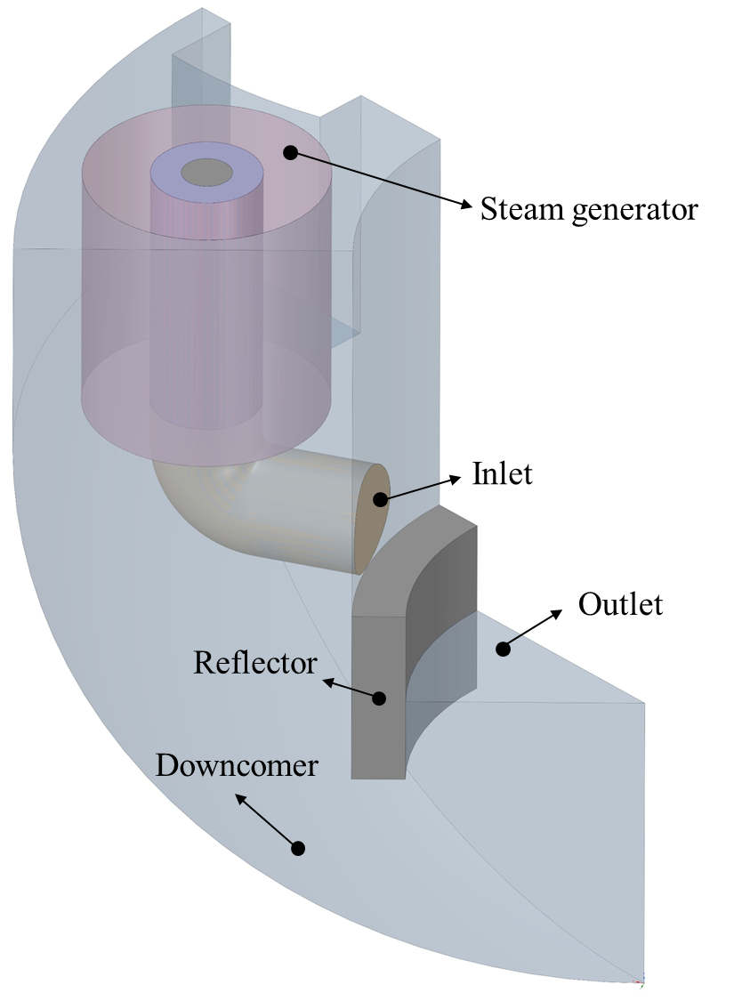

*Fig. 1. The geometric model*

The simulation calculation is carried out using Ansys Fluent [22]. The velocity and temperature of the inlet in the calculation domain are 1.242 m/s and 480 °C, respectively [23]. The outlet of the calculation domain is the core inlet and is set as the pressure outlet. The steam generator is simplified as a porous hollow cylinder with an energy source, which refers to Dong et al. [23]. Kays model is employed as the turbulence-Prandtl-number model on the basic of Standard *k-ε* to simulate the liquid metal flow in primary system [24, 25].. After generating the unstructured polyhedral cells via Fluent Meshing, the mesh independence analysis is performed by adapting four types of mesh structure with the cell number ranging from 0.4 million to 2.94 million. The core inlet averaged temperature and pressure drop in the steam generator are used to assess, as illustrated in Fig. 2, and the results agree with the design standard within acceptable deviation with error less than 3 K and 2.8 kPa [20, 26]. Finally, the 1.5-million-cell structure is selected to carry out the following calculation.



*Fig. 2. Core inlet averaged temperature and pressure drop in steam generator calculated by different numbers of cells*

Regarding to the potential small tube crack and the bubble break-up effect due to hydrodynamic instabilities, bubbles with diameter range of 0.1 to 1 millimeter are used in this work [27, 28]. Since in the Discrete Particle Model (DPM), the Lagrangian method can be used to track the movement of discrete phases, and also has the advantage of calculating small-scale discrete phases in large-scale grids. Therefore, in this paper, the movement of bubbles after SGTR is tracked based on the DPM. Subsequently, selecting an appropriate drag model is the key to the accurate simulation of bubble transportation. Here, the correlation from Tomiyama is adapted considering its [feasibility](javascript:;) for the pure and contaminated system [29], which is more practical in nuclear reactor system since some metallic oxide would be entertained in the primary coolant after running for a while. The correlations of the bubble drag coefficient in the pure and contaminated systems are shown in Eq. (1) and Eq. (2).

Pure system:

 (1)

Contaminated system:

, (2)

where *Re*b is the bubble Reynolds number, and *Eo* is Eötvös number which equals to .

The bubble terminal velocities in pure and contaminated lead are obtained on the basis of the Tomiyama drag force model and the framework of DPM. Then, the results are compared to the unified correlation developed by Jamialahmadi et al. [30], who combined Stocks’ law and Mendelson’s equation [31, 32]. The validation results are depicted in Fig. 3, which shows a consistent curve shape within an acceptable deviation.



*Fig. 3. Bubble terminal velocity in lead*

***II.B. Machine learning***

In this paper, we select Gaussian Process Regression (GPR) method to predict the bubble transportation after the SGTR accident in LFR. GPR is a non-parametric probabilistic machine learning approach based on kernel functions, which has lately obtained popularities in many fields, including heat transfer capability [14], battery management and health [33-35], material processing [36], etc. Derived from the Bayesian framework, GPR model employs the Gaussian process priors for regression analysis of data, and it could promise accuracy with less data. The probability distribution of GPR is described in Eq. (3), where the mean function *m*(*x*i) and covariance function (kernel function) *k*(*x*i, *x*j|*θ*) fully determine the prediction performance. Therefore, selecting kernel function to learn from the training dataset should be prudential. In addition, Automatic Relevance Determination (ARD) function is a way to introduce different length scales for each input feature (or dimension) of the data, which allows the Gauss progress to automatically determine the relevance of different input features in predicting the output variable more accurately and efficiently. In this work, the mean function is parameterized as a constant 0, and four kernel functions modified with ARD structure are chosen to predict the bubble transportation, as details of the functions listed in Table I, where *σ*f and *σ*m respectively represent the signal standard deviation and the length scale of the predictor. The transformation of different kernel functions are realized with the help of toolbox in MATLAB 2021. Before training these models, all the components of *x*i are normalized between 0 and 1 in order to make the variable domain uniform.

|  |  |  |
| --- | --- | --- |
|  |  | (3) |

Based on the dataset from simulation results, GPR models are trained using 80% of data and tested using the remaining 20% of data. After the training and testing processes, the model is assessed using Root-mean-square error and R-squared, as defined below:

|  |  |  |
| --- | --- | --- |
|  | , | (4) |

where *y*(*i*) is the predicted value by GPR, is the simulation value,  is the mean of the predicted values, and *N* is the number of samples.

*Table I. Kernel functions for GPR model.*

|  |  |
| --- | --- |
| Kernel | Function |
| ARD Rational Quadratic |  |
| ARD Matern 3/2 |  |
| ARD Matern 5/2 |  |
| ARD Squared Exponential |  |

III. Results and discussion

***II.A. Simulation results***

Fig. 3 illustrates the flow and heat transfer performance, explicitly showing the lead being cooled down in the steam generator and flowing back to the core inlet through the downcomer. In the DPM, the core inlet is defined as trap type, which records the bubble reaching the core inlet and entering the core. Escape type is employed for the top of the steam generator to record the bubbles escaping from the system. While those bubbles neither entering core nor reaching the top of the steam generator are considered as remaining in the system. Bubbles are randomly injected into the system to simulate the SGTR, where four different plane heights measuring from the SG bottom are selected (0.524~2.096 m). The simulation results for the bubble transportation are summarized in Figure 5, which shows the possibilities of bubbles entering core, (a,d) escaping from the top of steam generator (b), or remaining in the system (c). As depicted in Fig. 5 (a), the bubble with a diameter of 0.1 mm tends to be entrained by the primary flow and has the largest possibility of entering the core because of its low buoyancy. The bubble injected at the lower plane is easier to be entrained into the core since there is a prominent downward velocity component near the SG. With the increase of bubble diameter, the buoyancy dominates the flow regime more than the drag force. Therefore, fewer bubbles are entrained in the flow, and more bubbles tend to lift and escape directly. When the bubble diameter exceeds 0.5 mm, all will reach the SG top to escape, no matter at high or low leakage heights in the pure system. Furthermore, part of the entrained bubbles would remain in the system, which is more significant for a bubble with a diameter of 0.3 mm injected from a lower leakage height, as illustrated in Fig. 5 (c). This could be explained by the vortex region with low velocity near the reflector and connecting pipe. The simulation results for contaminated systems are strongly affected because of the enhanced entrainment ability where the bubble with a diameter of 1 mm could reach the core inlet. A typical result at leakage height *h*4 under contaminated condition is depicted in Fig. 5 (d), where P1, P2, and P3 represent the probability of bubbles entering in the core, reaching the SG top, and staying in the system, respectively. The bubble begins to reach top SG until diameter exceeds 0.6 mm.

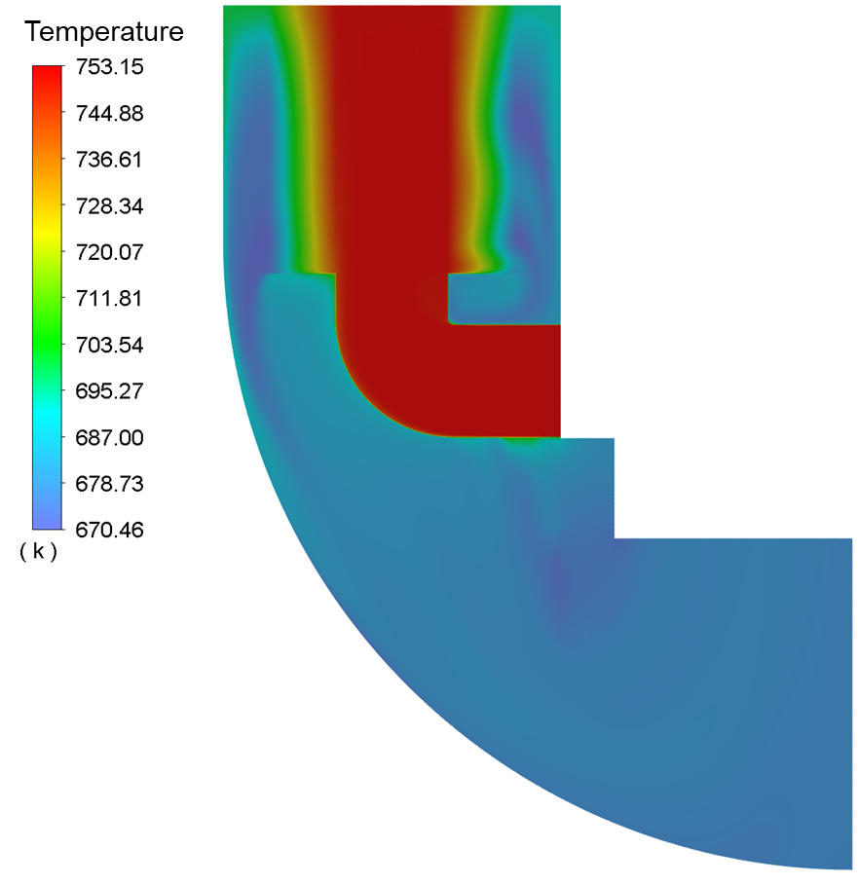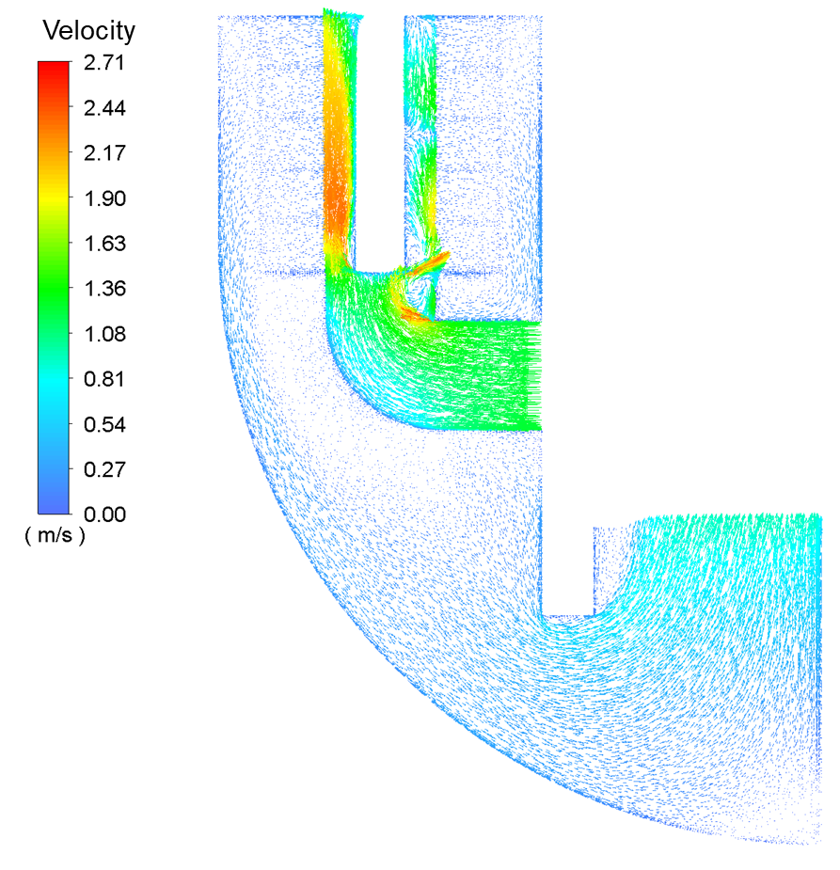

|  |  |
| --- | --- |
| (a) | (b) |

*Fig. 4. Temperature (a) and velocity (b ) field under steady condition*



*Fig. 5. Bubble transportation results under different conditions*

***II.B. Prediction based on GPR***

After getting the bubble transportation datasets, we perform machine learning to predict based on Gauss Process Regression. Then, the input dataset employs all influencing factors on the transportation results, such as bubble diameter, leakage height, final location, and system purity, represented by terminal velocity, while the percentage of bubbles is used as the output. There are 240 groups in total using the results of bubble diameter between 0 and 1 mm since those exceeding 1 mm are relatively insignificant to predict. Finally, the input-output matrix is fed into the machine learning model for training and testing. Fig. 6 presents the training and testing results using four different kernel functions: (a) ARD Rational quadratic, (b) ARD Matern 5/2, (c) ARD Matern 3/2, and (d) ARD Squared exponential.

Fig. 6 (a) summarizes the training results of four kernels under steady condition, where the results between prediction and simulation are compared. It can be observed that all of R2 are over 0.99, and among them, the ARD Rational quadratic kernel function shows the best prediction result with an RMSE of 0.16%. While the accuracy of ARD Squared exponential is relatively lower, with a total RMSE of 3.22%, especially for the transport results of bubbles with diameters over 0.5 mm. The other two kernel functions also demonstrate satisfying results, with RMSE of 1.56 and 1.015, respectively. For the testing process, the R2 of four kernels [exceed](javascript:;)s 0.9, as illustrated in Fig. 6(b). It is evident that the GPR model with ARD Rational quadratic kernel function demonstrates the best performance, with the lowest RMSE of 4.08% and highest R2 of 0.9866. Also, in the frequency distribution figure of absolute error, we can observe that the largest absolute error is lower than 0.1, and the error for most data lies in ±0.04, as shown in Fig. 6(c). On the contrary, the prediction results by ARD Matern 5/2 show the worst performance, with RMSE and R2 of 8.99% and 0.9479, respectively, and the largest absolute error reach over 0.3. In addition, the prediction performance of the other two kernel function is not accuracy neither, with a bad fitting result and a relatively large absolute error. Based on the above evaluation, ARD Rational quadratic is the most suitable model to predict the steady bubble transportation in the primary system. Furthermore, the training and testing processes using the kernel function of ARD Rational quadratic are repeated ten times with an averaged R2 of 0.9832, which illustrates the independence of the randomly split data.



*Fig. 6. Prediction results different kernel functions in GPR*

IV. Conclusions

In this paper, the simulation investigation on the bubble transportation in the system after SGTR is carried out. The effect of leakage height, bubble diameter, system contamination degree on the bubble motion are studied. Based on the simulation dataset, machine learning model is trained and tested to predict the bubble transportation result. The main conclusions are as follows:

(1) The bubbles injected at lower heights tend to reach the core easily, especially for those with a diameter of less than 0.3 mm. Contrarily, bubbles would get the SG top under a higher leakage height. With the increasing bubble diameter, the entrainment ability of primary flow decrease, and they are prone to escape from the SG top. The contaminated system would affect the bubble terminal velocity, thus influencing the transportation results.

(2) The Gauss Process Regression could predict well for steady conditions. The prediction results by the kernel function of ARD Rational Quadratic show the best accuracy in predicting the percentages of bubbles reaching the core, top of the steam generator and staying in the system, with a total RMSE of 3.22%.

Overall, this work illustrates that machine learning algorithms could accurately describe the bubble transportation behavior after the SGTR accident in the lead-cooled fast reactor. Moreover, it is significant to note that the proposed model is easily adaptable to other nuclear reactor systems for bubble transportation prognosis. Finally, these intelligent techniques’ feasibility in predicting bubble movements can be evaluated as a future study based on experiment data.

Acknowledgments

The authors are grateful for the support of Guangdong Provincial Key R&D Program, Grant/Award Number: 2021B0101250002; Natural Science Foundation of Guangdong Province, China, Grant/Award Number: 2020a15110753.

References

[1] J.E. Kelly, Generation IV International Forum: A decade of progress through international cooperation, Progress in Nuclear Energy, 77 (2014) 240-246.

[2] K. Dong, S. Ahmad, S.A. Khan, P. Ding, W. Li, J. Zhao, Thermal‐hydraulic analysis of wire‐wrapped rod bundle in lead‐based fast reactor with non‐uniform heat flux, International Journal of Energy Research, 46(12) (2022) 16538-16549.

[3] Y. Zhang, C. Wang, Z. Lan, S. Wei, R. Chen, W. Tian, G. Su, Review of Thermal-Hydraulic Issues and Studies of Lead-based fast reactors, Renewable and Sustainable Energy Reviews, 120 (2020).

[4] Q. Yu, S. Qiu, C. Wang, D. Zhang, W. Tian, G.H. Su, An experimental review of steam generator tube rupture accident in lead-cooled fast reactors: Thermal-hydraulic experiments classification and methods introduction, Progress in Nuclear Energy, 160 (2023).

[5] T.N. Dinh, Multiphase flow phenomena of steam generator tube rupture in a lead-cooled reactor system: A scoping analysis, in: Societe Francaise d'Energie Nucleaire - International Congress on Advances in Nuclear Power Plants - ICAPP 2007, "The Nuclear Renaissance at Work", 2008, pp. 2765-2775.

[6] M. Jeltsov, Application of CFD to Safety and Thermal-Hydraulic Analysis of Lead-Cooled Systems, in, 2011.

[7] M. Eriksson, J. Wallenius, M. Jolkkonen, J.E. Cahalan, Inherent safety of fuels for accelerator-driven systems, Nuclear technology, 151(3) (2005) 314-333.

[8] Y. Sibamoto, Y. Kukita, H. Nakamura, Small-scale experiment on subcooled water jet injection into molten alloy by using fluid temperature-phase coupled measurement and visualization, Journal of nuclear science and technology, 44(8) (2007) 1059-1069.

[9] R. Sa, Study on thermal-hydraulic behaviors in direct contact of high temperature lead alloy and subcooled water, Tokyo Institute of Technology, 2012.

[10] R. Sa, M. Takahashi, Experimental study on thermal interaction of ethanol jets in high temperature fluorinert, Journal of Power and Energy Systems, 6(2) (2012) 314-323.

[11] C. Zhang, R. Sa, D. Zhou, H. Jiang, Effects of gas velocity and break size on steam penetration depth using gas jet into water similarity experiments, Progress in Nuclear Energy, 98 (2017) 38-44.

[12] M. Sharifzadeh, A. Sikinioti-Lock, N. Shah, Machine-learning methods for integrated renewable power generation: A comparative study of artificial neural networks, support vector regression, and Gaussian Process Regression, Renewable and Sustainable Energy Reviews, 108 (2019) 513-538.

[13] M.A. Moradkhani, S.H. Hosseini, M. Song, Robust and general predictive models for condensation heat transfer inside conventional and mini/micro channel heat exchangers, Applied Thermal Engineering, 201 (2022).

[14] M.A. Moradkhani, S.H. Hosseini, L. Shangwen, S. Mengjie, Intelligent computing approaches to forecast thickness and surface roughness of frost layer on horizontal plates under natural convection, Applied Thermal Engineering, 217 (2022).

[15] K.M. Kim, P. Hurley, J.P. Duarte, Physics-informed machine learning-aided framework for prediction of minimum film boiling temperature, International Journal of Heat and Mass Transfer, 191 (2022).

[16] T. Cong, R. Chen, G. Su, S. Qiu, W. Tian, Analysis of CHF in saturated forced convective boiling on a heated surface with impinging jets using artificial neural network and genetic algorithm, Nuclear Engineering and Design, 241(9) (2011) 3945-3951.

[17] H. Tohver, R. de Oliveira, M. Jeltsov, Interpretable time series forecasting of NPP parameters in accident scenarios, Nuclear Engineering and Design, 403 (2023) 112145.

[18] J. Song, K. Ha, A simulation and machine learning informed diagnosis of the severe accidents, Nuclear Engineering and Design, 395 (2022) 111881.

[19] A. Alemberti, J. Carlsson, E. Malambu, A. Orden, D. Struwe, P. Agostini, S. Monti, European lead fast reactor—ELSY, Nuclear Engineering and Design, 241(9) (2011) 3470-3480.

[20] M. Jeltsov, W. Villanueva, P. Kudinov, Steam generator leakage in lead cooled fast reactors: Modeling of void transport to the core, Nuclear Engineering and Design, 328 (2018) 255-265.

[21] Q. Yu, Y. Zhang, C. Wang, C. Guo, J. Deng, D. Zhang, W. Tian, S. Qiu, G.H. Su, Numerical simulation of bubble transport during steam generator tube rupture accident of Lead-cooled Fast Reactor, Annals of Nuclear Energy, 153 (2021).

[22] A. Inc., ANSYS fluent user’s guide, Ansys Fluent, 15317 (2013) 2498.

[23] Z. Dong, H. Qiu, M. Wang, W. Tian, S. Qiu, G.H. Su, Numerical simulation on the thermal stratification in the lead pool of lead-cooled fast reactor (LFR), Annals of Nuclear Energy, 174 (2022).

[24] W.M. Kays, Turbulent Prandtl Number—Where Are We?, Journal of Heat Transfer, 116(2) (1994) 284-295.

[25] D. Wang, C. Peng, Y. Guo, Thermal-hydraulic analysis of a 7-pin sodium-cooled fast reactor wire-wrapped fuel bundle, International Journal of Heat and Mass Transfer, 160 (2020).

[26] A. Onea, M. Böttcher, D. Struwe, Lead pressure loss in the heat exchanger of the ELSY fast lead-cooled reactor by CFD approach, Benchmarking of CFD Codes for Application to Nuclear Reactor Safety (CFD4NRS-3), (2010).

[27] A.V. Beznosov, S.S. Pinaev, D.V. Davydov, A.A. Molodtsov, T.A. Bokova, P.N. Martynov, V.I. Rachkov, Experimental Studies of the Characteristics of Contact Heat Exchange Between Lead Coolant and the Working Body, Atomic Energy, 98(3) (2005) 170-176.

[28] Y. Xie, S. Orsten, F. Oeters, Behaviour of Bubbles at Gas Blowing into Liquid Wood's Metal, ISIJ International, 32(1) (1992) 66-75.

[29] A. Tomiyama, I. Kataoka, I. Zun, T. Sakaguchi, Drag Coefficients of Single Bubbles under Normal and Micro Gravity Conditions, JSME International Journal Series B, 41(2) (1998) 472-479.

[30] M. Jamialahmadi, C. Branch, H. Muller-Steinhagen, Terminal bubble rise velocity in liquids, Chemical Engineering Research and Design, 72(A1) (1994) 119-122.

[31] H.D. Mendelson, The prediction of bubble terminal velocities from wave theory, AIChE Journal, 13(2) (1967) 250-253.

[32] R. Clift, J.R. Grace, M.E. Weber, Bubbles, drops, and particles, (2005).

[33] K. Liu, Y. Li, X. Hu, M. Lucu, W.D. Widanage, Gaussian Process Regression With Automatic Relevance Determination Kernel for Calendar Aging Prediction of Lithium-Ion Batteries, IEEE Transactions on Industrial Informatics, 16(6) (2020) 3767-3777.

[34] S.A. Khan, C. Eze, K. Dong, A.R. Shahid, M.S. Patil, S. Ahmad, I. Hussain, J. Zhao, Design of a new optimized U-shaped lightweight liquid-cooled battery thermal management system for electric vehicles: A machine learning approach, International Communications in Heat and Mass Transfer, 136 (2022).

[35] R.R. Richardson, M.A. Osborne, D.A. Howey, Gaussian process regression for forecasting battery state of health, Journal of Power Sources, 357 (2017) 209-219.

[36] H. Wei, S. Zhao, Q. Rong, H. Bao, Predicting the effective thermal conductivities of composite materials and porous media by machine learning methods, International Journal of Heat and Mass Transfer, 127 (2018) 908-916.