**Basic analysis of the thermal-hydraulics of the Advanced Micro Reactor (AMR)**

WA Boyes1, JFM Slabber2, CG du Toit3, R Prinsloo4

# 1STL Nuclear (Pty) Ltd, Pretoria, South Africa

*2University of Pretoria, Pretoria, South Africa*

*3North-West University, Potchefstroom, South Africa*

*4South African Nuclear Energy Corporation NECSA (SOC, Ltd), Pretoria, South Africa*

*Emails:wayne.boyes@thorium100.com1;* [*johan.slabber@up.ac.*](mailto:johan.slabber@up.ac.)*za2;* [*jat.dutoit@nwu.ac.za*](mailto:jat.dutoit@nwu.ac.za)*3; rian.prinsloo@necsa.co.za4*

Abstract – *South Africa can achieve clean, safe affordable base load energy using nuclear power integrated with renewable energy sources on a decentralized basis. This suggests the development of a micro modular nuclear reactor, to supply energy to towns, small communities, mines, and processing plants. A High Temperature Advanced Micro Reactor (AMR) is in the process of being developed for this purpose and the design philosophy is to design for inherent safety and and other requirements for the next generation reactors as specified by the Generation IV International Forum (GIF). The concept is based, amongst others, on existing experience and expertise gained during the Pebble Bed Modular reactor (PBMR) project. The AMR reactors are to be factory built to obtain good quality control and rolled out to various sites after being loaded with fuel at a licensed organisation and put under International Atomic Energy Agency seals. Once the reactor has reached its end of life, it would be returned to a licensed organisation for refuelling. The AMR produces 10MW of thermal power. The reactor configuration in the core uses hexagonal graphite blocks for structural and moderator material, which are arranged to form an approximate cylindrical core layout. The fuel assemblies are silicon carbide tubes that house coated particle fuel, immersed in a lead-bismuth eutectic alloy (LBE). Each fuel assembly is contained in a boring within the graphite blocks that allows an annulus for cooling. There are 420 fuel assemblies per layer with 3 layers equating to 1260 fuel assemblies in total. Each of these fuel assemblies uses low enriched fuel in the form of UO2 TRISO coated particles. The helium coolant enters the core at 320˚C and exits at 750˚C. The thermal-hydraulic design of the AMR is being analysed using the Flownex code package and is used to determine the thermal-hydraulic and safety evaluation for the Design Base Accident (DBA) specifically the Depressurized Loss of Forced Cooling (DLOFC) event.*

**Keywords:** Depressurized Loss of Forced Cooling (DLOFC), High Assay Low Enriched Uranium (HALEU), High Temperature Gas Reactor (HTGR), Lead Bismuth Eutectic (LBE), Silicon Carbide (SiC), TRIstructural-ISOtropic (TRISO), Uranium Dioxide (UO2)

I. Introduction

STL Nuclear (Pty) Ltd., the University of Pretoria, the North-West University in conjunction with the South African Nuclear Energy Corporation (NECSA) are developing a 10 MWth Small Modular Reactor (SMR) called the Advanced Micro Reactor (AMR). This reactor falls in the category of the High-Temperature Gas Cooled Reactors (HTGRs). The AMR uses helium as the coolant and is graphite moderated. It uses graphite hexagonal blocks as the moderator and these blocks are arranged to form a cylindrical configuration. The graphite core contains 420 borings per block with three layers of blocks stacked on top of one another. Each layer contains 420 silicon carbide (SiC) tubes, totaling 1260 for the entire core. The individual SiC fuel assemblies contain TRISO coated particles with uranium dioxide (UO2) ceramic fuel kernels of 19.9 wt% enriched uranium. The voids between the coated particles are filled with a Lead Bismuth Eutectic (LBE) alloy to provide good heat transfer from the fuel particles to the fuel assembly cladding. The outer diameter of the Reactor Pressure Vessel (RPV) is 2.44 m. Road transportability was taken into consideration in the design which limited the outer diameter of the RPV.

The reactor is designed to:

1. Have excess reactivity to operate for several years before refueling is required.
2. Enable road transportation and for making it easier to fabricate.
3. Be factory assembled to ensure good quality control.
4. Utilize proven HTR and other technologies developed and validated in other nuclear programs albeit in different configurations

The AMR is shown in Fig. 1.

*Fig. 1. AMR reactor*

II. AMR Design

***II.A. Design Attributes***

The design objectives adopted for the reactor have been taken from the guidelines developed by the Generation IV International Forum (GIF) **[1]** with major focus on enhanced safety, minimised waste production and proliferation resistance features.

The reactor is a high temperature helium-gas cooled reactor with a thermal power of 10 MW. The helium coolant is circulated through the reactor core by an electric blower located within the pressure boundary and integrated into the heat exchanger. As is the custom for thermal neutron-spectrum high temperature reactors, graphite is used as moderator, which in this design, is in the form of hexagonal graphite blocks packed to form an approximate cylindrical configuration with a nominal active diameter of ~2.2 m and an active length of 2.2 m. This gives it a volume of 8.36 m3 resulting in a core power density of ~1.195 MW/m3. The fuel assemblies are silicon carbide tubes that contain the fuel in the form of low-enriched uranium (LEU) dioxide (UO2) TRIstructural-ISOtropic (TRISO) coated particles, immersed in a Lead Bismuth Eutectic (LBE) (45 % Pb and 55% Bi) alloy. The lead bismuth eutectic has a very good thermal conductivity and a low coefficient of thermal expansion while being nearly transparent to neutrons **[2]**. The fuel assemblies are evenly spaced lengthwise in the hexagonal block graphite structures with an annulus around each for cooling by the helium entering the core at the top. A graphite neutron reflector surrounds the core on the sides, top and bottom. The reactor core design parameters are listed in Table I.

*Table I Reactor Core Design parameters*

|  |  |
| --- | --- |
| *Parameter* | *Value* |
| *Reactor core thermal power* | *10 MWth* |
| *Primary coolant* | *Helium* |
| *Moderator* | *Graphite* |
| *Core geometry* | *Cylindrical (approximate)* |
| *Core diameter (active)* | *2.2 m* |
| *Core height (active)* | *2.2 m* |
| *Core volume* | *8.36 m3* |
| *Height to diameter ratio (H/D)* | *~1* |
| *Average core power density* | *~ 1.195 MW/m3* |
| *Linear power density of a fuel assembly* | *0.017 MW/m* |
| *Power density of a fuel assembly* | *150.25 W/cm3* |
| *Reactor core inlet temperature* | *320 ˚C* |
| *Reactor core outlet temperature* | *750 ˚C* |
| *Reactor core helium mass flow rate* | *4.48 kg/s* |
| *Reactor core operating pressure* | *4.0 MPa* |

A cross section of the reactor vessel and internal structures is shown in Fig. 2 where the core layout configuration can be seen.

The reactor core model is based on a conventional prismatic reactor core layout. The helium coolant enters the reactor vessel through the annulus of the co-axial duct attached to the reactor pressure vessel at the bottom. The helium then flows upwards in the helium risers located in the outer graphite reflector. Helium leak flow also enters the annular space between the Core Barrel (CB) and the inside of the Reactor Pressure Vessel (RPV). The main helium flow enters the top of the reactor core where it is evenly directed to the 420 borings containing the fuel assemblies as well as between the annuli of the control rod guide-tubes. The cooling of the top and bottom domes as well as the structures in those volumes are cooled by means of coolant flows that leak from the mainstream core coolant. The mainstream core coolant flow is directed downwards in the coolant annuli around the fuel assemblies to remove heat and exits the core at 750°C. It is then collected in a lower core hot gas plenum that is part of the lower core support structures and flows back through a hot duct (connected to the hot gas plenum) to the Heat Pipe Heat Exchanger (HPHE).

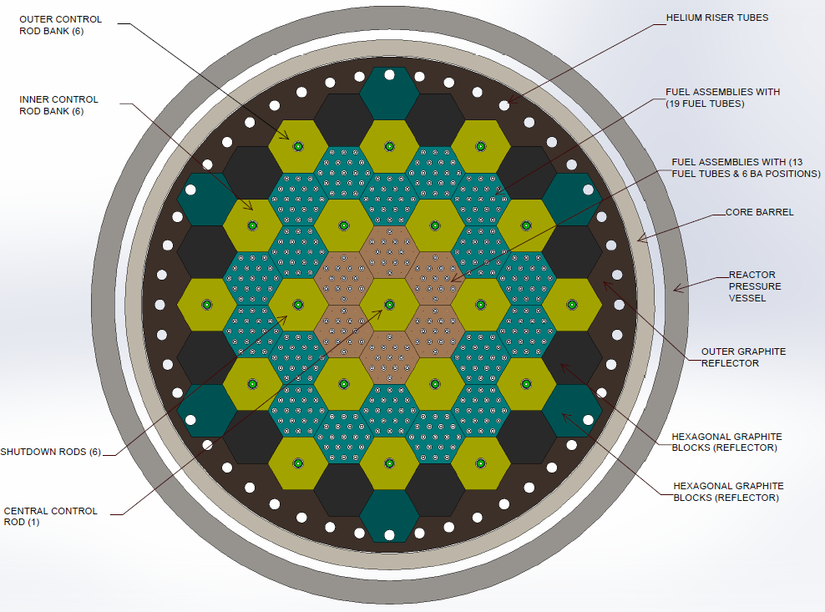

*Fig. 2*. *Cross section of* *AMR core*

III. Fuel and Moderator

***III.A. Coated Particles***

The defining characteristic of the high temperature reactor and the key to the safety and operational simplicity of the AMR is the use of TRISO fuel particles.

Fig. 3 shows the construction details of a typical coated particle. The SiC is the main layer for the retention of fission products.

Although the AMR is designed for UO2, it is not limited to the use of only UO2 fuel shown in Table II. In Germany and in the U.S., the fuel kernel of the TRISO particles have been manufactured into other chemical forms, such as UCO or UC2.

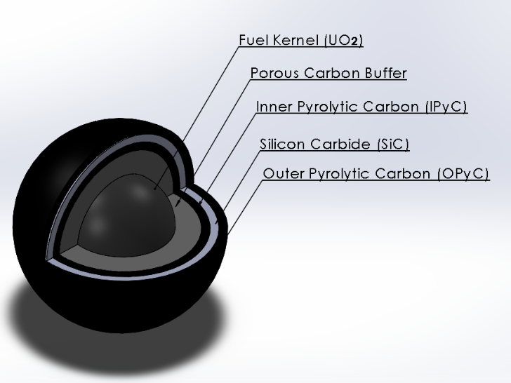

*Fig. 3. TRISO coated particle*

The AMR utilizes kernel diameters of 500 microns (μm) and coated particle diameters of 910 microns (μm) can also be utilized. The AMR is not restricted to using only high assay low enriched uranium (HALEU).

The AMR, while maintaining inherent safety characteristics, can use alternate fuels without modifications to the reactor. Advanced fuel cycles for later investigation for use in the AMR range from a (Th, U)O2 fuel cycle using both LEU and HEU, to a UC2 fuel cycle.

*Table II TRISO coated particle parameters*

|  |  |
| --- | --- |
| *Parameter* | *Value* |
| *Fuel type* | *UO2 TRISO coated particles* |
| *U235 Enrichment* | *HALEU 19.9 wt%* |
| *Fuel kernel diameter* | *500 µm* |
| *Fuel kernel density* | *10.8 g/cm3* |
| *Kernel coating material* | *C/IPyC/SiC/OPyC* |
| *Layer thickness* | *90/40/35/40 µm* |
| *Layer densities* | *1.15/1.95/3.21/1.95 g/cm3* |

***III.B. Fuel assembly***

The fuel assembly is a ~733 mm long (measured across the ends) Silicon Carbide tube with an outside diameter of 15 mm and a wall thickness of 1.5 mm leaving an inner diameter of 12 mm. Coated particles together with a heat transfer/filler/matrix material consisting of a eutectic alloy of lead and bismuth (LBE) forms the inside of the fuel assembly. The tube is manufactured with one end sealed while the open end is sealed after it is filled with the fuel LBE mixture. Approximately ~200337 coated particles will be contained in a typical fuel assembly. There are 420 fuel assemblies per layer with 3 layers equating to 1260 fuel assemblies in total. The Silicon Carbide tube wall provides a secondary barrier against the release of fission products from the fuel.

***III.C. Moderator/reflector characteristics***

There are four types of hexagonal blocks making up the core structures. All blocks have the same dimensions but contain a different number of borings and/or material. The blocks without any borings are called reflector blocks, blocks with a single large boring are called control rod blocks and then the blocks containing the fuel assemblies are of two types; namely blocks with 13 (this contains 6 burnable poison positions) and 19 borings respectively. Fig. 4 shows an image of a block with 19 borings. The core is surrounded by solid graphite blocks that fulfill the role as neutron reflector. The graphite in all the foregoing descriptions functions as moderator although, due to its neutron scattering characteristics it also functions well as a good neutron reflector on the outer edge of the core. Three hexagonal blocks are stacked upon one another lengthwise in the core. The borings in the fuel containing blocks have a diameter of 22 mm and with the fuel assembly centered inside these borings an annulus with thickness of 3.5 mm is provided for the flow of coolant. The main reason for using a fuel assembly of the same length as a block is to simplify quality of manufacture. Some of the fuel-containing blocks also contain in some of the borings, tubes loaded with burnable neutron absorber material for the purpose of lengthening the operational period between fuel reloading.

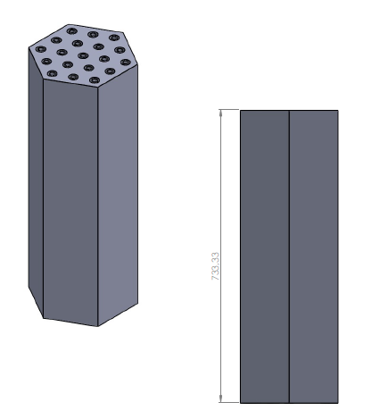

*Fig. 4. Fuel block*

IV. Heat Pipe Heat Exchanger

A Heat Pipe Heat Exchanger (HPHE) is used to transfer heat from the primary core cooling circuit to the secondary power conversion loop containing air. The working fluid of the HPHE is a lead bismuth eutectic (LBE) alloy. It is used to absorb heat from the primary helium coolant flowing in a central bundle of tubes (located in the central U-tube bundle) and surrounded by a flow-directing shroud. This heat is then exchanged by means of natural convection with the secondary power loop (in the form of a multiplicity of U-tubes) located in the annulus between the flow-directing shroud and the inner wall of the outer shell of the heat exchanger. The LBE returns to the central hot helium bundle at the bottom through several portals in the flow-directing shroud. This flow of LBE in this design can be described as "toroidal natural convection flow". The HPHE coupled to the AMR shown in Fig. 5 only demonstrates a limited number of tubes to illustrate the gas flow paths.

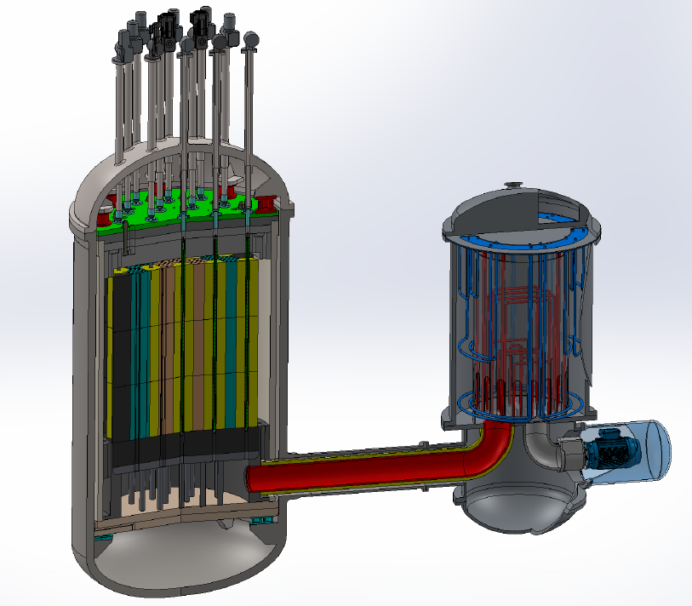

*Fig. 5. Heat Pipe Heat Exchanger (HPHE) concept (limited tubes) coupled to the Advanced Micro Reactor (AMR).*

V. Safety characteristics

The four principles of stability have been incorporated into the AMR design; these are as follows:

1. Nuclear stability – Nuclear transients may never lead to unallowable power output excursions or cause unallowable overheating of the fuel.
2. Thermal stability – The reactor core cannot melt or overheat to a temperature where its capability to retain fission products is compromised.
3. Mechanical stability – The core may never be allowed to deform or change composition.
4. Chemical stability – Fuel assemblies and core structures may not be exposed to conditions where it will structurally corrode.

These design principles, taken as a design guide, resulted in the following specific characteristics:

1. Nuclear stability: If all control and shutdown systems are accidentally withdrawn, it will not lead to fuel damage or a radionuclide release. There is no requirement for active safety systems or operator action to prevent fuel damage. This is achieved with a relatively large negative temperature coefficient of reactivity over the entire operational range, a low core power density, a core geometry that will ensure passive decay heat removal and the radionuclide retention capacity of the TRi-Structural ISOtropic (TRISO) particle fuel as well as the SiC structure of the fuel assembly.

Xenon oscillations are damped due to the H/D ratio of the core of less than 3 which is normally used as guideline for inherent stability.

2. Thermal stability: The low power density is ensured in the core design as well as a high thermal capacity and height to diameter ratio (H/D) to ensure that the decay heat removal can solely be achieved through conduction, natural convection, and radiation through the reactor structures. Reutler and Lohnert determined that increasing the height/diameter ratio beyond 0.97 is a trade-off between neutron losses versus the advantage of gaining passive decay heat removal via the walls of a steel pressure vessel in the event of a DLOFC **[3].**

A key inherent safety characteristic of typical HTR design is keeping the fuel temperatures during a Depressurized Loss of Forced Cooling (DLOFC) event low enough that the escape of radioactive fission products through the coating layers around the fuel kernels will be limited to acceptable levels. From the German fuel qualification results the design target is that the maximum fuel temperature during a DLOFC event should remain below the set limit of 1600°C for the dioxide-based fuel (UO2).

3. Mechanical stability: The design also ensures that the materials of construction remain below the structural design limits and the maximum fuel temperatures in an accident condition remain below the set fuel damage limits

4. Chemical stability: The design of the core and its coolant routing is such that in an event that could allow air to leak into the pressure boundary, there is no possibility that a sustained corrosion of core components by air can take place. The reactor also does away with the possibility of a water or steam ingress scenario **[4]** as the helium coolant will transfer heat to a Heat Pipe Heat Exchanger (HPHE) which is a single-phase natural convection heat pipe heat exchanger using Lead Bismuth (Pb-Bi) Eutectic (LBE) as working fluid.

The use of a HPHE also introduces another important safety feature by eliminating the possibility of tritium, produced in the primary helium cooling circuit to contaminate the air in the secondary circuit by diffusing through a single tube wall.

The neutronics of the equilibrium core was analysed with the OSCAR-5 and SERPENT codes. The Flownex code is used to assess the thermal hydraulic behavior of the AMR core and to assess the loss of coolant events.

This study investigates the thermal-hydraulic performance in normal operations and focuses on the Depressurized Loss of Forced Cooling (DFLOC) and No-Loss of Forced Cooling (NLOFC) scenarios.

VI. Thermal-hydraulic model

The thermal-hydraulic analysis for steady-state and transient conditions was performed using the system network code Flownex SE **[5]**. An axi-symmetric thermal-hydraulic network of the AMR was constructed and consists of three inter-connected networks. The first network models the graphite blocks, core barrel (CB), reactor pressure vessel (RPV), reactor cavity and reactor cavity cooling system (RCCS) face plate located around the RPV next to the concrete citadel. The second network models the flow paths, control rods and the SiC tubes of the fuel. The third network models the UO2 and LBE mix inside the SiC tubes. The details of the layouts of the networks can be found in Boyes et al. **[6]**.

The Flownex networks consist of collections of one-dimensional (1D) components. Pipe components are used to model the flow in the risers, plenums, coolant channels and inlet and outlet pipes. The convection heat transfer between the solids and the gas is modelled using convection components. Conduction components are used to model the heat conduction heat transfer through the solids. Finally, radiation heat transfer components are used to model the radiation heat transfer across the gaps between the outer reflector and the CB, between the CB and the RPV, and between the RPV and RCCS face plate. For each ring of blocks only a representative control rod, a representative fuel rod, a representative coolant channel, and a representative riser channel, as applicable, are modelled.

Under steady-state conditions helium enters the cold inlet at a flowrate of 4.4783 kg/s and a temperature of 320 oC and exits the hot outlet at a pressure of 4 MPa. Following Lommers et al. **[7]** the cooling flow in the RCCS was not modelled and a fixed temperature of 65 oC was prescribed at the outer surface of the RCCS face plate. The heat generated in the fuel was distributed in the axial direction according to a cosine power profile. The emissivities of the CB, RPV and RCCS were assumed to be 0.8 and the associated convection heat transfer coefficients to be 4.0 W/m2K.

Flownex employs a finite volume-based implicit pressure correction method **[8]** to obtain the solution of the conservation equations.

***VI.A. Steady-state thermal-hydraulic results***

Under steady-state conditions it was found that the maximum fuel temperature occurs in the inner ring of fuel blocks and has a value of 1027.7 oC. The maximum graphite temperature of 804.5 oC also occurs in the inner ring of fuel blocks. The inner surface of the CB has a maximum temperature of 356.7 oC, whilst the maximum temperature on the inner surface of the RPV is 251.7 oC. All the temperatures are below the maximum allowable limits. The outlet temperature of the helium is 746.5 oC. The RPV releases 85.7 kW, 83.4% being due to radiation, which is rejected by the RCCS.

***VI.B. Transient thermal-hydraulic results***

Two transient scenarios have been considered. The first is a Depressurized Loss of Forced Cooling (DFLOC) and the second is No-Loss of Forced Cooling (NLOFC). In both cases the reactor is scrammed, but in the second case the flowrate of the coolant and the system pressure are maintained.

The decay power $Q_{DH}$ was modelled employing the Wigner-Way correlation **[9]** given in Eq. (1):

$Q_{DH}\left(t\right)=Q_{0}×0.06×\left(t_{s}^{-0.2}-{\left(t_{s}+t_{0}\right)}^{-0.2}\right)$ (1)

Here $Q_{0}$ is nominal power, $t_{s}=t-t_{1}$ the time since the scram, $t_{1}$ time at which the scram occurred and $t_{0}$ time in seconds after 15 years of operation.

In the case of the DLOFC the transient variation of the coolant mass flowrate $\dot{m}$ at the inlet after the scram was modelled using Eq. (2):

$\dot{\dot{m}\left(t\right)={\dot{m}}_{∞}+\frac{∆\dot{m}}{2}×\left(cos\left(π\left(\frac{t-t_{1}}{t_{2}-t_{1}}\right)\right)+1\right)}$ (2)

Here $t_{2}$ is the time when the mass flowrate transient ends, ${\dot{m}}_{∞}$ the ultimate mass flowrate and $∆\dot{m={\dot{m}}_{0}-{\dot{m}}_{∞}}$ with ${\dot{m}}_{0}$ the nominal mass flowrate. In this study it was assumed that $t_{1}=5 s$, $t_{2}=10 s$ and ${\dot{m}}_{∞}=0.001 kg/s$. The transient variation of the outlet total pressure $p_{0}$ after the scram was modelled using Eq. (3):

$p_{0}\left(t\right)=p_{0∞}+\frac{∆p_{0}}{2}×\left(cos\left(π\left(\frac{t-t_{1}}{t_{2}-t_{1}}\right)\right)+1\right)$ (3)

Here $p_{0∞}$ is the ultimate total pressure, $∆p_{0}=p_{00}-p_{0∞}$ with $p_{00}$ the nominal total pressure. In this study it was assumed that $p_{0∞}=103 kPa$.

The variation of the temperatures at the centre of the fuel assemblies for the inner ring of fuel blocks for the first 500 s is shown in Fig. 6.

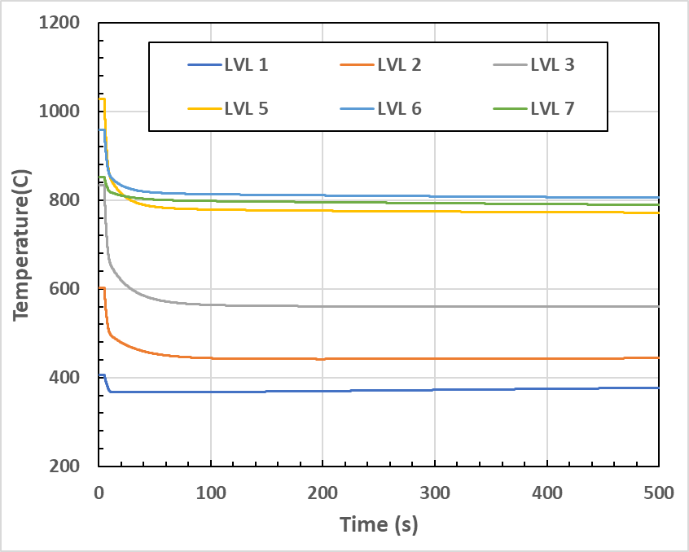

*Fig. 6. Temperatures at centre of fuel of inner fuel blocks as functions of time.*

Level 1(LVL 1) is at the top of the core and level 7 at the bottom of the core. After an initial sharp drop the temperatures level out and then change gradually. The highest fuel temperature at steady-state conditions occurs at level 5 but reduces to level 6 after the scram. The highest graphite temperature in the inner ring of fuel blocks under steady-state and transient conditions occurs at level 6. Due to thermal inertia, directly after the scram until the mass flowrate reaches its minimum value, the graphite surrounding the coolant channel releases heat to the coolant. After the mass flowrate reached its minimum the graphite absorbs heat from decay heat being released by the fuel. The gradual change in the fuel temperatures after the initial sharp drop, is because the temperatures of the fuel cannot be lower than that of the surrounding graphite when no coolant is flowing. The heat rejected by the RCCS increases from the initial 85.7 kW to reach a maximum of 108.3 kW at 8.7 h after the scram. The decay heat generated in the fuel becomes less than the heat rejected by the RCCS after approximately 2.0 h. After reaching a maximum, the heat rejected by the RCCS gradually approaches the decay heat generated. A careful study of the temperatures and heat fluxes in the core and associated structures show how the heat redistributes in the structures attempting to equalize the temperatures in the axial direction and set-up the required temperature gradient in radial direction to reject heat through the RCCS to the surrounding environment.

Table III summarizes the variation in time of the maximum fuel temperature $T_{f}$, the maximum graphite temperature $T_{g}$, the maximum core barrel temperature $T_{CB}$ and the maximum reactor pressure vessel temperature $T_{RPV}$ after a DLOFC.

*Table III Summary of selected maximum temperatures as function of time for DLOFC.*

|  |  |  |  |  |
| --- | --- | --- | --- | --- |
| $$t (h)$$ | $$T_{f} (℃)$$ | $$T_{g}(℃)$$ | $$T_{CB}(℃)$$ | $$T_{RPV}(℃)$$ |
| 0 | 1027.7 | 804.5 | 356.7 | 251.7 |
| 1 | 735.9 | 746.1 | 392.3 | 255.2 |
| 10 | 506.9 | 501.8 | 404.4 | 289.2 |
| 100 | 311.6 | 305.0 | 262.0 | 188.0 |
| 200 | 259.4 | 253.4 | 220.9 | 159.7 |
| 600 | 208.4 | 203.7 | 181.2 | 133.8 |

It can be seen in Table III that all the temperatures remain below the maximum allowable limits during the time duration considered. Not shown is that the temperatures of the inner reflector are at steady-state lower than those of the graphite of the inner fuel ring. This is for heat to be transferred to the coolant flowing through the control rod channel in the inner reflector. After the flow of coolant is stopped the inner reflector first needs to be heated before it can start to cool down. At 1 h the inner reflector is already hotter than the graphite of the inner fuel ring and transfers heat to the inner fuel ring. Similarly, the top part of the core first needs to heat up before it can cool down. From these results it can be concluded that passive measures will be sufficient (due to a passive RCCS cooling system being driven by natural buoyancy **[10]**) to cool down the reactor after shutdown, whether due to an accident condition or scheduled.

Table IV summarizes the variation in time of the maximum fuel temperature $T_{f}$, the maximum graphite temperature $T_{g}$, the maximum core barrel temperature $T_{CB}$ and the maximum reactor pressure vessel temperature $T_{RPV}$ when the coolant mass flowrate and the system pressure are maintained after the reactor has been shut down.

*Table IV Summary of selected maximum temperatures as function of time for NLOFC.*

|  |  |  |  |  |
| --- | --- | --- | --- | --- |
| $$t (h)$$ | $$T_{f} (℃)$$ | $$T_{g}(℃)$$ | $$T_{CB}(℃)$$ | $$T_{RPV}(℃)$$ |
| 0 | 1027.7 | 804.5 | 356.7 | 251.7 |
| 1 | 332.2 | 368.4 | 328.1 | 249.3 |
| 10 | 322.7 | 320.8 | 291.2 | 211.1 |
| 100 | 320.4 | 319.4 | 289.3 | 206.0 |
| 200 | 320.0 | 319.1 | 289.3 | 206.0 |
| 600 | 319.4 | 318.7 | 289.2 | 205.6 |

It can be seen in Table IV how the reactor cools down over the duration considered. It can also be observed how after 10 h the cool down of the reactor is constrained by the inlet temperature of 320 oC of the coolant. Over this period the heat rejected by the RCCS has decreased from 85.7 kW to 60.0 kW. From the results in Tables III and IV it can be concluded, should the intention be to transport the reactor to a licensed organization for refueling, that a cooling strategy must be developed to cool down the reactor in a reasonable amount of time after a shutdown. This can be a passive system using buoyancy driven effects to remove heat from the reactor system.

VII. Conclusions

The thermal-hydraulic analysis of the AMR has shown that under normal operation conditions and DLOFC accident conditions all the temperatures of the reactor will remain below the maximum allowable limits. The analysis has also shown that after shutdown of the reactor a passive cooling strategy must be employed to cool down the reactor in a reasonable amount of time should the intention be to transport the reactor to licensed organization for refueling.

VIII. Acknowledgments

The authors hereby wish to acknowledge the contributing members of the Radiation & Reactor Theory (RRT) Group at NECSA, the STL Nuclear neutronics and thermal-hydraulics department, the University of Pretoria, the North-West University, the Computer Aided Designer (CAD)/Mechanical Designer that all participated in the design of the AMR.

IX. Nomenclature

m: Mass flow rate (kg/s)

QDH: Decay Heat (W)

p: Pressure of coolant gas (KPa)

t: time (hours)

Tf: Maximum fuel temperature (˚C)

Tg: Maximum graphite temperature (˚C)

TCB: Maximum core barrel temperature (˚C)

TRPV: Maximum reactor pressure vessel temperature  
 (˚C)

X. References

1. Generation IV International Forum (Generation IV Goals 2020).
2. Handbook on Lead-bismuth Eutectic Alloy and Lead Properties, Materials Compatibility, Thermal-hydraulics and Technologies (2015 Edition), Nuclear Energy Agency Organisation for Economic Co-Operation and Development. OECD 2015. NEA. No. 7268 (2015).
3. H. Reutler, G. H. Lohnert, “The Advantages of going Modular in HTRs”, Nuclear Engineering and Design, **78**, 129-136 (1984).
4. G.H. Lohnert, “The consequences of water ingress into the primary circuit of an HTR-Modul - From the design basis accident to hypothetical postulates,” Nuclear Engineering and Design, **134**, 159-176 (1992).
5. M-Tech Industrial, *Flownex Simulation Environment,* <http://www.flownex.com/>, Version 8.14.1.4844 (2022).
6. W.A. Boyes, J. Slabber, C. du Toit, F. van Heerden, “Evaluation of the Basic Neutronic and Thermal-Hydraulics for the Safety Evaluation of the Advanced Micro Reactor (AMR),” Nuclear Science, **8**, 1, 8-29 (2023).
7. I.J. Lommers, B.E. Mays, F. Shahrokhi, “Passive heat removal impact on AREVA HTR design”, Nuclear Engineering and Design, **271**, 568-577 (2014).
8. G.P. Greyvenstein, “An implicit method for the analysis of transient flows in pipe networks,” International Journal of Numerical Methods in Engineering*,* **53**, 1127-1143 (2002).
9. W.J. Garland, F. Saunders, “*Decay heat estimates for MNR*,” Technical Report 1998-03, McMaster University (1998).
10. C.G. du Toit, H.J. van Antwerpen, “Effect of reactor vessel cooling insulation and reflector heat pipes on the temperatures of a pebble-bed reactor using a system CFD approach”, Nuclear Engineering and Design, **357**, 110421 (2020).