Impact of Fuel Element Shape on Material Testing Reactor using OpenMC Code

Alaa H. Alnahdi ^{1,2,3}, Ahmed A. Alghamdi ⁴, and Abdullah I. Almarshad ⁵
¹ MS in Nuclear Engineering Program, College of Engineering, King Saud University, Riyadh 12372, Saudi Arabia;
² K.A. CARE Energy Research and Innovation Center at Riyadh, King Saud University, Riyadh 11421, Saudi Arabia.
³ Engineering and Project Management Sector, King Abdullah City for Renewable and Atomic Energy (K.A.CARE), Riyadh 11451, Saudi Arabia.
⁴ Nuclear Technologies Institute, King Abdulaziz City for Science and Technology (KACST), Riyadh 11442, Saudi Arabia.
⁵ Chemical Engineering Department, King Saud University, Riyadh 12372, Saudi Arabia
442105846@student.ksu.edu.sa, ahmedg@kacst.edu.sa, aalmarshad1@ksu.edu.sa.

Abstract –This study investigates the impact of simulating different fuel shapes for a material testing reactor (MTR) using the OpenMC code. Two 2-dimensional infinte bare fuel element models were constructed: one with a curved fuel element shape to represent the actual dimensions of the MTR, and another with a simplified flat fuel element shape with the same amount of fuel as the curved model. The neutron distribution and k-inf were calculated and compared between the two models. The neutron distribution and k-inf showed only slight differences due to shape changes. The results indicate that simulating the MTR fuel as flat elements provides a satisfactory approximation of the real shape. However, it may introduce discrepancies for in-depth simulation studies.

Keywords: Material testing reactor (MTR); OpenMC; Monte Carlo, Bare Reactor

I. Introduction

Nuclear Material Testing Reactors (MTR) are pivotal in nuclear research and development, with applications spanning materials sciences, nuclear power, medicine, and physics [1]. They support nuclear fuel testing and study radiation-resistant materials. MTRs influence nuclear power plant design using their diverse power range (0 to 200 MW_{th}) and higher fuel enrichment (up to 20% ²³⁵U) [2]. These reactors come in pool-type, tank-type, or tank-in-pool-type designs, informing new nuclear power plant parameters.
In nuclear reactor theory [3], realizing the external power yield and control of the fission reaction relies on two fundamental considerations. Firstly, meticulous attention must be given to the material composition of the fuel assembly and core of the nuclear reactor. Secondly, the reactor core geometry, including the shape of the fuel, plays a vital role, as variations in geometry can impact the output of the fission reaction and induce changes in several control parameters. The synergy of these considerations yields valuable insights into the behavior of neutrons within the core. Notably, the interaction between the nuclear fuel and neutrons stands at the forefront of the fission reaction, and gaining a profound understanding of this interaction holds utmost importance for the effective control of the reactor.
The primary focus of this paper lies in the meticulous examination of the shape of Material Testing Reactor (MTR) fuel elements' plates. Traditionally, MTR fuel elements are deliberately designed and fabricated in a curved configuration to ensure structural stability and mitigate thermal expansion arising from the substantial power generation within the fuel plates [4]. Introducing curvature to the fuel plates provides enhanced structural integrity, bolstering sustainability during reactor operation.
In preceding studies [5,6], the simulation of MTR fuel elements adopted a non-curved plate configuration for the sake of simplicity. As a consequence, these investigations might not have fully captured the involved geometric characteristics of the fuel, which, in turn, needs further exploration. To address this aspect, the present paper investigates into the profound impact of various fuel element shapes on key parameters, encompassing both the curved and non-curved fuel assemblies. By building upon a previous study [7], which investigated into the primary discrepancies arising from changes in the shape of the fuel element, this research seeks to focus on bare infinite reactors for both fuel shapes in order to investigate those discrepancies.
The comparative analysis in this study revolves around two aspects: the k-inf, 2D fission distribution and XY flux distribution, given their profound susceptibility to model geometry. The initial step entails a meticulous examination of the designed shape of the fuel plates (curved) in relation to a flattened shape, while ensuring that the total volume of the fuel remains constant. By preserving the total volume, any observed variations in the k-inf will clearly show the impact of shape alterations on the reactor's neutronics performance.
This study aims to explore how the shape of the fuel elements impacts a 2D bare reactor setup. By focusing on the 2D configuration instead of a 3D core and using bare fuel elements, we can isolate the effects of the fuel element shape more effectively. This allows us to concentrate on the essential aspects without being influenced by other reactor components.
The research seeks to reveal the relationship between fuel shape and its influence on the reactor's parameters, specifically in the 2D bare reactor context. The insights gained from this investigation can lead to improvements in reactor performance, safety, and efficiency. Ultimately, the study's findings will contribute to a better understanding of how fuel element geometry affects reactor parameters, which can have significant implications for future reactor design and optimization efforts.

II. Background

A Material Testing Reactor (MTR) is among the earliest nuclear reactors specifically designed for advancing future nuclear reactor concepts [8]. Initially built in 1944 at Clinton Laboratories, now Oak Ridge National Laboratory, its primary role was military-based [9]. However, over time, MTRs have evolved to serve medical, industrial, and educational applications. Currently, there are 47 pool-type MTR reactors worldwide, featuring fuel elements composed of curved aluminum-clad plates vertically housed within a box [10]. Considered a pioneering research reactor, the MTR continues to influence future designs and remains instrumental in testing various nuclear scenarios for power reactor development.
The Monte Carlo method, initially developed to estimate probabilities under uncertain conditions, serves as a suitable approach for understanding neutron movements and interactions. As a result, this method finds practical utility in neutron transport theory, facilitating the analysis of nuclear reactors. By utilizing the Monte Carlo method, researchers gain valuable insights into the intricate behavior of neutrons within reactor systems.
OpenMC stands as an open source Monte Carlo neutron and photon transport simulation code. With OpenMC, researchers can conduct fixed source, k-eigenvalue, and subcritical multiplication calculations, utilizing constructive solid geometry-based models. The code originated in 2011 from the efforts of the Computational Reactor Physics Group at the Massachusetts Institute of Technology [11]. Since its inception, OpenMC has found extensive application in numerous studies, facilitating the analysis of neutron transport in various model configurations.
In contrast to the previous study [7], which focused on full core geometry, the present research concentrate on a simplified 2D fuel element. The investigation explores into the implications of simulating different fuel shapes within the framework of a material testing reactor (MTR). Two OpenMC models were developed, one employing curved fuel elements to replicate the MTR's real shape, and the other employing flat fuel elements with the same fuel mass. The study specifically examines the effects of fuel element geometry on neutronics behavior within the 2D bare reactor configuration. This approach allows for a more targeted exploration, isolating the critical aspects of interest and providing valuable insights into fuel shape's impact on reactor performance.

III. Methodology

III.A. Simulation Setup

In OpenMC, the simulation setup involves employing a constructive solid geometry representation to model complex geometric objects. This approach represents closed volumes, or cells, as intersections of multiple half-spaces, where each half-space is defined by a plane or quadratic surface, distinguishing the positive or negative side. Notably, this technique allows for precise modeling of curved surfaces, such as spheres and cylinders, without any tolerance due to mesh discretization, thereby enhancing simulation accuracy.
In this study, the OpenMC model was executed with identical conditions to the previous study [7], where the same nuclear data library of ENDF/B-VII.1 was employed. The cross-section libraries for the OpenMC simulations were defined at a temperature of 293.6 K. Additionally, the fuel was considered fresh, and the initial neutron source assumed a uniform distribution throughout the fissile material for all models. These consistent simulation settings allowed for a direct comparison of the fuel element models while controlling for relevant parameters.

III.B. Fuel Element Models

For the flat fuel element, all conditions and parameters were maintained the same as curved. However, transforming the curved fuel plate shape into a flat plate necessitated adjustments in the fuel dimensions to maintain a fixed fuel volume. Additionally, the dimensions of the flat fuel plate were determined based on its cross-sectional area, with the width determined while retaining the thickness unchanged. Equation (1) was employed to determine the required modifications as follows:
${Area}_{curved}={Area}_{flat}$ (1)
where ${Area}_{curved}$ is the area of the curved plates while ${Area}_{flat}$ is the area of the flat plates.
$θ×\left(r_{out}^{2}-r_{in}^{2}\right)=\left(regtangular length\right)×\left(thickness\right)$ (2)
where $θ$ stands for the angle of curvature (degree) that is used to calculate the area of the arc. The parameters $r_{out}$ and $r_{in}$ are the outer and inner radii of the curve, respectively.
$⇒thickness= r_{out}-r_{in}$ (3)
Consequently, the thickness of the flat fuel plate was redefined to maintain a fixed cross-section area in both simulations. Fig. 1 and Fig. 2 presents the XY view displaying the simulated curved and flat fuel plates for visual comparison.
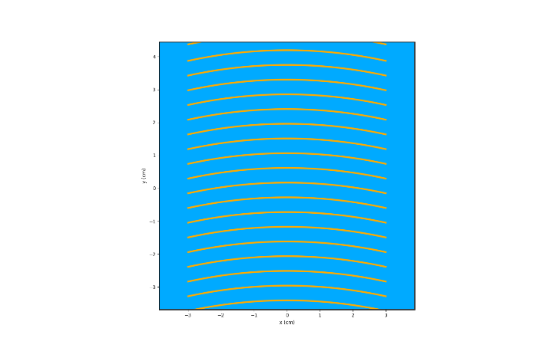
Fig. 1. Curved bare fuel plate
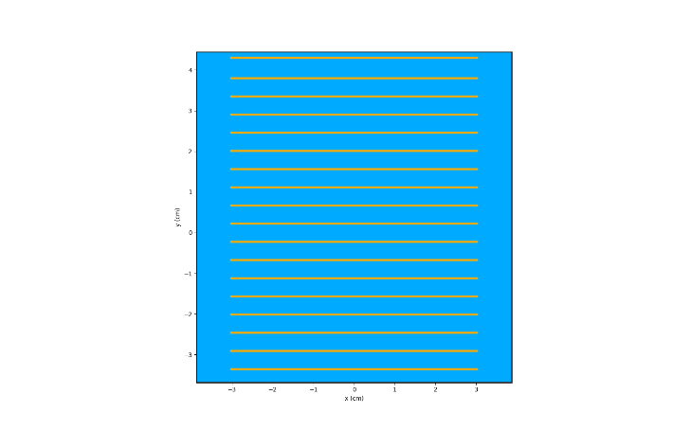
Fig. 2. flat bare fuel plate

III.C. Comparison Parameters

For this study, several key parameters were identified for comparing the two fuel element models: the curved and flat configurations. The primary parameter of interest was the k-inf, representing the multiplication factor that characterizes the reactor's criticality. Additionally, the 2D fission and XY flux distribution were examined, as these aspects are significantly affected by the fuel element shape.

III.D. Simulation Procedure

both curved and flat fuel element configurations were systematically modeled within a 2D bare fuel element. Maintaining consistency and considering essential factors, this approach facilitated a focused comparison of neutron behavior. The procedure as follows:
Boundary and Material Setup:
- Both fuel elements (curved and flat) were assumed to be submerged in water, with no other materials present.

Table I Material composition used in the OpenMC model.
Material | Isotopic Composition (Atomic Percentage [a/o])
U₃Si₂-Al  (19.75% enriched) | U-238 | (0.129533)
 | U-235 | (0.032287)
 | Si-28 | (0.099366)
 | Si-29 | (0.005046)
 | Si-30 | (0.003326)
 | Al-27 | (0.730443)

- The boundary condition was set to be periodic, ensuring an infinite reactor parameter.

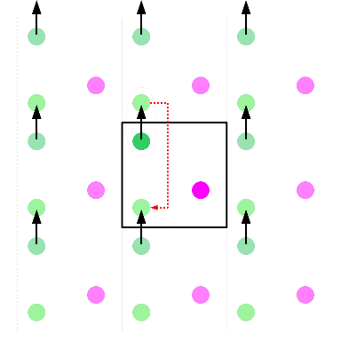
Fig. 3. Periodic Boundary Condition

Geometry Inputs:
- The geometry inputs for the simulations were identical for both fuel element models, with the only difference being the fuel dimension.
Volume Estimation:
- The volume of each fuel element was determined using the volume calculation provided by OpenMC.
- A total of ${1×10}^{11}$ samples were chosen for the volume estimator to ensure accurate results.
Particle and Generation Setup:
- The number of generations and particles per generation were fixed for both fuel element models.
- Specifically, 1,015 generations were used, with 15 generations to be skipped.
- Each generation contained 200,000 particles, contributing to a thorough analysis of neutron behavior.
Distribution Analysis:
- Distribution analysis was carried out for flux, neutron scattering, and fission phenomena to investigate the behavior of these parameters in both fuel element models.

II.D. Data analysis

In the comparative analysis, the difference $∆k$ in the multiplication factor and its uncertainty $σ_{∆k}$ were evaluated using Equations (4) and (5), respectively. The bias $∆k$ was expressed in percent mille (pcm), as per established methodology [12]:

$∆k=\left(k_{inf}-{ k}_{inf}^{*}\right)×{10}^{5}$ (4)

$σ_{∆k}=\sqrt{\left(σ_{k_{inf}}^{2}+{σ_{k_{inf}}^{*}}^{2}\right)} ×{10}^{5}$ (5)

where$k_{inf}$ and $σ_{k_{inf}}$ are the determined multiplication factor and its uncertainty, respectively, while ${ k}_{inf}^{*}$ and $σ_{k_{inf}}^{*}$ are the reference multiplication factor and its uncertainty, respectively.
In addition, OpenMC incorporates a stochastic method for determining volumes of cells, materials, and universes. This process involves overlaying a bounding box, sampling points from within the box, and assessing the fraction of points within the desired domain. The advantage of using this stochastic approach, as opposed to equally-spaced points, lies in its ability to provide reliable error estimates for each stochastic quantity. This stochastic volume determination capability enhances the accuracy and precision of the simulations conducted within OpenMC [11].

IV. Results and Discussion:

The simulation results for both the curved and flat fuel element configurations in the 2D bare fuel element are presented and discussed in this section. The key parameters analyzed include the k-inf, 2D fission distribution, and radial flux distribution.

IV.A. K-Infinity:

The k-inf, which represents the multiplication factor characterizing infinite reactor criticality, was obtained for both fuel element models. The results indicate a slight difference in the k-inf between the curved and flat configurations.

Table II k-inf for Both Shapes Curved and Flat

Model | $$k_{inf}$$ | $$±$$ | $$σ$$ | $$k_{inf}$$ | $$±$$ | $$σ$$
 |  |  | $$\left[×{10}^{-5}\right]$$ |  |  | $$\left[×{10}^{-5}\right]$$
Curve | 1.56509 | $$±$$ | 6 | $$ref$$
Flat | 1.56616 | $$±$$ | 6 | 107 | $$±$$ | 8.485

Remarkably, the flat fuel element model exhibited a marginally higher k-inf compared to the curved fuel element model. This finding suggests that the specific geometry of the fuel elements may have a subtle influence on the criticality of the reactor. However, it is important to note that the observed difference remains within an acceptable range, indicating that simulating the MTR fuel as flat elements still provides a satisfactory estimation of the real shape's criticality behavior.

IV.B. Fission Distribution:

The spatial distribution of fission reactions within the simulated models, represented by the 2D fission distribution, was examined for both fuel element configurations as shown in Fig. 4 to Fig. 6. Both models displayed similar patterns in fission distribution, suggesting that the fuel element's geometric shape had minimal impact on the spatial distribution of fission reactions. However, the Fig. 6 is illustrating the difference in distribution among x-axis with maximum difference of 4.4%. This result supports the use of simplified flat fuel element models for certain simulation scenarios, as they yield comparable fission distribution to the real curved shape.

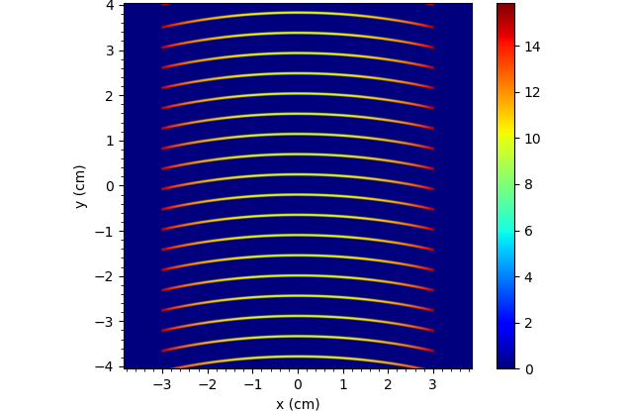
Fig. 4. Curved fission distribution

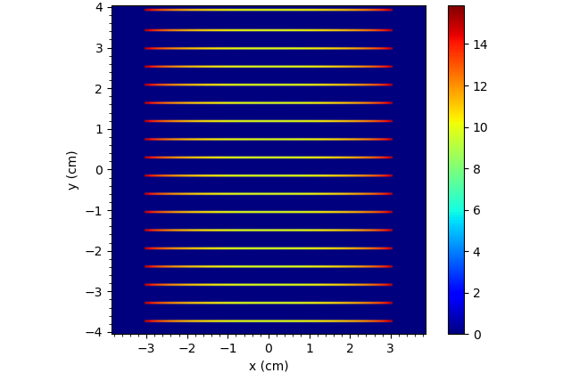
Fig. 5. Flat fission distribution
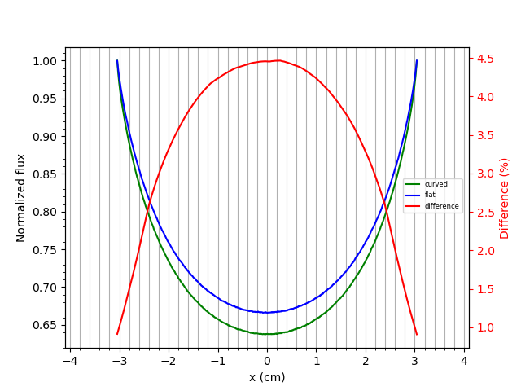
Fig.6. Fission Distribution of Bare Curved and Flat Elements and the Difference Between Them Among X-axis

IV.C. XY Flux Distribution:

The XY flux distribution, which represents the neutron flux variation across the core plane, was analyzed for both fuel element models. Six figures were generated (Fig. 7 to Fig. 12) to depict the scattering and flux for each configuration, as well as the differences between flux.
In both models, the scattering and flux profiles exhibited a similar pattern across most of the fuel element. However, insignificant 0.25% differences (as shown in Fig. 11) were observed in the center of the flux due to the geometrical shape variations. The curved fuel element model demonstrated a more localized flux distribution, while the flat fuel element model showed a broader distribution in the central region. These differences could be attributed to the influence of the curved and flat shapes on neutron scattering and flux behaviors in case of burning the fuel during operation.

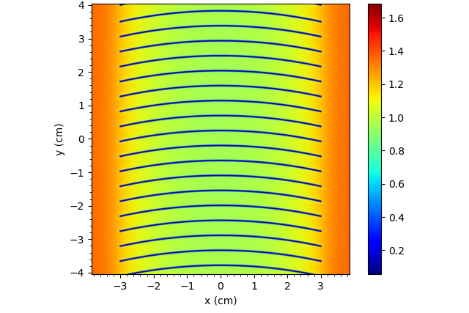
Fig. 7. Curved Scattering Neutron Distribution

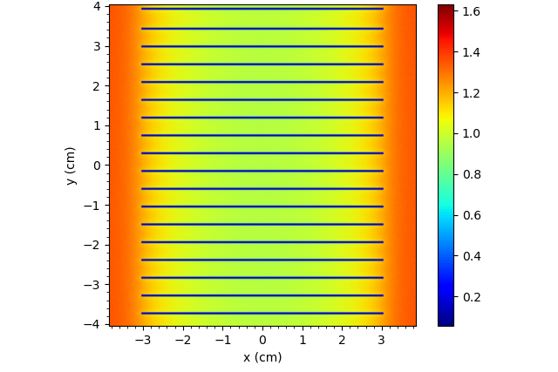
Fig. 8. Flat Scattering Neutron Distribution

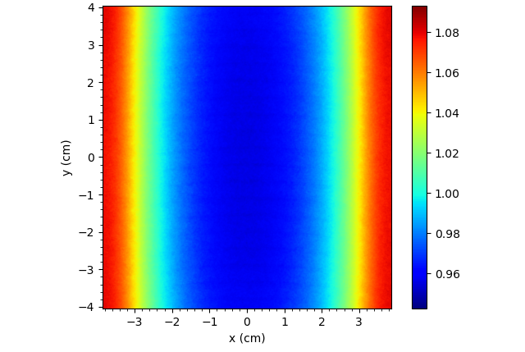
Fig. 9. Curved Flux Neutron Distribution

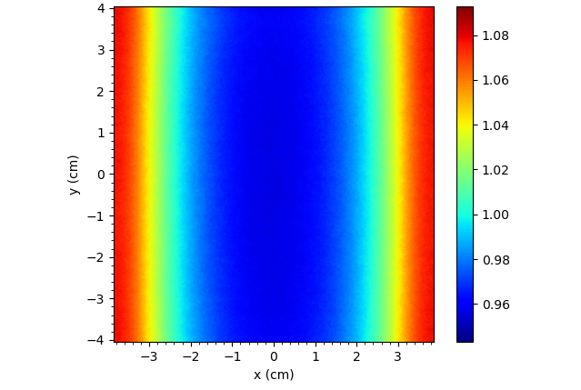
Fig. 10. Flat Flux Neutron Distribution

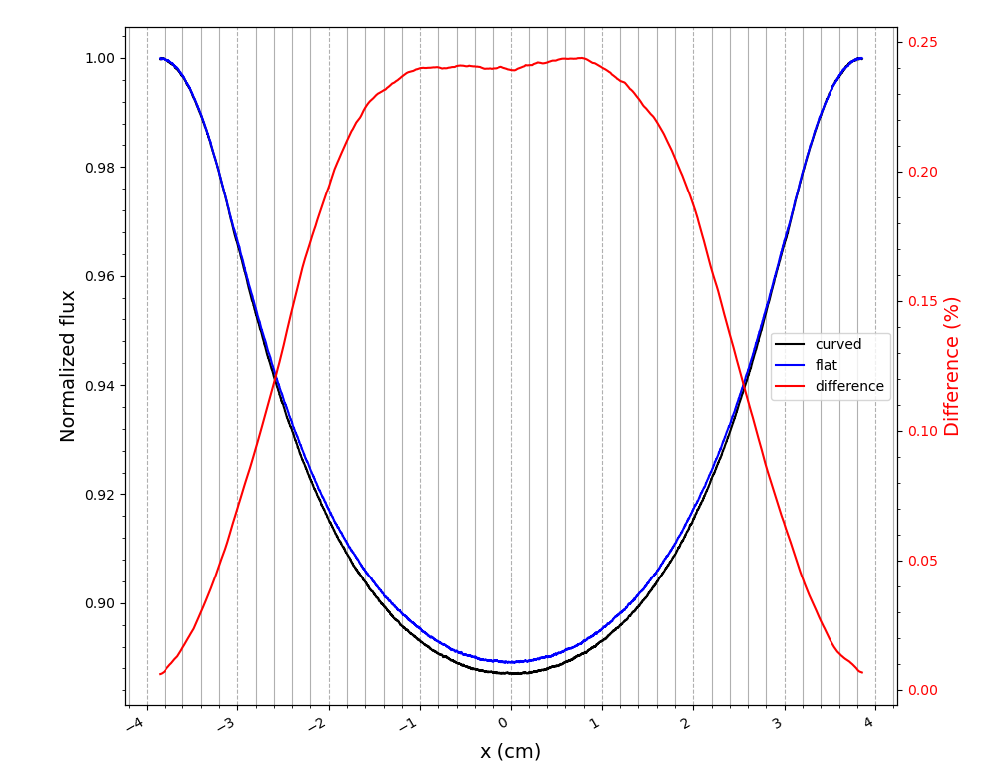
Fig. 11. Flux of Bare Curved and Flat Elements and the Difference Between Them Among X-axis

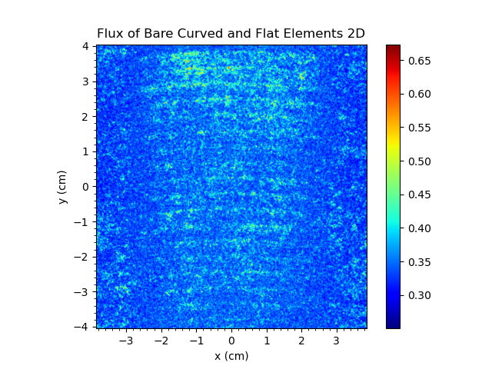
Fig. 12. Special Difference of the Flux of Bare Curved and Flat Elements

IV.D. Volume Statistics:
Volume statistics were obtained for both fuel element models and are summarized in Table III.

Table III.1 Atomic Statistics Calculation for the Curved Fuel Element

Atoms | Curved
 | $$atoms$$ | $$±$$ | $$σ$$
 | $$[×10^{21}]$$ |  | $$[×10^{21}]$$
U-238 | 2.79785 | $$±$$ | 0.00016
U-235 | 0.69738 | $$±$$ | 0.00004
Si-28 | 2.14626 | $$±$$ | 0.00012
Si-29 | 0.10899 | $$±$$ | 0.00001
Si-30 | 0.07184 | $$±$$ | 0.00000
Al-27 | 15.77700 | $$±$$ | 0.00090
H-1 | 74.94360 | $$±$$ | 0.00250
H-2 | 0.01167 | $$±$$ | 0.00000
O-16 | 37.46340 | $$±$$ | 0.00120
O-17 | 0.01420 | $$±$$ | 0.00000

Table III.2 Atomic Statistics Calculation for the Flat Fuel Element
Atoms | Flat
 | $$atoms$$ | $$±$$ | $$σ$$
 | $$[×10^{21}]$$ |  | $$[×10^{21}]$$
U-238 | 2.79856 | $$±$$ | 0.00016
U-235 | 0.69756 | $$±$$ | 0.00004
Si-28 | 2.14680 | $$±$$ | 0.00012
Si-29 | 0.10902 | $$±$$ | 0.00001
Si-30 | 0.07186 | $$±$$ | 0.00000
Al-27 | 15.78120 | $$±$$ | 0.00090
H-1 | 74.93680 | $$±$$ | 0.00250
H-2 | 0.01167 | $$±$$ | 0.00000
O-16 | 37.46000 | $$±$$ | 0.00120
O-17 | 0.01420 | $$±$$ | 0.00000

Table III.3 Atomic Statistics Calculation Difference Between Curved and Flat
Atoms | Differences
 | $$∆atoms$$ | $$±$$ | $$σ$$
 | $$[×10^{21}]$$ |  | $$[×10^{21}]$$
U-238 | 0.00071 | $$±$$ | 0.00023
U-235 | 0.00018 | $$±$$ | 0.00006
Si-28 | 0.00054 | $$±$$ | 0.00017
Si-29 | 0.00003 | $$±$$ | 0.00001
Si-30 | 0.00002 | $$±$$ | 0.00001
Al-27 | 0.00420 | $$±$$ | 0.00127
H-1 | -0.00680 | $$±$$ | 0.00354
H-2 | 0.00000 | $$±$$ | 0.00000
O-16 | -0.00340 | $$±$$ | 0.00170
O-17 | 0.00000 | $$±$$ | 0.00000

Table III.4 Volume Statistics Calculation for Curved Fuel Element
Material | Curved
 | $$Volume$$ | $$±$$ | $$σ$$
 | $${cm}^{3}$$ |  | $${cm}^{3}$$
Fuel | 0.39740 | $$±$$ | 0.00002
Water | 1.12090 | $$±$$ | 0.00004

Table III.5 Volume Statistics Calculation for Flat Fuel Element
Material | Flat
 | $$Volume$$ | $$±$$ | $$σ$$
 | $${cm}^{3}$$ |  | $${cm}^{3}$$
Fuel | 0.39750 | $$±$$ | 0.00002
Water | 1.12079 | $$±$$ | 0.00004

Table I.6 Volume Statistics Calculation Differences Between Curved and Flat Fuel Element
Material | Flat
 | $$Volume$$ | $$±$$ | $$σ$$
 | $$∆{cm}^{3}$$ |  | $${cm}^{3}$$
Fuel | 0.00010 | $$±$$ | 0.00003
Water | -0.00011 | $$±$$ | 0.00005

The tables show the number of atoms and volume of each fuel element model, along with the difference between the two models. The difference in volume between the curved and flat fuel elements is approximately 0.0001 ∆atom ($×{10}^{21}$), with a slightly higher volume observed in the flat fuel element model. The successful volume matching further strengthens the validity of the comparison between the curved and flat fuel element models, as it eliminates potential discrepancies arising from varying fuel volumes.

V. Conclusion

This study investigated the impact of simulating different fuel shapes for a material testing reactor (MTR) using the OpenMC code. Specifically, the comparison focused on the performance of the MTR fuel when modeled as curved and flat fuel elements in a 2D bare reactor configuration.
The analysis of the simulation results revealed that the k-inf, representing infinite reactor criticality, showed a slight difference between the curved and flat fuel element models.
The investigation into the 2D fission distribution and XY flux distribution showed that the spatial distribution of fission reactions has a difference of 4.4% that localized in the center. However, neutron flux has minimal effect of 0.25 % by the fuel element shape. The similarity in these distributions between the curved and flat fuel element models can support the use of simplified flat fuel element models for certain simulation scenarios, as they yield comparable fission and flux behaviors to the real curved shape.
Furthermore, scholastic volume estimation similarities confirmed that the flat fuel element maintained the same fuel volume as the curved fuel element, despite their different shapes.
Overall, this study contributes to a deeper understanding of the impact of fuel element shape on reactor performance. The findings suggest that simulating the MTR fuel as flat elements can offer a reliable approximation of the neutron behavior in the 2D bare reactor core. However, it is essential to recognize the limitations of the 2D configuration, and further investigations in a full 3D core setting are essential to gain a more comprehensive analysis.
In conclusion, the results obtained in this study demonstrate the applicability of using flat fuel element models for certain MTR simulation scenarios. These findings contribute to the optimization of simulation methodologies in nuclear research and facilitate more efficient and accurate simulations for future MTR design and analysis.
Acknowledgments

The authors extend their heartfelt gratitude to Abdulaleem Bugis for his invaluable support throughout the course of this research. Additionally, the authors wish to acknowledge the Master’s Degree in Nuclear Engineering program at the College of Engineering, King Saud University, as well as the Nuclear Engineering program director Dr. Essam A. Alammar. The authors would ike to express gratitude to the generous support from King Abdulaziz City for Science and Technology (KACST) and King Abdullah City for Atomic and Renewable Energy (K.A.CARE). The authors are especially thankful to K.A.CARE Energy Research and Innovation Center at Riyadh in King Saud University for facilitating the execution of simulations on the university workstation.
References

- International Atomic Energy Agency (IAEA). Applications of Research Reactors; IAEA Nuclear Energy Series No. NP-T-5.3; IAEA: Austria, Vienna, 2014.

- International Atomic Energy Agency (IAEA). Research Reactors: Purpose and Future; IAEA Reports; IAEA: Austria, Vienna, 2016

- Duderstadt, J.J.; Hamilton, L.J.; Nuclear Reactor Analysis, 1st ed; John Wiley & Sons Ltd.: New York, NY, USA, 1976.

- Seamone, A. Thermal-Hydraulics Feasibility for an Ultra-Compact Nuclear Reactor Core Assembly. In Proceedings of the 2019 SURF Symposium, Reactor Operations and Engineering, 6 August 2019.

- MacConnachie, E.L.; Novog, D.R. Measurement, simulation, and uncertainty quantification of the neutron flux at the McMaster Nuclear Reactor. Ann. Nucl. Energy 2021, 151, 107879. ISSN 0306-4549.

- Alqahtani, M.; Day, S.E.; Buijs, A. OSCAR-4 Code System Comparison and Analysis with a First Order Semi-Empirical Method for Core-Follow Depletion Calculation in McMaster Nuclear Reactor (MNR). CNL Nuclear Review 2019, 9, 73–82.

- Alnahdi, A.H.; Alghamdi, A.A.; Almarshad, A.I. Investigation of the Fuel Shape Impact on the MTR Reactor Parameters Using the OpenMC Code. Processes 2023, 11, 637. https://doi.org/10.3390/pr11020637.

- Phillips Petroleum Company. Fundamentals in the Operation of Nuclear Test Reactors: Volume 2; Materials Testing Reactor Design and Operation; report; Idaho Falls, ID, USA, 1963.

- Huffman, J.R.; The Materials Testing Reactor Design; Idaho Operations Office; U.S. Atomic Energy Commission: 1953. [osti].

- World Nuclear Association. Available online: https://world-nuclear.org/information-library/non-power-nuclear-applications/radioisotopes-research/research-reactors.aspx (accessed on 8 November 2022).

- Romano, P.K.; Horelik, N.E.; Herman, B.R.; Nelson, A.G.; Forget B.; Smith, K. OpenMC: A State-of-the-Art Monte Carlo Code for Research and Development. Ann. Nucl. Energy, Vol 82,p 90–97. ISSN 0306-4549. 2015.

- Bugis, A.A. Modeling a Nuclear Research Reactor and Radiation Dose Estimation in an Accident Scenario. Ph.D. Thesis, Missouri University of Science and Technology, Rolla, MO, USA, 2020.

