Finding Resolution and Efficiency for multiple gamma energies for LYSO(Ce), CaF2(Eu), and NE102A crystals using SiPM

Tareq Hussein, Nabel Alem, Abdulsalam M. Alhawsaw
Nuclear Department, Faculty of Engineering, King Abdulaziz University
P.O. Box 80204, Jeddah 21589, Saudi Arabia
Email(s): talihussein@stu.kau.edu.sa

Abstract –The scintillation detectors are one of the best for gamma spectroscopy. Thus, the goal of this experiment is to determine the resolution and efficiency for the detection system composed of a SiPM board in addition to three types of scintillation crystals. Two of the crystals are inorganic, CaF2 and LYSO, and the third one is organic plastic scintillator crystal, NE102A. 4 different sources are studied in this experiment as follow, Am-241 and Ba-133 for their low energies, Cs-137 for its mid-range energy, and Co-60 for its high energy. Each crystal was tested with each source to determine the resolution and efficiency. For the CaF2, the resolution for the Am-241 and Cs-137 is 113.14% and 36.78% respectively. As for the LYSO the resolution for the Am-241, Ba-133 (30.8 and 81 keV), and Cs-137 (32 and 662 keV) is 35.58%, 73.74%, 21.97%, 91.52%, and 11.10%, respectively. Moreover, the NE102A plastic scintillator crystal, the resolution for the Am-241 is 37.5%. In addition, the efficiency was calculated for each source using different crystals, For the CaF2, the absolute efficiency for the Am-241 and Cs-137, is 2.76E-03% and 2.15E-04% respectively. As for the LYSO the absolute efficiency for the Am-241, and Cs-137 (662 keV) is 0.104% and 0.013%, respectively. Moreover, the NE102A plastic scintillator crystal, the absolute efficiency for the Am-241 is 1.62E-03%.

Keywords: Radiation detection; Scintillation; SiPM; Silicon photomultiplier; Detector’s efficiency; Detector’s resolution

I. Introduction

As it is known, the world of nuclear technology and activities around us is in a continuous development. As time passes, more countries are indulging in the use of nuclear power and techniques to achieve various objectives. With this rise in usage of nuclear material, more advanced and sophisticated security measures need to be developed in order to ensure the safety and security of the environment and the people. Consequently, there is a need for the development of a good detection system that can identify various radioisotopes in case of nuclear accidents or emergencies to guarantee the right action is taken against it.

II. Literature review

II.A. Resolution

One of the main factors that sets detection systems apart is the resolution of the detector. The energy resolution of a detector measures its ability to distinguish gamma-rays with close energy. The lower the value of the resolution the better its ability to detect different radioisotopes with similar energies [1]. Resolution can be calculated using eq 1.

$Resolution \left(\%\right)=\frac{FWHM}{H_{0}}*100$ (1)
Where:
- FWHM represents the full width at half maximum.
- H₀ represents the centroid of the peak in interest.

II.B. Efficiency

Radiation detectors are not a perfect device, due to the multiple variable radiation interactions with matter they regularly have less than 100% efficiency [2]. In order to fully comprehend the values achieved through the detection system, the efficiency of the detection system has to be precisely identified. Since it relates the number of radiations received and detected by the system and the number of the radiation actually released by the radioactive source. The efficiency of a detector can be classified in two divisions:
- Absolute Efficiency: relates the number of pulses recorded by the detector and the total number of incident radiation released by the radiation source (eq 2):
$ϵ_{abs}=\frac{number of pulse recorded}{number of radiation quanta emitted by source}$ (2)

- Intrinsic Efficiency: relates the number of pulses recorded by the detector and the number of incidents radiation that reaches the detection surface only (eq 3).
$ϵ_{int}=\frac{number of pulse recorded}{number of radiation quanta incident on detector}$ (3)

The two efficiency values must be known; thus, the following equations relate them to each other through the Solid Angle Ω as follows (eq 4).

$ϵ_{int}= ϵ_{abs}*\left(\frac{4π}{Ω}\right)$ (4)

III. Materials and Equipment

III.A. Materials used in the set up

- SiPM board.
- Scintillation crystals (LYSO(Ce), NE102-A, and CaF₂(Eu)).
- Silicon Optical Grease.
- Teflon Tape.
- Radiation Source (Cs-137, Am-241, and Ba-133).
- Amplifier.
- Voltage Source.
- RX1200 digital data processer.
- Computer with RayPannel application compatibility.
- Coaxial cable.
- Housing for the system (dark box).

III.B. Equipment Information

Three sources are used in this experiment that covers low to mid-range energies. These sources are chosen to produce practical results that prove the effectiveness of the detection system in this range of energies. The source information can be seen in Table I:

Table I Radioactive sources information

Source | Activity (Ci) | Current Activity (bq) | Half-life (yr) | Production Date | Energy (keV)
Cs-137 | 3.00E-05 | 4.22E+05 | 30.07 | 1978 | 32 -662
Am-241 | 1.25E-06 | 4.32E+04 | 432.6 | 1978 | 59.6
Ba-133 | 1.0E-06 | 1.06E+04 | 10.5 | 2003 | 31 - 81

The SiPM board technical information according to Onsemi the manufacturing company’s datasheet which is represented in Table II.

Table II SiPM board technical information
Parameter | Value
Sensor Size | 6 mm X 6 mm
Breakdown Voltage | 24.7 V
Peak Wavelength | 420 nm
Photon Detection Efficiency (PDE) | 40%
Rise time | 1 ns
Maximum Current | 20 mA
Refractive Index at 420 nm | 1.59
No. of Microcells | 18980 microcells

Three crystals have been used in this experiment, LYSO(Ce), NE102-A, and CaF2(Eu). Each one of these crystals has its own properties that can be considered as advantages or disadvantages. The technical information regarding the crystals is displayed in Table III.

Table III Crystal information

Category | LYSO(Ce) | NE102A | CaF2(Eu)
Density (g/cm³) | 7.25 | 1.05 | 3.18
Emission Wavelength (nm) | 420 | 415 | 435
Light Output (photons/MeV) | 29,000 | 10,000 | 24,000
Decay Time (ns) | 42 | 2.4 | 900
Refractive Index | 1.82 | 1.58 | 1.47
Hygroscopic | No | No | No

IV. Methodology

The following method was used to optimize the result collected at the end of the experiment. First, the scintillation crystals are to be wrapped tightly with Teflon tape from all sides except the one facing the SiPM board. To ensure good light collection hold the crystal to a light source and make sure no light is getting through. Apply a smidge of the optical grease to the unwrapped side of the scintillation crystal, while ensuring no air bubbles are present. In case of air bubble presence, reapply the optical grease. set the scintillation crystal on top of the detection surface of the SiPM board as seen in figure 1.

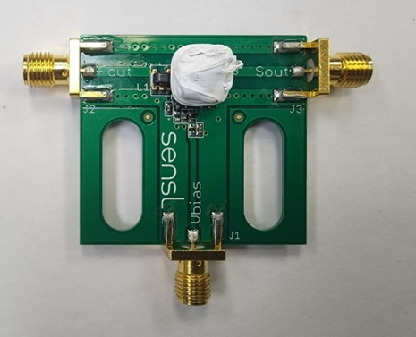
Fig. 1. Crystal attached to the SiPM board

After attaching the crystal to the SiPM, set the SiPM board with the crystals inside the system housing case made (dark box) to ensure no ambient light is getting through. Then, connect the power supply, to the Vbias terminal of the SiPM, and the amplifier input terminal to the Fast output (F.out) terminal of the SiPM using coaxial cables. In addition, connect the voltage supply to the amplifier as well. Then, connect the amplifier output terminal to the input of the RX1200 digital processer. Next, connect the RX1200 output to the computer that runs the RayPannel application. Finally, set the voltage to 27 V for the SiPM board and 15 V for the amplifier, and power the system. The final set up can be seen in figure 2 with the SiPM set inside the black box.

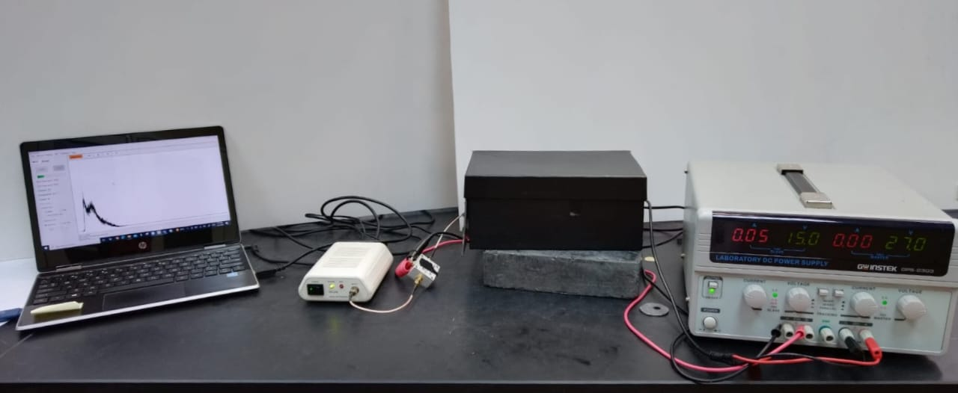
Fig. 2. Complete setup for the experiment

V. Results and Discussion

V.A. Resolution

- LYSO(Ce): The detection time was set at 900 seconds (15 minutes). The calculated resolution for the Cs-137 peaks of 32 keV and 662 keV is 91.52% and 11.10%, respectively. According to the experiment that was done by Kryemadhi and Chrestay in 2015, they managed to achieve a 19% resolution for the 662 keV peak using the LYSO crystal. In addition, there was no recorded resolution for the 32 keV [3]. Thus, the experiment using LYSO(Ce), and Cs-137 source has generated better results than what is currently published. All of the distinguishable features of the Cs-137 can be seen in the spectrum generated in this experiment. The Cs-137 spectrum is shown in figure 3.

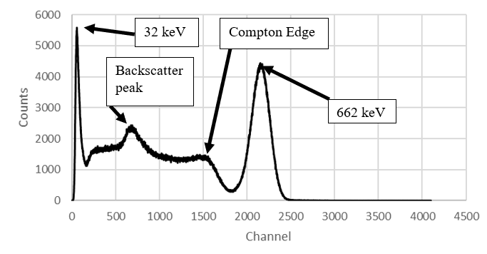
Fig. 3. Cs-137 spectrum generated using the LYSO(Ce) crystal with SiPM board.

The calculated resolution for the Am-241 59.6 keV is 35.58%. According to Gros-Daillon, et al. during a study they made in 2013, the resolution acquired by them for the Am-241 at 59.6 keV was 40% [4]. A spectrum for the Am-241 is shown in figure 4.

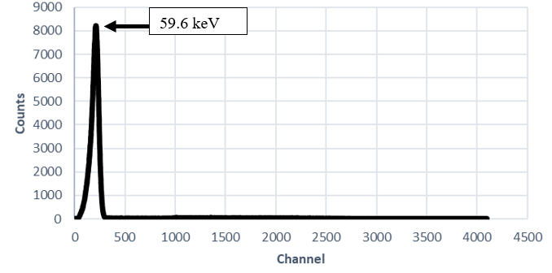
Fig. 4. Am-241 spectrum generated using the LYSO(Ce) crystal with SiPM board.

For the Ba-133 spectrum as shown in figure 5. The resolution for the 30.8 and 81 keV was found to be 73.74% and 21.97% respectively. Compared with results of (Kryemadhi & Chrestay, 2015) they got a resolution of 47% for the 81 keV [3].
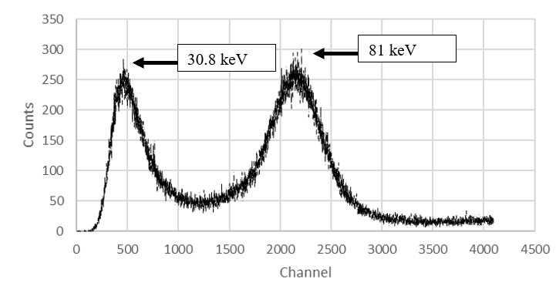
Fig. 5. Ba-133 spectrum generated using the LYSO(Ce) crystal with SiPM board.

Due to the presence of Lutetium which has 2.6% ¹⁷⁶Lu that decays by beta emission. It has a mean energy and a maximum energy for its beta emissions at 182 keV and 593 keV, respectively [5]. To observe the effect, it has on the generated spectra, the radiation sources were removed, and the program ran to measure the crystal intrinsic radiation alone. The recorded spectrum is in figure 6.

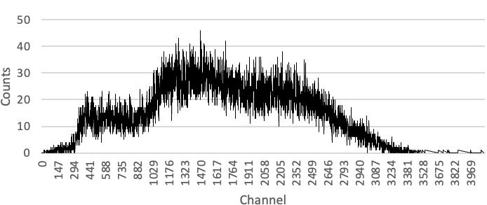
Fig. 6. LYSO(Ce) crystal internal radiation spectrum.

It can be seen from the graph in figure 7, the resolution is high at low energies, then starting from 100 keV, it remains constant at 11.1% until 662 keV energy. To find the resolution in different energy we fitted a curve whose equation is given in eq 5.
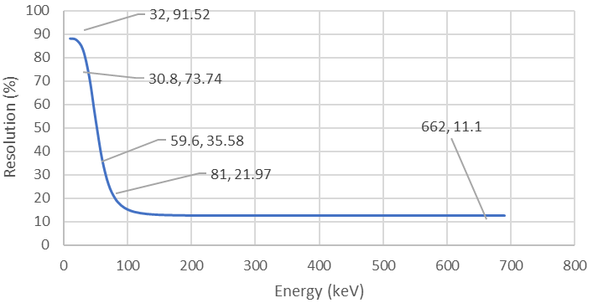
Fig. 7. Resolution Curve for the LYSO(Ce).

(5)

- NE102-A: The detection time was set at 900 seconds (15 minutes). The resolution cannot be calculated due to poor data as shown in figure 8.

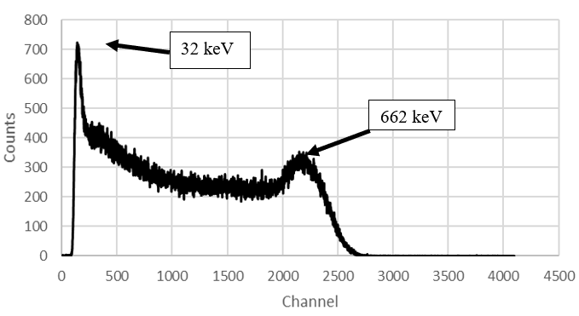
Fig. 8. Cs-137 spectrum generated using the NE102-A crystal with SiPM board.

For the Am-241 The resolution for the 59.6 keV peak as shown in figure 9 is 37.5 %.
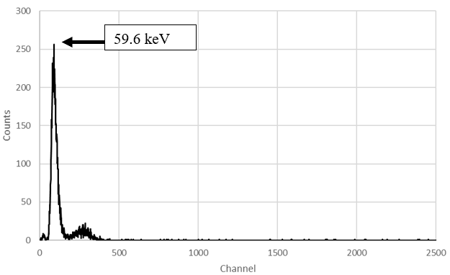
Fig. 9. Am-241 spectrum generated using the NE102-A crystal with SiPM board.

As can be seen from figure 10, the resolution cannot be calculated since the two peaks are superimposed.

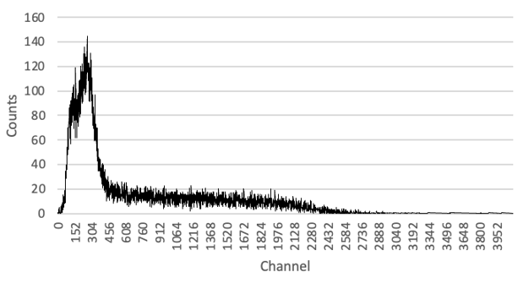
Fig. 10. Ba-133spectrum generated using the NE102-A crystal with SiPM board.

Since there was only one data point for resolution, we cannot fit a curve due to not knowing the relation between resolution and energy.

- CaF2(Eu): The detection time was set 45 minutes. The resolution for the 662 keV was found to be 36.78 % as can be seen in figure 11. Comparing these results with (Plettner et al., 2013) work, they found the resolution for the 662 keV energy to be 5.7–6.07 % [4]. Note that their crystal was larger 5 to 6 times that of our crystal.

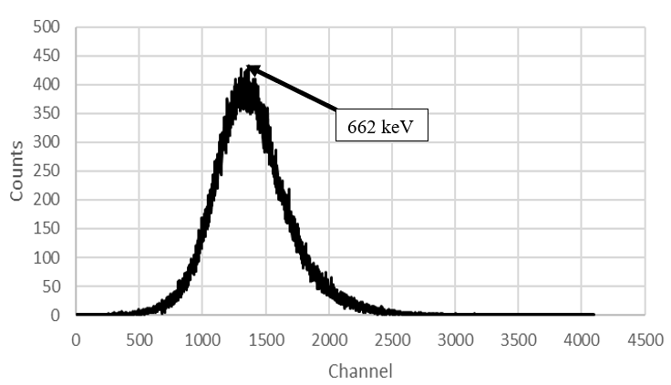
Fig. 11. Cs-137 spectrum generated using the CaF2(Eu) crystal with SiPM board.

The resolution for the 59.6 keV was found to be 113.14% as can be seen in figure 12. Comparing with the results of (Gros-Daillon et al., 2013). They found the resolution to be 40% for the 59.6 keV [5]. Note that their crystal was larger 5 to 6 times that of our crystal.

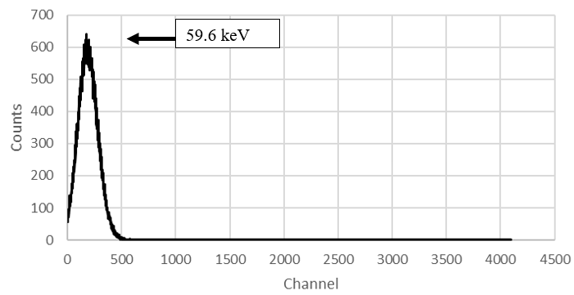
Fig. 12. Am-241 spectrum generated using the CaF2(Eu) crystal with SiPM board

As can be seen from figure 13. We Cannot identify the 30.8 and 81 keV energy peaks.
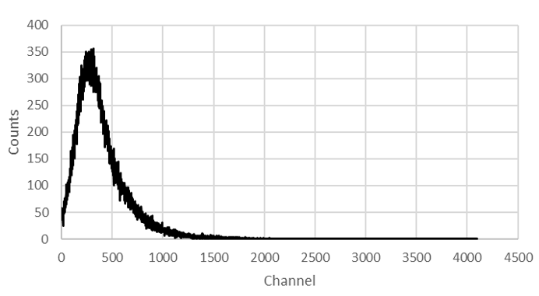
Fig. 13. Ba-133 spectrum generated using the CaF2(Eu) crystal with SiPM board.

We were only able to get the resolution for two different energies. Although, it can be seen that the resolution decreases as the energy increases. The graph in figure 14 shows the resolution curve for the CaF2 whose equation is given by equation 6.

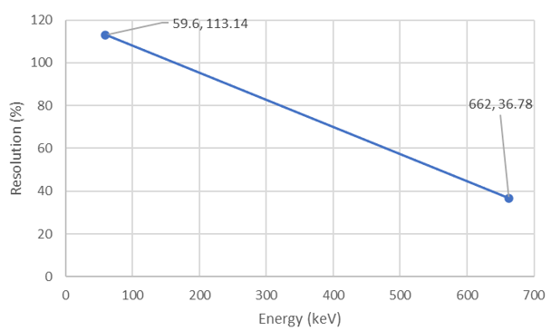
Fig. 14. Resolution Curve for the CaF2(Eu).

(6)
After obtaining the spectrum for each radiation source using the three different crystals, the calculation of the resolution is made and the following table (Table IV) of comparison between crystals was generated.

Table IV : Resolution comparison for all sources using the three scintillation crystals.
Source/Crystal | LYSO(Ce) | NE-102A | CaF2
 | Resolution (%)
Cs-137 (32 keV) | 91.52 | - | -
Cs-137 (662 keV) | 11.10 | - | 36.78
Am-241 (59.6 keV) | 35.58 | 37.5 | 113.14
Ba-133 (30.8 keV) | 73.74 | - | -
Ba-133 (81 keV) | 21.97 | - | -

V.B. Efficiency

Before starting to calculate the efficiency of the detection system, a few adjustments to the set up need to be made. First, add lead plates around the box to eliminate scattered radiation quanta as shown in figure 15. Then set the radiation source of interest at a distance of 5 cm away from the detection surface.

Fig. 15. Adjusted setup for efficiency measurements

LYSO(Ce): Counting for 15 min. The net count was found to be 43265 counts. The absolute efficiency for the 662 keV was found to be 0.013%. The intrinsic efficiency for that energy was calculated and found to be 11.69%. The first two peaks in figure 16 are a combination of the characteristic x ray for lead (L and K shell with energies 15,70 keV) and the 32 keV x-ray for the cesium. The spectrum is shown in figure 16.

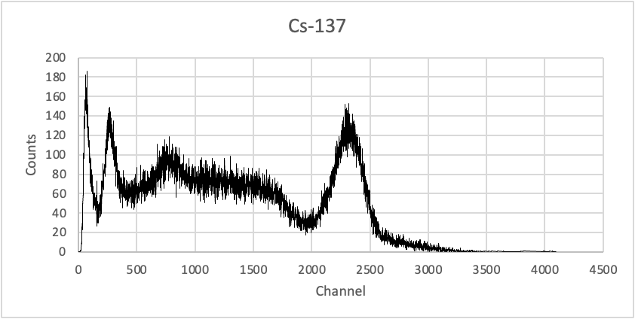
Fig. 16. Cs-137 spectrum using the LYSO(Ce)

For the Am-241, The net count was found to be 14356 counts. The absolute efficiency for the 59.6 keV was found to be 0.104%. The intrinsic efficiency for that energy was calculated and found to be 90.42%. The spectrum for this set up can be seen in figure 17.

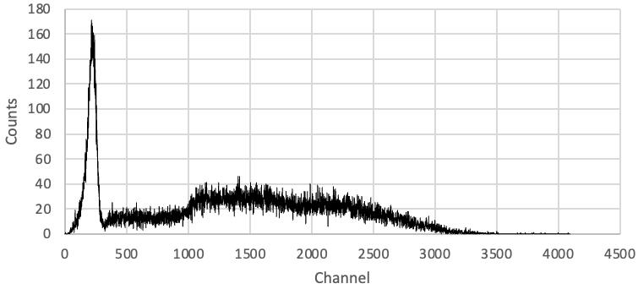
Fig. 17. Am-241 spectrum using the LYSO(Ce)
The first two peaks in figure 18 is a combination of the characteristic x ray for lead (L and K shell with energies 15,70 keV respectively) and 30.8 and 81 keV gamma rays of the Barium-133, So it would be falsified value to calculate the efficiency at these energies. Since we cannot know the activity of the L and K shell x rays and compare them with what has been measured.
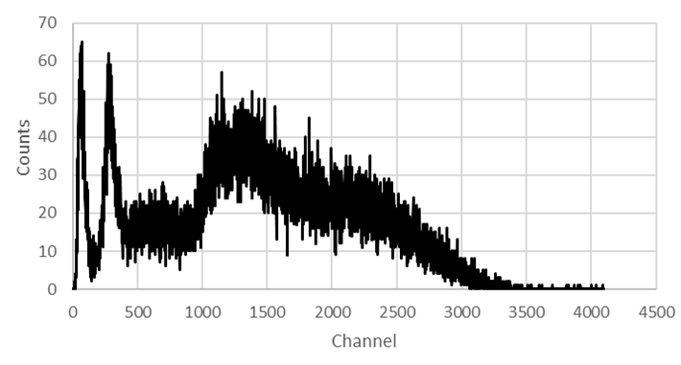
Fig. 18. Ba-133 spectrum using the LYSO(Ce)

As can be seen from figure 19, the absolute efficiency for the LYSO decreases as the energy increases, this makes sense, since high energy gamma does not deposit all its energy in one interaction (Compton scattering), the fitted eq 7 for the efficiency.
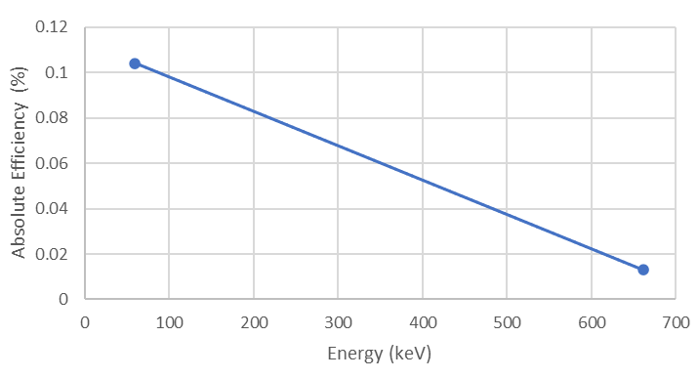
Fig. 19. Ba-133 spectrum using the LYSO(Ce)
(7)

NE102-A: Counting for 15 min. As can be seen from figure 20, we had the Same problem in the resolution case which is that we cannot isolate the peak for 662 keV.
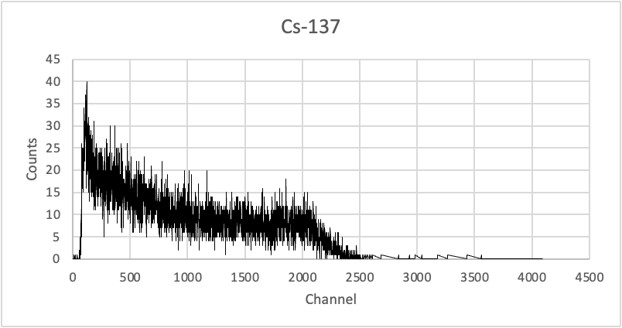
Fig. 20. Cs-137 spectrum using the NE102-A

The net count for the Am-241was found to be 225 counts. The absolute efficiency for the 59.6 keV was found to be 1.62E-03%. The intrinsic efficiency for that energy was calculated and found to be 1.417%. The spectrum for this set up can be seen in figure 21.
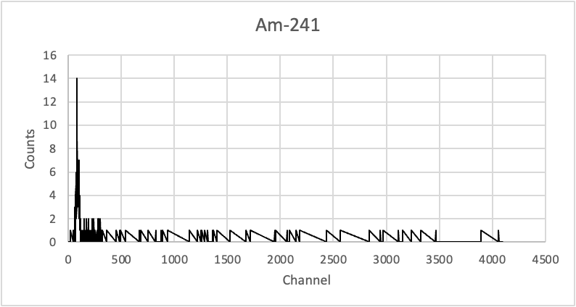
Fig. 21. Am-241 spectrum using the NE102-A

Since there was only one data point for absolute efficiency, we cannot fit a curve due to not knowing the relation between absolute efficiency and energy.

CaF₂(Eu): Counting for 15 min. Counting time for 15 minutes. The net count was found to be 693 counts. The absolute efficiency for the 662 keV was found to be 2.15E-04%. The intrinsic efficiency for that energy was calculated and found to be 0.187%. The spectrum for this set up can be seen in figure 22.
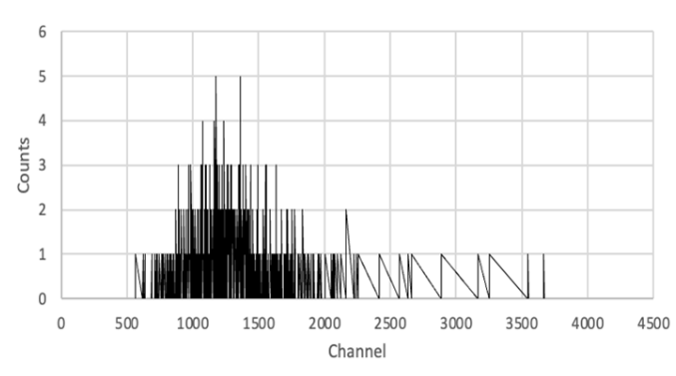
Fig. 21. Cs-137 spectrum using the CaF2(Eu)

The net count was found to be 383 counts. The absolute efficiency for the 59.6 keV was found to be 2.76E-03%. The intrinsic efficiency for that energy was calculated and found to be 2.413%. The spectrum for this set up can be seen in figure 22.
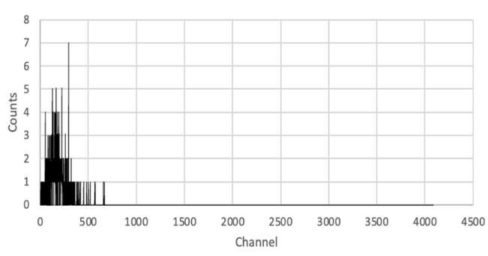
Fig. 22. Am-241 spectrum using the CaF2(Eu)
As can be seen from figure 23, the absolute efficiency for the CaF2 decreases as the energy increases, the fitted equation is given in equation 8.

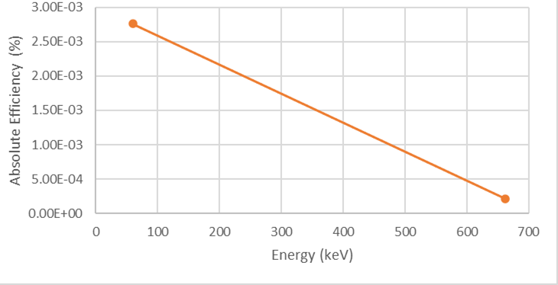
Fig. 23. Efficiency curve for CaF2(Eu)

(8)

After obtaining the spectrum for the different radiation sources using each of the three scintillation crystals, the calculation of the efficiency is made and the following table of comparison between crystals was generated.

Table V : Efficiency comparison for all sources using the three scintillation crystals
Source  /Crystal | LYSO(Ce) |  | CaF2(Eu) |  | NE-102A
 | Absolute Efficiency (%) | Intrinsic Efficiency (%) | Absolute Efficiency (%) | Intrinsic Efficiency (%) | Absolute Efficiency (%) | Intrinsic Efficiency (%)
Cs-137 | 0.013 | 11.69 | 2.15E-04 | 0.187 | - | -
Am-241 | 0.104 | 90.43 | 2.76E-03 | 2.413 | 1.62E-03 | 1.417

VI. Conclusion
The crystal that had the best efficiency and restitution was LYSO. The best resolution achieved is for the Cs-137 (662 keV) at 11.10%, As for LYSO efficiency, it had achieved the higher value with the Am-241 with 90.43% as intrinsic efficiency. Organic crystal had a much faster decay time but in comparison, inorganic crystals such as the LYSO compensate for that with higher light output. The efficiency for our case was found to be inversely proportional to the energy, where it decreases as energy increases. However, the resolution gives better results at higher energies when compared to lower energies. A better set-up is needed to decrease errors, so a 3D printed model is required to case our detection system.
References

- Castro, Filipe. (2015). Re: Is a detector resolution (%) the same as the efficiency of the detector to measure incident gamma rays emanating from the sample.

- G. KNOLL, RADIATION DETECTION AND MEASUREMENT. [S.l.]: JOHN WILEY, 2020.

- A. Kryemadhi and K. Chrestay, “Gamma Ray Spectroscopy with a silicon photomultiplier and a LYSO Crystal,” American Journal of Physics, vol. 83, no. 4, pp. 378–381, 2015.

- C. Plettner, G. Pausch, F. Scherwinski, C. M. Herbach, R. Lentering, Y. Kong, K. Römer, M. Grodzicka, T. Szcześniak, J. Iwanowska, and M. Moszyński, “CAF2(eu): An ``old'' scintillator revisited,” Journal of Instrumentation, vol. 8, no. 06, 2013.

- E. Gros-Daillon, L. Maingault, L. André, V. Reboud, L. Verger, E. Charbon, C. Bruschini, C. Veerappan, D. Stoppa, N. Massari, M. Perenzoni, L. H. Braga, L. Gasparini, R. K. Henderson, R. Walker, S. East, L. Grant, B. Jatekos, E. Lorincz, F. Ujhelyi, G. Erdei, P. Major, Z. Papp, and G. Nemeth, “First Characterization of the SPADnet sensor: A Digital Silicon Photomultiplier for Pet Applications,” Journal of Instrumentation, vol. 8, no. 12, 2013.

