Characterization of the Direct and Scattered Neutron Flux Around Cyclotron Target

Mohammed A. Alawi ¹*, Yahya Z. Hazzaa¹, Rayan B. Fawrah¹, Firas M. Alhusini¹, Abdulsalam M. Alhawsawi^{1,2}, Essam M. Banoqitah^{1,2}

*Corresponding author: e-mail: eng.m.alawi@gmail.com - Cell phone: +966557870132
1 King Abdulaziz University, Faculty of Engineering, Department of Nuclear Engineering, P.O. Box 80204, Jeddah 21589, Saudi Arabia
2 King Abdulaziz University, Center for Training & Radiation Prevention, P.O. Box 80204, Jeddah 21589, Saudi Arabia

Abstract – This study was part of a project that aims to investigate direct and scattered neutron flux, specifically, thermal and epithermal energy ranges around an unshielded PETtrace 880 cyclotron's target in several locations at a medical facility in the western region of Saudi Arabia. Efforts were made to characterize the neutron flux in a diagonal formation using a 3D-printed array within the allowable safe distance from the cyclotron target. The foil activation method was employed to estimate the thermal and epithermal neutron fluxes. The experimental design aimed to irradiate three batches of several sets of gold foils with and without cadmium filters, collect the activated foils and measure the photons emitted from the activated foils using a calibrated Broad Energy Germanium (BEGe) Detector. After covering the gold foils with cadmium from two sides (sandwich setup), the mean thermal and epithermal neutron fluxes were found to be in the order of 1.11E+06 ± 1.10E+05 neutrons cm⁻²s⁻¹ and 7.11E+05 ± 1.78E+04 neutrons cm⁻²s⁻¹, respectively, at almost all investigated locations. The contribution from the scattered neutrons was found to have an increment in the total flux by 45-86% after applying the sandwich setup. Further experiments will investigate neutrons with higher energies in the fast range to fully characterize the area around the cyclotron's target.

Keywords: Neutron Flux, Neutron Scattering, Neutron Activation Analysis, Cyclotron
I. Introduction
There are various ways to produce neutrons. One of these ways is medical cyclotrons. They produce radioisotopes used in Positron Emission Tomography (PET) scans. Among many isotopes, the medical cyclotron produces ¹⁸F-fluorodeoxyglucose (¹⁸FDG), the most commonly used radiopharmaceutical, to assess glucose metabolism in cells, image tumors, and evaluate Alzheimer’s disease [1]. The radiopharmaceutical ¹⁸F is produced by bombarding an H²₁₈O target with accelerated protons above the reaction threshold energy of 2.6 MeV; the reaction of interest is ¹⁸O(p,n)¹⁸F. As a result, high-energy neutrons yielded, in all directions, from the target. The generated energetic neutrons undergo multiple scattering events before they lose most of their energy, become thermal neutrons, and are absorbed by the structure materials.
There are numerous methodologies to evaluate the neutron flux spectrum. These methodologies are experimental-based, simulation-based, or a combination of both [2]–[4]. Some experimental methods use Bonner sphere detectors with different moderators to determine neutron spectral distributions [5]. Other methods involve using special detection systems, such as CR-39 detectors. These detectors are subjected to chemical etching techniques and analyzed with optical microscopy. This method eliminates angular resolution issues compared to other measurement techniques, such as Bonner sphere detectors [6]. Another method is the foil monitor technique; an alternative method that is also applied broadly to measure the neutron flux spectrum [7]–[9]. This method investigates various neutron energy ranges by exposing a set of foils consisting of different materials to a neutron flux. The probability of foil’s neutron capture corresponds to a certain neutron energy range, therefore proper selection of foil material is a key aspect in ensuring correct results [10], [11].
This work evaluates the direct and scattered neutrons at selected positions in a diagonal formation close to the PETtrace 880 cyclotron target to identify highly irradiated locations through the foil monitor technique. By understanding the scattered neutron behavior, various stakeholders can benefit, such as nuclear regulatory bodies when facility operators submit decommissioning plans, research institutes when conducting studies concerning neutron damage on materials, and facility operators when developing countermeasures against instrumentation aging and radiation protection plans during target maintenance.

II. Methods and Materials

II.A. Cyclotron Facility

The cyclotron facility is divided into four main rooms. The control room, power supply room, maze and cyclotron bunker. The cyclotron bunker encompasses the PETtrace 880 cyclotron instrument. The walls inside the cyclotron bunker are made of concrete to shield against the radiation originating from the cyclotron, as recommended by the manufacturer [12]. The length, width and height of the cyclotron bunker are 400, 400 and 500 cm, respectively. The cyclotron target, where the neutrons are produced, is located between the lead shield and the PETtrace 880 instrument, shown in Fig. 1. The thickness, width and height of the lead shield situated in front of the target are 15, ~70 and more than 200 cm, respectively. The relatively large concrete and lead shield thicknesses were selected to avert the neutrons and gamma radiation from leaking out of the cyclotron bunker. Even though the concrete and lead shield were placed to shield against the radiation, still they have undesired effects, which are activation of the surrounding materials caused by the neutrons inside the cyclotron bunker, neutron elastic and inelastic scattering events.
Elastic scattering is the most likely outcome of a neutron-nucleus interaction, regardless of the nuclide or neutron energy. In this work, the elastic scattering microscopic cross-sections were considered only for lead and the data of the microscopic cross-sections were obtained from the Evaluated Nuclear Data File (ENDF) library [13], as shown in Fig. 2.

Fig. 1. Layout view of the PETtrace 880 cyclotron facility exhibiting the main areas.

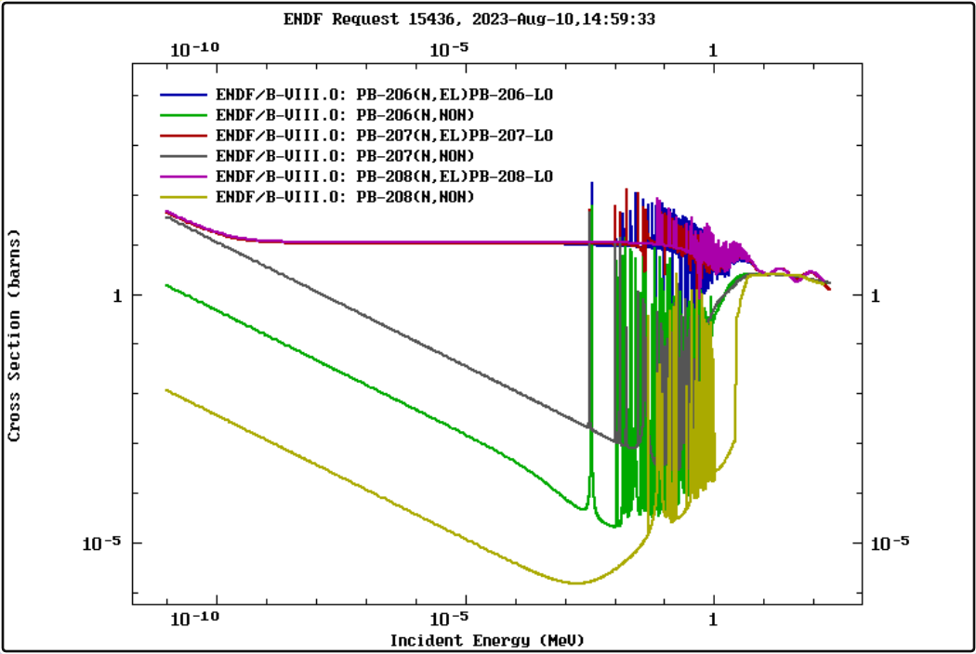
Fig. 2. The reproduced lead’s (Pb) isotopes neutron elastic and inelastic microscopic cross-sections from the Evaluated Nuclear Data File (ENDF) library.

II.B. Foil Monitor Technique and Foil Selection

The foil monitor technique was used to estimate the neutrons in the area between the cyclotron target, lead shield and concrete wall at selected locations. In principle, a foil made of material that has a high neutron capture cross-section to an energy/ energies range of interest will be exposed to the neutron’s spectrum. The atom’s nucleus of a foil captures the neutrons under the energy range of interest and causes the nucleus of atoms to excite. The excited nucleus de-excites by emitting gamma rays. With proper corrections, the emitted gamma rays can be measured by a calibrated high-purity germanium detector and correlated to the incident neutron flux.
In the present work, gold foil was selected due to its large capture cross-section to thermal and epithermal neutrons. The gold thermal and epithermal cross-sections are 98.65 ± 0.09 and 1550 ± 28 barns, respectively. The gold ¹⁹⁷Au captures neutrons and becomes ¹⁹⁸Au with a half-life of 2.6952 days. The benefit of using gold foil is that the number of experiments will be reduced to one-half since it has high capture cross-sections for thermal and epithermal neutrons. Cadmium foil was selected to filter neutrons that have kinetic energy below the cadmium cut-off energy (~0.5 eV). Because the thermal neutron energy is below 0.4 eV, cadmium foil with a thickness of 0.5 mm is sufficient to absorb almost all the incoming thermal neutrons. The selected gold foils are cylindrical with a diameter of 1 cm and a thickness of 100 µm. They have masses ranging from 0.1531 to 0.1570 grams. The cadmium foils are cubes with 1 cm² area and 0.1 cm thickness.

II.C. Experiments

The team has run several experiments to evaluate the direct and scattered neutrons. The distance between the gold foils and the center of the target is 10 cm in the beam forward direction, as per the cyclotron’s operator recommendations. The irradiation duration of the gold foils varied between 60 to 90 minutes. The experiments were designed to investigate three locations in a diagonal formation close to the target, lead shield and concrete wall using a 3D-printed array, as shown in Fig. 3.
The selected locations are rich in neutrons originating from the target and neutrons scattered from the lead shield and concrete wall, as illustrated in Fig. 4. The gold and cadmium foils were positioned in a stick-holder at two elevations (P1 and P2). The two selected elevations P1 and P2 are within a 30º neutron flux emission angle; the emission angle represents the angle of neutron flux emission from the target. In the course of the experiments, the P1 was occupied at one selected position, while the P2 was occupied during the whole experiment. The stick-holder is then placed in the 3D-printed array’s selected positions (S1, S2 and S3). The procedure followed in this experiment is to: 1) irradiate three batches (referred to as arrangements hereinafter) of several sets of gold foils with and without cadmium filters, 2) collect the activated foils and 3) measure the photons emitted from the activated foils using a calibrated Broad Energy Germanium (BEGe) detector.
Initially, the first arrangement (A1) which includes, bare gold foils was irradiated to measure the direct and scattered thermal and epithermal neutron fluxes. Then, a second arrangement (A2) of one-side cadmium (Cd) covered gold foils was irradiated to account for the direct epithermal and scattered neutron fluxes. The third arrangement (A3) setup differed slightly from the first two, where gold foils were inserted between two cadmium filters in a sandwich setup before the irradiation. The objective of the third arrangement irradiation was to isolate the thermal neutrons from the direct and scattered neutron fluxes. The 3D-printed array, selected locations, indexing system and arrangement setup used in this work are provided in Fig. 5.

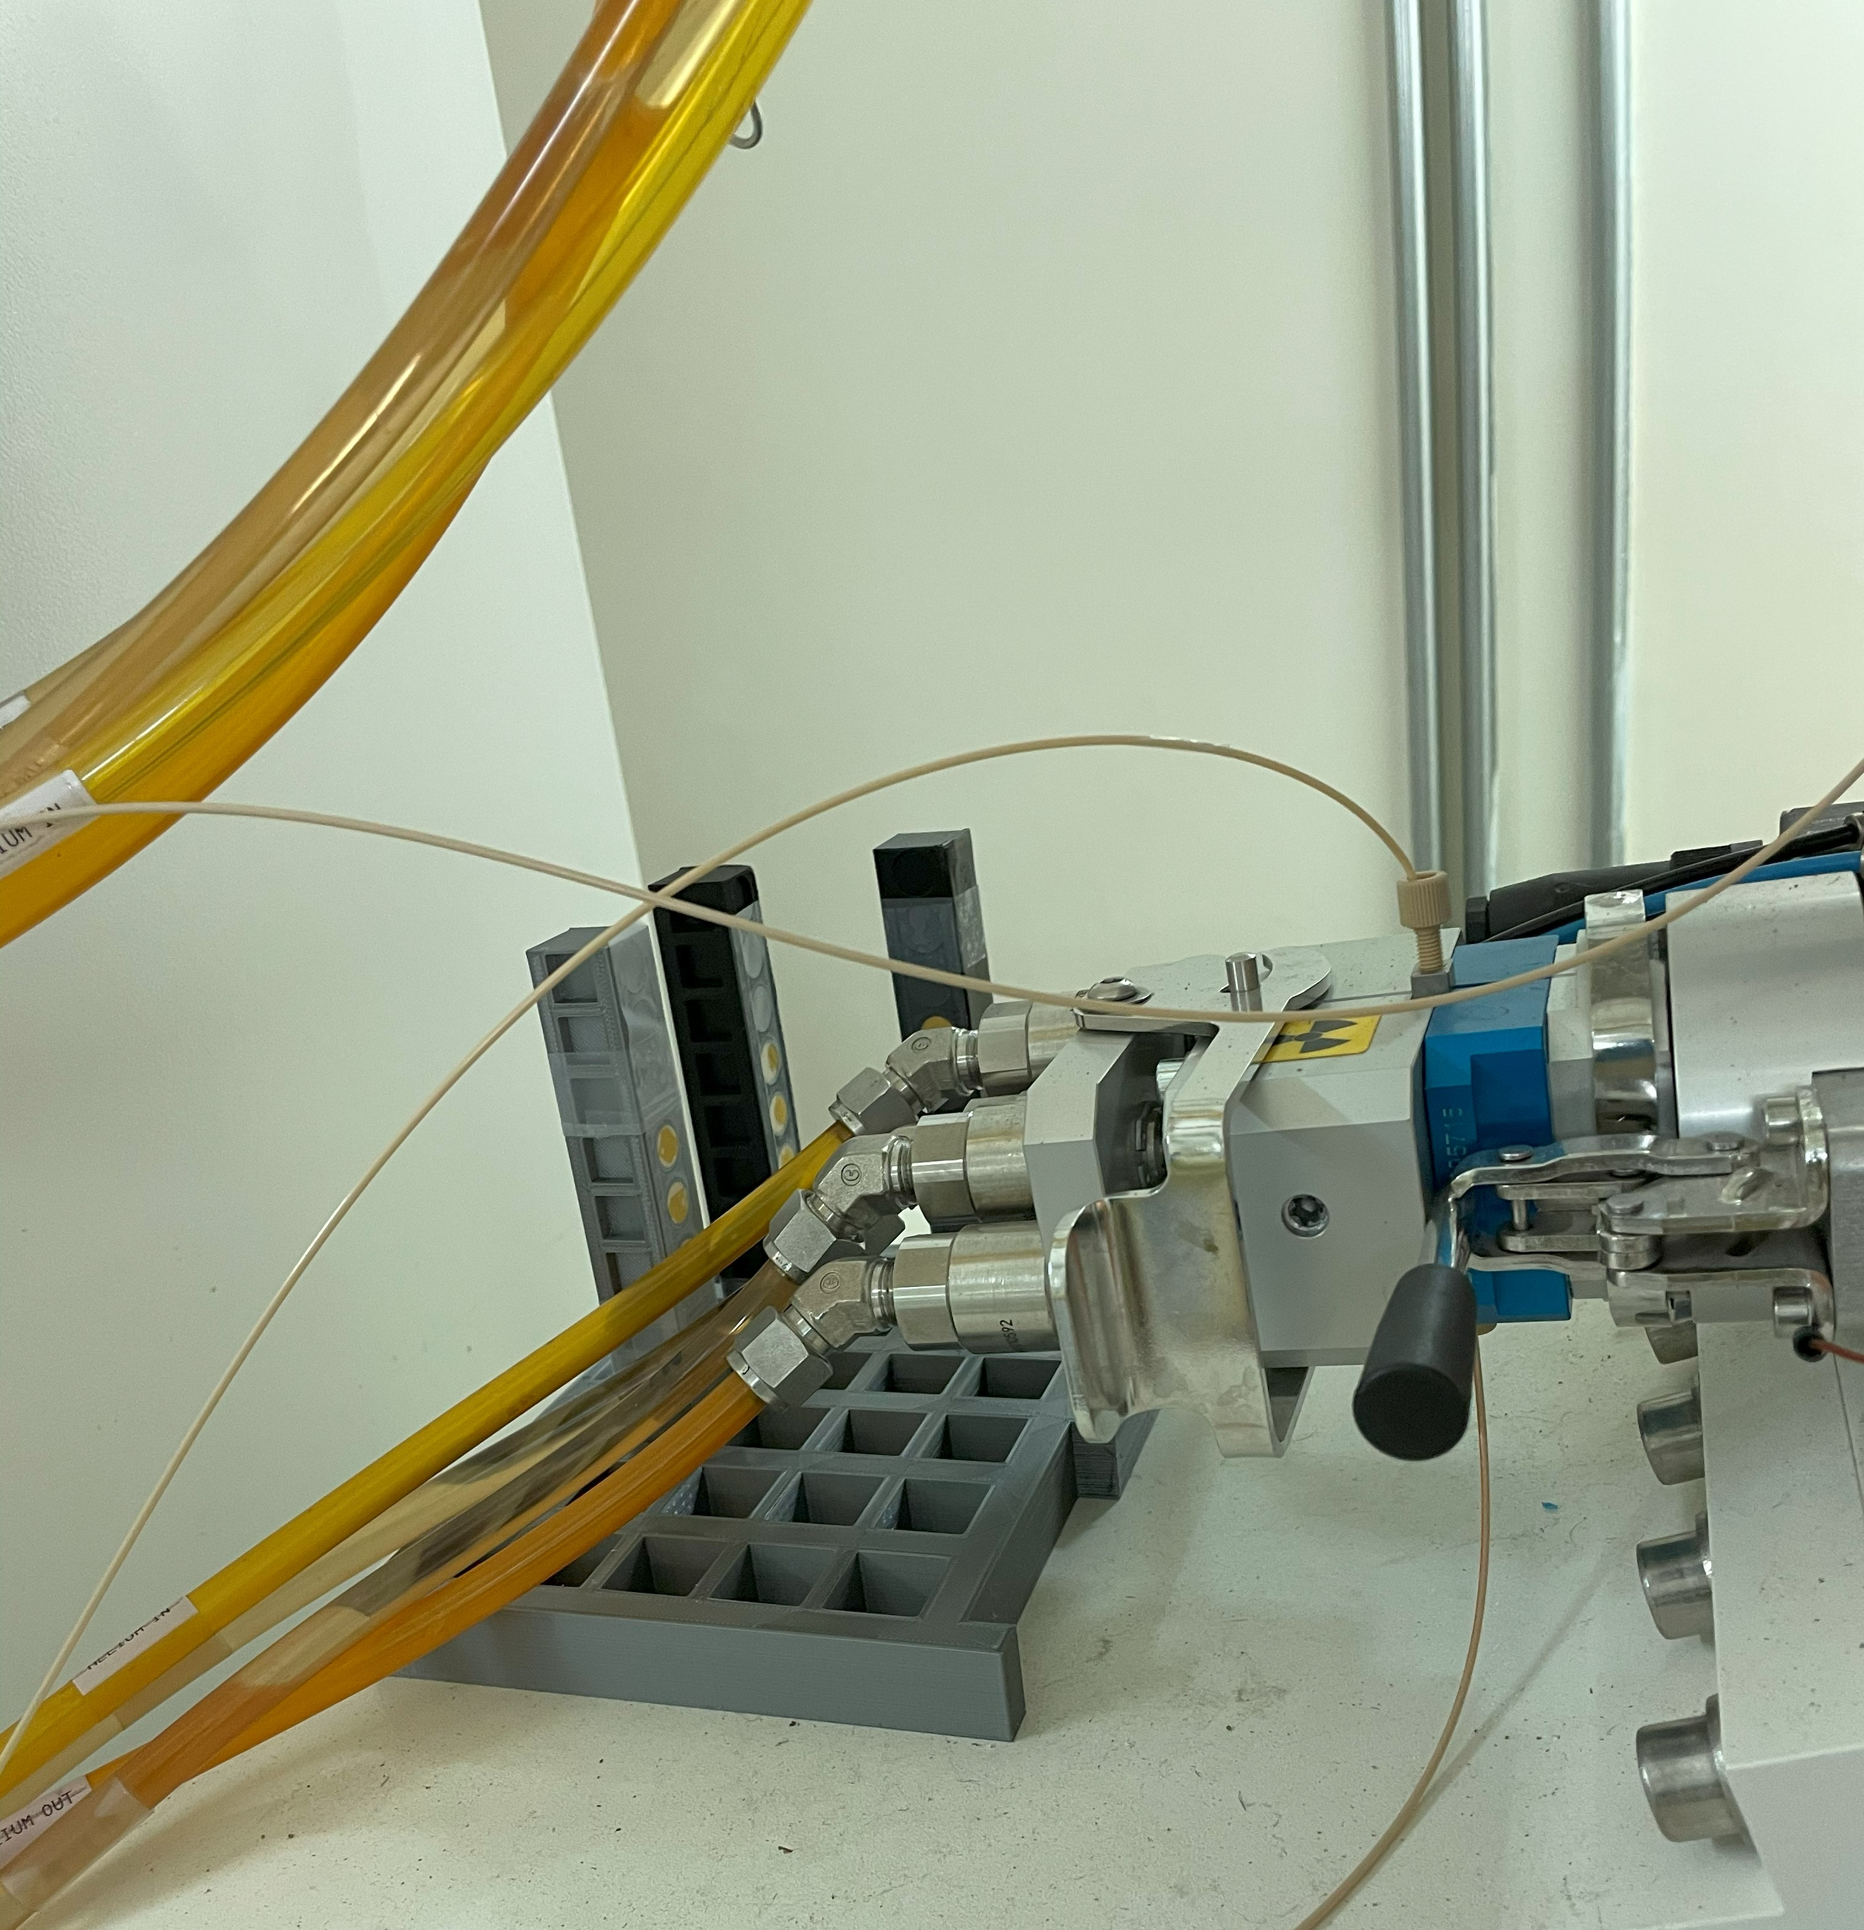
Y
Z
X
concrete wall
Lead shield
Target
3D-printed array
Fig. 3. Demonstration of experiments setup including the 3D-printed array, target, lead shield and concrete wall.

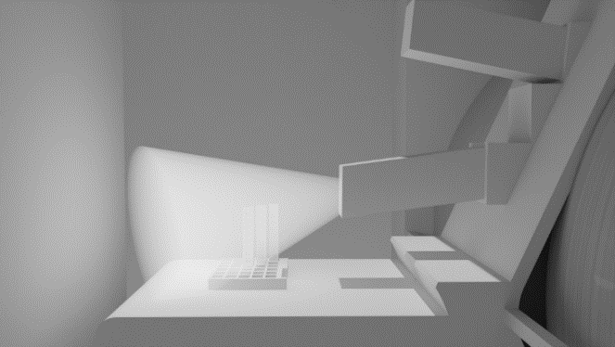
Y
Z
X
(a)
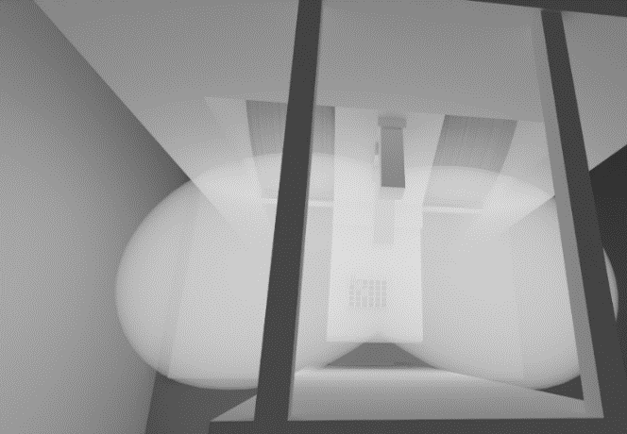
X
Z
(b)
Fig. 4. SolidWorks illustration, in white color, of the neutron flux field in the area of interest. Based on the manufacturer manual [12], a) is a side view of the neutron flux cone shape with a maximum 30º degree angle and b) is a top view of the projected direct and scattered neutron flux field.
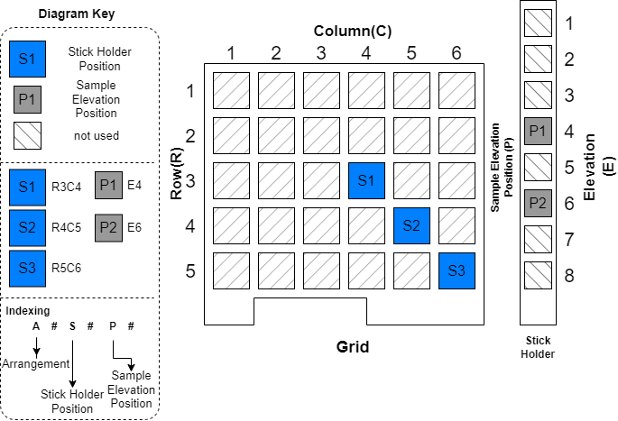
X
Z
X
Y
(a)
Arrangement 1: (A1)  Bare gold foil  Y | Arrangement 2: (A2)  One layer of Cadmium | Arrangement 3: (A3)  Two layers of Cadmium
(b)
X
Fig. 5. The 3D-printed array involves a) the three investigated locations (S1, S2 and S3) and elevations (P1 and P2) and b) the three arrangements A1, A2 and A3.

III. Results and Discussion

The activity of the activated gold foils in the three arrangements A1, A2 and A3 were measured at an energy of 411 keV using the BEGe detector, sample of measured spectra are exhibited in Fig. 6. The measured activities revealed insignificant variations in the S1, S2 and S3 except for the two-sides Cd-covered gold foils, as illustrated in Fig. 6. The activity, using the equations in ref [7], was converted to neutron flux and the values of the estimated neutron flux are exhibited in Fig. 7. From these values, when the gold foils are covered with cadmium from one side in the direction facing the target, the values of thermal neutron flux considerably decrease in all locations. Conversely, the epithermal neutron flux becomes dominant. These two observations suggest that the cadmium foil absorbed all the thermal neutrons coming from the target direction.
When the gold foils are covered with cadmium from two sides in a sandwich setup, the values of the thermal neutron flux significantly increase. In contrast, the values of the epithermal flux have shown a slight decrease compared to the one-side Cd-covered setup. The increase in the thermal neutron flux values is assumed to be caused by the elastic scattering of high-range neutron energies with the lead shield and the cadmium foils placed at the side facing the lead shield. Furthermore, the assumption agrees also with the slight decrease observed in the epithermal neutron flux values.
The mean total neutron flux values of the one-side and two-side Cd-covered foils were measured at 1.09E+06 ± 1.20E+05 and 1.82E+06 ± 1.09E+05 neutrons cm⁻² s⁻¹, respectively. The mean thermal neutron fluxes in the one and two-side Cd-covered setups are 2.93E+05 ± 1.23E+05 and 1.11E+06 ± 1.10E+05 neutrons cm⁻² s⁻¹, respectively. The mean epithermal neutron fluxes in the one and two-side Cd-covered setups are 8.01E+05 ± 1.95E+04 and 7.11E+05 ± 1.78E+04 neutrons cm⁻² s⁻¹, respectively. The total neutron flux values, the thermal to total and epithermal to total neutron flux ratio values are provided in Table I and Table II.
More investigations need to be carried out to study the scattered neutrons from the lead shield, in terms of directions, as well as the concrete wall to establish a comprehensive understanding of the scattered neutrons. The knowledge of the scattered neutrons’ behavior is going to support further studies in estimating the induced activity in the surrounding materials. This in turn will lead to providing proper shielding solutions and consequently reducing the dose in the cyclotron bunker.

Table I The total neutron flux, thermal to total and epithermal to total flux ratios of the A2 (one-side Cd-covered)
Sample position | Total Flux (n/ cm². s) | Relative Error | Thermal to Total Flux Ratio | Epithermal to Total Flux Ratio
S1P1 | 1.16E+06 | 10% | 35% | 65%
S1P2 | 9.88E+05 | 13% | 13% | 87%
S2P2 | 1.05E+06 | 13% | 17% | 83%
S3P2 | 1.18E+06 | 9% | 38% | 62%
Table II The total neutron flux, thermal to total and epithermal to total flux ratios of the A3 (two-sides Cd-covered)
Sample position | Total Flux (n/ cm². s) | Relative Error | Thermal to Total Flux Ratio | Epithermal to Total Flux Ratio
S1P1 | 1.68E+06 | 7% | 57% | 43%
S1P2 | 1.84E+06 | 6% | 60% | 40%
S2P2 | 1.85E+06 | 7% | 59% | 41%
S2P3 | 1.90E+06 | 5% | 67% | 33%

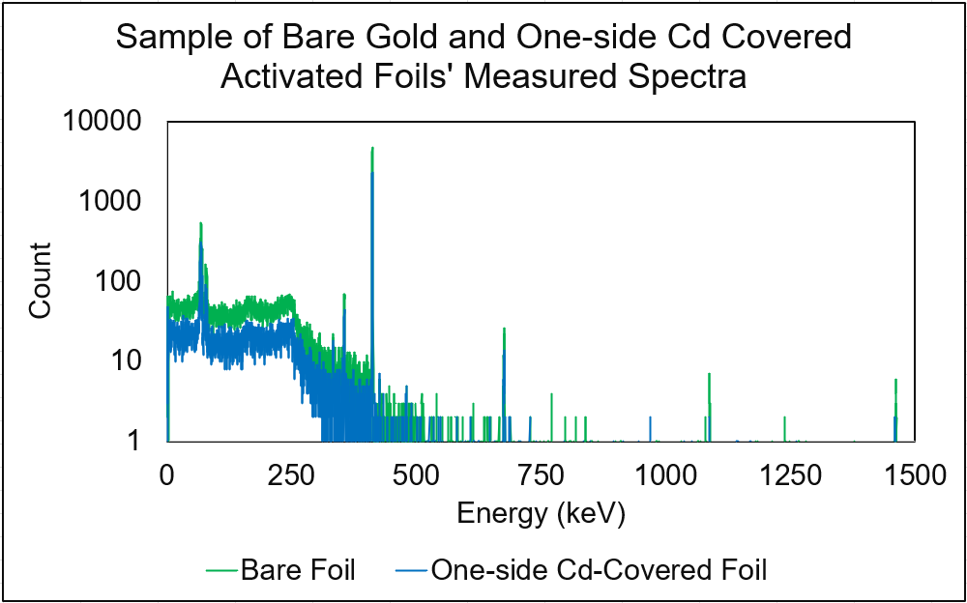
Fig. 6. Measured spectra of activated bare gold and one-side Cd-covered foils.

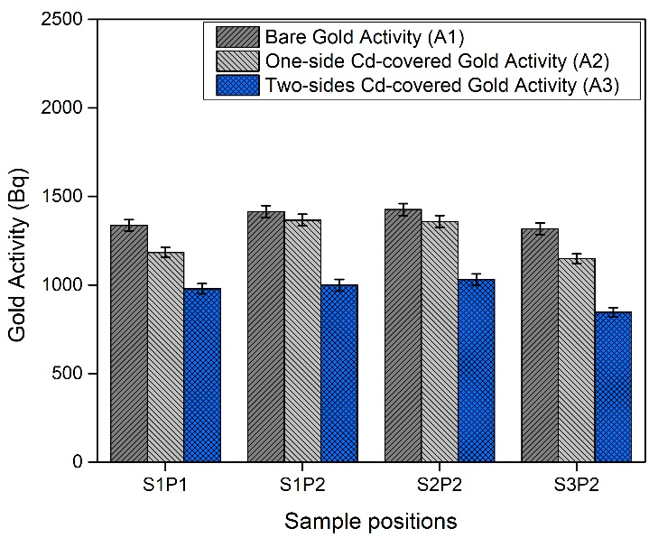
Fig. 7. Measured gold activity for the three arrangements A1, A2 and A3 after irradiation at the selected locations.
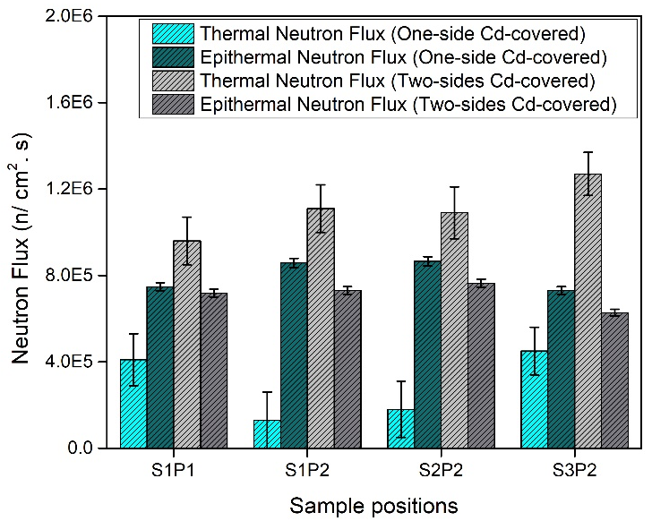
Fig. 8. Comparison of the thermal and epithermal neutron flux estimated values between the one-side and two-side Cd-covered gold foils at the three selected locations S1, S2 and S3.

IV. Conclusions
The direct and scattered thermal and epithermal neutron flux values were evaluated at three locations in a diagonal using a 3D-printed array close to the unshielded PETtrace 880 cyclotron's target at a medical facility in the western region of Saudi Arabia.
Several irradiation experiments were conducted using the foil monitor technique to characterize the direct and scattered neutron fluxes. The total mean neutron flux values for the one and two-side Cd-covered foils setups were measured to be 1.09E+06 ± 1.20E+05 and 1.82E+06 ± 1.09E+05 neutrons cm⁻² s⁻¹, respectively. Although the total neutron flux values, in all investigated locations, are in the same order of magnitude, the thermal and epithermal neutron flux values have varied in the two setups. The mean thermal neutron fluxes in the one and two-side Cd-covered setups are 2.93E+05 ± 1.23E+05 and 1.11E+06 ± 1.10E+05 neutrons cm⁻² s⁻¹, respectively. The mean epithermal neutron fluxes in the one and two-side Cd-covered setups are 8.01E+05 ± 1.95E+04 and 7.11E+05 ± 1.78E+04 neutrons cm⁻² s⁻¹, respectively.
Even though a lead shield was used in front of the cyclotron target to avert the neutrons from leaking out of the cyclotron bunker, the backscattered neutrons have had a major contribution to the activation of the gold foils at the investigated locations. This finding suggests that the surrounding structure's activation is attributed greatly to the neutrons scattered back, by elastic scattering, from the lead shield. Furthermore, the results confirm that the activity inside the cyclotron bunker is driven by the selection of the shielding materials in front of the target. Further studies are going to be conducted to investigate the effect of shielding materials on the activity level inside the cyclotron bunker. Special attention will be given to the cost and the availability of the materials understudy.

Acknowledgment
We would like to express our sincere gratitude to the staff at the Molecular Imaging Center (I-ONE) for their invaluable support and assistance throughout our research. Their expertise and cooperation were essential to the success of our work.
References

[1] F. Xie and F. Peng, “Radiopharmaceuticals for Assessment of Altered Metabolism and Biometal Fluxes in Brain Aging and Alzheimer ’ s Disease with Positron Emission Tomography,” vol. 59, pp. 527–536, 2017, doi: 10.3233/JAD-170280.
[2] M. A. S. Lacerda, D. A. M. Campolina, A. M. Guimarães, J. A. Benavente, and T. A. Silva, “Use of the MCNPX to calculate the neutron spectra around the GE-PETtrace 8 cyclotron of the CDTN / CNEN , Brazil,” Appl. Radiat. Isot., vol. 83, pp. 235–241, 2014, doi: 10.1016/j.apradiso.2013.07.022.
[3] K. Aoki, T. Kin, M. Kamida, and N. Araki, “Determination of Accelerator-based Neutron Energy Distribution by Means of Multiple-foil Activation Method Using GRAVEL , MAXED , and RooUnfold,” vol. 011033, pp. 1–6, 2019, doi: 10.7566/JPSCP.24.011033.
[4] K. Tadahiro KIN, Md. Kawchar Ahmed PATWARY, Masaki KAMIDA, Y. W. AOKI, Naoto ARAKI, Kosuke YOSHINAMI, and M. ITOH, “Development of Radioisotopes Production Method by Accelerator-based Neutron : Activity at Kyushu,” vol. 011031, pp. 1–6, 2019, doi: 10.7566/JPSCP.24.011031.
[5] R. Gallerani, G. Cicoria, E. Fantuzzi, M. Marengo, and D. Mostacci, “Progress in Nuclear Energy Neutron production in the operation of a 16 . 5 MeV PETrace cyclotron,” Prog. Nucl. Energy, vol. 50, no. 8, pp. 939–943, 2008, doi: 10.1016/j.pnucene.2008.02.006.
[6] S. Paul, G. S. Sahoo, S. P. Tripathy, S. C. Sharma, D. S. Joshi, and T. Bandyopadhyay, “Measurement of thick target neutron yield from the reaction (p + 181<mml:mi mathvariant="normal">Ta</mml:mi>) with projectiles in the range of 6–20 MeV,” Nucl. Inst. Methods Phys. Res. A, 2017, doi: 10.1016/j.nima.2017.10.046.
[7] F. A. Abolaban et al., “Estimation of Thermal & Epithermal Neutron Flux and Gamma Dose Distribution in a Medical Cyclotron Facility for Radiation Protection Purposes Using Gold Foils and Gate 9,” Radiat. Prot. Dosimetry, vol. 193, no. 3–4, pp. 176–184, 2021, doi: 10.1093/rpd/ncab034.
[8] J. A. Benavente-Castillo, M. A. S. Lacerda, A. V. Ferreira, H. M. Dalle, and T. A. Da Silva, “Assessment of the neutron radiation field with activation foils and intermittent irradiations around a PETtrace biomedical cyclotron,” Appl. Radiat. Isot., vol. 153, p. 108823, 2019, doi: 10.1016/j.apradiso.2019.108823.
[9] M. Košťál et al., “The methodology of characterization of neutron leakage field from PET production cyclotron for experimental purposes,” Nucl. Instruments Methods Phys. Res. Sect. A Accel. Spectrometers, Detect. Assoc. Equip., vol. 942, no. April, p. 162374, 2019, doi: 10.1016/j.nima.2019.162374.
[10] B. D. Jeffries et al., “Characterization of the neutron flux during production of 18F at a medical cyclotron and evaluation of the incidental neutron spectrum for neutron damage studies,” Appl. Radiat. Isot., vol. 154, no. May, 2019, doi: 10.1016/j.apradiso.2019.108892.
[11] D. W. Nigg et al., “Modification of the University of Washington Neutron Radiotherapy Facility for optimization of neutron capture enhanced fast-neutron therapy Modification of the University of Washington Neutron Radiotherapy Facility for optimization of neutron capture enhanced fast-neutron therapy,” vol. 359, no. 2000, 2005, doi: 10.1118/1.598839.
[12] G. Healthcare, “PETtrace 800 Series Site Planning Guide,” 2013.
[13] D. A. Brown et al., “ENDF/B-VIII.0: The 8th Major Release of the Nuclear Reaction Data Library with CIELO-project Cross Sections, New Standards and Thermal Scattering Data,” Nucl. Data Sheets, vol. 148, pp. 1–142, 2018, doi: 10.1016/j.nds.2018.02.001.

