From Environmental Contamination to Policy Reform: Radiological Impact of Unregulated Tin-Tailing in Support of Malaysia’s Nuclear Safety Framework

AZNAN FAZLI ISMAIL^{1,2}*, MUHAMMAD ABDULLAH RAHMAT ^{1,2}, NABIHA MOHD YUSSUF ^{1,2}

¹Nuclear Energy & Radiological Assessment (NERA), University Research Group, Faculty of Science and Technology, Universiti Kebangsaan Malaysia, 43600 UKM Bangi, Malaysia.
²Nuclear Science Programme, Faculty of Science and Technology, Universiti Kebangsaan Malaysia, 43600 UKM Bangi, Malaysia.

Email(s): aznan@ukm.edu.my

I. Introduction

Since the 1980s tin market collapse, Malaysia has shifted to extracting valuable metals and rare earth elements from tin tailings, which also contain naturally occurring radioactive materials (NORM) and toxic heavy metals.
Many processing plants operate without proper licenses, safety measures, or waste management system, leading to risks of inhalation, ingestion, leaching and direct radiation exposure.
Regulatory gaps, such as the 1994 exemprion order, allow unsafe practices like open-air stockpiling to persists. Similar contamination and radiation exposure issues have been reported in other tin-producing countries, including Nigeria and Indonesia.
This study provides a comprehensive assessment of radiological and heavy metal contamination in tin tailing plants and their potential impacts on health and the environment.
Figure 1 Rock type distribution over Peninsular Malaysia
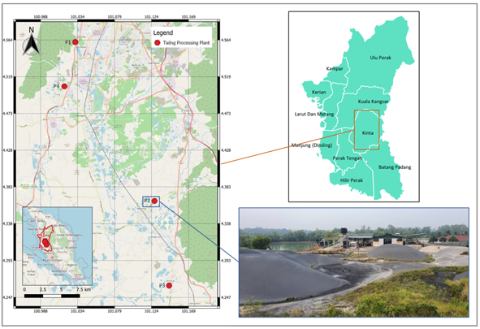

II. Sampling area and method

The study was conducted in Perak, Malaysia, an area with a long history of tin mining and abundant granite-rich geology, which hosts numerous tin processing plants (Fig. 1). A total of 51 samples, comprising soil, tailing, sediments, and control samples, were collected from four selected plants across the state, then dried, ground and sieved for analysis (Fig. 2).
Figure 2 Study site and visual representation on stockpiles commonly found in processing plants
For natural radioactivity assessment, the samples were sealed for three weeks before being analyzed for ²²⁶Ra, ²³²Th and ⁴⁰K using gamma spectrometry (Figure 3) . Heavy metal content, including Cd, Pb and As, was determined by acid digestion of the samples followed by ICP-MS analysis.

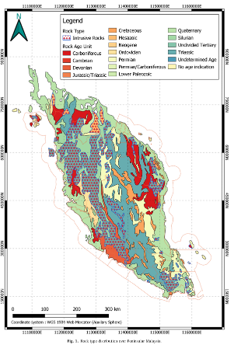

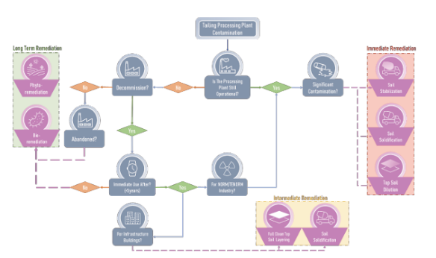
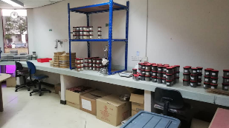
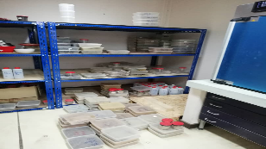
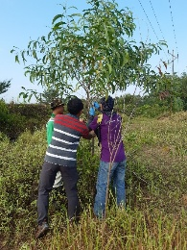
Figure 3 Samples collection
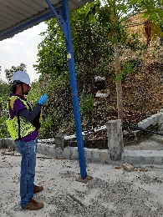
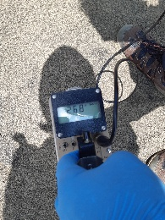

III. Results
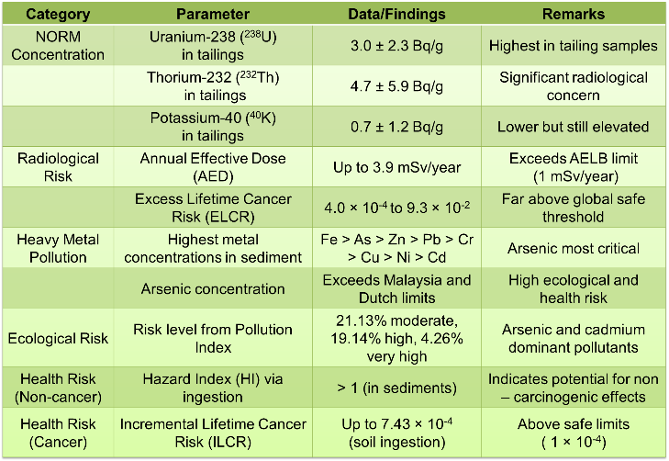
The results presented in the table 1 clearly demonstrate that both radiological and chemical contaminants in unregulated tin tailing sites exceed national and international safety limits, posing significant human health and environmental risks.
Table 1 Radiological and chemical contaminants in unregulated tin tailing sites

IV. Conclusions

This study reveals serious environmental and radiation risks from unregulated tin tailing processing in Malaysia. High levels of natural radionuclides and toxic heavy metals, including arsenic and lead, exceed safe limits and pose health hazards to workers and communities. Weak regulations under the 1994 exemption order worsen the issue. Urgent policy reforms, stricter safety enforcement, and gradual implementation strategies are needed to align with global standards, protect public health, and ensure environmental sustainability in affected areas.

Acknowledgments
This research was funded by the Ministry of Science, Technology and Innovation (MOSTI), Malaysia and Universiti Kebangsaan Malaysia (UKM) under the research grants ST-2019-004 and DIP-2020-022, respectively. The authors express gratitude to the staffs of the Nuclear Science Program, UKM and Atomic Energy Licensing Board (AELB) for their technical support through the research.
References

- Rahmat M.A., Ismail A.F., Aziman E.S., Rodzi N.D., Mohamed F. and Rahman I.A. (2022). The impact of unregulated industrial tin-tailing processing in Malaysia: Past, present and way forward. Resources Policy 78.
- Rahmat M.A., Ismail A.F., Aziman E.S., Rodzi N.D., Idris W.M.R. and Lihan T. (2022). Assessment of natural radionuclides and heavy metals contamination to the environment: Case study of Malaysian unregulated tin-tailing processing industry. Nuc. Eng. and Tech. 54. (2230-2243).
- AELB, 2021. Atomic energy licensing (small amang factory)(exemption)(revocation) order 2021. At. Energy Licens 1984, 11–13.
- AELB, 2011. Peraturan-peraturan Perlesenan Tenaga Atom (Pengurusan Sisa Radioaktif). Akta Pelesenan Tenaga Atom 1984. In press. https://www.aelb.gov. my/malay/dokumen/perundangan/P.U.(A)274.pdf, 2011. (Accessed 10 April 2019).
- AELB, 1994. Perintah Perlesenan Tenaga Atom (Kilang Amang Kecil) (Pengecualian) 1994. Akta Perlesenan Tenaga Atom 1984. AELB, 2010.

