Radon Exhalation Rates and Dose Assessment from Some Marble and Granite Used in Saudi Arabia

Tariq Al-Abdullah ^{1, 2, *}, Muzahir Ali Baloch ², Fatai Liadi ¹, Mohamed Mitwalli ², Afaque Shams ^{2,3}

1-Department of Physics, King Fahd University of Petroleum and Mineral, Dhahran 31261, Saudi Arabia

2- IRC for Industrial Nuclear Energy, King Fahd University of Petroleum and Mineral, Dhahran 31261, Saudi Arabia
3- Department of Mechanical Engineering, King Fahd University of Petroleum and Mineral, Dhahran 31261, Saudi Arabia
Email(s): tariq.alabdullah@kfupm.edu.sa

I. Introduction
The general public receives more than 50% of the radiation exposure from radon and its byproducts which are identified as leading cause of lung cancer [1]. Besides soil and rocks, building materials can also be a significant source of radon in indoor air, leading to considerable gamma ray exposure and increasing indoor radon levels. The high levels of radioactivity in imported granite, ceramic and marble materials can pose numerous health risks that require direct measurement of radon content on surfaces of these materials [2]. Consequently, this study employed a short-term measurement method to assess radon exhalation rates and evaluate the radon effective dose from marble and granite samples.
II. Methodology
The different types of marble (Spanish (S1), Omani (S2), and Turkish (S3)) and granite (Indian (S4), Saudi (S5), and Chinese (S6)) are collected from the local market in Saudi Arabia for building structures. All of the samples (20 mm thickness), which ranged in mass from 0.7 to 0.9 kg, were dried in an oven set to 105°C for 24 hours to remove moisture. Fig. 1 shows the various marble and granite tile specimens.

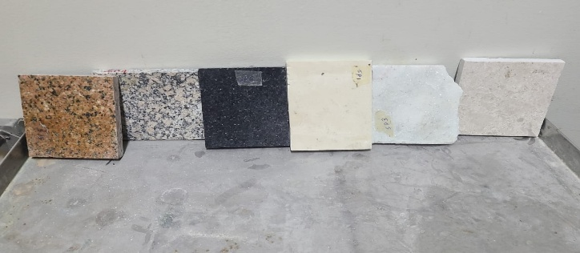
Fig. 1. Marble and granite tiles specimens.
The experimental apparatus (see Fig. 2) consisted of a stainless-steel cylindrical container (51.4 L) with a removable gas-tight lid that was linked in a closed loop with CaSO₄ desiccant to a RAD7 detector for the measurement of radon exhalation. The amount of radon in the container was monitored every hour for 24 hours at a flow rate of 0.8 to 1.9 L/min. Based on slope fitting method, the radon surface exhalation rate ($E_{S}$) and radon mass exhalation rate ($E_{M}$) were calculated using the following equations.
$E_{S}(Bq m^{-2}h^{-1})= \frac{\left(m + λ_{Rn-222}C_{o}\right)V}{A_{S}}$ (1)
$E_{M}(Bq {kg}^{-1}h^{-1})= \frac{\left(m + λ_{Rn-222}C_{o}\right)V}{M_{S}}$ (2)
Where, m (Bq m⁻³ h⁻¹) is the initial slope of elevated radon concentration (see Fig. 3) in short period of time (24 h), C_{o} (Bqm⁻³) is initial radon concentration at t = 0 and V (m³) is total volume of analytical system. A_{S} and M_{S} are the surface area (m²) and mass (kg) of the sample, respectively.
The indoor radon concentration (C_{in}) for the standard room model (dimensions 5 × 4 × 2.8 m³) with walls and floor covered with a 3 cm thickness of marble and granite tiles is determined through the following formula.
$C_{in} \left(Bq m^{-3}\right)= \frac{E_{S} . A_{R}}{λ_{V} . V_{R}}$ (3)
In the above formula, A_{R}, V_{R} and λ_{V} are surface area of wall with floor (89.6 m²), volume of the room (56 m³) and ventilation rate (h⁻¹), respectively.
The annual inhalation effective dose (AIED) from radon and its progeny is calculated using the following formula.
$AIED \left(mSvy^{-1}\right)= C_{in}×F × D_{CF} ×O$ (4)
In the above formula, radon equilibrium equivalent concentration factor is represented by F taken as 0.4 for inhabitants [3]. The dose conversion factor ($D_{CF}$) for ²²²Rn is 9 nSv (Bqhm⁻³)⁻¹ and $O$ represents the annual occupancy (7000 h y⁻¹) indicating that the average time or 80 % of time spent inside the building during a year [3].
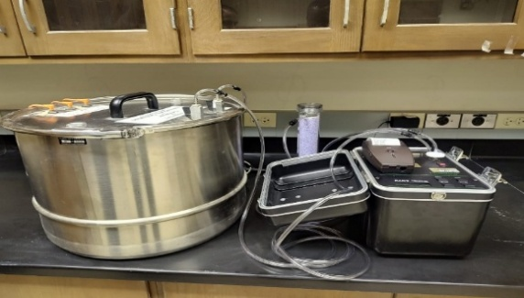
Fig. 2. Experimental set-up for radon exhalation measurements.
III. Results and Discussion
The average radon concentration (C_{Rn}) in the chamber is 26.14 ± 10.47 Bq m⁻³. Sample (S5) showed the highest C_{Rn}, as shown in Fig 3 while S6 had the lowest, demonstrating that granite composition and structure can vary considerably and influence radon release independently of material classification.
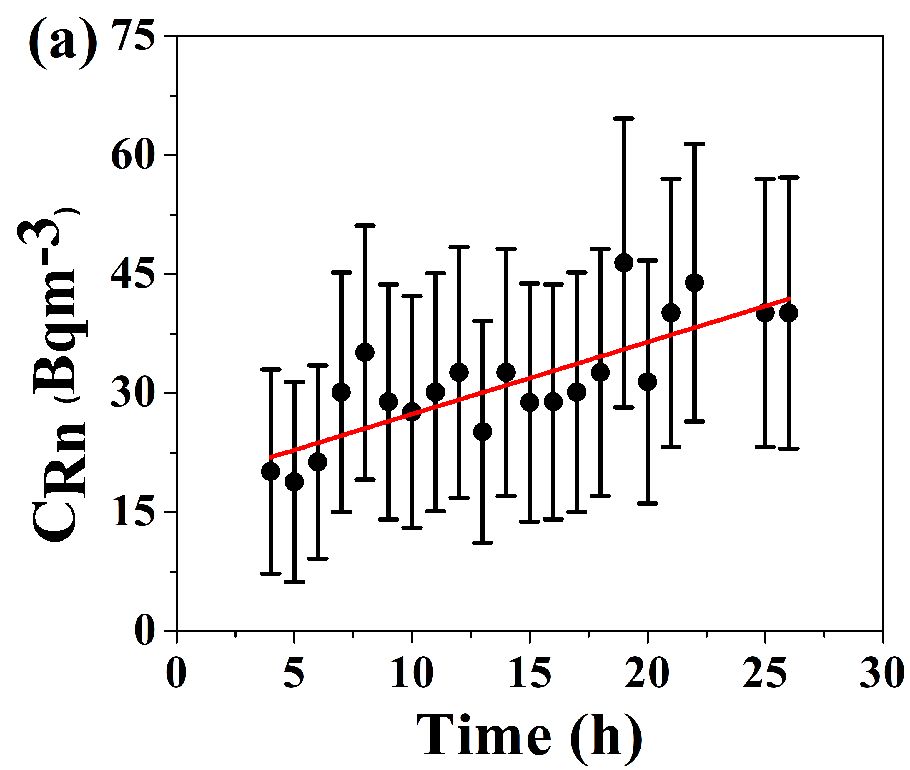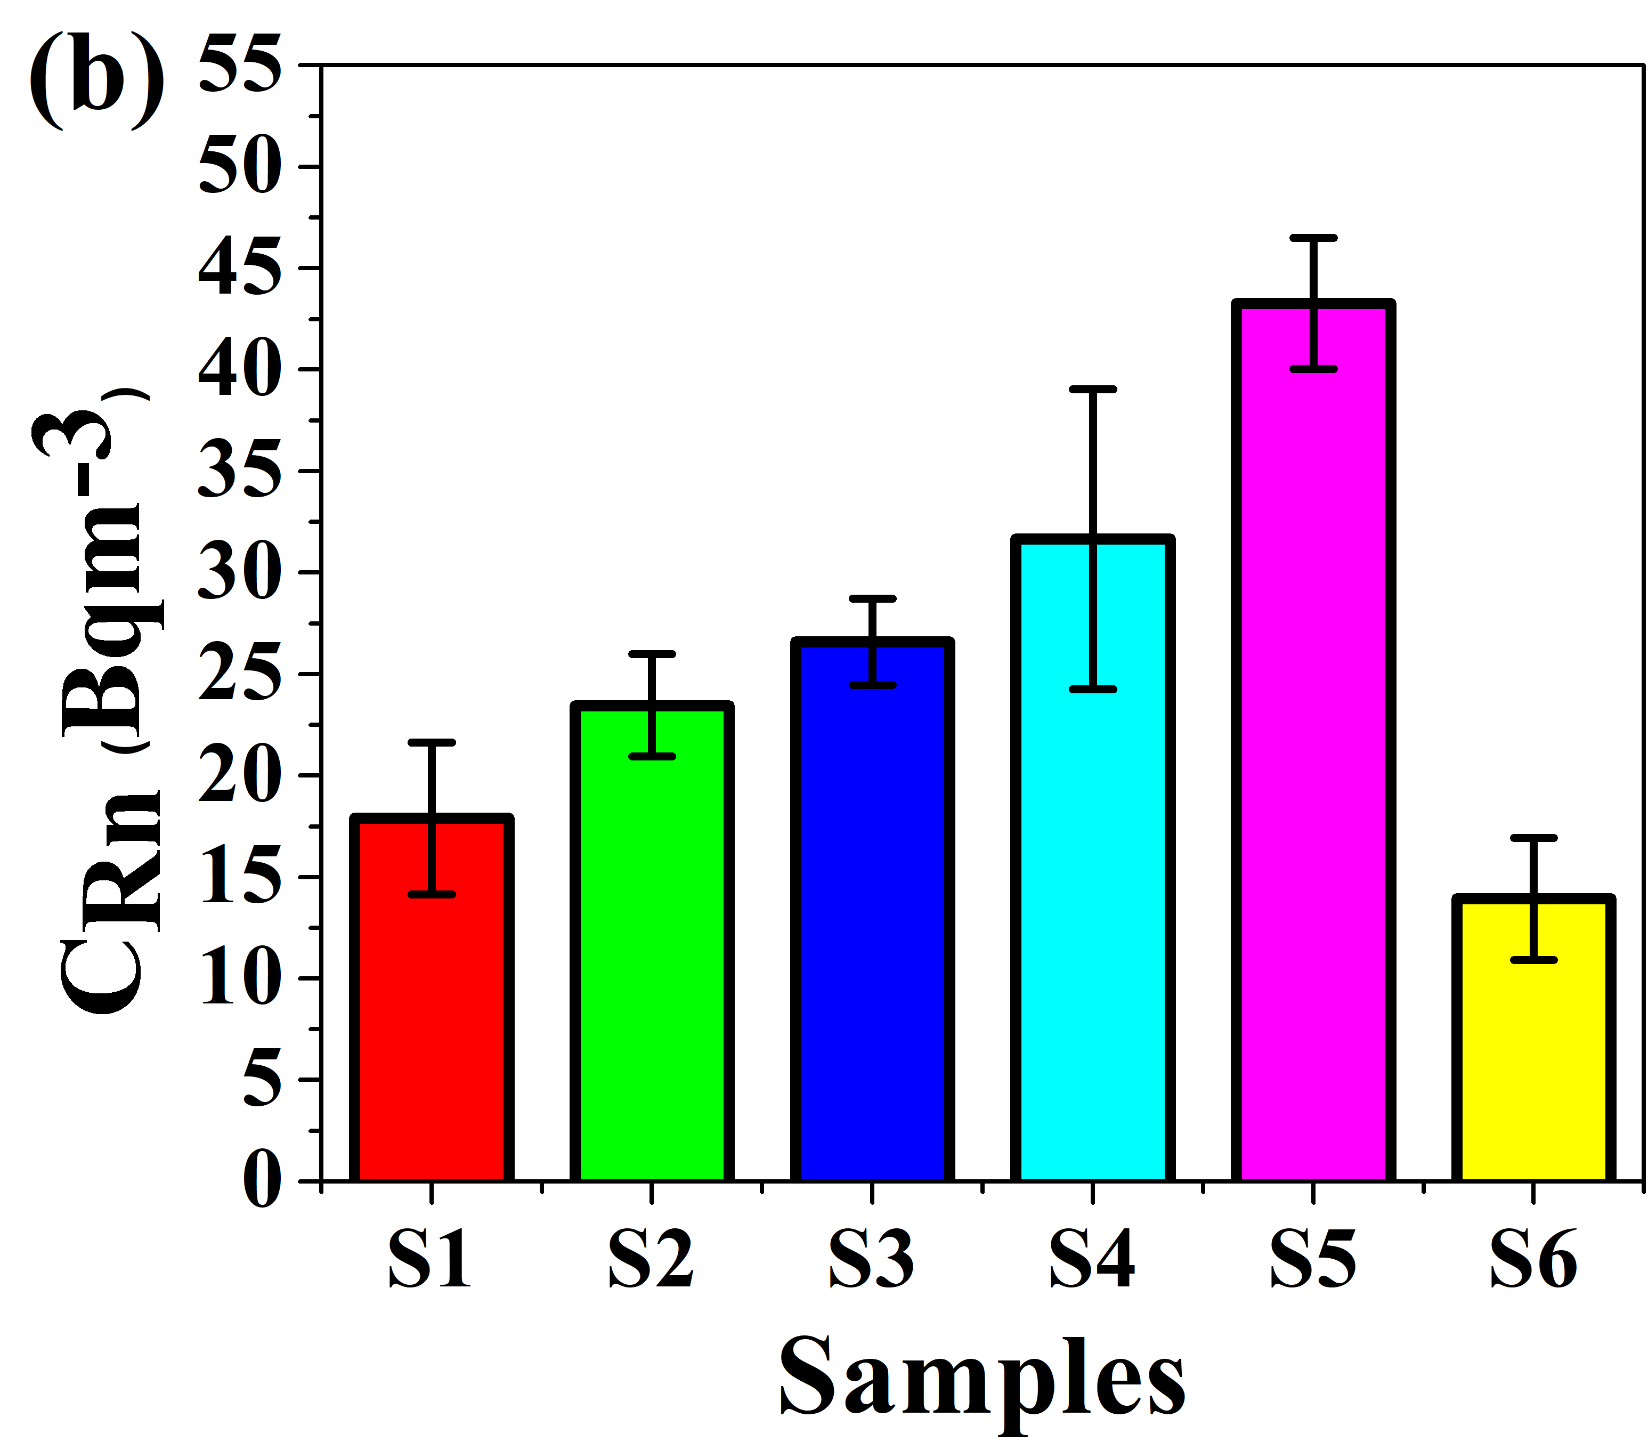
Fig. 3. (a) The build-up of radon (C_{Rn}) exhalating from sample S4 in 50.4 L closed container and (b) levels of C_{Rn} in marble and granite samples.

The E_{S} values for all samples varied from 0.72 ± 0.23 Bq m⁻²h⁻¹ to 3.13 ± 0.46 Bq m⁻²h⁻¹, with an average of 1.56 ± 1.02 Bq m⁻²h⁻¹. The estimated E_{M} for samples varied from 14.62 ± 5.80 mBq kg⁻¹h⁻¹ to 68.75 ± 10.00 mBq kg⁻¹h⁻¹ with an average of 32.20 ± 21.84 mBq kg⁻¹h⁻¹. Fig 4 indicates that granite samples, particularly S4 and S5 have 2 to 3 times higher radon exhalation rates (E_{S} & E_{M}) than marble due to higher measured ²²⁶Ra contents (24.20 ± 4.05 to 75.18 ± 6.70 Bq kg⁻¹ for granite and 18.10 ± 3.76 to 21.83 ± 5.17 Bq kg⁻¹ for marble). In addition, other factors like larger surface area which contributed to higher ion exchange as well as adsorption capacities and porosity may also contribute to radon release, particularly in coarse-grained granites. All samples exhibited E_{S} and E_{M} values significantly lower than the global average or world limits, which are 0.016 Bq m⁻² s⁻¹ or 57.6 Bqm⁻²h⁻¹ for surface exhalation rate and 35 Bq kg⁻¹h⁻¹ for mass exhalation rate [3].
The C_{in} across all samples ranged from 0.57 ± 0.20 Bq m⁻³ to 25.04 ± 3.68 Bq m⁻³, obtained by using the ventilation rate range (0.2 h⁻¹ to 2 h⁻¹) with a geometrical mean of 0.63 h⁻¹ for standard room model. In Fig. 4, sample (S4) exhibited the highest $C_{in}$ (25.04 ± 3.68 Bq m⁻³) at $λ_{V}=0.20$ h⁻¹, indicating that granite foundations in poorly ventilated areas may produce potential health risks to individuals whereas the lowest value of $C_{in}$ (0.57 ± 0.20 Bq m⁻³) at $λ_{V}=2$ h⁻¹ was found in sample (S1). All $C_{in}$ values were lower than the global average of 40 Bq m⁻³ for indoor radon [3].
The average AIED values at λ_{V} = 0.2, 0.63 and 2 h⁻¹ are 0.31 ± 0.20 mSv y⁻¹, 0.10 ± 0.06 mSv y⁻¹ and 0.03 ± 0.02 mSv y⁻¹, respectively. The marble and granite samples show no inhalation risk (see Fig. 4) from indoor radon as all estimated AIED values are within the non-occupational exposure limit of 1 mSv y⁻¹ [4] and lower than the global annual average effective dose of 1.26 mSvy⁻¹ [3].

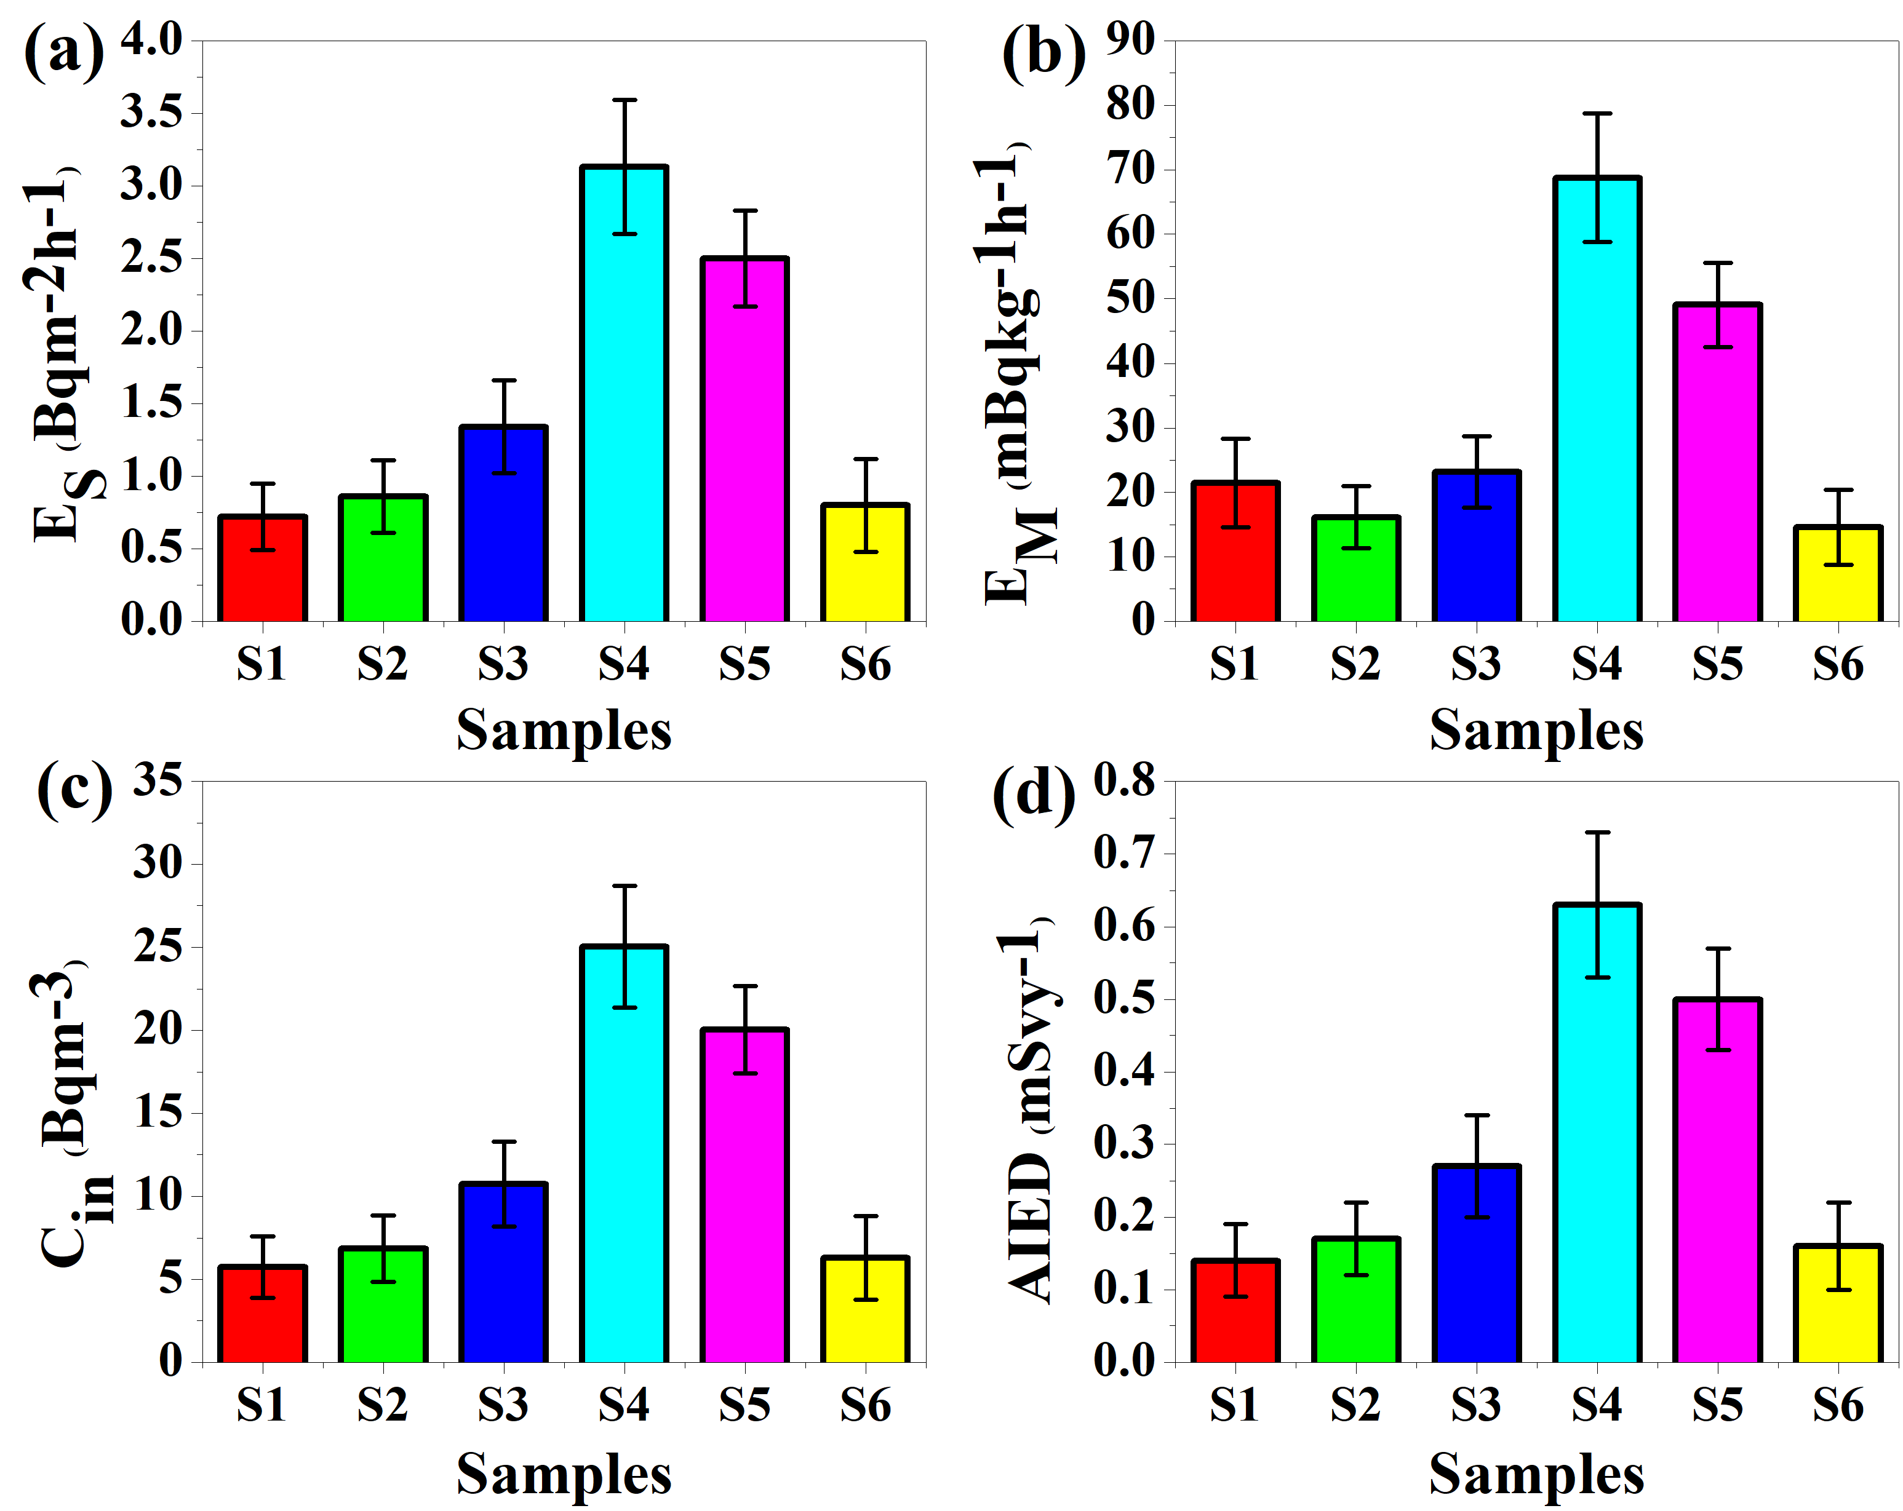
Fig. 4. (a) Radon surface exhalation rate, E_{S} (b) radon mass exhalation rate, E_{M} (c) indoor radon concentration, C_{in} (at λ_{V} = 0.2 h⁻¹) and (d) annual inhalation effective doses, AIED (at λ_{V} = 0.2 h⁻¹) for marble and granite samples.

IV. Conclusions
This study evaluated radon exhalation rates and indoor radon dose levels from commercially available marble and granite samples used for construction of dwellings in Saudi Arabia. The measured levels of radon exhalation rates ($E_{S}$ & $E_{M}$), indoor radon concentration ($C_{in}$), and effective dose (AIED) are lower than the international safety limits. So, the analyzed marble and granite samples are safe to use for indoor interior and do not pose significant health risks from radon inhalation under normal ventilation conditions.
Acknowledgments
This work is a part of project IRC-INNE2404 funded by King Fahd University of Petroleum and Minerals, Dhahran, Saudi Arabia.
References
- F. Bochicchio, M. Ampollini, S. Antignani, C. Carpentieri, M. Caprio, B. Caccia, C. D. Carlo, S. Pozzi, S. Valentini, G. Venoso, Protection from radon in Italy: Past, present and perspectives. Rom. J. Phys. 64, 817 (2019).
- A. Saad, H.H. Al-Awami, N. Hussein, Radon exhalation from building materials used in Libya. Radiat. Phys. Chem. 101, 15–19 (2014).
- United Nations Scientific Committee on the Effects of Atomic Radiation (UNSCEAR). Sources and Effects of Ionizing Radiation, United Nations, New York, USA, Volume I, 2000.
- ICRP, Compendium of dose coefficients based on ICRP publication 60, 2012.

