Project Management Strategies for Managing Low to Moderate Nuclear Incidents in Saudi Arabian Nuclear Power Plants

Mohammed Alhajji^{1*}, Muhammad Yusuf², Afaque Shams^{1,2}
¹Department of Mechanical Engineering, King Fahd University of Petroleum & Minerals (KFUPM), Dhahran, 31261, Saudi Arabia
²Interdisciplinary Research Center for Industrial Nuclear Energy (IRC-INE), King Fahd University of Petroleum and Minerals (KFUPM), Dhahran, 31261, Kingdom of Saudi Arabia

I. Introduction
The Kingdom of Saudi Arabia's strategic move toward constructing its first nuclear power plant marks a pivotal shift in the nation's energy paradigm, which has long relied on oil. As part of Vision 2030 and the Saudi Green Initiative, this initiative not only aims to diversify the energy mix and reduce carbon emissions but also holds the potential to enhance energy security through low-carbon, sustainable sources such as nuclear power. With the planned deployment of two reactors contributing 2.8 GWe, which is approximately 5% of national electricity demand, this transition will support long-term goals such as desalination, technological advancement, and economic diversification.
However, introducing nuclear technology presents complex challenges, particularly managing low-to-moderate nuclear incidents, which require robust project management and risk governance frameworks. Despite regional interest in nuclear energy, including projects in the UAE and Iran, Saudi Arabia lacks extensive civilian nuclear experience. Public perception remains cautious, influenced by historical unfamiliarity and geopolitical concerns [1],[2],[3]. Therefore, effective management strategies are vital for building public trust and ensuring safety compliance.
This study addresses the critical gap in tailored incident management approaches specific to Saudi Arabia's emerging nuclear context. The novelty of this research lies in integrating ISO 31000 risk management standards with Project Management Body of Knowledge (PMBOK) based project management practices to propose a strategic framework for mitigating low to moderate nuclear incidents, especially for Saudi Arabia's best practices. Learning from international experiences, such as Finland's Olkiluoto 3 facility, the study emphasizes the importance of proactive risk assessment, stakeholder coordination, and cultural contextualization. The urgency of implementing this framework cannot be overstated, as it is vital for the safe and successful development of Saudi Arabia's nuclear energy sector.
Ultimately, the risk assessment study offers actionable strategies that align with global safety benchmarks, providing a solid foundation for Saudi Arabia's unique environmental, institutional, and social landscape. The proposed framework strengthens regulatory readiness, enhances communication, and supports the Kingdom's aspiration to lead peaceful nuclear energy development safely. This alignment with global safety benchmarks should reassure all stakeholders of the commitment to safety in developing Saudi Arabia's nuclear energy sector.

II. Methodology
This paper outlines a framework to apply international project and risk management standards to Saudi Arabia’s emerging nuclear sector. The goal is to prevent, mitigate, and respond to nuclear events classified under INES Levels 1–3, as defined by the International Atomic Energy Agency [4], in ways that are technically robust and contextually appropriate for the country’s climate, infrastructure, and socio-political environment.

Table I Examples of INES 1–3 Events and Lessons

Event | INES Level | Key Lesson
Sellafield Leak (UK) | 3 | Improve automated leak detection
Flamanville Corrosion (France) | 2 | Implement predictive maintenance
Forsmark Valve Malfunction (Sweden) | 1 | Enhance procedural compliance

II.A. Project-Based Safety Framework

Applying ISO 31000 ensures contextual risk evaluation (e.g., cooling failure during sandstorms), while PMBOK supports stakeholder engagement and incident response. Technologies such as AI diagnostics, blockchain safety logs, and passive safety systems (e.g., APR1400) enhance operational resilience.

III. Results and Discussions

This study addresses the critical gap in tailored incident management approaches for Saudi Arabia’s emerging nuclear sector. By integrating ISO 31000 risk management principles and PMBOK project governance methodologies, it proposes a framework for handling low-to-moderate nuclear incidents (INES Level 1–3). Lessons are drawn from international experiences, including Barakah (UAE), Flamanville (France), and Kashiwazaki-Kariwa (Japan), where these frameworks improved resilience, oversight, and stakeholder trust.
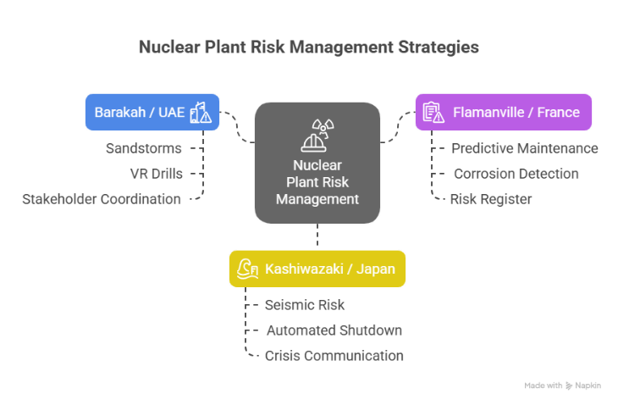
Figure 1 Nuclear Plant Risk Management Strategies
These cases demonstrate how ISO 31000 helps identify and prioritize environmental and operational hazards, while PMBOK provides actionable project planning, risk mitigation, and stakeholder alignment. For Saudi Arabia, the combination enables a proactive safety culture and regulatory readiness, tailored to its desert climate and socio-political environment. The proposed framework aligns with global safety benchmarks and provides a strategic foundation for Saudi Arabia’s nuclear safety roadmap.

IV. Conclusions

The study concludes that integrating ISO 31000 and PMBOK into Saudi Arabia’s nuclear development enhances safety, supports international compliance, and builds public trust. Tailored adaptations—like sandstorm filtration, water-efficient cooling, and cultural communication strategies—are essential for INES-level event preparedness and response.

Acknowledgments

The author extends sincere thanks to Dr. Afaque Shams and Dr. Mohammed Yousef for their supervision and guidance. Appreciation also goes to KFUPM for supporting this research.
References

- Al-Suwaidan, A. (2023). Public Perception of Nuclear Energy in Saudi Arabia. Riyadh: King Abdulaziz City for Science and Technology.
- Alrashed, F., Alqahtani, M., & Alzahrani, S. (2022). Societal Views on Emerging Nuclear Technologies in the Middle East. Journal of Energy Policy Studies, 14(2), 78–95.
- Fattah, W., & El-Katiri, L. (2018). Nuclear Energy in the Gulf States: Prospects and Risks. Oxford Institute for Energy Studies.
- IAEA. (2013). INES User’s Manual: The International Nuclear and Radiological Event Scale. Vienna: International Atomic Energy Agency.

