Pressurized Thermal Shock in Pressurized Water Reactor
Abdelrahman Irbai^{1*}, Osman Siddiqui^{1,2}, Tomasz Kwiatkowski^{3,} Afaque Shams^{1,2}
¹ Mechanical Engineering Department, KFUPM, Kingdom of Saudi Arabia
² IRC for Industrial Nuclear Energy, KFUPM, Kingdom of Saudi Arabia
³ National Centre for Nuclear Research (NCBJ), Poland
*Email(s): g202313070@kfupm.edu.sa

I. Introduction
Pressurized thermal shock happened in pressurized water reactors when cold fluid enters the hot downcomer region. This temperature difference leads to create stresses which cause a crack that propagate and cause an accident. In this work, Velocity profiles, temperature profiles, turbulent kinetic energy, and turbulent heat flux along the stream wise and spanwise directions are studied by using StarCCM + by Simens. and compared with direct numerical simulation (DNS) data. Seven different models are used. Two of them are linear eddy viscosity models: linear k Epsilon with low Re and linear SST k omega. In addition to, five nonlinear eddy viscosity models: cubic k Epsilon with low Re, cubic SST k omega, elliptic blending k epsilon, lag elliptic blending k epsilon, and elliptic blending Reynolds stress model.

II. Numerical Methods
II.A. Geometry
The geometry considered in this work is the simplified pressurized thermal shock case as per the DNS reference database [1] as shown in Fig. 1. A translational periodic boundary condition is used through the square duct to generate the fully developed flow with a mass flow rate of 0.0756 kg/s. This flow rate corresponds to Reynolds number equal to 5400 and an inlet velocity of 0.00756 m/s. In addition, the duct and downcomer walls are assumed as an adiabatic no-slip boundary condition to ensure steady state simulation as discussed in [1]. These flow parameters and fluid properties are listed in Table 1.

II.B. Mesh
Four different hexahedral meshes are studied for mesh sensitivity tests. The meshes are generated using the sweep method from the inlet face. Reducing the base element size for the inlet face and the swept element size in the streamwise direction by 15 % starting from 0.01 m and 0.0025 m, respectively, for mesh A is used as a pattern as listed in Table 2 . Also, the inflation is implemented with 13 layers, constant growth factors, and the first layer thickness to be half of y+ which correspond to 2.4×10­4 m from the wall.

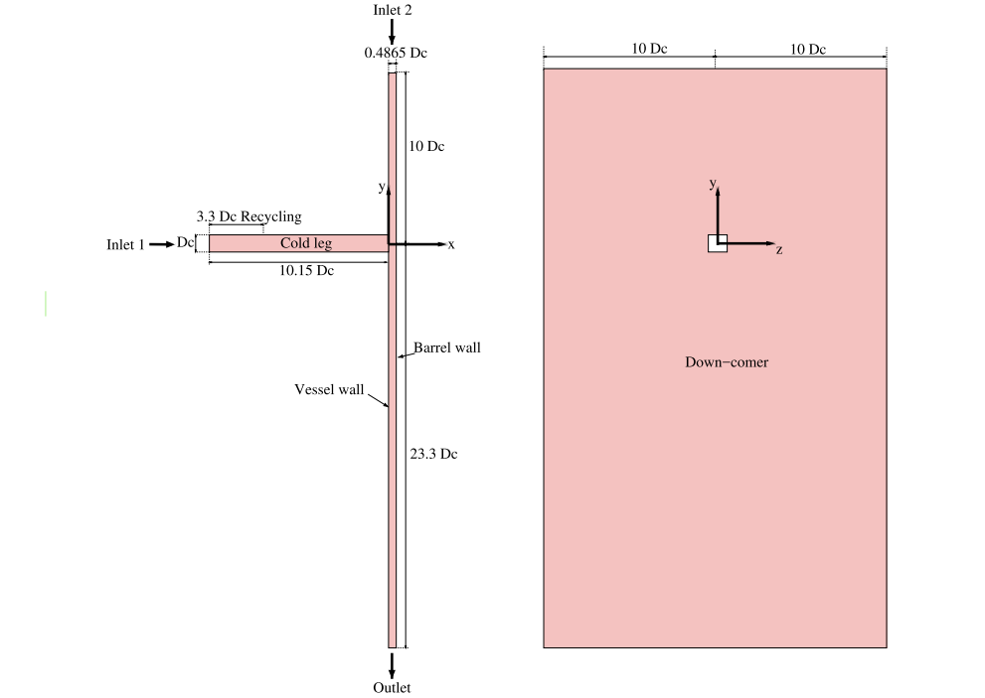

Figure 1: side and front views of the geometry used for the modeling PTS.

Table 1: The flow parameters used for fluid modeling.
Parameter | Value
The edge length, DC | 10 cm
Duct Inlet velocity | 0.00756 m/s
Downcomer Inlet velocity | 0.000756 m/s
Prandtl number, Pr | 1
Density, ρ | 1000 kg/m3
Viscosity, μ | $1.4x$10-4 Pa.s
Specific heat, Cp | 4200 J/(kg.K)
Thermal conductivity, k | 0.588 W/(m.K)
Cold Temperature | 300 K
Hot Temperature | 360 K

Table 2: The statistics for the 4 meshes considered showing in the increment in element number.

 | Base element size | Sweep element size | Inflation growth factor | Total elements
Mesh A | 0.01 | 0.0025 | 1.25 | 4,644,000
Mesh B | 0.0085 | 0.002125 | 1.25 | 6,028,680
Mesh C | 0.007225 | 0.00180625 | 1.25 | 8,054,706
Mesh D | 0.00614125 | 0.0015353125 | 1.25 | 11,224,102

Cubic standard 𝑘 − 𝜀 with low Re is used to do mesh sensitivity. Whereas the mean velocity and temperature profiles are compared through three different lines: line 1 (Z*=0 and Y*=4), line 2 (X*=0.5 and Y*=-16), line 3 (X*=0.4 and Z*=0). The mesh sensitivity study shows that the error of velocity and temperature profiles is negligible especially between meshes C and D. This leads to choosing mesh C for further simulations.

III. Turbulence Modelling
For the incompressible Newtonian turbulent flow with constant viscosity, momentum equations will be written as follows
$ρ \frac{DV_{i}}{Dt} =-\frac{∂p}{∂i}+μ\left(\frac{∂^{2}V_{i}}{{∂x}^{2}}+\frac{∂^{2}V_{i}}{{∂y}^{2}} +\frac{∂^{2}V_{i}}{{∂z}^{2}}\right)+ρg_{i}+ρ\left(\frac{∂{{(V}^{'}}_{x}{V^{'}}_{i})}{∂x}+\frac{∂\left({V^{'}}_{y}{V^{'}}_{i}\right)}{∂y}+\frac{∂\left({V^{'}}_{z}{V^{'}}_{i}\right)}{∂z}\right)+ \frac{2}{3} ρkI$ Eq. (1)
Where i indicates the coordinates and $ρ, V, P,μ, g, k, I$ are density, velocity, pressure, dynamic viscosity, gravity, turbulent kinetic energy, and the identity tensor, respectively.

The second last term includes three terms that represent turbulent shear stress ($τ_{RANS }$) which can be solved in two ways depending on the model used; namely the eddy viscosity model and the Reynolds stress transport model. The governing equations for each model are available in the manual user guide [2]. In general, to calculate Reynolds shear stress, RSM has equations to solve them, while the other models use Boussinesq approximation.

For the eddy viscosity model, the Boussinesq approximation is used to calculate the Reynold shear stress as follows:
$τ_{RANS }= µ_{τ} \left(∇\overline{V}+∇{\overline{V}}^{T}\right)- \frac{2}{3} \left(µ_{τ} ∇∙\overline{V}\right) I$ Eq. (2)

IV. Results and Discussion
Two temperature distribution figures, Fig. 2 and Fig. 3, are put in this section. One for mesh sensitivity and another for different models results compared with DNS at X* equals 0.4 and Z* equals 0.
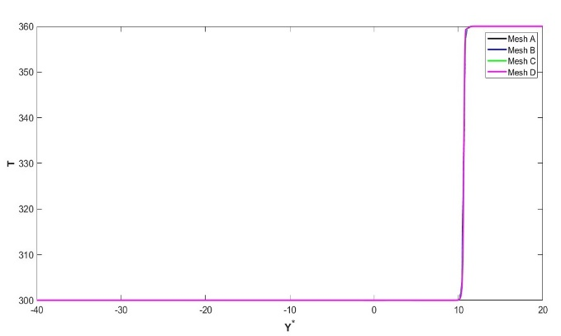
Figure 2: Mesh sensitivity result for temperature distribution at X*=0.4 and Z* =0.
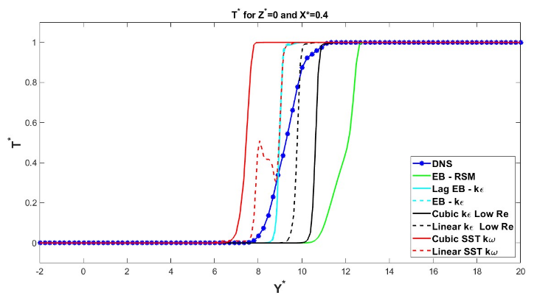 Figure 3: Temperature distribution at X*=0.4 and Z* =0 for the studied models compared with DNS data.

V. Conclusions

In general, four nonlinear eddy viscosity show ability to predict DNS profiles. These models are Lag EB k epsilon, EB k epsilon, RSM, and Cubic k epsilon with low RE. However, the accuracy of each model changes based on the parameter and location that are studied. The best model that give the lowest error for all profiles and locations is determined.
In conclusion, lag elliptic blending k epsilon is recommended to visualize the PTS scenario however it fails sometimes such as turbulent heat flux at Z0Y9 and Z0Y10.
Acknowledgments

The authors acknowledge the support provided by the Interdisciplinary Research Center for Industrial Nuclear Energy (IRC-INE) at King Fahd University of Petroleum & Minerals (KFUPM) for providing support for this work.
References

- Shams, D. De Santis, D. Rosa, T. Kwiatkowski, and E. J. M. Komen, “Direct numerical simulation of flow and heat transfer in a simplified pressurized thermal shock scenario,” Int. J. Heat Mass Transf., vol. 135, pp. 517–540, 2019, doi: 10.1016/j.ijheatmasstransfer.2019.01.144.

- “Siemens StarCCM+ 2306.” Siemens Inc., 2023.

