Towards a Self-Reliant Nuclear Future: An Analysis of Saudi Arabia's Potential in Localizing Nuclear Power Plant Equipment Production

Mohammed Alhajji^{1*}, Muhammad Yusuf², Afaque Shams^{1,2}
¹Department of Mechanical Engineering, King Fahd University of Petroleum & Minerals (KFUPM), Dhahran, 31261, Saudi Arabia
²Interdisciplinary Research Center for Industrial Nuclear Energy (IRC-INE), King Fahd University of Petroleum and Minerals (KFUPM), Dhahran, 31261, Kingdom of Saudi Arabia

I. Introduction
As Saudi Arabia initiates its first nuclear power plant, localizing nuclear equipment production becomes vital for energy security and economic diversification. Vision 2030 promotes reduced oil dependence and local content growth and deployment of Small Modular Reactor (SMR) in 2040, yet the Kingdom still heavily relies on foreign expertise and supply chains [1,2]. A weak domestic manufacturing base threatens technological sovereignty and cost control, especially for complex nuclear components.
While global examples, such as Poland and the UK, show success through policy, training, and investment incentives, Saudi Arabia faces unique geopolitical and institutional challenges [1,3]. This study fills a research gap by evaluating the Kingdom’s capacity to localize nuclear equipment, adapting lessons from oil and gas localization initiatives like In-Kingdom Total Value Add (IKTVA).
By leveraging the evolving circular economy and regional content programs [4,5] this research proposes an integrated strategy for phased localization. The findings offer a foundation for policymakers to boost domestic manufacturing and position Saudi Arabia as a regional hub for safe, self-reliant nuclear technology.

II. Methodology
This study employs a case-based analytical approach to evaluate the localization potential of nuclear power plant (NPP) equipment in Saudi Arabia. The methodology involves a detailed breakdown of NPP infrastructure involving experts to get more comprehensive classifications. The results were classified into 27 distinct equipment categories, enabling systematic assessment across a nuclear facility's full operational scope. Cost estimations for each equipment type were meticulously and rigorously compiled from authoritative sources, culminating in a total projected cost of $2.086 billion for a single NPP unit. This serves as the baseline for localization potential analysis.
Furthermore, the study integrates market investigation through engagement with domestic companies, including site visits and expert consultations, to evaluate local manufacturing capabilities. Companies were mapped according to specialization areas, which allowed for identifying strategic opportunities to develop a self-sufficient nuclear equipment supply chain. This approach provides a comprehensive framework for assessing Saudi Arabia's readiness to transition toward a self-reliant nuclear future.

III. Results and Discussions
The localization analysis of nuclear power plant (NPP) equipment in Saudi Arabia, when interpreted alongside Figures 1 and 2, underscores the substantial gap between the Kingdom’s strategic aspirations and its current manufacturing capabilities. As Figure 1 reveals, only 7% of NPP equipment costs are currently localized, with the remaining 93% reliant on imports. Figure 2 provides a more granular breakdown, showing that critical components such as reactor vessels, control rod drive mechanisms, control rods, and fuel assemblies remain entirely imported.
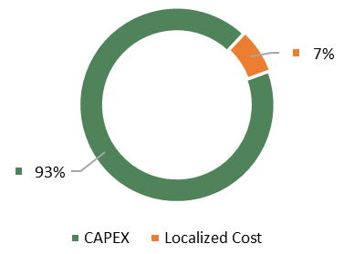
Figure 1. Localized Percentage
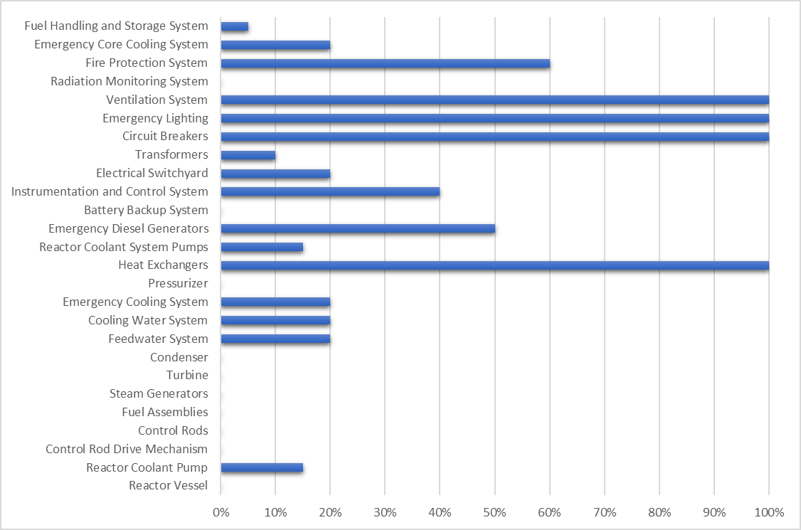
Figure 2. Percentage of NPP Equipment Localization
This complete dependency on external suppliers for core nuclear systems reflects the high entry barriers posed by technical complexity, safety-critical design, and material requirements. In contrast, auxiliary systems such as heat exchangers, emergency lighting, ventilation systems, and emergency diesel generators exhibit partial to full localization. Notably, equipment like heat exchangers and emergency core cooling systems have achieved up to 100% localization, suggesting that Saudi industry has the potential to scale its role in less complex or non-nuclear-specific systems.
The figures also highlight promising entry points for industrial development, where existing capacity can be leveraged for incremental localization. To enhance localization outcomes, Saudi Arabia must invest in R&D, skilled labor development, and nuclear-grade supply chain infrastructure. Additionally, international technology partnerships and public-private collaboration will be pivotal in bridging expertise gaps. The combined evidence confirms that a phased, strategic localization model is essential to achieve a self-reliant nuclear future.

IV. Conclusions
This study concludes that while the Kingdom of Saudi Arabia has made an initial strategy toward localizing nuclear power plant (NPP) equipment production into 27 categories by applying the local content policies in Saudi Arabia, such as In-Kingdom Total Value Add (IKTVA), which has been applied in oil and gas sector. By adopting IKTVA strategies, the current state reflects substantial challenges to achieving self-reliance. Only 7% of the total NPP equipment cost, estimated at $2.086 billion per unit, is presently localized, with core components such as reactor vessels, control rod drive mechanisms, and fuel assemblies entirely dependent on imports. This research highlights critical gaps in technical expertise, supply chain readiness, and specialized infrastructure.
However, auxiliary and support systems, including heat exchangers, ventilation systems, and emergency lighting, demonstrate partial to complete localization, which indicates latent industrial capabilities in non-nuclear-specific segments. The findings suggest that incremental and strategically phased localization is feasible, particularly if targeted investments in research and development (R&D), workforce development, and nuclear-grade manufacturing facilities are supported.
Furthermore, collaboration with international nuclear technology providers and integration of local content policies such as IKTVA can catalyze knowledge transfer and industrial growth. Achieving a self-reliant nuclear future will ultimately depend on aligning technical development with policy frameworks and industrial readiness across Saudi Arabia’s evolving energy landscape.
References
- Savio, R., 2021. IKTVA and Saudi Arabia Vision 2030. Eximia 2, 1.
- Zhdaneev, O.V., Ovsyannikov, I.R., 2024. From import substitution to technological leadership: how local content policy accelerates the development of the oil and gas industry. Journal of Mining Institute.
- Alam, F., Sarkar, R., Paul, A.R., Aldiab, A., 2021. Nuclear Power Plants and Human Resources Development in South Asia. Springer Singapore, Singapore, pp. 1603-1613.
- Almulhim, A.I., Al-Saidi, M., 2023. Circular economy and the resource nexus: Realignment and progress towards sustainable development in Saudi Arabia. Environmental Development 46, 100851.
- Zainaddin, I., 2022. Enhancing Operational Business Decision Making by Better Understanding Gcc's Oil and Gas Energy Sector Local Content Programs. International Petroleum Technology Conference.

